

Capstone Project

Project title: **Website Gadget Development Platform**

**FINAL REPORT**

**VERSION 1.0**

|  |  |
| --- | --- |
| **Webgad Team** | |
| **Supervisor** | **Trần Quý Ban** |
| **Group member** | **Nguyễn Xuân Chức - SE04713**  **Tô Quang Duy - SE04431**  **Nguyễn Ngọc Lâm - SE04432**  **Nguyễn Thanh Sơn - SE04448**  **Nguyễn Văn Vũ - SE04475** |
| **Project code** | **Webgad System** |

**HaNoi, Jan 3, 2019**

Acknowledgement

*This study could not have been completed without the help and support of many individuals and organizations. Therefore, we would like to express our appreciation and gratitude to those who have supported us during the most important milestone of university years.*

*First and foremost, we would love to express our deep gratitude to our supervisor, Mr. Tran Quy Ban. Without his assistance and dedicated involvement in every step throughout the process, this paper would have never been accomplished. We also sincerely thank to all of our teachers who had taught us in four years in FPT University.*

*We also grateful to our friends whom we have had the pleasure to know and work with during this semester. We could say that the capstone project could not have been fully accomplished without their support.*

*Nobody has been more important to us in the pursuit of this project than our family. We would love to thank our parents, our sisters and brothers and our friends who offered unlimited encouragement and support.*

Hoa Lac, Jan 3, 2019

Authors of capstone project

Table of Contents

DEFINITIONS AND ACRONYMS 7

CHAPTER 1: INTRODUCTION 8

1.1 Propose 8

1.2 Project Information 8

1.3 The People 8

1.4 Background 9

1.5 The problem 9

1.6 Literature review 9

1.7 The proposal 12

1.8 System functions 13

CHAPTER 2: SOFTWARE PROJECT MANAGEMENT PLAN (SPMP) 14

2.1 Purpose 14

2.2 Software process model 14

2.2.1 About the iterative model 14

2.2.2 Advantages and disadvantages considering 15

2.3 Project organization 15

2.3.1 Organization structure 15

2.3.2 Roles and Responsibilities 16

2.4 Tools and Techniques 18

2.5 Project management plan 18

2.5.1 Project schedule 18

2.5.2 Meeting minute template 19

2.5.3 Risk management plan 21

2.5.4 Communication plan 23

2.5.5 Coding convention 25

CHAPTER 3: SOFTWARE REQUIREMENTS SPECIFICATION (SRS) 26

3.1 Introduction 26

3.1.1 Purpose 26

3.1.2 Definitions, Acronyms and Abbreviations 26

3.2 User requirement specification 27

3.2.1 Business process diagram of creating a gadget 27

3.2.2 Gadget state diagram 28

3.3 System requirement specification 29

3.4 Specific Requirements 29

3.4.1 Functional Requirements Specification 29

3.4.2 Non-Functional Requirements Specification 65

3.5 Entity relationship diagram 66

CHAPTER 4: SOFTWARE DESIGN DESCRIPTION 67

4.1 Purpose 67

4.2 Architecture overview 67

4.2.1 System Architecture 67

4.2.2 System Architecture Explanation 68

4.2.3 Layer architecture diagram 72

4.2.4 Component diagram 73

4.3 Detailed design 74

4.3.1 Package diagram 74

4.3.2 Class diagram 75

4.3.3 User interface design 190

4.3.4 Sequence diagram for each function 203

4.4 Database design 222

Table Relationship Diagram: 222

Database Explanation: 223

4.5 Recommendation implementation detail 231

4.5.1 Introduction 231

4.5.2 Description 232

4.5.3 Reference 240

4.5.4 Related content 240

CHAPTER 5: SOFTWARE TESTING DOCUMENT 241

5.1 Purpose 241

5.2 Test strategy 241

5.2.1 Objective and scope 241

5.2.2 Testing tools and environment 241

5.2.3 Resources and responsibilities 242

5.2.4 Acceptance criteria 243

5.2.5 Risk list 243

5.2.6 Test process 243

5.3 Test plan 244

5.3.1 Test model 244

5.3.2 Stage of testing 244

5.3.3 Function to be tested 245

5.3.4 Function not to be tested 246

5.3.5 Type of testing 246

5.3.6 Test milestone 247

5.3.7 Deliverables 248

5.4 Test approach 248

5.4.1 Unit test 248

5.4.2 Integration test 251

5.4.3 Acceptance Test 251

5.5 Defect log 252

5.5.1 Defect life cycle 252

5.5.2 Defect sample 254

5.6 Test report 254

5.6.1 Unit test report 254

5.6.2 Integration test report 256

CHAPTER 6: SOFTWARE USER’S MANUAL 257

6.1 Webgad System deployment guidelines 257

6.1.1 Prepare environment 257

6.1.2 Deploy webgad server 258

6.2 Recommendation server deployment guidelines 258

6.2.1 Prepare environment 258

6.2.2 Deploy recommendation server 259

6.3 User guides 260

6.3.1 Guide for Guest 260

6.3.2 Guide for User 266

6.3.3 Guide for Gadget User 274

6.3.4 Guide for Gadget Developer 284

6.4 Admin guides 294

6.4.1 Verify gadget 294

6.4.2 Verify claim 296

References 298

# DEFINITIONS AND ACRONYMS

|  |  |  |
| --- | --- | --- |
| **No** | **Definition & Acronym** | **Explanation** |
| 1 | Webgad | Website Gadget. |
| 2 | Gadget | A stand-alone application that can be embedded into third party sites by user on a web page |
| 3 | Webgad Store | Website Gadget Store |
| 4 | Webgad Console | Website Gadget Console |
| 5 | Gadget Developer | People who develops gadget for web applications. |
| 6 | Gadget User | People who need web gadget for their website. |
| 7 | User | The term includes Gadget Developer and Gadget User |
| 8 | Guest | People who visit the Webgad Store and haven’t had the account yet. |
| 9 | SRS | Software requirement specification. |
| 10 | PM | Project manager. |
| 11 | Dev | Developer. |

# CHAPTER 1: INTRODUCTION

## Propose

This chapter provides an overview of the capstone project. It includes the project information, the background of the capstone project, the problem and our proposal to solve the problem.

## Project Information

* Project name: Website Gadget Development Platform.
* Project code: Webgad System.
* Project group name: WebgadTeam
* Project type: Web Application
* Timeline: 10/09/2018 - 31/12/2018

## The People

Supervisor:

|  |  |  |  |
| --- | --- | --- | --- |
| **Full name** | **Phone** | **E-Mail** | **Title** |
| Trần Quý Ban | 0988091804 | BanTQ3@fe.edu.vn | Supervisor |

|  |  |  |  |  |  |
| --- | --- | --- | --- | --- | --- |
| **No.** | **Full name** | **Code** | **Phone** | **E-mail** | **Role** |
| 1 | Nguyễn Xuân Chức | SE04713 | 0987100562 | chucnxse04713@fpt.edu.vn | Leader |
| 2 | Tô Quang Duy | SE04431 | 0366664451 | duytqse04431@fpt.edu.vn | Member |
| 3 | Nguyễn Ngọc Lâm | SE04432 | 0358024207 | lamnnse04432@fpt.edu.vn | Member |
| 4 | Nguyễn Thanh Sơn | SE04448 | 0964532407 | sonntse04448@fpt.edu.vn | Member |
| 5 | Nguyễn Văn Vũ | SE04475 | 0353602746 | vunvse04475@fpt.edu.vn | Member |

Members:

## Background

The need for developing websites is becoming more popular nowadays, the number of new websites is increasing and the web technology is changing rapidly, leading to the heavy workload for programmers and they had to spend more time learning new technologies.

## The problem

When developing a new website, developers have to re-develop a function for their sites that would be the other developers have developed already. Besides, when using a new library, they will have to visit the home page of that library, learn how to use. This process takes time and effort.

## Literature review

Before starting to develop Webgad System, we take glimpse at several other well-established sites for develop and share gadgets. However they still have some limitations and we will explain why Webgad System should be built.

**Website:** [*https://widgetpack.com/*](https://widgetpack.com/) and [*http://100widgets.com/*](http://100widgets.com/)

“widgetpack.com” and “100widgets.com” are websites sharing gadgets. But they still have some issues below:

* Just have one side developing gadgets. User can’t create or sharing their gadgets.
* Don’t have search, rating or review gadgets.
* Can’t customize their gadgets about color, font, …

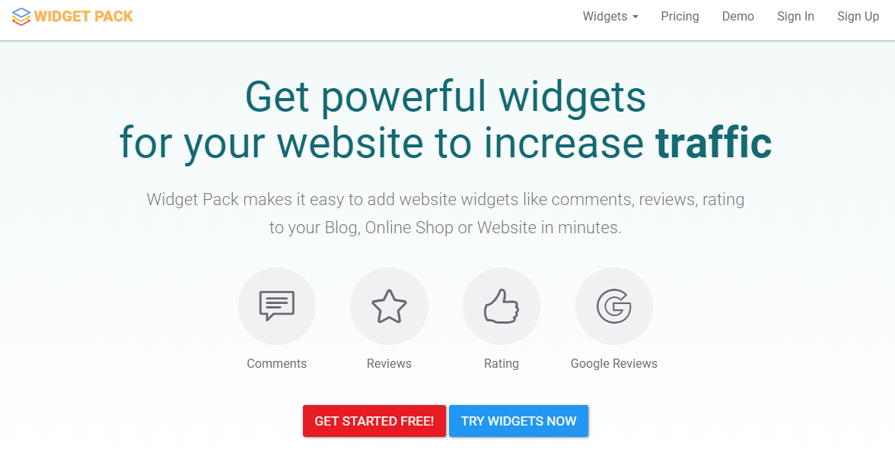

*Figure 1-1a.Website:* [*https://widgetpack.com/*](https://widgetpack.com/)

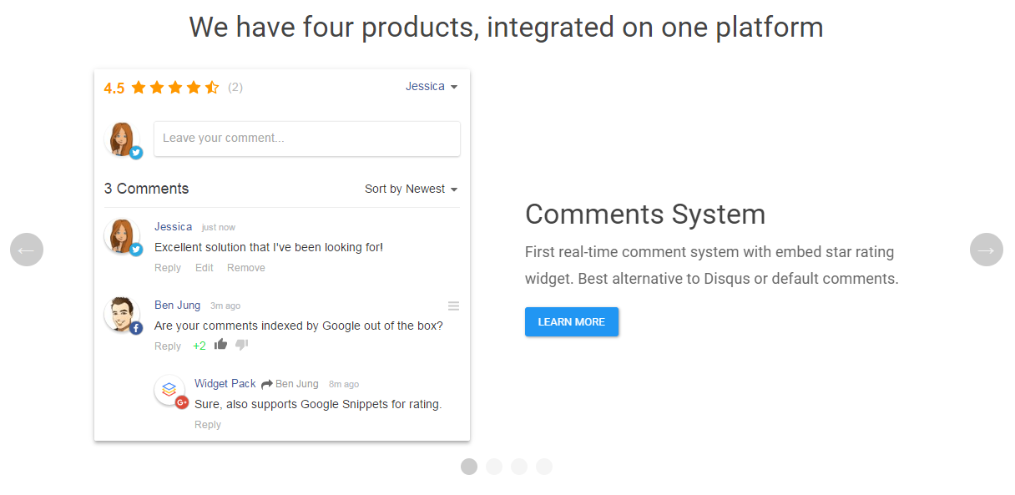

*Figure 1-1b.Website:* [*https://widgetpack.com/*](https://widgetpack.com/)

* “widgetpack.com” just has four products.

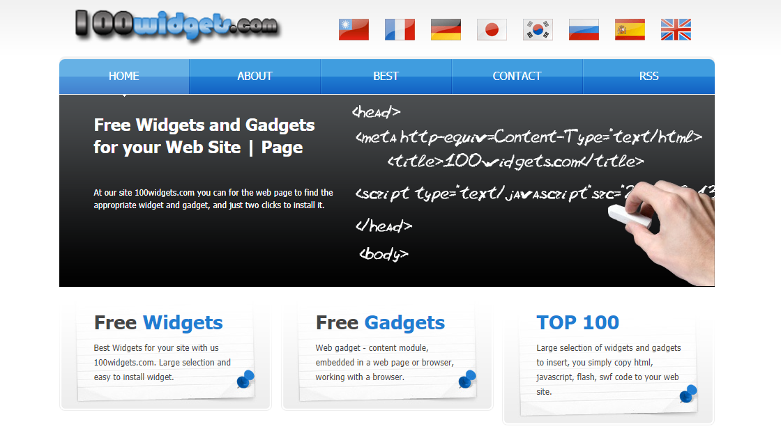

*Figure 1-2a. Website:* [*https://100widgets.com/*](https://100widgets.com/)

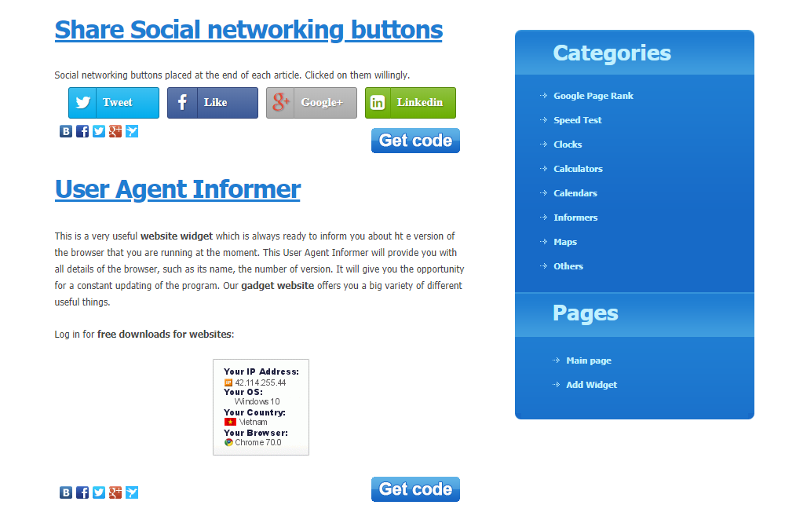

*Figure 1-2b. Website:* [*https://100widgets.com/*](https://100widgets.com/)

* User can’t make money from their gadgets in “100widgets.com”.

**Website:** [*https://www.wix.com/*](https://www.wix.com/)

* Install app function of wix is limited for another website.

***Comparison with other existing system:***

|  |  |  |  |
| --- | --- | --- | --- |
|  | **100widgets.com** | **widgetpack.com** | **wix.com** |
| Developers can create and publish their gadgets |  |  | x |
| Gadget can be used in any website | x | x |  |
| Diverse products | x |  | x |
| Users can rate and comment a gadget |  | x | x |
| Payment |  | x | x |
| Recommendation gadget |  |  |  |
| Full text search |  |  | x |
| Customize gadget |  | x | x |
| Version of gadget |  | x | x |

## The proposal

Gadget developers can deploy their gadgets on the server, then publish them to the store so they can share the gadget with other users as well as reuse the gadget for other their website. The gadget can handle function from client and server side and store database on the server. Users can easily find gadgets in the store and use them easily and quickly. Gadgets will be rating by the user, comment to evaluate its usefulness.

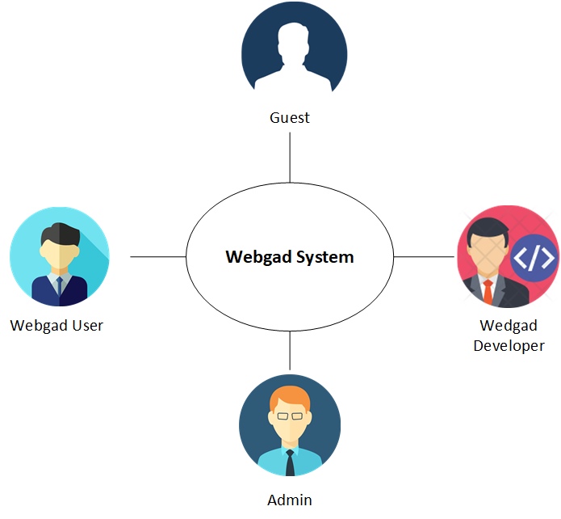

*Figure 1-3.Roles in Webgad system*

## System functions

The system has the following 5 modules and main function:

* **Webgad Account:**
* Register accounts or forgot password.
* Sign in and sign out system.
* Change password.
* Update information.
* **Webgad Store:**
* Search and view gadgets.
* Purchase and install gadgets.
* Update new version or customize gadgets.
* Report gadgets.
* Give rating and review gadgets.
* **Webgad Console:**
* Create and deploy gadgets.
* Publish or unpublished gadgets.
* Upgrade or delete gadgets.
* Manage all gadgets.
* **Webgad Admin:**
* Verify request publish gadgets.
* Verify request report gadgets.
* **Mongo client library:**
* Help gadget developers connect to our nosql database server.

# CHAPTER 2: SOFTWARE PROJECT MANAGEMENT PLAN (SPMP)



## Purpose

Project plan describes the software process model, team organization and management plan of the project. All team members must follow this section as a guideline to complete assigned tasks and deadline.

## Software process model

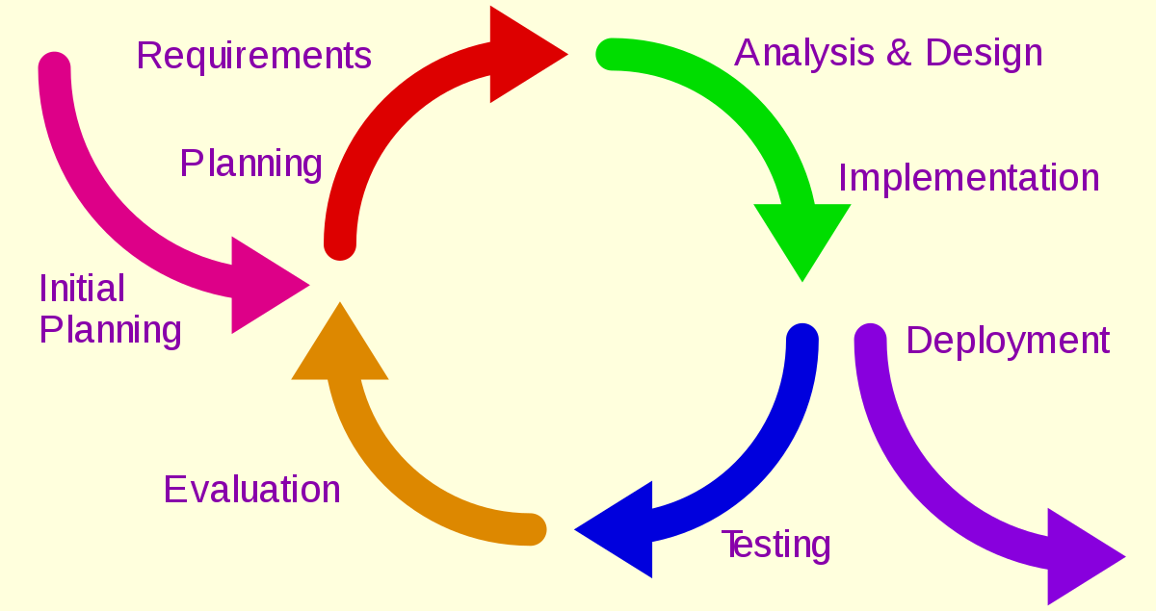

*Figure 2-1.Iterative development model*

### About the iterative model

The iterative model is a particular implementation of a software development life cycle (SDLC) that focuses on an initial, simplified implementation, which then progressively gains more complexity and a broader feature set until the final system is complete. Each cycle (iteration) ends with a usable system.

* **Planning & Requirements:** the first step is go through an initial planning stage to map out the specification documents.
* **Analysis & Design:** the second step is performed to nail down the appropriate business logic, database models. The design stage also occurs here, establishing any technical requirements to meet the needs of the analysis and design stage.
* **Implementation:** the actual implementation and coding process can now begin. All planning, specification, and design docs up to this point are coded and implemented into this initial iteration of the project.
* **Verification and testing:** the next step is to go through a series of testing procedures to identify and locate any potential bugs or issues that have cropped up.
* **Evaluation:** the last step is evaluating the development up to this stage. This allows the entire team to examine where the project is at, where it needs to be, what should change.

### Advantages and disadvantages considering

|  |  |
| --- | --- |
| **Advantages** | **Disadvantages** |
| Innovative technology is involved-developer team can learn as they work on the project. | Heavily document changes when there are more and more iteration. |
| The major requirements are defined, while some functionalities enhancements evolve with the process of the development process. | Issues about system architecture may turn out to be a big problem when lacking of a full requirements specification. |
| Functional prototypes are developed early and delivery for each iteration. | Highly skilled resources are required for analysis skill. |

## Project organization

### Organization structure

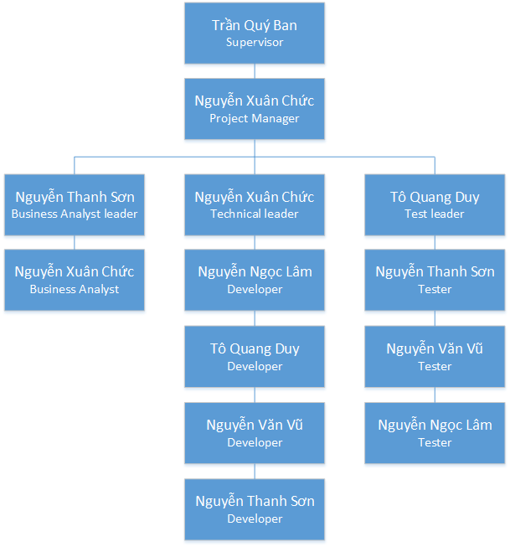

*Figure 2-2.Organization Structure*

### Roles and Responsibilities

|  |  |  |
| --- | --- | --- |
| **Role** | **Responsibilities** | **Full name** |
| Project manager | * Guide team toward the goal of successfully passing the final capstone project. * Develop schedule and assigning task with responsibilities for each member. * Review and make sure the capstone project succeed. | Nguyễn Xuân Chức |
| **Business analyst team** | | |
| BA leader | * Analyze requirement. * Define scope and create SRS document. * Design entity relationship diagram. | Nguyễn Thanh Sơn |
| BA | Define business process flow and object state. | Nguyễn Xuân Chức |
| BA | Capture and specific describe use case. | Nguyễn Văn Vũ |
| **Developer** | | |
| Technical leader | * Define high level architecture base on SRS. * Implement configuration and web server * Coding for controller, services and server API * Research and implement UX design for frontend. * Develop client functions in console system | Nguyễn Xuân Chức |
| Developer | * Coding for controller, services and server API in console system * Develop client functions in console system | Nguyễn Ngọc Lâm |
| Developer | * Coding for controller, services and server API in store system * Develop client functions in store system | Tô Quang Duy |
| Developer | * Research and implement UX design for frontend document system * Coding for controller, services and server API in document system * Develop client functions in document system | Nguyễn Văn Vũ |
| **Tester** | | |
| Test leader | * Create template testing document. * Define test strategy, create test plan and defect log template. | Tô Quang Duy |
| Tester | * Create test cases * Implement test case and log defect | Nguyễn Thanh Sơn |
| Tester | * Create test cases * Implement test case and log defect | Nguyễn Văn Vũ |

## Tools and Techniques

|  |  |  |
| --- | --- | --- |
| **Software Tool** | **Version** | **Description** |
| Microsoft project | 2013 | Management tools |
| Trello | Online | Management tools |
| Gitlab | Online | Source code control |
| Source tree | 2.6.10 | Source code control |
| Eclipse | Photon 4.8.0 | IDE for coding |
| Visual Studio Code | 1.27.0 | IDE for coding |
| Microsoft Words | 2016 | Document tools |
| Microsoft Excel | 2016 | Document tools |
| MySQL Workbench | Community 6.3 | Software to interact with SQL Server |
| MySQL Community Server | 8.0.11 | Sql server |
| Microsoft Visio | 2013 | Diagram, chart, UML tool |
| Facebook | Online | Communication tool |
| Skype |  | Communication tool |

## Project management plan

### Project schedule

The task lists detail is described in: ***Webgad_Project_Management_Plan.mpp***

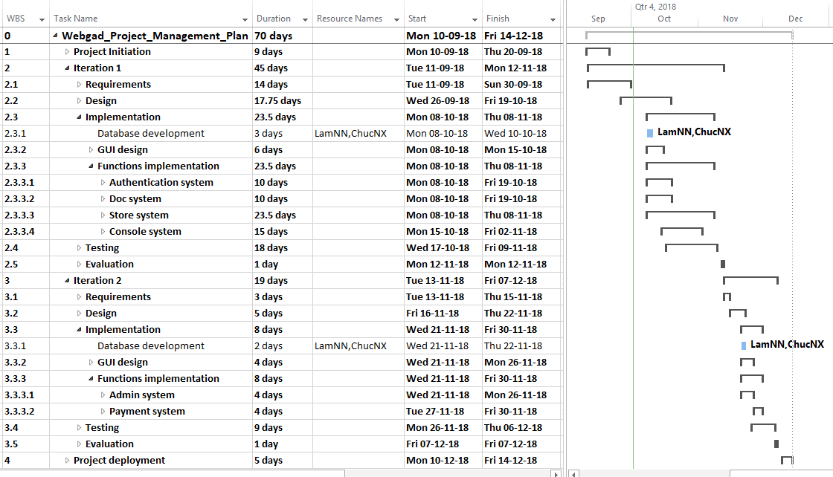

*Figure 2-3.Task list*

### Meeting minute template

Meeting minutes are written for any meeting. The following template is used:

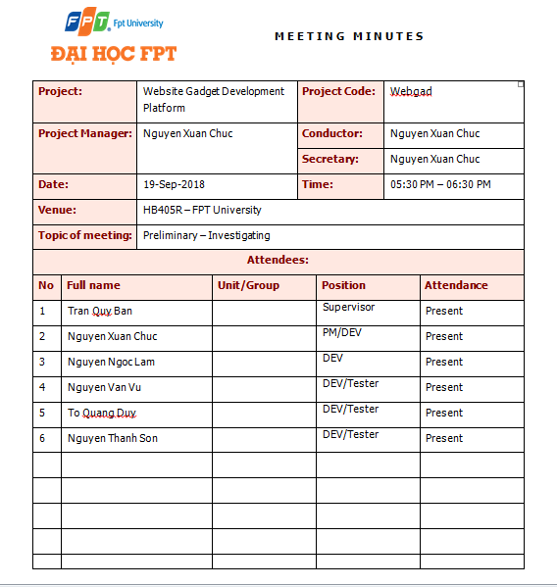

*Figure 2-4a.Meeting minute template*

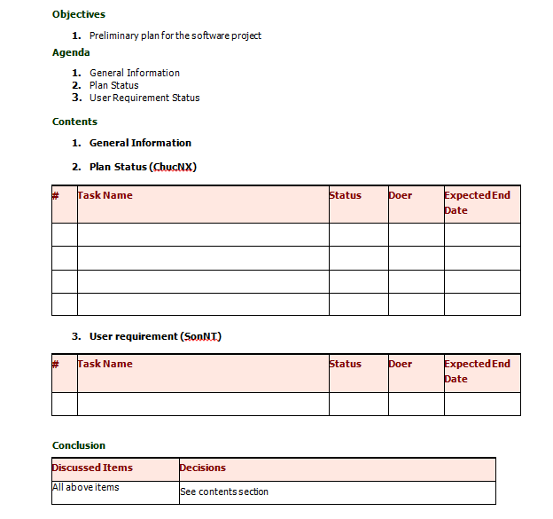

*Figure 2-4b.Meeting minute template*

### Risk management plan

* ***Risk identification***

|  |  |  |  |  |
| --- | --- | --- | --- | --- |
| **No** | **Risk description** | **Contingency/Mitigation plan** | **Probability** | **Impact** |
| 1 | Poor planning work task for each member, inappropriate resource allocation | Discuss with team member for each task planning. | Medium | High |
| 2 | Change Requirement/Objective during the project | Meeting and redefine objective with each team member. | Medium | High |
| 3 | Team member do not meet the deadline | * Find the root cause of the problems. * Assign task to other team member. * Break down task to smaller tasks and assign new tasks to team members. | Medium | Medium |
| 4 | Team members lack technical skills and knowledge | Technical leader assists team member personally or in group to develop required skills and knowledge. | Medium | Low |
| 5 | Absences of team members | Assign important tasks to other suitable team members. | Low | Medium |
| 6 | Required task missing from the schedule | * Analyze the requirements carefully. * Monitor the process carefully. | Medium | Medium |
| 7 | Conflicts among team members | * Transfer problems to whole team to resolve it. * Create a happy and friendly environment among team members | Low | Medium |
| 8 | High impact risks are not identified | * Discussion with team member. * Meeting with supervisor, expert. | Medium | Medium |
| 9 | Design document is poorly written lead to implementation wrongly | * Technical review * Meeting with supervisor, expert. | Low | High |
| 10 | Program testing is not fully covered | Meeting with supervisor, expert. | High | Medium |

* ***Probability/impact matrixes***

|  |  |  |  |  |
| --- | --- | --- | --- | --- |
| Probability | High |  | R10 |  |
| Medium | R4 | R3, R6, R8 | R1, R2 |
| Low |  | R5. R7 | R9 |
|  |  | Low | Medium | High |
|  |  | Impact | | |

### Communication plan

#### Member information

|  |  |  |  |
| --- | --- | --- | --- |
| **No** | **Name** | **Position** | **Contact information** |
| 1 | Nguyễn Xuân Chức | Project manager | Email: chucnxse04713@fpt.edu.vn Phone: 0987 100 562 |
| 2 | Tô Quang Duy | Developer/Tester | Email: duytqse04431@fpt.edu.vn Phone: 036 666 4451 |
| 3 | Nguyễn Ngọc Lâm | Developer | Email: lamnnse04432@fpt.edu.vn Phone: 035 802 4207 |
| 4 | Nguyễn Thanh Sơn | Developer/Tester | Email: sonntse04448@fpt.edu.vn Phone: 0964 532 407 |
| 5 | Nguyễn Văn Vũ | Developer/Tester | Email: vunvse04475@fpt.edu.vn Phone: 035 360 2746 |

#### Project report and meeting

|  |  |  |  |  |
| --- | --- | --- | --- | --- |
| **No** | **Activity** | **Stakeholder** | **Time** | **Description** |
| 1 | Weekly report | * Team member * Supervisor | Wednesday | * Report in meeting minutes. * Review status based on weekly report. * Plan for next weekly work. |
| 2 | Daily report | Project manager | Daily | * Report issue and planning * Support to solve issues. |
| 3 | Ad-hoc report | Team members | Event-based | * Report and talking face to face. |

#### Project communication

|  |  |  |
| --- | --- | --- |
| **No** | **Communication type** | **Description** |
| 1 | Weekly meeting schedule | Spend one day in a week for meeting to report the progress, review and update solution for problems. |
| 2 | Unscheduled meeting | If any team member has problems that he wants to solve immediately, we will have a meeting for discussion. |
| 3 | Communication channel | Our main communication is face-to-face meeting, chat box, email, Facebook messenger and skype call. However, we sometimes make a phone call or instant message if someone has problem |

### Coding convention

**Purposes:**

* Easy maintenance, fix bug.
* Let others understand your source code.
* Uniform code between team members.

**Follow Java Coding Convention at:**

<https://www.oracle.com/technetwork/java/codeconventions-150003.pdf>

# CHAPTER 3: SOFTWARE REQUIREMENTS SPECIFICATION (SRS)



## Introduction



### Purpose

This chapter is organized by use cases for major system features. In the following, necessary description is provided for each use cases in the system. Each use case description provides information of the associated actors, triggering condition, preconditions, post conditions, response sequences, exceptions and functional requirements (assumptions). Being a major important section of the SRS, this section is expected to go through iterative improvement to make the most logical sense for the intended product.

### Definitions, Acronyms and Abbreviations

|  |  |  |
| --- | --- | --- |
| **No** | **Definition & Acronym** | **Explanation** |
| 1 | UC-CM | Common use case |
| 2 | UC-WD | Gadget Developer use case |
| 3 | UC-WU | Gadget User use case |
| 4 | UC-AD | Admin use case |

## User requirement specification

### Business process diagram of creating a gadget

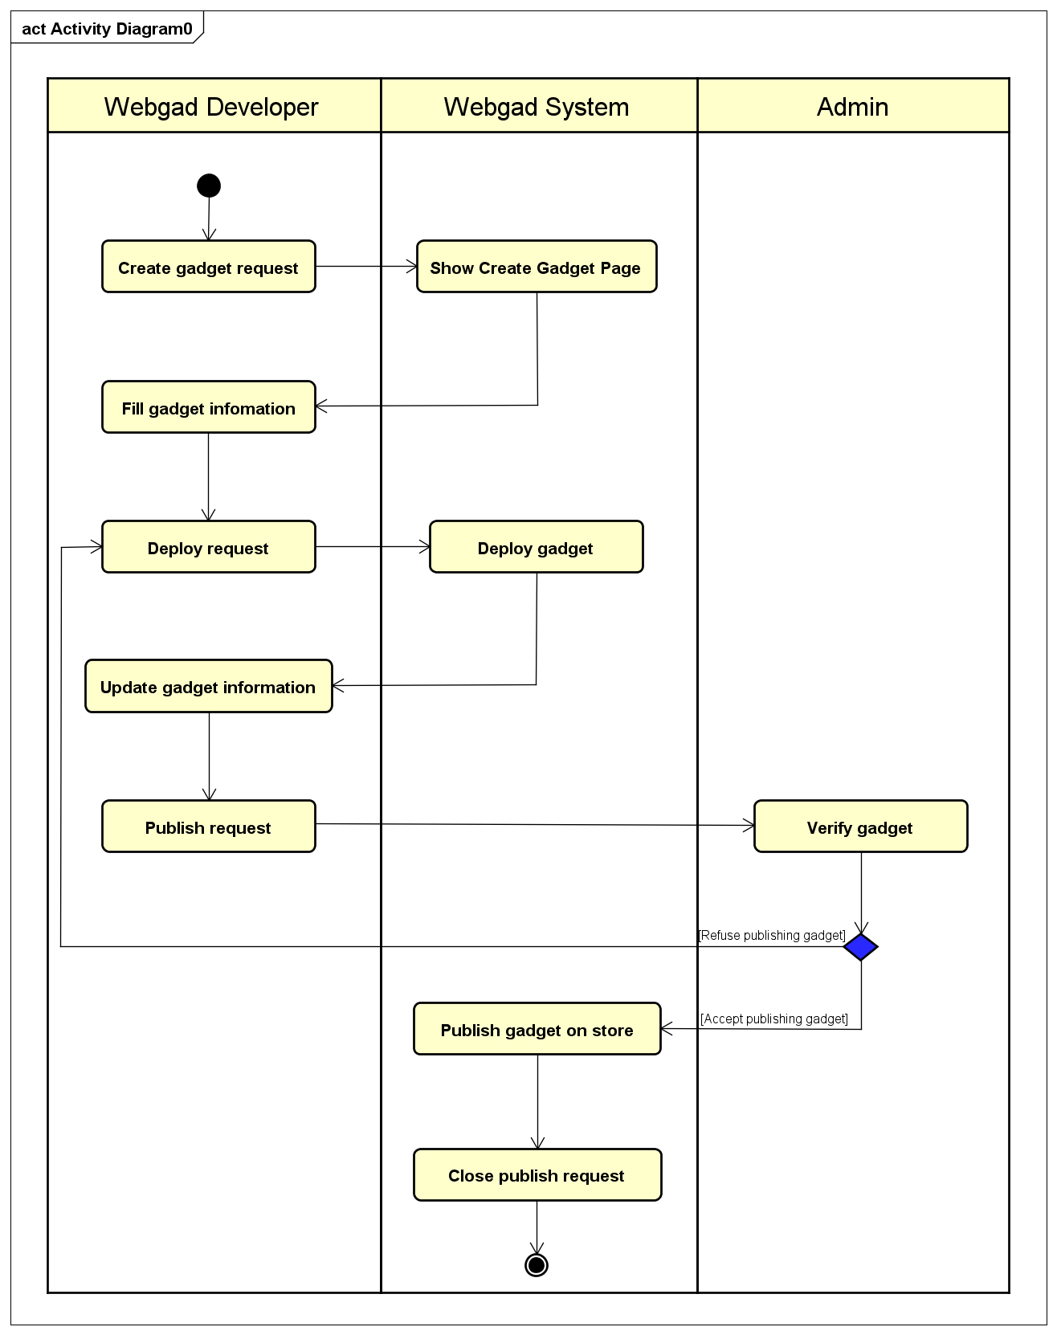

*Figure 3-1.Business process of create gadget*

**Description:**

When gadget developers want to create a gadget, they send request to server and fill all information of their gadget. After deploy gadget on server successfully, they can publish the gadget to Webgad Store. Admin will verify gadget and if the gadget is valid, it will be published to Webgad Store. Every user can search, buy and install the gadget.

After gadget is published to Webgad Store, gadget developers can upgrade new version for their gadget. They will update gadget information, deploy, send request publish to server and admin re-verify then publish to Webgad Store. Every user can also upgrade the gadget in their websites if they want.

### Gadget state diagram

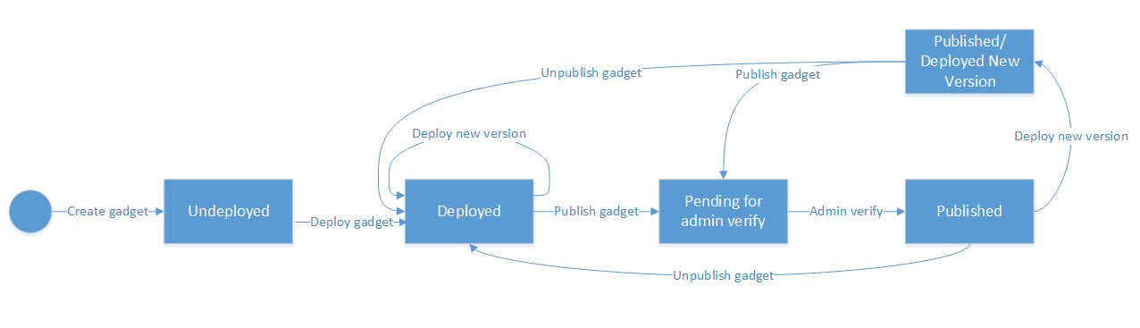

*Figure 3-2.Gadget state diagram*

**Description:**

|  |  |  |
| --- | --- | --- |
| **No** | **State** | **Description** |
| 1 | Undeployed | State of gadget after Gadget Developer created. |
| 2 | Deployed | State of gadget after Gadget Developer deploy gadget on server. |
| 3 | Pending | Gadget is waiting for admin verify. |
| 4 | Published | Gadget is verified by admin and published to Webgad Store. |
| 5 | Unpublished | Gadget is rejected by admin or Gadget Developer update new version. |
| 6 | Published/Deployed new version | Gadget is published and developer of the gadget deploy a new version. |

## System requirement specification

**User Interface:** The text is written in English.

**Hardware Interface:** The web application is purely designated for software and does not require any hardware interface.

**Software interface:** The Webgad System uses Google Oauth2[6] for login with google account.

**Communication:** The website is communicated with web service by HTTPS requests, send notification email (SMTP).

## Specific Requirements

The major services, functional and non-functional requirements for the product can be illustrated by system features. This section is organized by use cases for major system features. In the following, necessary description is provided for each use cases in the system. Each use case description provides information of the associated actors, triggering condition, preconditions, post conditions, response sequences, exceptions and functional requirements (assumptions). Being a major important section of the SRS, this section is expected to go through iterative improvement to make the most logical sense for the intended product.

### Functional Requirements Specification

#### Business rule repository

**Domain business rule:**

|  |  |
| --- | --- |
| **No** | **Description** |
| BR-1 | Gadget Developer can create, deploy, publish gadget to Webgad Store to make money. |
| BR-2 | If gadget is free, user can install gadget for free, otherwise user must pay fees before installing gadget. |
| BR-3 | User can give feedback a gadget only if after installing it. |
| BR-4 | User can claim a gadget only after purchasing it. |
| BR-5 | Gadget can be rated only once by each user |
| BR-6 | Gadget can be commented only once by each user but they can update posted comment. |
| BR-7 | Name of gadget must not exceed 100 characters and not contain special characters. |
| BR-8 | Banner images of gadget have maximum 10 images. |
| BR-9 | Only Gadget Developer can manage their’s gadget profile. |
| BR-10 | User can upgrade new version but doesn't roll back older version the gadget. |
| BR-11 | Gadget User can manage all gadget purchased. |

**Specific business rule:**

|  |  |
| --- | --- |
| **No** | **Description** |
| BI-1 | The field must be filled by characters consist of alphabet, numbers and space. |
| BI-2 | The field must be filled by characters consist of alphabet and numbers. |
| BI-3 | The field must be filled, follow by format “X@X.Y”, where X is characters and Y is alphabets. X and Y are at least 1 character. |
| BI-4 | Must enter from 6 to 50 characters. |

#### Use case diagram

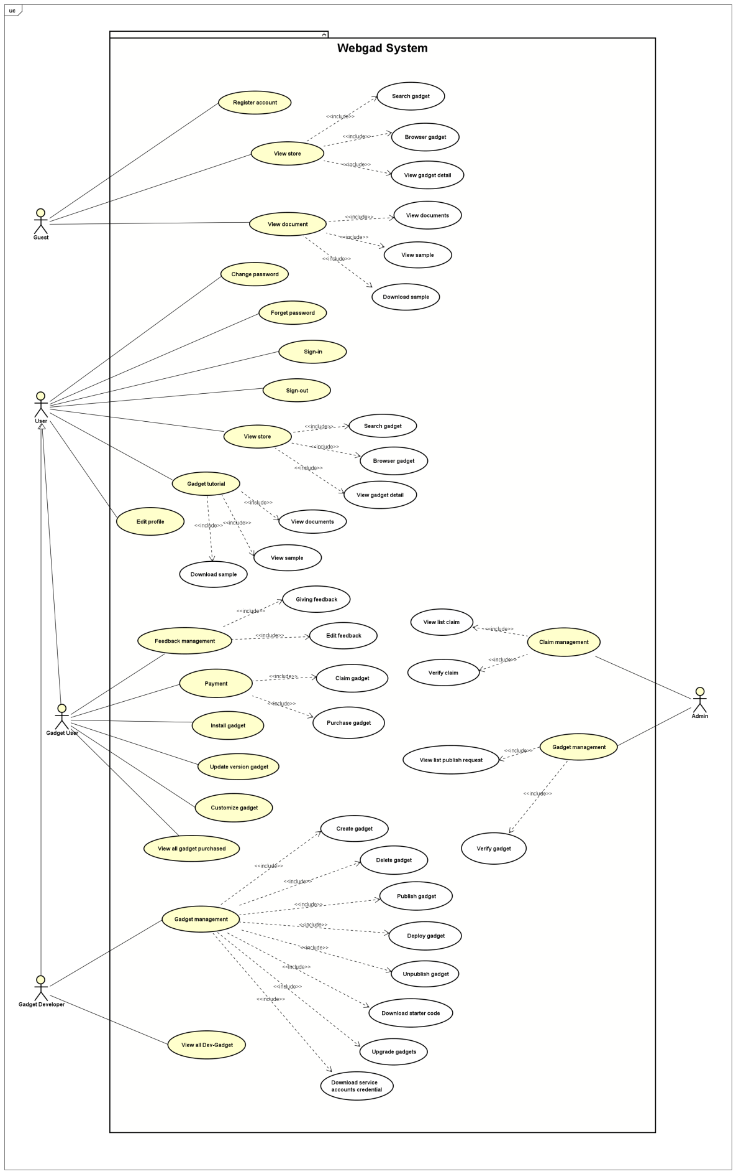

*Figure 3-3.Use case of Webgad system*

#### Use case list

|  |  |  |
| --- | --- | --- |
| **Actors** | **Use case ID** | **Use case name** |
| Admin, User, Guest | UC-CM-01 | Register account |
| UC-CM-02 | Sign-in |
| UC-CM-03 | Sign-out |
| UC-CM-04 | Forget password |
| UC-CM-05 | Change password |
| UC-CM-06 | Edit profile |
| UC-CM-07 | Search gadgets |
| UC-CM-08 | Browse gadgets |
| UC-CM-09 | View detail gadget |
| UC-CM-10 | View documentation |
| UC-CM-11 | View sample |
| UC-CM-12 | Download sample |
| Gadget User | UC-WU-01 | Purchase a gadget |
| UC-WU-02 | Install a gadget |
| UC-WU-03 | Customize gadget |
| UC-WU-04 | View all gadget purchased |
| UC-WU-05 | Giving feedback |
| UC-WU-06 | Edit feedback |
| UC-WU-07 | Claim gadget |
| UC-WU-08 | Update version gadget |
| Gadget Developer | UC-WD-01 | Create Gadget |
| UC-WD-02 | Download starter code |
| UC-WD-03 | Deploy gadget |
| UC-WD-04 | Publish gadget |
| UC-WD-05 | Unpublished gadget |
| UC-WD-06 | Delete Gadget |
| UC-WD-07 | Upgrade gadget |
| UC-WD-08 | View all Dev-Gadget |
| UC-WD-09 | Download service accounts credential |
| Admin | UC-AD-01 | Verify claim |
| UC-AD-02 | Verify gadget |
| UC-AD-03 | View list claim |
| UC-AD-04 | View list publish request |

#### Use case description

##### **Guest:**

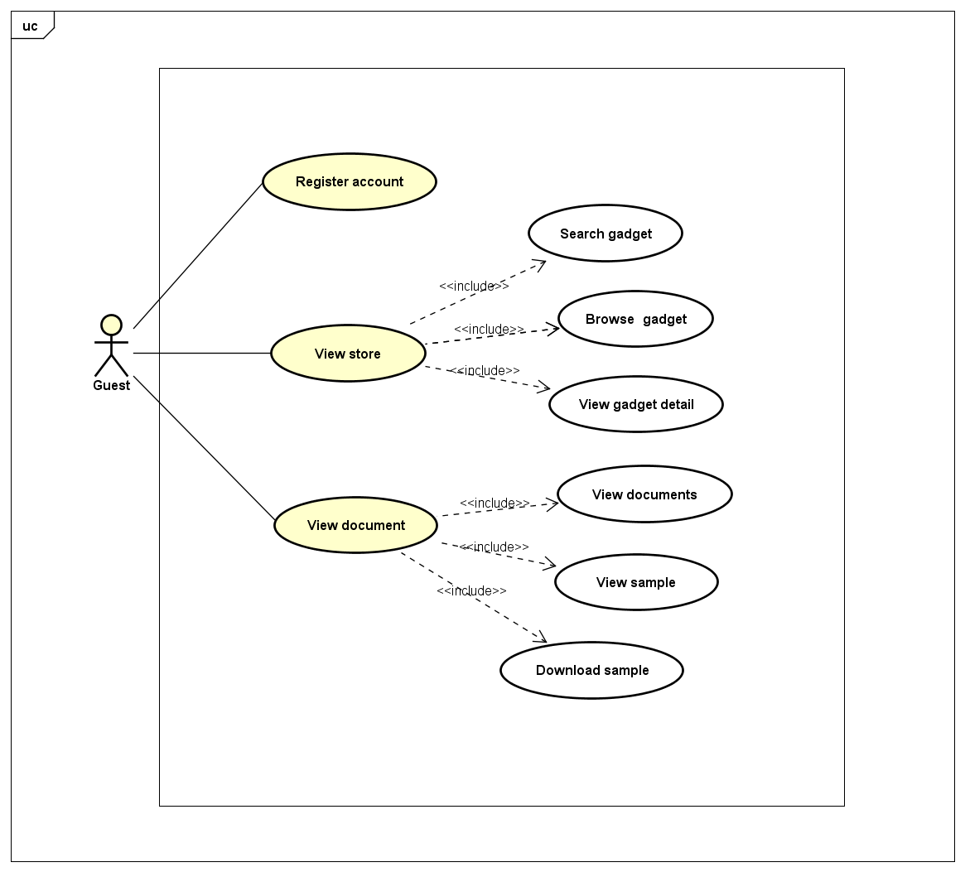

*Figure 3-4.Use case of guest*

###### **Register Account**

|  |  |  |  |
| --- | --- | --- | --- |
| **Use Case ID** | | | UC-CM-01 |
| **Use Name** | | | Register account. |
| **Actor** | | | Guest |
| **Description** | | | Allows the actor to register new account to use inside webgad system. |
| **Precondition** | | | Guest wants to register account. |
| **Trigger** | | | Click on button “Create account”. |
| **Post-Condition** | | | Register account successfully. |
| **Main flows** | | | |
| ***Step*** | | ***Actor*** | ***Action*** |
| *1* | | Guest | Click on button “Create account”. |
| *2* | | System | Show create account page. |
| *3* | | Guest | User enters name, email, password, re-enter password, and click button “Register”. |
| *4* | | System | Send confirm email to registered email. |
| *5* | | Guest | Click on link confirm register account. |
| *6* | | System | Redirect to sign in page. |
|  | |  |  |
| **Alternative Flows:** | | | |
| AT1 | At step 4 in the main flows**,** if the email user entered is already registered. | | |
| ***Sub step*** | | ***Actor*** | ***Action*** |
| *4.1* | | System | Display error message “This email is registered. Please enter another email”. |
| **Extension Flows: N/A** | | | |
| **Exception: N/A** | | | |
| **Business Rules: BI-1, BI-2, BI-3, BI-4** | | | |

###### **View Store**

* **Search Gadget**

|  |  |  |
| --- | --- | --- |
| **Use Case ID** | | UC-CM-07 |
| **Use Name** | | Search gadget |
| **Actor** | | Users, Admin, Guest |
| **Description** | | This function allows users to search gadget. |
| **Precondition** | | Users visit the "Webgad Store" website. |
| **Trigger** | | Users click on “Search” button. |
| **Post-Condition** | | Show search results that match the search request. |
| **Main flows** | | |
| ***Step*** | ***Actor*** | ***Action*** |
| *1* | User, Admin, Guest | Enter the keyword in the search field then click on “Search” button. |
| *2* | System | Show search results that match the search keyword. |
|  |  |  |
| **Alternative flows:** | | |
| AT1 | At step 1 | |
| ***Step*** | ***Actor*** | ***Action*** |
| *1.1* | User, Admin, Guest | Enter the keyword in the search field then press “Enter” keyboard. |
| *1.2* | System | Show search results that match the search keyword. |
| **Extension Flows: N/A** | | |
| **Exception: N/A** | | |
| **Business Rules: N/A** | | |

* **Browser Gadget**

|  |  |  |
| --- | --- | --- |
| **Use Case ID** | | UC-CM-08 |
| **Use Name** | | Browse gadgets |
| **Actor** | | Users, Admin, Guest |
| **Description** | | In this case, users are able browse gadgets by category, top install, latest updated gadget, on trending gadget, top charts gadget, new release gadget. Users can see gadgets’ name, pictures, prices, and other features. |
| **Precondition** | | Users visit the gadget store website. |
| **Trigger** | | Users visit the "Webgad Store" website. |
| **Post-Condition** | | Users can browse gadgets. |
| **Main flows** | | |
| ***Step*** | ***Actor*** | ***Action*** |
| *1* | User, Admin, Guest | Go to the store website. |
| *2* | System | Show gadgets by category. |
| *3* | User, Admin, Guest | Scroll up or down the home page. |
|  |  |  |
| **Alternative Flows: N/A** | | |
| **Extension Flows: N/A** | | |
| **Exception: N/A** | | |
| **Business Rules: N/A** | | |

* **View Gadget Detail**

|  |  |  |
| --- | --- | --- |
| **Use Case ID** | | UC-CM-09 |
| **Use Name** | | View detail gadget |
| **Actor** | | Users, Admin, Guest |
| **Description** | | In this case, users are able to view the details of a gadget. |
| **Precondition** | | The gadget is published. |
| **Trigger** | | Users click on a gadget’s image or name in a gadget category. |
| **Post-Condition** | | The detail of a gadget is showed. |
| **Main flows** | | |
| ***Step*** | ***Actor*** | ***Action*** |
| *1* | User, Admin, Guest | Click on a gadget’s image or name in a gadget category on home page or search page. |
| *2* | System | Show gadget’s information in details. |
|  |  |  |
| **Alternative Flows: N/A** | | |
| **Extension Flows:** | | |
| EF1 | After step 2 | |
| ***Step*** | ***Actor*** | ***Action*** |
| *2.1* | User, Amin, Guest | Click on “READ ALL REVIEWS” button. |
| *2.2* | System | Show more reviews content. |
| EF2 | After step 2 | |
| ***Step*** | ***Actor*** | ***Action*** |
| *2.3* | User, Admin, Guest | Click on “See more” button of Similar category. |
| *2.4* | System | Show “Similar” category. |
| **Exception: N/A** | | |
| **Business Rules: N/A** | | |

###### **View Document**

* **View Documentation**

|  |  |  |
| --- | --- | --- |
| **Use Case ID** | | UC-CM-10 |
| **Use Name** | | View documentation |
| **Actor** | | User, Admin, Guest |
| **Description** | | Show all guidelines to using system. |
| **Precondition** | | Users visit the "Webgad Docs" website. |
| **Trigger** | | Users click to menu “Guides”. |
| **Post-Condition** | | Display document about using system. |
| **Main flows** | | |
| ***Step*** | ***Actor*** | ***Action*** |
| *1* | User, Admin, Guest | Click on menu “Guides”. |
| *2* | System | Display guidelines to using system. |
|  |  |  |
| **Alternative Flows: N/A** | | |
| **Extension Flows: N/A** | | |
| **Exception:** | | |
| EX1 | At step 2 in the main flows**,** if there is an internal error in the system, | |
| ***Sub step*** | ***Actor*** | ***Action*** |
| *2.1* | System | Display "Error" page with message "Internal System Error, please contact with administrator". |
| **Business Rules: N/A** | | |

* **View Sample**

|  |  |  |
| --- | --- | --- |
| **Use Case ID** | | UC-CM-11 |
| **Use Name** | | View sample |
| **Actor** | | User, Admin, Guest |
| **Description** | | The function show sample gadget. |
| **Precondition** | | Users visit the "Webgad Docs" website. |
| **Trigger** | | Users click on menu “Sample”. |
| **Post-Condition** | | Display sample gadget |
| **Main flows** | | |
| ***Step*** | ***Actor*** | ***Action*** |
| *1* | User, Admin, Guest | Click to menu “Sample” |
| *2* | System | Display sample gadget |
|  |  |  |
| **Alternative Flows: N/A** | | |
| **Extension Flows: N/A** | | |
| **Exception:** | | |
| EX1 | At step 2 in the main flows**,** if there is an internal error in the system, | |
| ***Sub step*** | ***Actor*** | ***Action*** |
| *2.1* | System | Display "Error" page with message "Internal System Error, please contact with administrator". |
| **Business Rules: N/A** | | |

* **Download Sample**

|  |  |  |
| --- | --- | --- |
| **Use Case ID** | | UC-CM-12 |
| **Use Name** | | Download sample |
| **Actor** | | User, Admin, Guest |
| **Description** | | The function allow user download sample gadget |
| **Precondition** | | Users visit the "Webgad Docs" website. |
| **Trigger** | | Users click on menu “Sample” and click on button “Download” |
| **Post-Condition** | | Show dialog download sample gadget |
| **Main flows** | | |
| ***Step*** | ***Actor*** | ***Action*** |
| *1* | User, Admin, Guest | Click to menu “Sample”. |
| *2* | System | Display sample gadget. |
| *3* | User, Admin, Guest | Click to “Download Sample”. |
| *4* | Browser | Show dialog download. |
|  |  |  |
| **Alternative Flows: N/A** | | |
| **Extension Flows: N/A** | | |
| **Exception:** | | |
| EX1 | At step 4 in the main flows, if there is an internal error in the system, | |
| ***Sub step*** | ***Actor*** | ***Action*** |
| *4.1* | System | Display "Error" page with message "Internal System Error, please contact with administrator". |
| **Business Rules: N/A** | | |

##### **User:**

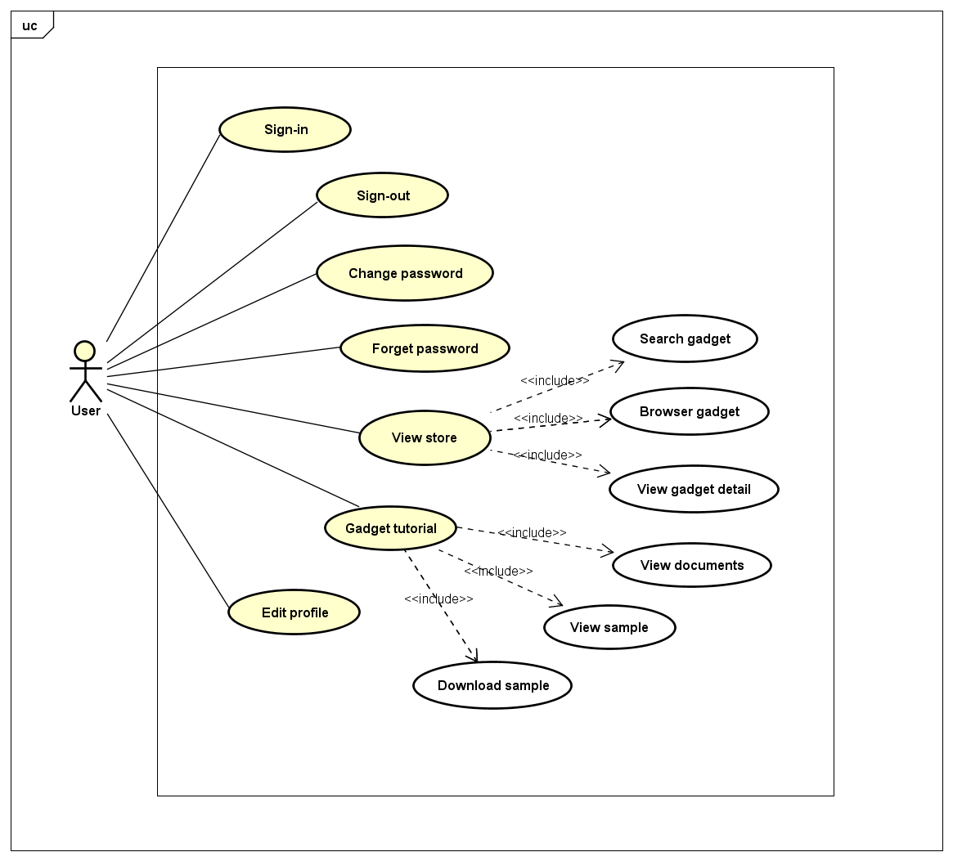

*Figure 3-5.Use case of common user*

###### **Sign-in**

|  |  |  |
| --- | --- | --- |
| **Use Case ID** | | UC-CM-02 |
| **Use Name** | | Sign-in |
| **Actor** | | User, Admin |
| **Description** | | Allows users to sign-in the "Webgad System". |
| **Precondition** | | Guest visit the website, was registered and activated account. |
| **Trigger** | | Click on button “Sign in”. |
| **Post-Condition** | | Sign in successfully. |
| **Main flows** | | |
| ***Step*** | ***Actor*** | ***Action*** |
| *1* | User | Click on button “Sign in”. |
| *2* | System | Show sign in page. |
| *3* | User | User enters email, password and click button “Sign in”. |
| *4* | System | System redirect to web page which user is accessing. |
|  |  |  |
| **Alternative Flows:** | | |
| AT1 | At step 4 in the main flows**,** if “Webgad System” failed to validate email & password | |
| ***Sub step*** | ***Actor*** | ***Action*** |
| *4.1* | System | Show error message "Your user name or password is not correct." |
| AT2 | At step 4 in the main flows**,** if “Webgad System” cannot connect to database server | |
| ***Sub step*** | ***Actor*** | ***Action*** |
| *4.2* | System | Show error message "The authorization server is currently unable to handle the request." |
| **Extension Flows: N/A** | | |
| **Exception: N/A** | | |
| **Business Rules: BI-1, BI-2, BI-3, BI-4** | | |

###### **Sign-out**

|  |  |  |
| --- | --- | --- |
| **Use Case ID** | | UC-CM-03 |
| **Use Name** | | Sign-out |
| **Actor** | | User, Admin |
| **Description** | | Allows users to sign out from the "Webgad System". |
| **Precondition** | | Users have signed in "Webgad System". |
| **Trigger** | | Click on button “Sign out”. |
| **Post-Condition** | | Sign out successfully. |
| **Main flows** | | |
| ***Step*** | ***Actor*** | ***Action*** |
| *1* | User | Click on avatar at the top-right of the website. |
| *2* | System | Show user information box. |
| *3* | User | User click button “Sign out”. |
| *4* | System | System sign out user and show sign in button. |
|  |  |  |
| **Alternative Flows : N/A** | | |
| **Extension Flows: N/A** | | |
| **Exception: N/A** | | |
| **Business Rules: N/A** | | |

###### **Forget password**

|  |  |  |  |
| --- | --- | --- | --- |
| **Use Case ID** | | | UC-CM-04 |
| **Use Name** | | | Forget password |
| **Actor** | | | User, Admin |
| **Description** | | | Allows users to recover their password. |
| **Precondition** | |  | Users have registered and activated account in "Webgad System". |
| **Trigger** | | | Click on button “Forgot your password?”. |
| **Post-Condition** | | | Link to create new password is sent to user via email |
| **Main flows** | | | |
| ***Step*** | ***Actor*** | | ***Action*** |
| *1* | User | | Click on button “Forgot your password?”. |
| *2* | System | | Show reset password form |
| *3* | User | | User enter email address and click button “Recover password” |
| *4* | System | | System send an email which contains link to create new password |
| *5* | User | | User open email and click the link |
| *6* | System | | Open create new password page |
| *7* | User | | User enter new password, re-enter new password and click button “Save”. |
| *8* | System | | Update user password, show success message and redirect user to sign in page |
|  |  | |  |
| **Alternative Flows:** | | | |
| AT1 | At step 4 in the main flows**,** if email user entered is not registered | | |
| ***Sub step*** | ***Actor*** | | ***Action*** |
| *4.1* | System | | Show error message "Your email is not registered". |
| **Extension Flows: N/A** | | | |
| **Exception: N/A** | | | |
| **Business Rules: BI-1, BI-2, BI-3, BI-4** | | | |

###### **Change password**

|  |  |  |  |
| --- | --- | --- | --- |
| **Use Case ID** | | | UC-CM-05 |
| **Use Name** | | | Change password |
| **Actor** | | | User, Admin |
| **Description** | | | Allows users to change their password. |
| **Precondition** | |  | Users have signed in "Webgad System". |
| **Trigger** | | | Click on button “Change password”. |
| **Post-Condition** | | | Change password successfully. |
| **Main flows** | | | |
| ***Step*** | ***Actor*** | | ***Action*** |
| *1* | User | | Click on button “My account” and click on button “Change password”. |
| *2* | System | | Show change password form. |
| *3* | User | | User enter “Old password”, “New password” and “Confirm new password” then click on button “Change Password”. |
| *4* | System | | Show pop-up message “Password has been changed successfully” and redirect to “Webgad Account” page. |
|  |  | |  |
| **Alternative Flows:** | | | |
| AT1 | At step 4 in the main flows**,** if “Confirm new password” is not equal “New password”. | | |
| ***Sub step*** | ***Actor*** | | ***Action*** |
| *4.1* | System | | Show error message "Confirm new password not equal New password". |
| **Extension Flows: N/A** | | | |
| **Exception: N/A** | | | |
| **Business Rules: BI-2, BI-4** | | | |

###### **Edit profile**

|  |  |  |
| --- | --- | --- |
| **Use Case ID** | | UC-CM-06 |
| **Use Name** | | Edit profile |
| **Actor** | | User |
| **Description** | | Allows users to update their information. |
| **Precondition** | | Users is signed in to system |
| **Trigger** | | Click on button “My account”. |
| **Post-Condition** | | Update user information successfully. |
| **Main flows** | | |
| ***Step*** | ***Actor*** | ***Action*** |
| *1* | User | Click on button “My Account”. |
| *2* | System | Show "Webgad Account" page. |
| *3* | User | Users enter "Name", "Email", "Address", "Phone" then click on button "Save". |
| *4* | System | Show pop-up message “Your information has been updated” |
|  |  |  |
| **Alternative Flows: N/A** | | |
| **Extension Flows:** | | |
| EF1 | At step 3 in the main flows, users still can update developer information to display in "Webgad Store". | |
| ***Sub step*** | ***Actor*** | ***Action*** |
| *3.1* | User | Users click on menu "Developer preferences" and enter "Developer name", "Email", "Website", "Address" then click on button "Save". |
| *3.2* | System | Show pop-up message “Your information has been updated” |
| **Exception: N/A** | | |
| **Business Rules: BI-1, BI-2, BI-3, BI-4** | | |

###### **View Store**

Refer to: *View Store**.*

###### **Gadget tutorial**

Refer to: *View Document**.*

##### **Gadget User:**

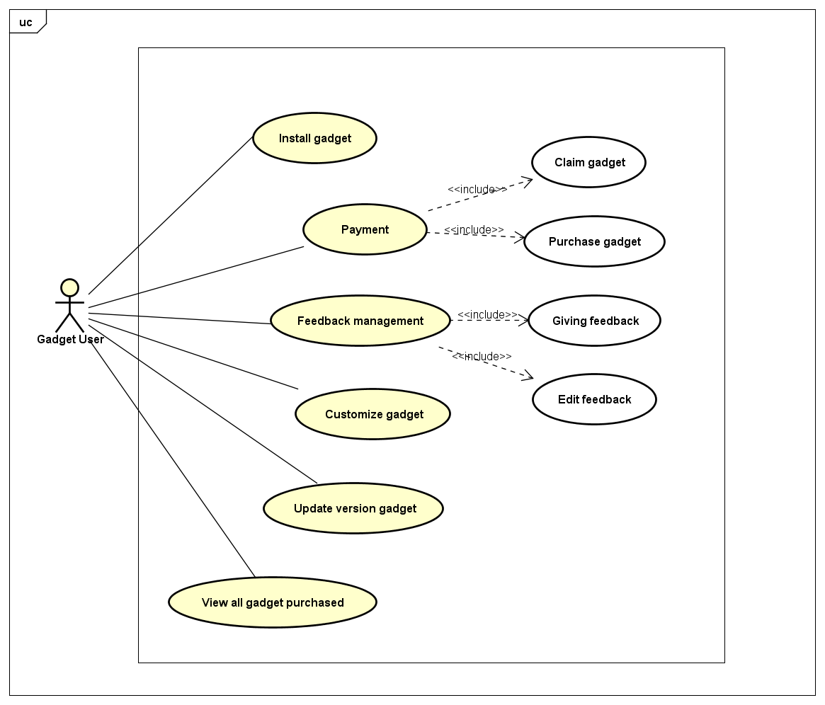

*Figure 3-6.Use case of Gadget User*

###### **Install a gadget**

|  |  |  |
| --- | --- | --- |
| **Use Case ID** | | UC-WU-02 |
| **Use Name** | | Install a gadget |
| **Actor** | | Gadget User |
| **Description** | | Gadget users are able to install a gadget. |
| **Precondition** | | Gadget users have signed in "Webgad System" and have already purchased gadget (with paid gadget). |
| **Trigger** | | Gadget users click on button “Install”. |
| **Post-Condition** | | Install gadget successfully. |
| **Main flows** | | |
| ***Step*** | ***Actor*** | ***Action*** |
| *1* | Gadget User | Go to "Webgad Store", select and purchase one gadget then click on “Install” button. |
| *2* | System | Show installation form. |
| *3* | Gadget User | Enter website address want to install gadget and click on button “Continue” then follow the instructions in installation form. |
| *4* | System | Show installation form. |
|  |  |  |
| **Alternative Flows** | | |
| AT1 | At step 1, Gadget User also can install gadgets already paid before. | |
| ***Sub step*** | ***Actor*** | ***Action*** |
| *1.1* | Gadget User | Click on “My gadget” navigation bar. |
| *1.2* | System | Show all gadget already purchased. |
| *1.3* | Gadget User | Select a gadget then click on “Install” button. |
| *1.4* | System | Resume main flows at step 2. |
|  |  |  |
| **Extension Flows: N/A** | | |
| **Exception: N/A** | | |
| **Business Rules: N/A** | | |

###### **Payment**

* **Purchase a gadget**

|  |  |  |
| --- | --- | --- |
| **Use Case ID** | | UC-WU-01 |
| **Use Name** | | Purchase a gadget |
| **Actor** | | Gadget User |
| **Description** | | Gadget users are able to buy a gadget. |
| **Precondition** | | Gadget users have signed in "Webgad System". |
| **Trigger** | | Gadget users click on button “Install”. |
| **Post-Condition** | | Gadget users purchased successfully. |
| **Main flows** | | |
| ***Step*** | ***Actor*** | ***Action*** |
| *1* | Gadget User | Go to "Webgad Store", select one gadget then click on “Install” button. |
| *2* | System | Show installation form. |
| *3* | Gadget User | Enter website address want to install gadget and click on button "Continue". |
| *4* | System | Show PayPal’s payment confirmation. |
| *5* | Gadget User | Click on “Confirm” button. |
| *6* | System | Show message “Payment successfully” message box. Close form payment and show installation form. |
|  |  |  |
| **Alternative Flows: N/A** | | |
| **Extension Flows:** | | |
| EF1 | At step 5, users cancel form payment. | |
| ***Sub step*** | ***Actor*** | ***Action*** |
| *5.1* | Gadget User | Click on “Cancel” button. |
| *5.2* | System | Close PayPal’s payment confirmation then go to the previous page. |
| **Exception: N/A** | | |
| **Business Rules: BR-2** | | |

* **Claim gadget**

|  |  |  |
| --- | --- | --- |
| **Use Case ID** | | UC-WU-07 |
| **Use Name** | | Claim gadget |
| **Actor** | | Gadget User |
| **Description** | | Gadget users can request to refund a gadget. |
| **Precondition** | | Gadget users have signed in "Webgad System" and have already purchased gadget. Gadget just refund after purchased 2 days. |
| **Trigger** | | Users click on button “Request a refund”. |
| **Post-Condition** | | The claim is sent to the admin. |
| **Main flows** | | |
| ***Step*** | ***Actor*** | ***Action*** |
| *1* | Gadget User | Click on “My gadget” navigation bar and select a gadget want to refund then click on button “Request a refund”. |
| *2* | System | Show form "Request to refund". |
| *3* | Gadget User | Select site, enter title and reason to refunding, choose image description then click on button "Request refunding" |
| *4* | System | Send request refund to the admin and close form "request to refund". |
|  |  |  |
| **Alternative Flows: N/A** | | |
| **Extension Flows:** | | |
| EF1 | At step 3, users cancel form “Request to refund”. | |
| ***Sub step*** | ***Actor*** | ***Action*** |
| *3.1* | Gadget User | Click on “Cancel” button. |
| *3.2* | System | Close form "Request to refund" and do nothing. |
| **Exception: N/A** | | |
| **Business Rules: BI-1, BR-7** | | |

###### **Feedback management**

* **Giving Feedback**

|  |  |  |
| --- | --- | --- |
| **Use Case ID** | | UC-WU-05 |
| **Use Name** | | Giving feedback |
| **Actor** | | Gadget User |
| **Description** | | Users are able to give review about a gadget, they can post comment & rating on a gadget. |
| **Precondition** | | Users have signed in "Webgad System" and gadget want to give the feedback have been purchased. |
| **Trigger** | | Users click on “Submit” button in form gadget’s review. |
| **Post-Condition** | | Ratings & comments are posted on gadget’s reviews. |
| **Main flows** | | |
| ***Step*** | ***Actor*** | ***Action*** |
| *1* | Gadget User | Select the score want to ratings and write comments into text box then click on “Submit” button. |
| *2* | System | Show message "Giving reviews gadget successfully". |
|  |  |  |
| **Alternative Flows: N/A** | | |
| **Extension Flows: N/A** | | |
| **Exception: N/A** | | |
| **Business Rules: BI-1,BR-3,BR-5,BR-6** | | |

* **Edit feedback**

|  |  |  |
| --- | --- | --- |
| **Use Case ID** | | UC-WU-06 |
| **Use Name** | | Edit feedback |
| **Actor** | | Gadget User |
| **Description** | | Users are able to edit review about a gadget. |
| **Precondition** | | Users have signed in "Webgad System" and select gadget has been given review. |
| **Trigger** | | Users click on “Edit review” button in gadget’s review. |
| **Post-Condition** | | Ratings & comments are edited. |
| **Main flows** | | |
| ***Step*** | ***Actor*** | ***Action*** |
| *1* | Gadget User | Click on button “Edit review”. |
| *2* | System | Show previous ratings & comments. |
| *3* | Gadget User | Edit the score they want to ratings and edit comments in text box then click on “Submit” button. |
| *4* | System | Show message "Giving reviews gadget successfully". |
|  |  |  |
| **Alternative Flows: N/A** | | |
| **Extension Flows: N/A** | | |
| **Exception: N/A** | | |
| **Business Rules: BI-1,BR-3,BR-5,BR-6** | | |

###### **Customize gadget**

|  |  |  |
| --- | --- | --- |
| **Use Case ID** | | UC-WU-03 |
| **Use Name** | | Customize gadget |
| **Actor** | | Gadget User |
| **Description** | | Users can customize such as color, font…of gadget. |
| **Precondition** | | Users have signed in "Webgad System" and select manage gadget have been installed. |
| **Trigger** | | User select customize then click on button "Save". |
| **Post-Condition** | | Customize gadget successfully. |
| **Main flows** | | |
| ***Step*** | ***Actor*** | ***Action*** |
| *1* | Gadget User | Click on button “Manage gadget”. |
| *2* | System | Show form manage gadget. |
| *3* | Gadget User | Select properties want to customize then click on button "Save". |
| *4* | System | Show pop-up message "Save successfully". |
|  |  |  |
| **Alternative Flows: N/A** | | |
| **Extension Flows: N/A** | | |
| **Exception: N/A** | | |
| **Business Rules: BR-11** | | |

###### **View all gadget purchased**

|  |  |  |
| --- | --- | --- |
| **Use Case ID** | | UC-WU-04 |
| **Use Name** | | View all gadget purchased |
| **Actor** | | Gadget User |
| **Description** | | Users manage all gadgets have been purchased. |
| **Precondition** | | Users have signed in "Webgad System" and have gadget purchased. |
| **Trigger** | | Users select menu "My gadget". |
| **Post-Condition** | | Show all gadget purchased. |
| **Main flows** | | |
| ***Step*** | ***Actor*** | ***Action*** |
| *1* | Gadget User | Select menu "My gadget". |
| *2* | System | Show all gadget purchased. |
|  |  |  |
| **Alternative Flows: N/A** | | |
| **Extension Flows: N/A** | | |
| **Exception: N/A** | | |
| **Business Rules: BR-11** | | |

###### **Update version gadget**

|  |  |  |
| --- | --- | --- |
| **Use Case ID** | | UC-WU-08 |
| **Use Name** | | Update version gadget |
| **Actor** | | Gadget User |
| **Description** | | Users can update version if this gadget release new version. |
| **Precondition** | | Users have signed in "Webgad System" and have gadget purchased. |
| **Trigger** | | Users click on button "Update". |
| **Post-Condition** | | Gadget update new version. |
| **Main flows** | | |
| ***Step*** | ***Actor*** | ***Action*** |
| *1* | Gadget User | Select a gadget and click on button "Update". |
| *2* | System | Show form update version gadget. |
| *3* | Gadget User | Click on button update ever site or update all. |
| *4* | System | Show pop-up message update successful and hide button update. |
|  |  |  |
| **Alternative Flows: N/A** | | |
| *AT1* | At step 3, User cancel form update nenw version | |
| ***Sub step*** | ***Actor*** | ***Action*** |
| *3.1* | Gadget User | Click on button "Cancel". |
| *3.2* | System | Hide form update new version and do nothing. |
| **Extension Flows: N/A** | | |
| **Exception: N/A** | | |
| **Business Rules: BR-11** | | |

##### **Gadget Developer:**

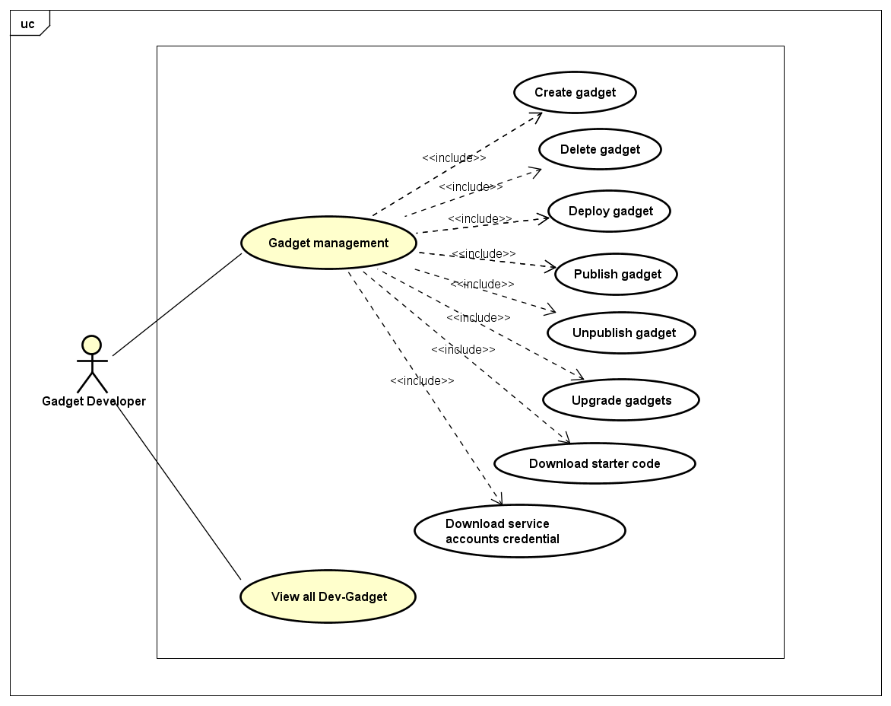

*Figure 3-7.Use case of Gadget Developer*

###### **Gadget management**

* **Create gadget**

|  |  |  |
| --- | --- | --- |
| **Use Case ID** | | UC-WD-01 |
| **Use Name** | | Create gadget |
| **Actor** | | Gadget Developer |
| **Description** | | The function allows a gadget developer to create gadget. |
| **Precondition** | | Gadget Developer has signed in "Webgad System". |
| **Trigger** | | Click button “Add Gadget” |
| **Post-Condition** | | Create gadget successfully |
| **Main flows** | | |
| ***Step*** | ***Actor*** | ***Action*** |
| *1* | User | Go to "Webgad Console", click on button add gadget |
| *2* | System | Show pop-up “Create Gadget” |
| *3* | User | Fill information and then click on button “Create Gadget” |
| *4* | System | Show successful message |
|  |  |  |
| **Alternative Flows: N/A** | | |
| **Extension Flows:** | | |
| EF1 | At step 3, users cancel form “Create Gadget”. | |
| ***Step*** | ***Actor*** | ***Action*** |
| *3.1* | User | Click on button “Cancel” |
| *3.2* | System | Close pop-up “Create Gadget”. |
| **Exception Flows: N/A** | | |
| **Exception: N/A** | | |
| **Business Rules: BI-1, BI-4, BR-7, BR-9** | | |

* **Delete gadget**

|  |  |  |
| --- | --- | --- |
| **Use Case ID** | | UC-WD-06 |
| **Use Name** | | Delete gadget |
| **Actor** | | Gadget Developer |
| **Description** | | The function allows a gadget developer to delete gadget. |
| **Precondition** | | Gadget Developer have signed in "Webgad System". |
| **Trigger** | | Click button “Delete gadget”. |
| **Post-Condition** | | Gadget deleted successfully. |
| **Main flows** | | |
| ***Step*** | ***Actor*** | ***Action*** |
| *1* | User | Select a gadget want to delete and click on menu tab “Setting”. |
| *2* | System | Show gadget settings. |
| *3* | User | Click on button “Delete gadget”. |
| *4* | System | Show confirmation message. |
| *5* | User | Click on button “Delete gadget”. |
| *6* | System | Close confirmation message and show successful message. |
|  |  |  |
| **Alternative Flows: N/A** | | |
| **Extension Flows** | | |
| EF1 | At step 5, users cancel delete gadget. | |
| ***Step*** | ***Actor*** | ***Action*** |
| *5,1* | User | Click on button “Cancel” |
| *5,2* | System | Close confirmation message and do nothing. |
| **Exception: N/A** | | |
| **Business Rules: BR-9** | | |

* **Deploy gadget**

|  |  |  |
| --- | --- | --- |
| **Use Case ID** | | UC-WD-03 |
| **Use Name** | | Deploy gadget |
| **Actor** | | Gadget Developer |
| **Description** | | Allows the developer to deploy their gadget. |
| **Precondition** | | Developer wants to deploy gadget on system. |
| **Trigger** | | Click on menu tab “Deploy”. |
| **Post-Condition** | | Deploy gadget successfully |
| **Main flows** | | |
| ***Step*** | ***Actor*** | ***Action*** |
| *1* | User | Click on menu tab “Deploy”. |
| *2* | System | Show deploy gadget page |
| *3* | User | Click button “Choose File” |
| *4* | Browser | Browser show choose file dialog |
| *5* | User | Select gadget file to deploy and click on button “Submit & Deploy”. |
| *6* | System | Webgad System receive gadget file. Webgad System validate gadget file. Webgad System deploy gadget file. Show message “Deploy gadget successfully” |
|  |  |  |
| **Alternative Flows: N/A** | | |
| **Exception Flows:** | | |
| EF1 | At step 6 in the main flows**,** if the gadget file is not valid | |
| ***Sub step*** | ***Actor*** | ***Action*** |
| *6.1* | System | Display error message “Could not deploy gadget” |
| **Exception: N/A** | | |
| **Business Rules: N/A** | | |

* **Publish gadget**

|  |  |  |
| --- | --- | --- |
| **Use Case ID** | | UC-WD-04 |
| **Use Name** | | Publish gadget |
| **Actor** | | Gadget Developer |
| **Description** | | Allows the developer to publish their gadget to "Webgad Store". |
| **Precondition** | | Developer has gadget deployed on system. |
| **Trigger** | | Click on menu tab “Publish/Unpublish gadget”. |
| **Post-Condition** | | Publish gadget successfully |
| **Main flows** | | |
| ***Step*** | ***Actor*** | ***Action*** |
| *1* | User | Select a gadget want to publish and click on menu tab “Publish/Unpublish gadget”. |
| *2* | System | Show publish gadget page |
| *3* | User | Select avatar gadget. Enter gadget name. Select gadget category. Select gadget description images. Enter gadget description. Enter what’s new description information. Enter additional information. Enter install guide description. Click on “Publish” button. |
| *4* | System | "Webgad System" receive request publish gadget. Send request verify gadget to admin. Show message “Please waiting for admin verify your gadget!”. |
|  |  |  |
| **Alternative Flows: N/A** | | |
| **Exception Flows: N/A** | | |
| **Exception: N/A** | | |
| **Business Rules: BI-1, BI-4, BR-1, BR-7, BR-8, BR-9** | | |

* **Unpublished gadget**

|  |  |  |
| --- | --- | --- |
| **Use Case ID** | | UC-WD-05 |
| **Use Name** | | Unpublished gadget |
| **Actor** | | Gadget Developer |
| **Description** | | Allows the developer to unpublished their gadget. |
| **Precondition** | | - Developer has published this gadget |
| **Trigger** | | Click on menu tab “Publish/Unpublish gadget”. |
| **Post-Condition** | | Unpublished gadget successfully |
| **Main flows** | | |
| ***Step*** | ***Actor*** | ***Action*** |
| *1* | User | Select a gadget want to unpublished and click on menu tab “Publish/Unpublish gadget”. |
| *2* | System | Show publish gadget page. |
| *3* | User | Click on button “Unpublish”. |
| *4* | System | Show message “Unpublished gadget successfully”. |
|  |  |  |
| **Alternative Flows: N/A** | | |
| **Extension Flows: N/A** | | |
| **Exception: N/A** | | |
| **Business Rules: BR-1, BR-9** | | |

* **Upgrade gadget**

|  |  |  |
| --- | --- | --- |
| **Use Case ID** | | UC-WD-07 |
| **Use Name** | | Upgrade gadget |
| **Actor** | | Gadget Developer |
| **Description** | | Allows the developer to upgrade new version their gadget. |
| **Precondition** | | Developer has gadget published on system. |
| **Trigger** | | Click on menu tab “Upgrade gadget”. |
| **Post-Condition** | | Upgrade gadget successfully |
| **Main flows** | | |
| ***Step*** | ***Actor*** | ***Action*** |
| *1* | User | Select a gadget want to publish and click on menu tab “Upgrade gadget”. |
| *2* | System | Show Update gadget page |
| *3* | User | Select avatar gadget.  Enter gadget name.  Select gadget category.  Select gadget description images.  Enter gadget description.  Enter what’s new description information.  Enter additional information.  Enter install guide description.  Click on “Publish” button. |
| *4* | System | "Webgad System" receive request publish gadget.  Send request verify gadget to admin.  Show message “Please waiting for admin verify your gadget!”. |
|  |  |  |
| **Alternative Flows: N/A** | | |
| **Exception Flows: N/A** | | |
| **Exception: N/A** | | |
| **Business Rules: BI-1, BI-4, BR-1, BR-7, BR-8, BR-9** | | |

* **Download starter code**

|  |  |  |
| --- | --- | --- |
| **Use Case ID** | | UC-WD-02 |
| **Use Name** | | Download starter code |
| **Actor** | | Gadget Developer |
| **Description** | | Allows the developer to download starter code so that developer can deploy their gadget on system. |
| **Precondition** | | Developer wants to deploy gadget on system. |
| **Trigger** | | Click on button “Download” in the Download starter code notification. |
| **Post-Condition** | | Download starter code successfully. |
| **Main flows** | | |
| ***Step*** | ***Actor*** | ***Action*** |
| *1* | User | Select a gadget and click on button “Download” in the Download starter code notification. |
| *2* | Browser | Download file to local. |
|  |  |  |
| **Alternative Flows: N/A** | | |
| **Extension Flows: N/A** | | |
| **Exception: N/A** | | |
| **Business Rules: N/A** | | |

* **Download service accounts credential**

|  |  |  |
| --- | --- | --- |
| **Use Case ID** | | UC-WD-09 |
| **Use Name** | | Download service accounts credential |
| **Actor** | | Gadget Developer |
| **Description** | | Allows the developer to download service accounts credential so that developer can deploy their gadget on MongoDB of system. |
| **Precondition** | | Developer wants to deploy gadget on MongoDB of system. |
| **Trigger** | | Click on button “Download credential” in the Download Service accounts credential notification. |
| **Post-Condition** | | Download service accounts credential successfully. |
| **Main flows** | | |
| ***Step*** | ***Actor*** | ***Action*** |
| *1* | User | Select a gadget and click on button “Download credential” in the Download Service accounts credential notification. |
| *2* | Browser | Download file to local. |
|  |  |  |
| **Alternative Flows: N/A** | | |
| **Extension Flows: N/A** | | |
| **Exception: N/A** | | |
| **Business Rules: N/A** | | |

* **View all Dev-Gadget**

|  |  |  |
| --- | --- | --- |
| **Use Case ID** | | UC-WD-08 |
| **Use Name** | | View all Dev-Gadget |
| **Actor** | | Gadget Developer |
| **Description** | | Allows a gadget developer to retrieve all the gadget they have create on the system. |
| **Precondition** | | Gadget Developer has signed in "Webgad System". |
| **Trigger** | | Go to "Webgad Console" page. |
| **Post-Condition** | | Show all gadget of developer. |
| **Main flows** | | |
| ***Step*** | ***Actor*** | ***Action*** |
| *1* | User | Gadget Developer has signed in "Webgad System" and go to "Webgad Console". |
| *2* | System | Show all gadget of developer. |
|  |  |  |
| **Alternative Flows : N/A** | | |
| **Extension Flows : N/A** | | |
| **Exception: N/A** | | |
| **Business Rules: N/A** | | |

##### **Admin:**

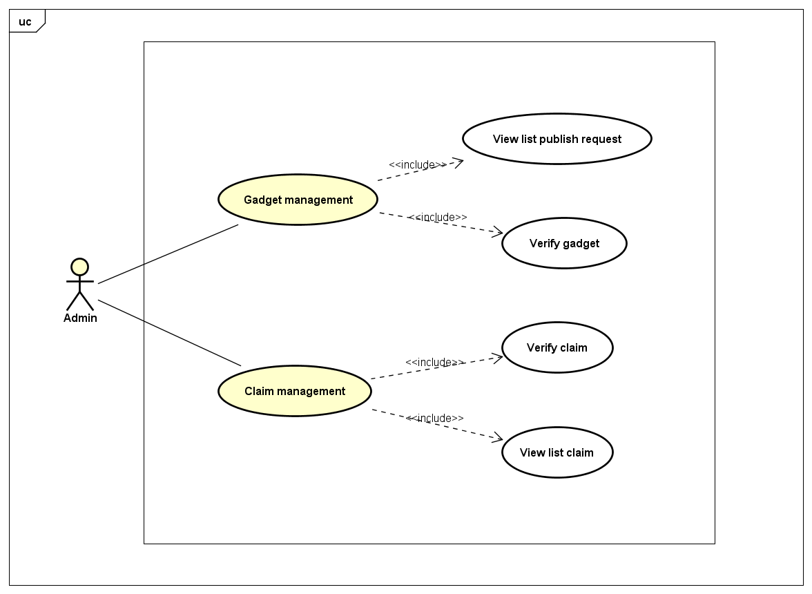

*Figure 3-8.Use case of Admin*

###### **Gadget management**

* **View list publish request**

|  |  |  |
| --- | --- | --- |
| **Use Case ID** | | UC-AD-04 |
| **Use Name** | | View list publish request. |
| **Actor** | | Admin |
| **Description** | | Allows the admin to manage list publish request. |
| **Precondition** | | Admin has signed in "Webgad System". |
| **Trigger** | | Click on menu tab “View list publish request”. |
| **Post-Condition** | | Show all publish request. |
| **Main flows** | | |
| ***Step*** | ***Actor*** | ***Action*** |
| *1* | Admin | Click on menu tab “View list publish request”. |
| *2* | System | Show list publish request. |
|  |  |  |
| **Alternative Flows : N/A** | | |
| **Extension Flows : N/A** | | |
| **Exception: N/A** | | |
| **Business Rules: N/A** | | |

* **Verify gadget**

|  |  |  |
| --- | --- | --- |
| **Use Case ID** | | UC-AD-02 |
| **Use Name** | | Verify gadget |
| **Actor** | | Admin |
| **Description** | | Allows the admin to verify new gadget quality to publish on "Webgad Store". |
| **Precondition** |  | Admin has signed in "Webgad System" and gadged has been sent publish request. |
| **Trigger** | | Select a gadget in list publish request and accept to publish. |
| **Post-Condition** | | Gadget publishes on "Webgad Store". |
| **Main flows** | | |
| ***Step*** | ***Actor*** | ***Action*** |
| *1* | Admin | Select a gadget in list publish request. |
| *2* | System | Show gadget information. |
| *3* | Admin | Checking and analyzing gadget information. Click on accept if gadget information is valid and works well. |
| *4* | System | Accepted mail is sent to developer via system. |
|  |  |  |
| **Alternative Flows : N/A** | | |
| **Extension Flows:** | | |
| ET1 | At step 3 | |
| ***Step*** | ***Actor*** | ***Action*** |
| *3.1* | Admin | Checking and analyzing gadget information. Click on refuse if gadget information is invalid and works badly. |
| *3.2* | System | Refused mail is sent to developer via system. |
| **Exception: N/A** | | |
| **Business Rules: N/A** | | |

###### **Claim management**

* **View list claim**

|  |  |  |
| --- | --- | --- |
| **Use Case ID** | | UC-AD-03 |
| **Use Name** | | View list claim |
| **Actor** | | Admin |
| **Description** | | Allows the admin to manage list claim |
| **Precondition** | | Admin has signed in "Webgad System". |
| **Trigger** | | Click on menu tab “View list claim”. |
| **Post-Condition** | | Show all claim requests. |
| **Main flows** | | |
| ***Step*** | ***Actor*** | ***Action*** |
| *1* | Admin | Click on menu tab “View list claim”. |
| *2* | System | Show all claim requests. |
|  |  |  |
| **Alternative Flows : N/A** | | |
| **Extension Flows : N/A** | | |
| **Exception: N/A** | | |
| **Business Rules: N/A** | | |

* **Verify claim**

|  |  |  |
| --- | --- | --- |
| **Use Case ID** | | UC-AD-01 |
| **Use Name** | | Verify claim |
| **Actor** | | Admin |
| **Description** | | Allows the admin to handle user’s claim request. |
| **Precondition** | | Admin has signed in "Webgad System" and gadged has been sent claim request. |
| **Trigger** | | Select a gadget in list claim request and accept to refund. |
| **Post-Condition** | | Claim is handled. |
| **Main flows** | | |
| ***Step*** | ***Actor*** | ***Action*** |
| *1* | Admin | Select a gadget in list claim request. |
| *2* | System | Show claim gadget information. |
| *3* | Admin | Checking and analyzing evidence that user provided. Click on accept if claim is correct. |
| *4* | System | System refunds money for user. Accepted claim mail is sent to both of Gadget User and Gadget Developer via system. |
|  |  |  |
| **Alternative Flows : N/A** | | |
| **Extension Flows:** | | |
| ET1 | At step 4 | |
| ***Step*** | ***Actor*** | ***Action*** |
| *4.1* | Admin | Checking and analyzing evidence that user provided. Click on refuse if claim is unfounded. |
| *4.2* | System | Refused claim mail is sent to Gadget User via system. |
| **Exception: N/A** | | |
| **Business Rules: N/A** | | |

### Non-Functional Requirements Specification

#### Security

* **Database Security**: Webgad System is built from Spring Framework, so the potential risk of SQL Injection is mitigated to the lowest.
* **Authentication**: Webgad System implements Oauth2 authentication protocols to improve the security.
* **MongoDB**: Each of gadgets is provided with one private nosql database space. The gadget’s activity data is stored in there and only this gadget has permission to access.

#### Performance

* Since this software is going to web – based, it does require a powerful server machine with high band internet access.
* Performance requirement by the user side is, web application should be developed as a lightweight web app so that it can work on almost any platform even with slower internet connections.
* Expected number of simultaneous user should be at least 1000. System should be able to deal with 1000 users at the same time. Also database of the system should handle at least a thousand of users at any periods.

#### Usability

* The interface should be easy to understand and friendly.
* The screen layout and color should be appealing.
* Using Full-text search technique for any search.
* The guideline in “Webgad Document” are clearly and easy to understand.

#### Maintainability & Scalability

* Using RESTful model for the system architect help improve scalability.
* Strictly follow the ESlint coding convention to help improve readability of source code and make the application more maintainable.
* Conformance to architecture standards, design standards, coding standards.

## Entity relationship diagram

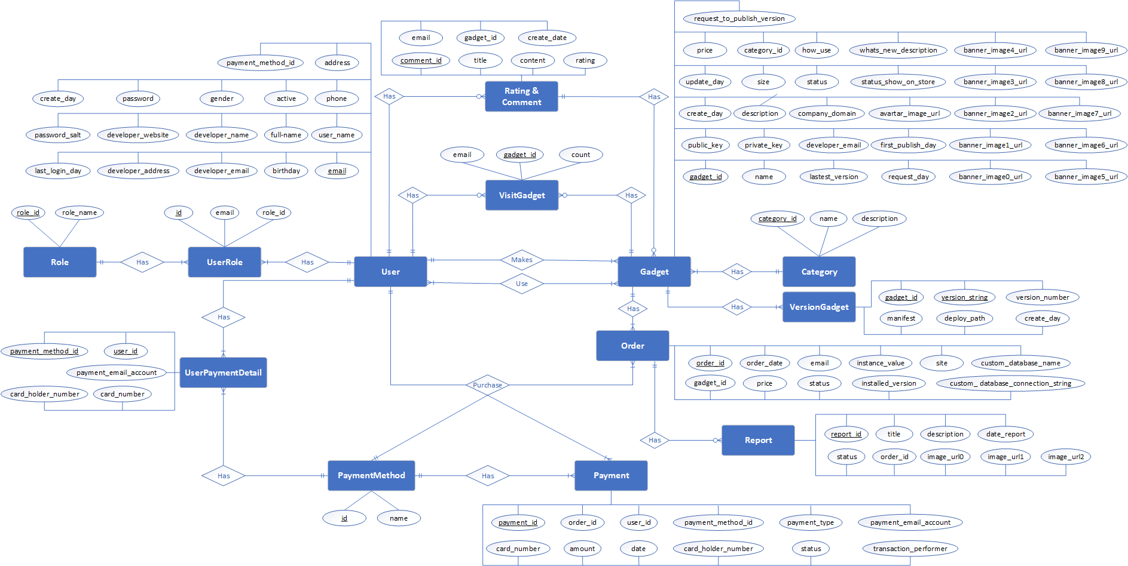

*Figure 3-9.ERD of Webgad System*

# CHAPTER 4: SOFTWARE DESIGN DESCRIPTION

## Purpose

This document is to give the developer team of what the system’s architecture is, and how they should be implemented. This document consists of:

* Architecture overview.
* Detailed design.
* Database design.
* Recommendation implementation detail.

## Architecture overview

### System Architecture

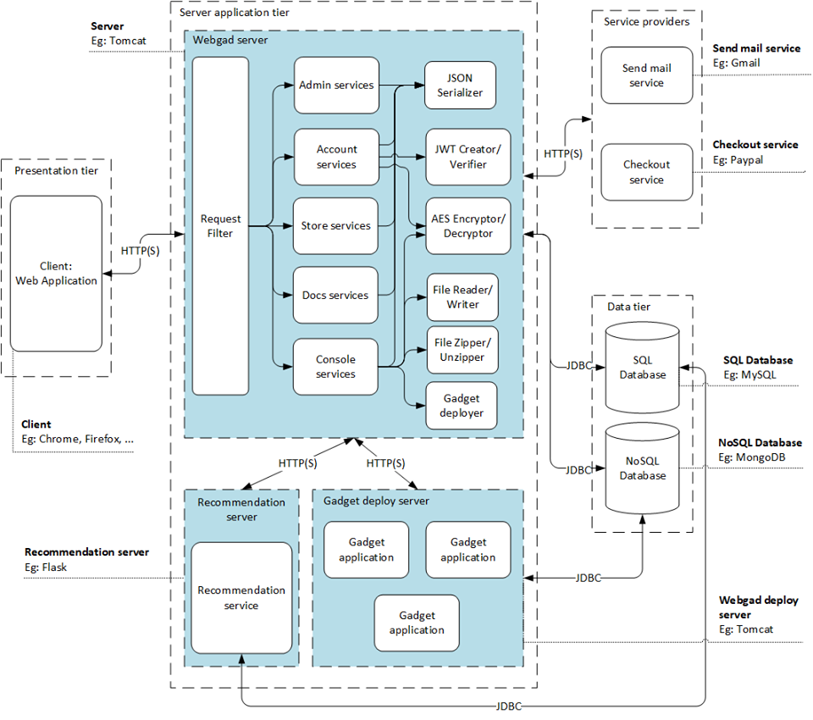

*Figure 4-1.Webgad System’s system architecture*

### System Architecture Explanation

#### Server application tier

##### **Webgad server and Deploy server – Tomcat server**



Apache Tomcat, is a **free open source** web server and servlet container developed by the Apache Software Foundation, it is the HTTP web server that run your java code. It is **easily to configuration** and **ease of use**, suitable for java base application.

##### **Recommendation server – Flask application**



Flask is a web application framework written in Python. It is developed by Armin Ronacher, who leads an international group of Python enthusiasts named Pocoo. Flask is based on the Werkzeug WSGI toolkit and Jinja2 template engine. Both are Pocoo projects.

WSGI: Web Server Gateway Interface (WSGI) has been adopted as a standard for Python web application development. WSGI is a specification for a universal interface between the web server and the web applications.

Werkzeug: It is a WSGI toolkit, which implements requests, response objects, and other utility functions. This enables building a web framework on top of it. The Flask framework uses Werkzeug as one of its bases.

jinja2: jinja2 is a popular templating engine for Python. A web templating system combines a template with a certain data source to render dynamic web pages.

#### Presentation tier

##### **Web application – HTML5 & CSS3 and VueJS**



Using **HTML5 and CSS3** provides advantages to businesses that develop and deploy web content and web applications, to create refined and accurate web pages and web systems that **operate across devices, operating systems and web browsers**.



Vue is a **progressive framework** for building user interfaces. Unlike other monolithic frameworks, Vue is designed from the ground up to be incrementally adoptable. The core library is focused on the view layer only, and is easy to pick up and integrate with other libraries or existing projects. On the other hand, Vue is also perfectly capable of powering sophisticated Single-Page Applications when used in combination with [**modern tooling**](https://vuejs.org/v2/guide/single-file-components.html) and [**supporting libraries**](https://github.com/vuejs/awesome-vue#components--libraries).

#### Data tier

##### **SQL Database – MySQL**



**MySQL** is a **powerful, free open-source database management system** that has been around for years. It is **very stable** and has a **big community** that helps maintain, debug and upgrade it.

##### **NoSQL Database – MongoDB**



**MongoDB** is a [**cross-platform**](https://en.wikipedia.org/wiki/Cross-platform)[**document-oriented database**](https://en.wikipedia.org/wiki/Document-oriented_database) program that used to be [**free and open-source**](https://en.wikipedia.org/wiki/Free_and_open-source_software) but has since changed to a proprietary license ([*Server Side Public License*](https://www.mongodb.com/licensing/server-side-public-license)). Classified as a [**NoSQL**](https://en.wikipedia.org/wiki/NoSQL)**database** program, MongoDB uses [**JSON**](https://en.wikipedia.org/wiki/JSON)-like documents with [schemata](https://en.wikipedia.org/wiki/Database_schema). MongoDB is developed by [**MongoDB Inc**.](https://en.wikipedia.org/wiki/MongoDB_Inc.).

#### Service providers

##### **Mail service – Google mail API**



* Use to send email in our system.
* High security because the Google mail API uses Oath 2.0 to authentication and authorization.

##### **Checkout service – PayPal wallet**

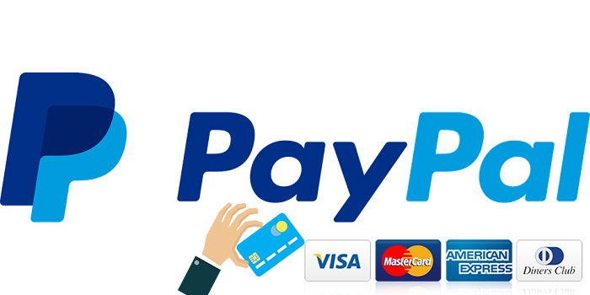

Used for payment feature in our system.

### Layer architecture diagram

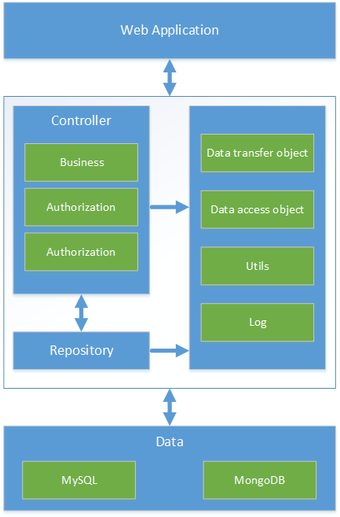

*Figure 4-2.Webgad System’s layer architecture diagram*

### Component diagram

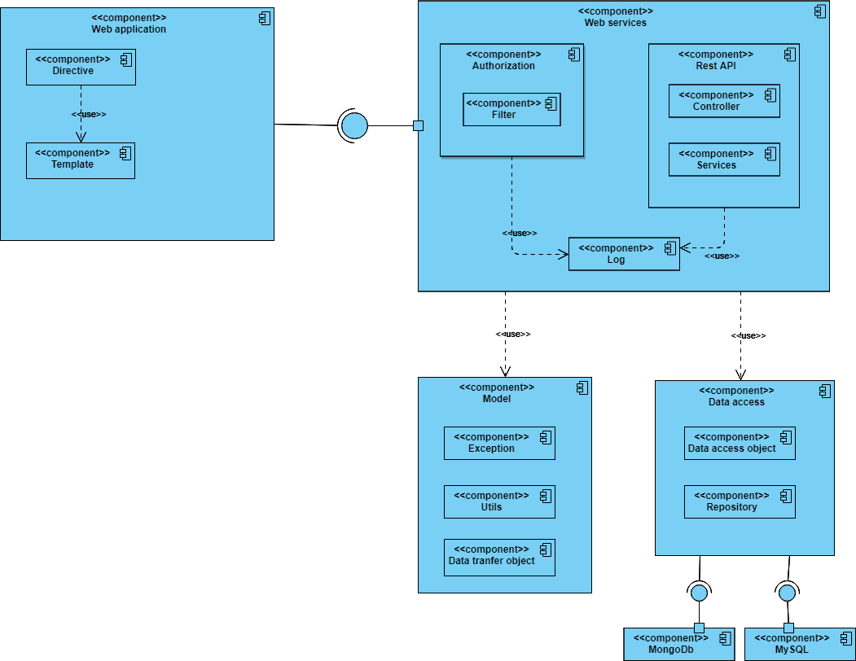

*Figure 4-3.Component diagram*

|  |  |  |
| --- | --- | --- |
| Web application | Directive | Change the DOM layout |
| Template | Syntax to express the dynamic part of our HTML |
| Authorization(Filter) | Authorize and authenticate user |
| Controller (Rest API) | the way the HTTP response body is created |
| Service (Rest API) | representational state transfer (REST) technology |
| Log | Recording of activity. |
| Data access | Data access object | lightweight persistence domain object |
| Repository | Java platform API |
| Model | Utils | Java collection frameworks. |
| Data transfer object | Object that carries data between processes |
| Exception | Categorize Exception |
| MySQL | MySQL | Save data to storage. |
| MongoDb | MongoDb | Save data to storage. |

## Detailed design

### Package diagram

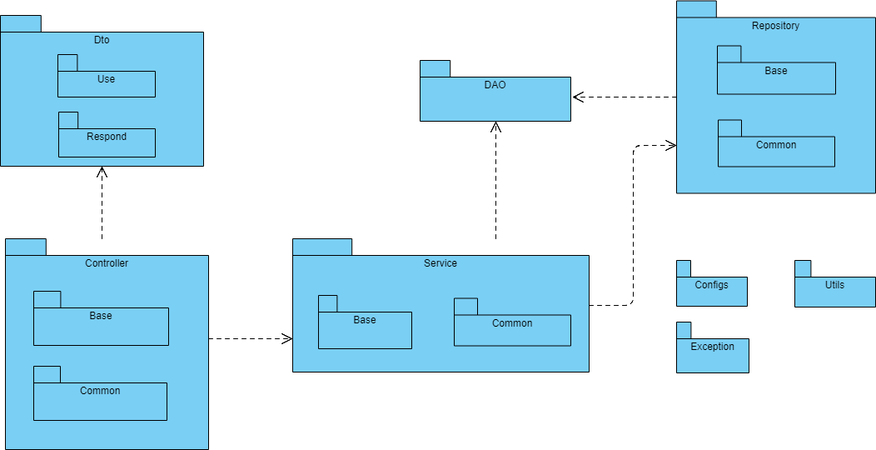

*Figure 4-4.Package diagram*

|  |  |  |
| --- | --- | --- |
| **Package** | | **Description** |
| Dto | Use | Common data transfer object classes to respond to client. |
| Respond | Common base respond object classes |
| Repository | Common | Group of interfaces, implementing and implemented classes that store queries. |
| Base | Base classes which are written in generic type |
| Controller | Base | Base classes which are written in generic type |
| Services | Base | Base classes which are written in generic type |
| Common | Group of interfaces, implemented classes and implementing classes that store logic services. |
| Configs | | Application config classes |
| Utils | | Util classes which are static classes and contain static methods to share public in system |
| Exception | | Exception classes for handling exception. |
| DAO | | Object classes which are ORM classes and are mapped to tables in databases |

### Class diagram

#### Account Module

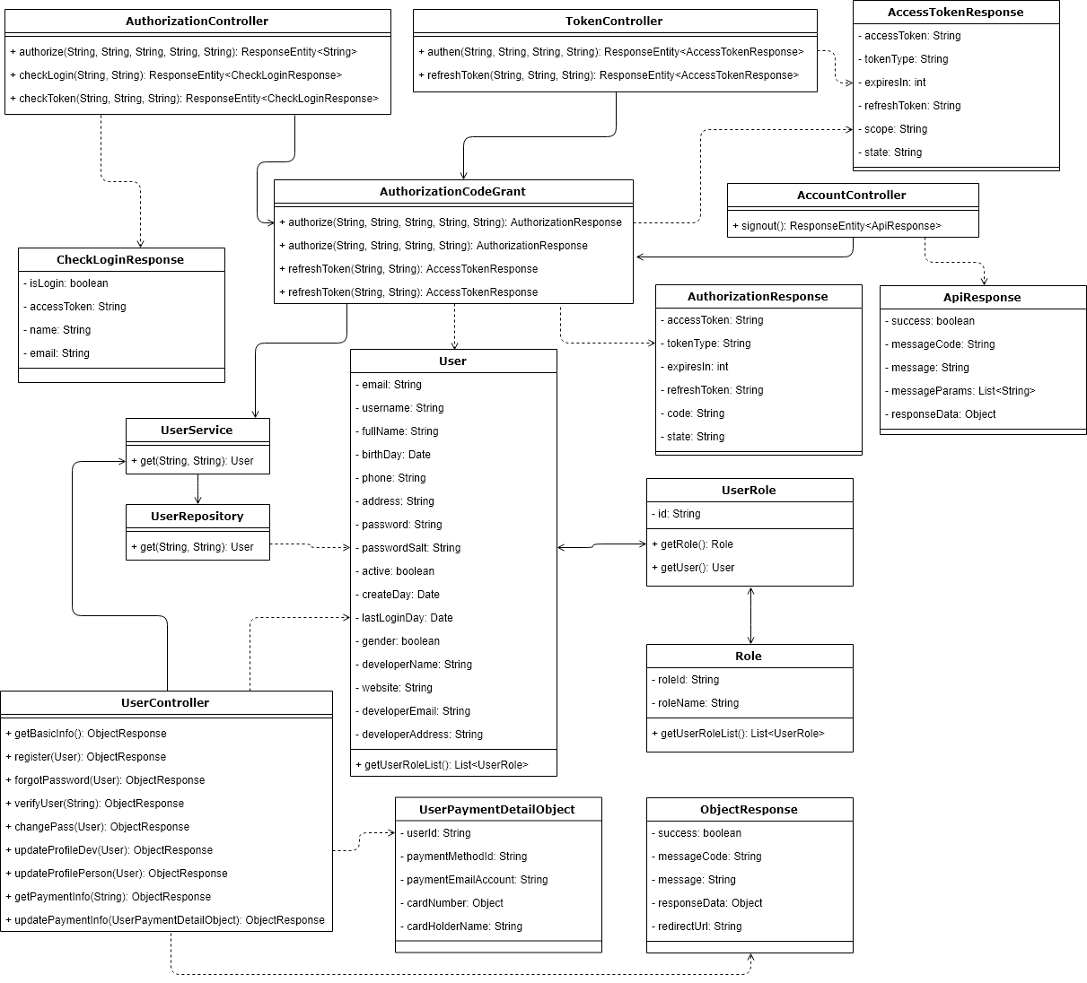

*Figure 4-5.Account Module*

##### **AccessTokenResponse**

|  |  |  |
| --- | --- | --- |
| Name | AccessTokenResponse | |
| Type | Class | |
| Package | vn.com.webgad.account.serverauth.dto | |
| Field Summary | | |
| Modifier and Type | | Name |
| private String | | access_token |
| private int | | expires_in |
| private String | | refresh_token |
| private String | | scope |
| private String | | state |
| private String | | token_type |
| Constructor Summary | | |
| AccessTokenResponse() | | |
| AccessTokenResponse(String access_token, String token_type, int expires_in, String refresh_token) | | |
| AccessTokenResponse(String access_token, String token_type, int expires_in, String refresh_token, String scope, String state) | | |
| Method Summary | | |
| Modifier and Type | | Name |
| String | | getAccess_token() |
| Int | | getExpires_in() |
| String | | getRefresh_token() |
| String | | getScope() |
| String | | getState() |
| String | | getToken_type() |
| Void | | setAccess_token(String access_token) |
| Void | | setExpires_in(int expires_in) |
| Void | | setRefresh_token(String refresh_token) |
| Void | | setScope(String scope) |
| Void | | setState(String state) |
| Void | | setToken_type(String token_type) |

##### **AccountController**

|  |  |  |
| --- | --- | --- |
| Name | AccountController | |
| Type | Class | |
| Package | vn.com.webgad.account.serverauth.controller | |
| Field Summary | | |
| Modifier and Type | | Name |
| (package private) AuthorizationCodeGrant | | authorizationCodeGrant |
| Constructor Summary | | |
| AccountController() | | |
| Method Summary | | |
| Modifier and Type | | Name |
| org.springframework.http.ResponseEntity | | signout() |

##### **ApiResponse**

|  |  |  |
| --- | --- | --- |
| Name | ApiResponse | |
| Type | Class | |
| Package | vn.com.webgad.account.serverauth.dto | |
| Field Summary | | |
| Modifier and Type | | Name |
| private String | | message |
| private String | | messageCode |
| private java.util.List | | messageParams |
| private Object | | responseData |
| private static long | | serialVersionUID |
| private boolean | | success |
| Constructor Summary | | |
| ApiResponse() | | |
| Method Summary | | |
| Modifier and Type | | Name |
| String | | getMessage() |
| String | | getMessageCode() |
| java.util.List | | getMessageParams() |
| Object | | getResponseData() |
| boolean | | isSuccess() |
| void | | setMessage(String message) |
| void | | setMessageCode(String messageCode) |
| void | | setMessageParams(java.util.List messageParams) |
| void | | setResponseData(Object responseData) |
| void | | setSuccess(boolean success) |

##### **AuthorizationCodeGrant**

|  |  |  |
| --- | --- | --- |
| Name | AuthorizationCodeGrant | |
| Type | Class | |
| Package | vn.com.webgad.account.serverauth.authorization | |
| Field Summary | | |
| Modifier and Type | | Name |
| (package private) UsersRepository | | usersRepository |
| Constructor Summary | | |
| AuthorizationCodeGrant() | | |
| Method Summary | | |
| Modifier and Type | | Name |
| AccessTokenResponse | | authorize(String grant_type, String username, String password, String scope) |
| AuthorizationResponse | | authorize(String response_type, String client_id, String redirect_uri, String scope, String state) |
| AccessTokenResponse | | refreshToken(String refreshToken, String scope) |

##### **AuthorizationController**

|  |  |  |
| --- | --- | --- |
| Name | AuthorizationController | |
| Type | Class | |
| Package | vn.com.webgad.account.serverauth.controller | |
| Field Summary | | |
| Modifier and Type | | Name |
| (package private) AuthorizationCodeGrant | | authorizationCodeGrant |
| private static org.apache.log4j.Logger | | logger |
| Constructor Summary | | |
| AuthorizationController() | | |
| Method Summary | | |
| Modifier and Type | | Name |
| org.springframework.http.ResponseEntity | | authorize(String response_type, String client_id, String redirect_uri, String scope, String state) |
| org.springframework.http.ResponseEntity | | checkLogin(String scope, String originalRefererEncrypted) |
| org.springframework.http.ResponseEntity | | checkToken(String token, String scope, String webgadPrivateKey) |

##### **AuthorizationResponse**

|  |  |  |
| --- | --- | --- |
| Name | AuthorizationResponse | |
| Type | Class | |
| Package | vn.com.webgad.account.serverauth.dto | |
| Field Summary | | |
| Modifier and Type | | Name |
| private String | | access_token |
| private String | | code |
| private int | | expires_in |
| private String | | refresh_token |
| private String | | state |
| private String | | token_type |
| Constructor Summary | | |
| AuthorizationResponse() | | |
| AuthorizationResponse(String code, String state) | | |
| AuthorizationResponse(String access_token, String token_type, int expires_in, String refresh_token) | | |
| Method Summary | | |
| Modifier and Type | | Name |
| String | | getAccess_token() |
| String | | getCode() |
| int | | getExpires_in() |
| String | | getRefresh_token() |
| String | | getState() |
| String | | getToken_type() |
| void | | setAccess_token(String access_token) |
| void | | setCode(String code) |
| void | | setExpires_in(int expires_in) |
| void | | setRefresh_token(String refresh_token) |
| void | | setState(String state) |
| void | | setToken_type(String token_type) |

##### **CheckLoginResponse**

|  |  |  |
| --- | --- | --- |
| Name | CheckLoginResponse | |
| Type | Class | |
| Package | vn.com.webgad.account.serverauth.dto | |
| Field Summary | | |
| Modifier and Type | | Name |
| private String | | access_token |
| private String | | email |
| private boolean | | isLogin |
| private String | | name |
| Constructor Summary | | |
| CheckLoginResponse() | | |
| CheckLoginResponse(boolean isLogin, String access_token, String name, String email) | | |
| Method Summary | | |
| Modifier and Type | | Name |
| String | | getAccess_token() |
| String | | getEmail() |
| String | | getName() |
| boolean | | isLogin() |
| void | | setAccess_token(String access_token) |
| void | | setEmail(String email) |
| void | | setLogin(boolean isLogin) |
| void | | setName(String name) |

##### **ObjectResponse**

|  |  |  |
| --- | --- | --- |
| Name | ObjectResponse | |
| Type | Class | |
| Package | vn.com.webgad.model | |
| Field Summary | | |
| Modifier and Type | | Name |
| private int | | code |
| private String | | errorMessageCode |
| private String | | errorMessages |
| private String | | messageCode |
| private String | | messages |
| private String | | redirectUrl |
| private Object | | responseData |
| private static long | | serialVersionUID |
| private boolean | | success |
| private int | | total |
| Constructor Summary | | |
| ObjectResponse() | | |
| Method Summary | | |
| Modifier and Type | | Name |
| int | | getCode() |
| String | | getErrorMessageCode() |
| String | | getErrorMessages() |
| String | | getMessageCode() |
| String | | getMessages() |
| String | | getRedirectUrl() |
| Object | | getResponseData() |
| int | | getTotal() |
| boolean | | isSuccess() |
| void | | setCode(int code) |
| void | | setErrorMessageCode(String errorMessageCode) |
| void | | setErrorMessages(String errorMessages) |
| void | | setMessageCode(String messageCode) |
| void | | setMessages(String messages) |
| void | | setRedirectUrl(String redirectUrl) |
| void | | setResponseData(Object responseData) |
| void | | setSuccess(boolean success) |
| void | | setTotal(int total) |

##### **TokenController**

|  |  |  |
| --- | --- | --- |
| Name | TokenController | |
| Type | Class | |
| Package | vn.com.webgad.account.serverauth.controller | |
| Field Summary | | |
| Modifier and Type | | Name |
| (package private) AuthorizationCodeGrant | | authorizationCodeGrant |
| Constructor Summary | | |
| TokenController() | | |
| Method Summary | | |
| Modifier and Type | | Name |
| org.springframework.http.ResponseEntity | | authen(String grant_type, String username, String password, String scope) |
| org.springframework.http.ResponseEntity | | refreshToken(String grant_type, String refresh_token, String scope) |
| String | | token() |

##### **UserController**

|  |  |  |
| --- | --- | --- |
| Name | UserController | |
| Type | Class | |
| Package | vn.com.webgad.account.controller | |
| Field Summary | | |
| Modifier and Type | | Name |
| private EmailService | | emailService |
| private static org.apache.log4j.Logger | | logger |
| private UserPaymentDetailRepository | | userPaymentDetailRepository |
| private UsersService | | usersService |
| Constructor Summary | | |
| UserController() | | |
| Method Summary | | |
| Modifier and Type | | Name |
| ObjectResponse | | changePass(ObjectUserInput objectUserInput) |
| ObjectResponse | | forgotPassUser(ObjectUserInput objectUserInput) |
| ObjectResponse | | getBasicInfo(javax.servlet.http.HttpServletRequest request) |
| ObjectResponse | | getPaymentInfo(String paymentMethodId, javax.servlet.http.HttpServletRequest request) |
| ObjectResponse | | register(javax.servlet.http.HttpServletRequest request, ObjectUserInput objectUserInput) |
| private void | | sendEmailForgotPass(Users u, String passRand) |
| private void | | sendEmailRegister(Users u, String url) |
| ObjectResponse | | updatePaymentInfo(UserPaymentDetailObject bodyInput, javax.servlet.http.HttpServletRequest request) |
| ObjectResponse | | updateProfileDev(ObjectUserInput objectUserInput, javax.servlet.http.HttpServletRequest request) |
| ObjectResponse | | updateProfilePerson(ObjectUserInput objectUserInput, javax.servlet.http.HttpServletRequest request) |
| private void | | validateUpdatePaymentInfo(UserPaymentDetailObject bodyInput) |
| ObjectResponse | | verifyUser(String accessToken) |

##### **UserPaymentDetail**

|  |  |  |
| --- | --- | --- |
| Name | UserPaymentDetail | |
| Type | Class | |
| Package | vn.com.webgad.entity | |
| Field Summary | | |
| Modifier and Type | | Name |
| private String | | cardHolderName |
| private String | | cardNumber |
| private String | | paymentEmailAccount |
| private String | | paymentMethodId |
| private static long | | serialVersionUID |
| private Users | | user |
| Constructor Summary | | |
| UserPaymentDetail() | | |
| Method Summary | | |
| Modifier and Type | | Name |
| String | | getCardHolderName() |
| String | | getCardNumber() |
| String | | getPaymentEmailAccount() |
| String | | getPaymentMethodId() |
| Users | | getUser() |
| Void | | setCardHolderName(String cardHolderName) |
| Void | | setCardNumber(String cardNumber) |
| Void | | setPaymentEmailAccount(String paymentEmailAccount) |
| Void | | setPaymentMethodId(String paymentMethodId) |
| Void | | setUser(Users user) |

##### **UserPaymentDetailObject**

|  |  |  |
| --- | --- | --- |
| Name | UserPaymentDetailObject | |
| Type | Class | |
| Package | vn.com.webgad.model | |
| Field Summary | | |
| Modifier and Type | | Name |
| private String | | cardHolderName |
| private String | | cardNumber |
| private String | | paymentEmailAccount |
| private String | | paymentMethodId |
| private String | | userId |
| Constructor Summary | | |
| UserPaymentDetailObject() | | |
| Method Summary | | |
| Modifier and Type | | Name |
| String | | getCardHolderName() |
| String | | getCardNumber() |
| String | | getPaymentEmailAccount() |
| String | | getPaymentMethodId() |
| String | | getUserId() |
| Void | | setCardHolderName(String cardHolderName) |
| Void | | setCardNumber(String cardNumber) |
| Void | | setPaymentEmailAccount(String paymentEmailAccount) |
| Void | | setPaymentMethodId(String paymentMethodId) |
| Void | | setUserId(String userId) |

##### **UserPaymentDetailRepository**

|  |  |  |
| --- | --- | --- |
| Name | UserPaymentDetailRepository | |
| Type | Class | |
| Package | vn.com.webgad.repository | |
| Field Summary | | |
| Modifier and Type | | Name |
| private org.hibernate.SessionFactory | | sessionFactory |
| Constructor Summary | | |
| UserPaymentDetailRepository() | | |
| Method Summary | | |
| Modifier and Type | | Name |
| UserPaymentDetail | | get(String userId, String paymentMethodId) |
| Void | | upsert(UserPaymentDetail userPaymentDetail) Insert or update comment if exists |

##### **UserRole**

|  |  |  |
| --- | --- | --- |
| Name | UserRole | |
| Type | Class | |
| Package | vn.com.webgad.entity | |
| Field Summary | | |
| Modifier and Type | | Name |
| private String | | Id |
| private Role | | role |
| private static long | | serialVersionUID |
| private Users | | user |
| Constructor Summary | | |
| UserRole() | | |
| Method Summary | | |
| Modifier and Type | | Name |
| String | | getId() |
| Role | | getRole() |
| Users | | getUser() |
| Void | | setId(String id) |
| Void | | setRole(Role role) |
| Void | | setUser(Users user) |

##### **Users**

|  |  |  |
| --- | --- | --- |
| Name | Users | |
| Type | Class | |
| Package | vn.com.webgad.entity | |
| Field Summary | | |
| Modifier and Type | | Name |
| private boolean | | Active |
| private String | | Address |
| private java.util.Date | | birthday |
| private java.util.Date | | createDay |
| private String | | developerAddress |
| private String | | developerEmail |
| private String | | developerName |
| private String | | Email |
| private String | | fullName |
| private java.util.List | | gadgetList |
| private boolean | | Gender |
| private java.util.Date | | lastLoginDay |
| private String | | Password |
| private String | | passwordSalt |
| private String | | paymentMethodId |
| private String | | Phone |
| private static long | | serialVersionUID |
| private String | | Username |
| private java.util.List | | userPaymentDetailList |
| private java.util.List | | userRoleList |
| private String | | Website |
| Constructor Summary | | |
| Users() | | |
| Users(String email, String userName) | | |
| Users(String email, String userName, String fullname) | | |
| Users(String email, String userName, String fullname, String paymentMethodId) | | |
| Method Summary | | |
| Modifier and Type | | Name |
| String | | getAddress() |
| java.util.Date | | getBirthDay() |
| java.util.Date | | getCreateDay() |
| String | | getDeveloperAddress() |
| String | | getDeveloperEmail() |
| String | | getDeveloperName() |
| String | | getEmail() |
| String | | getFullName() |
| java.util.List | | getGadgetList() |
| java.util.Date | | getLastLoginDay() |
| String | | getPassword() |
| String | | getPasswordSalt() |
| String | | getPaymentMethodId() |
| String | | getPhone() |
| String | | getUsername() |
| java.util.List | | getUserPaymentDetailList() |
| java.util.List | | getUserRoleList() |
| String | | getWebsite() |
| boolean | | isActive() |
| boolean | | isGender() |
| void | | setActive(boolean active) |
| void | | setAddress(String address) |
| void | | setBirthDay(java.util.Date birthDay) |
| void | | setCreateDay(java.util.Date createDay) |
| void | | setDeveloperAddress(String developerAddress) |
| void | | setDeveloperEmail(String developerEmail) |
| void | | setDeveloperName(String developerName) |
| void | | setEmail(String email) |
| void | | setFullName(String fullName) |
| void | | setGadgetList(java.util.List gadgetList) |
| void | | setGender(boolean gender) |
| void | | setLastLoginDay(java.util.Date lastLoginDay) |
| void | | setPassword(String password) |
| void | | setPasswordSalt(String passwordSalt) |
| void | | setPaymentMethodId(String paymentMethodId) |
| void | | setPhone(String phone) |
| void | | setUsername(String username) |
| void | | setUserPaymentDetailList(java.util.List userPaymentDetailList) |
| void | | setUserRoleList(java.util.List userRoleList) |
| void | | setWebsite(String website) |

##### **UsersRepository**

|  |  |  |
| --- | --- | --- |
| Name | UsersRepository | |
| Type | Class | |
| Package | vn.com.webgad.repository | |
| Field Summary | | |
| Modifier and Type | | Name |
| private org.hibernate.SessionFactory | | sessionFactory |
| Constructor Summary | | |
| UsersRepository() | | |
| Method Summary | | |
| Modifier and Type | | Name |
| Boolean | | addUsers(Users u) |
| Users | | findUsersByEmail(String email) |
| Users | | getUserByEmailWithRoleList(String email) |
| Users | | signin(String usermail, String password) |
| Users | | signin2(String usermail, String password) |
| Boolean | | updateUsers(Users u) |

##### **UsersService**

|  |  |  |
| --- | --- | --- |
| Name | UsersService | |
| Type | Class | |
| Package | vn.com.webgad.service | |
| Field Summary | | |
| Modifier and Type | | Name |
| private UsersRepository | | usersRepository |
| Constructor Summary | | |
| UsersService() | | |
| Method Summary | | |
| Modifier and Type | | Name |
| boolean | | addUser(Users u) |
| Users | | getUserByEmail(String email) |
| boolean | | updateUser(Users u) |

#### Console Module

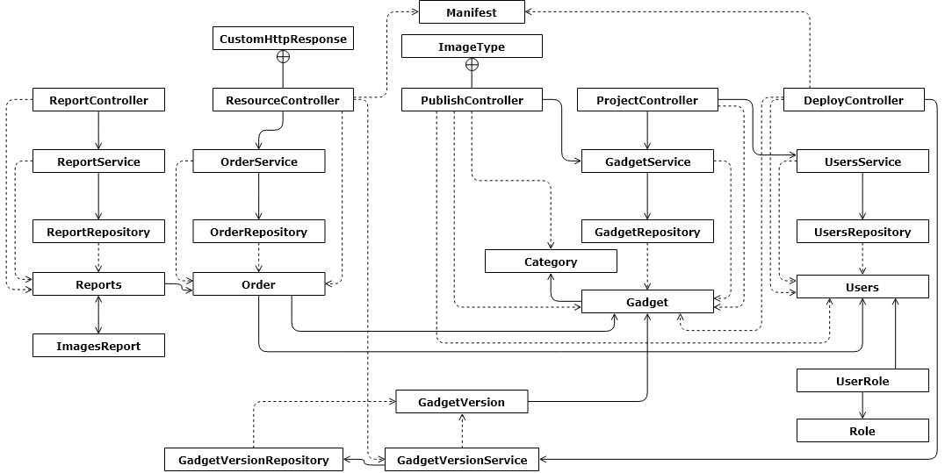

*Figure 4-6.Console Module*

##### **Category**

|  |  |  |
| --- | --- | --- |
| Name | Category | |
| Type | Class | |
| Package | vn.com.webgad.devconsole.entity | |
| Field Summary | | |
| Modifier and Type | | Name |
| private long | | categoryId |
| private String | | description |
| private java.util.List | | gadgetList |
| private String | | name |
| private static long | | serialVersionUID |
| Constructor Summary | | |
| Category() | | |
| Method Summary | | |
| Modifier and Type | | Name |
| long | | getCategoryId() |
| String | | getDescription() |
| java.util.List | | getGadgetList() |
| String | | getName() |
| void | | setCategoryId(long categoryId) |
| void | | setDescription(String description) |
| void | | setGadgetList(java.util.List gadgetList) |
| void | | setName(String name) |

##### **DeployController**

|  |  |  |
| --- | --- | --- |
| Name | DeployController | |
| Type | Class | |
| Package | vn.com.webgad.devconsole.controller | |
| Field Summary | | |
| Modifier and Type | | Name |
| private GadgetRepository | | gadgetRepository |
| private GadgetVersionRepository | | gadgetVersionRepository |
| static String | | MERGED_JS_FILENAME |
| static String | | SERVER_DEPLOY |
| Constructor Summary | | |
| DeployController() | | |
| Method Summary | | |
| Modifier and Type | | Name |
| ObjectResponse | | deploy(org.springframework.web.multipart.MultipartFile file, String gadgetId, javax.servlet.http.HttpServletRequest request) |
| private Manifest | | processManifestV1(String serverUrl, String deployServerUrl, String manifestContent, String gadgetId) |
| private void | | validateManifestV1(Manifest manifest) |

##### **Gadget**

|  |  |  |
| --- | --- | --- |
| Name | Gadget | |
| Type | Class | |
| Package | vn.com.webgad.devconsole.entity | |
| Field Summary | | |
| Modifier and Type | | Name |
| private String | | avatarImageUrl |
| private String | | bannerImage0Url |
| private String | | bannerImage1Url |
| private String | | bannerImage2Url |
| private String | | bannerImage3Url |
| private String | | bannerImage4Url |
| private String | | bannerImage5Url |
| private String | | bannerImage6Url |
| private String | | bannerImage7Url |
| private String | | bannerImage8Url |
| private String | | bannerImage9Url |
| private Category | | category |
| private String | | companyDomain |
| private java.util.Date | | createDay |
| private String | | description |
| private Users | | developer |
| private String | | gadgetId |
| private String | | howUse |
| private String | | latestVersion |
| private String | | name |
| private Double | | price |
| private String | | privateKey |
| private String | | publicKey |
| private java.util.Date | | requestDay |
| private static long | | serialVersionUID |
| private Float | | size |
| private Integer | | status |
| private java.util.Date | | updateDay |
| private String | | whatsNewDescription |
| Constructor Summary | | |
| Gadget() | | |
| Gadget(String gadgetId, Integer status) | | |
| Gadget(String gadgetId, String name, String latestVersion, Integer status) | | |
| Gadget(String gadgetId, String name, String avatarImageUrl, String latestVersion, Integer status, Users developer, java.util.Date requestDay, Double price) | | |
| Method Summary | | |
| Modifier and Type | | Name |
| String | | getAvatarImageUrl() |
| String | | getBannerImage0Url() |
| String | | getBannerImage1Url() |
| String | | getBannerImage2Url() |
| String | | getBannerImage3Url() |
| String | | getBannerImage4Url() |
| String | | getBannerImage5Url() |
| String | | getBannerImage6Url() |
| String | | getBannerImage7Url() |
| String | | getBannerImage8Url() |
| String | | getBannerImage9Url() |
| String | | getBannerImageUrl(int position) |
| Category | | getCategory() |
| String | | getCompanyDomain() |
| java.util.Date | | getCreateDay() |
| String | | getDescription() |
| Users | | getDeveloper() |
| String | | getGadgetId() |
| String | | getHowUse() |
| String | | getLatestVersion() |
| String | | getName() |
| Double | | getPrice() |
| String | | getPrivateKey() |
| String | | getPublicKey() |
| java.util.Date | | getRequestDay() |
| Float | | getSize() |
| Integer | | getStatus() |
| java.util.Date | | getUpdateDay() |
| String | | getWhatsNewDescription() |
| void | | setAvatarImageUrl(String avatarImageUrl) |
| void | | setBannerImage0Url(String bannerImage0Url) |
| void | | setBannerImage1Url(String bannerImage1Url) |
| void | | setBannerImage2Url(String bannerImage2Url) |
| void | | setBannerImage3Url(String bannerImage3Url) |
| void | | setBannerImage4Url(String bannerImage4Url) |
| void | | setBannerImage5Url(String bannerImage5Url) |
| void | | setBannerImage6Url(String bannerImage6Url) |
| void | | setBannerImage7Url(String bannerImage7Url) |
| void | | setBannerImage8Url(String bannerImage8Url) |
| void | | setBannerImage9Url(String bannerImage9Url) |
| void | | setBannerImageUrl(int position, String imageUrl) |
| void | | setCategory(Category category) |
| void | | setCompanyDomain(String companyDomain) |
| void | | setCreateDay(java.util.Date createDay) |
| void | | setDescription(String description) |
| void | | setDeveloper(Users developer) |
| void | | setGadgetId(String gadgetId) |
| void | | setHowUse(String howUse) |
| void | | setLatestVersion(String latestVersion) |
| void | | setName(String name) |
| void | | setPrice(Double price) |
| void | | setPrivateKey(String privateKey) |
| void | | setPublicKey(String publicKey) |
| void | | setRequestDay(java.util.Date requestDay) |
| void | | setSize(Float size) |
| void | | setStatus(Integer status) |
| void | | setUpdateDay(java.util.Date updateDay) |
| void | | setWhatsNewDescription(String whatsNewDescription) |

##### **GadgetRepository**

|  |  |  |
| --- | --- | --- |
| Name | GadgetRepository | |
| Type | Class | |
| Package | vn.com.webgad.devconsole.repository | |
| Field Summary | | |
| Modifier and Type | | Name |
| private static org.apache.log4j.Logger | | logger |
| private org.hibernate.SessionFactory | | sessionFactory |
| Constructor Summary | | |
| GadgetRepository() | | |
| Method Summary | | |
| Modifier and Type | | Name |
| int | | acceptPublishGadget(String gadgetId) |
| Gadget | | checkUserPermission(String email, String publicKey, String privateKey, String gadgetId) |
| Gadget | | deleteGadgetById(String devMail, String id) |
| boolean | | deleteGagetById(Gadget g) |
| boolean | | editGadget(Gadget g) |
| java.util.List | | findGadgetByEmail(String email, int firstResult, int maxResults) |
| Gadget | | findGadgetById(String id) |
| Gadget | | get(String id) |
| long | | getCountGadgetByEmail(String email) |
| Gadget | | getUserGadget(String devMail, String gadgetId) |
| boolean | | insertGadget(Gadget g) |
| java.util.List | | list(String email) |
| java.util.List | | listPendingAdminVerifyGadgets() List gadgets which is pending to publish (admin function) |
| int | | rejectPublishGadget(String gadgetId) |
| Gadget | | update(String devMail, Gadget newGadget) |
| int | | updateGadgetStatus(String devMail, String gadgetId, int status) |
| Gadget | | updateStatus(String devMail, String gadgetId, int status) |

##### **GadgetService**

|  |  |  |
| --- | --- | --- |
| Name | GadgetService | |
| Type | Class | |
| Package | vn.com.webgad.devconsole.service | |
| Field Summary | | |
| Modifier and Type | | Name |
| private GadgetRepository | | gadgetRepository |
| Constructor Summary | | |
| GadgetService() | | |
| Method Summary | | |
| Modifier and Type | | Name |
| boolean | | addGadget(Gadget g) |
| boolean | | editGadget(Gadget g) |
| long | | getCountGadgetByEamil(String email) |
| java.util.List | | getGadgetByEmail(String email, int firstResult, int maxResults) |
| Gadget | | getGadgetById(String id) |
| boolean | | removeGadget(Gadget g) |

##### **GadgetVersion**

|  |  |  |
| --- | --- | --- |
| Name | GadgetVersion | |
| Type | Class | |
| Package | vn.com.webgad.devconsole.entity | |
| Field Summary | | |
| Modifier and Type | | Name |
| private java.util.Date | | createDay |
| static String | | DEPLOY_VERSION |
| private String | | deployPath |
| private Gadget | | gadget |
| private String | | manifest |
| private static long | | serialVersionUID |
| private long | | versionNumber |
| private String | | versionString |
| Constructor Summary | | |
| GadgetVersion() | | |
| GadgetVersion(Gadget gadget, String versionString, long versionNumber, String manifest, java.util.Date createDay) | | |
| Method Summary | | |
| Modifier and Type | | Name |
| java.util.Date | | getCreateDay() |
| String | | getDeployPath() |
| Gadget | | getGadget() |
| String | | getManifest() |
| long | | getVersionNumber() |
| String | | getVersionString() |
| void | | setCreateDay(java.util.Date createDay) |
| void | | setDeployPath(String deployPath) |
| void | | setGadget(Gadget gadget) |
| void | | setManifest(String manifest) |
| void | | setVersionNumber(long versionNumber) |
| void | | setVersionString(String versionString) |

##### **GadgetVersionRepository**

|  |  |  |
| --- | --- | --- |
| Name | GadgetVersionRepository | |
| Type | Class | |
| Package | vn.com.webgad.devconsole.repository | |
| Field Summary | | |
| Modifier and Type | | Name |
| private org.hibernate.SessionFactory | | sessionFactory |
| Constructor Summary | | |
| GadgetVersionRepository() | | |
| Method Summary | | |
| Modifier and Type | | Name |
| String | | getDeployPath(String gadgetId, String versionString) |
| String | | getManifest(String gadgetId, String versionString) |
| GadgetVersion | | insert(GadgetVersion g) |
| void | | upsert(GadgetVersion g) |

##### **Manifest**

|  |  |  |
| --- | --- | --- |
| Name | Manifest | |
| Type | Class | |
| Package | vn.com.webgad.devconsole.deploy.entity.manifest.v1 | |
| Field Summary | | |
| Modifier and Type | | Name |
| private String | | defaultLocale |
| private String | | description |
| private String | | homepageUrl |
| private ManifestHosting | | hosting |
| private int | | manifestVersion |
| private String | | name |
| private java.util.List | | optionalPermissions |
| private ManifestHosting | | optionPage |
| private java.util.List | | permissions |
| private String | | version |
| private String | | versionName |
| Constructor Summary | | |
| Manifest() | | |
| Method Summary | | |
| Modifier and Type | | Name |
| String | | getDefaultLocale() |
| String | | getDescription() |
| String | | getHomepageUrl() |
| ManifestHosting | | getHosting() |
| int | | getManifestVersion() |
| String | | getName() |
| java.util.List | | getOptionalPermissions() |
| ManifestHosting | | getOptionPage() |
| java.util.List | | getPermissions() |
| String | | getVersion() |
| String | | getVersionName() |
| void | | setDefaultLocale(String defaultLocale) |
| void | | setDescription(String description) |
| void | | setHomepageUrl(String homepageUrl) |
| void | | setHosting(ManifestHosting hosting) |
| void | | setManifestVersion(int manifestVersion) |
| void | | setName(String name) |
| void | | setOptionalPermissions(java.util.List optionalPermissions) |
| void | | setOptionPage(ManifestHosting optionPage) |
| void | | setPermissions(java.util.List permissions) |
| void | | setVersion(String version) |
| void | | setVersionName(String versionName) |

##### **Order**

|  |  |  |
| --- | --- | --- |
| Name | Order | |
| Type | Class | |
| Package | vn.com.webgad.devconsole.entity | |
| Field Summary | | |
| Modifier and Type | | Name |
| private Gadget | | gadget |
| private String | | id |
| private String | | instanceValue |
| private java.util.Date | | orderDate |
| static int | | PAID_STATUS |
| private PaymentDeveloper | | paymentDeveloper |
| private float | | price |
| private static long | | serialVersionUID |
| private String | | site |
| private Integer | | status |
| private Users | | user |
| Constructor Summary | | |
| Order() | | |
| Method Summary | | |
| Modifier and Type | | Name |
| Gadget | | getGadget() |
| String | | getId() |
| String | | getInstanceValue() |
| java.util.Date | | getOrderDate() |
| PaymentDeveloper | | getPaymentDeveloper() |
| float | | getPrice() |
| String | | getSite() |
| Integer | | getStatus() |
| Users | | getUser() |
| void | | setGadget(Gadget gadget) |
| void | | setId(String id) |
| void | | setInstanceValue(String instanceValue) |
| void | | setOrderDate(java.util.Date orderDate) |
| void | | setPaymentDeveloper(PaymentDeveloper paymentDeveloper) |
| void | | setPrice(float price) |
| void | | setSite(String site) |
| void | | setStatus(Integer status) |
| void | | setUser(Users user) |

##### **OrderRepository**

|  |  |  |
| --- | --- | --- |
| Name | OrderRepository | |
| Type | Class | |
| Package | vn.com.webgad.devconsole.repository | |
| Field Summary | | |
| Modifier and Type | | Name |
| private static org.apache.log4j.Logger | | logger |
| private org.hibernate.SessionFactory | | sessionFactory |
| Constructor Summary | | |
| OrderRepository() | | |
| Method Summary | | |
| Modifier and Type | | Name |
| Order | | findOrderByOrderId(String orderId) |
| java.util.List | | findOrderSuccess() |
| Order | | get(String gadgetId, String instance) |
| java.util.List | | listBasedOnSite(String gadgetId, String site) |
| boolean | | saveOrder(Order order, String email) Add a Order |
| boolean | | updateOrder(Order o) |

##### **OrderService**

|  |  |  |
| --- | --- | --- |
| Name | OrderService | |
| Type | Class | |
| Package | vn.com.webgad.devconsole.service | |
| Field Summary | | |
| Modifier and Type | | Name |
| private OrderRepository | | orderRepository |
| Constructor Summary | | |
| OrderService() | | |
| Method Summary | | |
| Modifier and Type | | Name |
| java.util.List | | findOrderSuccess() |
| Order | | getOrderByOrderId(String orderId) |
| boolean | | updateOrder(Order o) |

##### **ProjectController**

|  |  |  |
| --- | --- | --- |
| Name | ProjectController | |
| Type | Class | |
| Package | vn.com.webgad.devconsole.controller | |
| Field Summary | | |
| Modifier and Type | | Name |
| private GadgetRepository | | gadgetRepository |
| private GadgetService | | gadgetService |
| private UsersService | | usersService |
| Constructor Summary | | |
| ProjectController() | | |
| Method Summary | | |
| Modifier and Type | | Name |
| ObjectResponse | | add(ObjectGadgetInput body, javax.servlet.http.HttpServletRequest request) |
| ObjectResponse | | delete(String id, javax.servlet.http.HttpServletRequest request) |
| ObjectResponse | | get(String id, javax.servlet.http.HttpServletRequest request) |
| private String | | getPackageName(String gadgetName, String companyDomain) |
| ObjectResponse | | list(javax.servlet.http.HttpServletRequest request) |

##### **PublishController**

|  |  |  |
| --- | --- | --- |
| Name | PublishController | |
| Type | Class | |
| Package | vn.com.webgad.devconsole.controller | |
| Field Summary | | |
| Modifier and Type | | Name |
| private GadgetRepository | | gadgetRepository |
| private String | | serverUrl |
| Constructor Summary | | |
| PublishController() | | |
| Method Summary | | |
| Modifier and Type | | Name |
| private String | | addImage(String gadgetId, org.springframework.web.multipart.MultipartFile imageFile, PublishController.ImageType imageType, int bannerImagePosition) |
| private void | | copyAndSetGadgetImage(Gadget gadget, org.springframework.web.multipart.MultipartFile imageFile, PublishController.ImageType imageType, String bannerImageLink, int bannerImagePosition) |
| private boolean | | deleteBannerImage(String gadgetId, int bannerImagePosition, String fileType) |
| org.springframework.http  .ResponseEntity | | publish(String gadgetId, org.springframework.web.multipart.MultipartFile avatarImg, String gadgetName, Integer categoryId, org.springframework.web.multipart.MultipartFile bannerImage0, org.springframework.web.multipart.MultipartFile bannerImage1, org.springframework.web.multipart.MultipartFile bannerImage2, org.springframework.web.multipart.MultipartFile bannerImage3, org.springframework.web.multipart.MultipartFile bannerImage4, org.springframework.web.multipart.MultipartFile bannerImage5, org.springframework.web.multipart.MultipartFile bannerImage6, org.springframework.web.multipart.MultipartFile bannerImage7, org.springframework.web.multipart.MultipartFile bannerImage8, org.springframework.web.multipart.MultipartFile bannerImage9, String oldBannerLink0, String oldBannerLink1, String oldBannerLink2, String oldBannerLink3, String oldBannerLink4, String oldBannerLink5, String oldBannerLink6, String oldBannerLink7, String oldBannerLink8, String oldBannerLink9, String descriptionTxt, String whatsNewInfoTxt, String guideTxt, String version, javax.servlet.http.HttpServletRequest request) |
| private boolean | | renameBannerImage(String gadgetId, int fromPosition, int toPosition, String fileType) |
| private void | | validatePublish(Gadget savedGadget, org.springframework.web.multipart.MultipartFile avatarImg, String gadgetName, Integer categoryId, org.springframework.web.multipart.MultipartFile bannerImage0, String oldBannerLink0, String descriptionTxt, String version) |

##### **PublishController.ImageType**

|  |  |  |
| --- | --- | --- |
| Name | PublishController.ImageType | |
| Type | Enum | |
| Package | vn.com.webgad.devconsole.controller | |
| Field Summary | | |
| Modifier and Type | | Name |
| N/A | | |
| Constructor Summary | | |
| N/A | | |
| Method Summary | | |
| Modifier and Type | | Name |
| static PublishController.ImageType | | valueOf(String name) Returns the enum constant of this type with the specified name. |
| static PublishController.ImageType[] | | values() Returns an array containing the constants of this enum type, in the order they are declared. |

##### **ResourceController**

|  |  |  |
| --- | --- | --- |
| Name | ResourceController | |
| Type | Class | |
| Package | vn.com.webgad.devconsole.controller | |
| Field Summary | | |
| Modifier and Type | | Name |
| private GadgetVersionRepository | | gadgetVersionRepository |
| private OrderRepository | | orderRepository |
| Constructor Summary | | |
| ResourceController() | | |
| Method Summary | | |
| Modifier and Type | | Name |
| private void | | checkOrder(String gadgetId, String referer) |
| ObjectResponse | | getManifest(String id, String version) |
| org.springframework.http.ResponseEntity | | getResource(String id, String version, String body, javax.servlet.http.HttpServletRequest request) |
| private Manifest | | readManifestV1(String manifestContent) |
| private ResourceController.CustomHttpResponse | | sendHttpRequest(String url, String method, java.util.HashMap params, String data) |

##### **Role**

|  |  |  |
| --- | --- | --- |
| Name | Role | |
| Type | Class | |
| Package | vn.com.webgad.devconsole.entity | |
| Field Summary | | |
| Modifier and Type | | Name |
| private String | | roleId |
| private String | | roleName |
| private static long | | serialVersionUID |
| Constructor Summary | | |
| Role() | | |
| Method Summary | | |
| Modifier and Type | | Name |
| String | | getRoleId() |
| String | | getRoleName() |
| void | | setRoleId(String roleId) |
| void | | setRoleName(String roleName) |

##### **Users**

|  |  |  |
| --- | --- | --- |
| Name | Users | |
| Type | Class | |
| Package | vn.com.webgad.devconsole.entity | |
| Field Summary | | |
| Modifier and Type | | Name |
| private boolean | | active |
| private String | | address |
| private java.util.Date | | birthDay |
| private java.util.Date | | createDay |
| private String | | developerName |
| private String | | email |
| private String | | fullName |
| private java.util.List | | gadgetList |
| private boolean | | gender |
| private boolean | | isDeveloper |
| private java.util.Date | | lastLoginDay |
| private String | | password |
| private String | | passwordSalt |
| private PaymentDeveloper | | paymentDeveloper |
| private java.util.List | | paymentMethodList |
| private String | | phone |
| private static long | | serialVersionUID |
| private String | | username |
| private java.util.List | | userRoleList |
| private String | | website |
| Constructor Summary | | |
| Users() | | |
| Method Summary | | |
| Modifier and Type | | Name |
| String | | getAddress() |
| java.util.Date | | getBirthDay() |
| java.util.Date | | getCreateDay() |
| String | | getDeveloperName() |
| String | | getEmail() |
| String | | getFullName() |
| java.util.List | | getGadgetList() |
| java.util.Date | | getLastLoginDay() |
| String | | getPassword() |
| String | | getPasswordSalt() |
| PaymentDeveloper | | getPaymentDeveloper() |
| java.util.List | | getPaymentMethodList() |
| String | | getPhone() |
| String | | getUsername() |
| java.util.List | | getUserRoleList() |
| String | | getWebsite() |
| boolean | | isActive() |
| boolean | | isDeveloper() |
| boolean | | isGender() |
| void | | setActive(boolean active) |
| void | | setAddress(String address) |
| void | | setBirthDay(java.util.Date birthDay) |
| void | | setCreateDay(java.util.Date createDay) |
| void | | setDeveloper(boolean isDeveloper) |
| void | | setDeveloperName(String developerName) |
| void | | setEmail(String email) |
| void | | setFullName(String fullName) |
| void | | setGadgetList(java.util.List gadgetList) |
| void | | setGender(boolean gender) |
| void | | setLastLoginDay(java.util.Date lastLoginDay) |
| void | | setPassword(String password) |
| void | | setPasswordSalt(String passwordSalt) |
| void | | setPaymentDeveloper(PaymentDeveloper paymentDeveloper) |
| void | | setPaymentMethodList(java.util.List paymentMethodList) |
| void | | setPhone(String phone) |
| void | | setUsername(String username) |
| void | | setUserRoleList(java.util.List userRoleList) |
| void | | setWebsite(String website) |

#### Admin Module

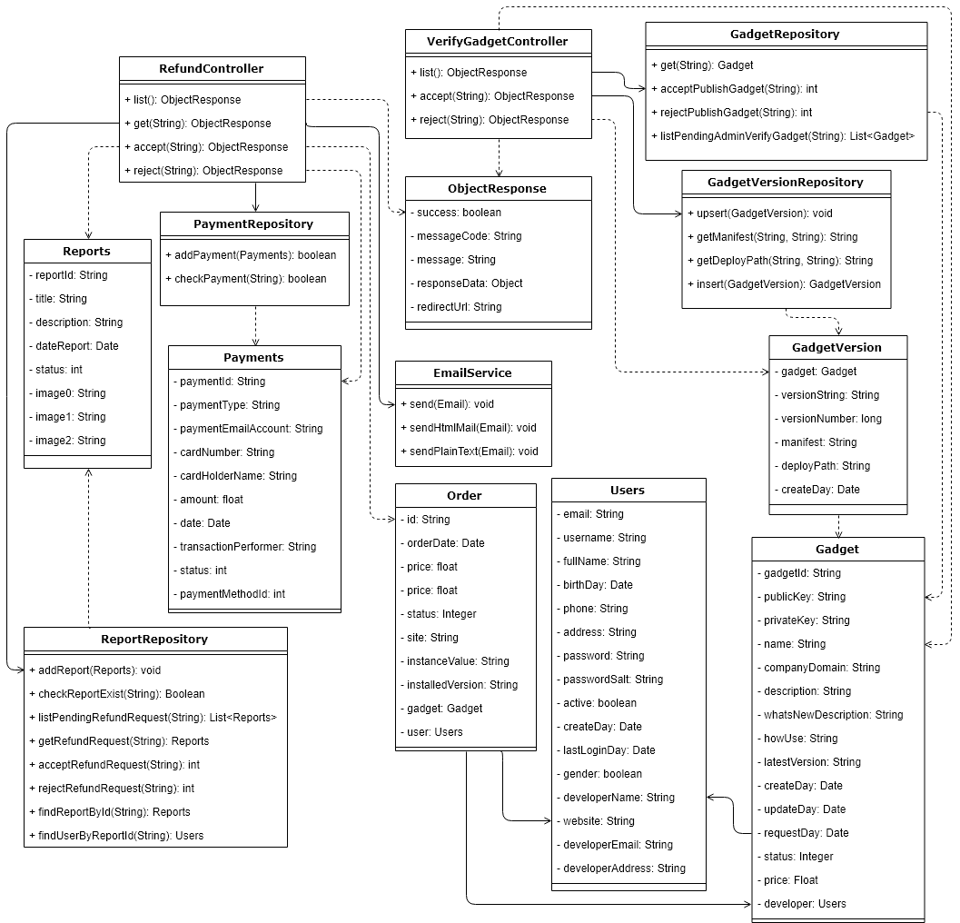

*Figure 4-7.Admin Module*

##### **Email**

|  |  |  |
| --- | --- | --- |
| Name | Email | |
| Type | Class | |
| Package | vn.com.webgad.model | |
| Field Summary | | |
| Modifier and Type | | Name |
| private java.util.List | | cc |
| private String | | from |
| private boolean | | isHtml |
| private String | | message |
| private String | | subject |
| private java.util.List | | to |
| Constructor Summary | | |
| Email() | | |
| Email(String from, String toList, String subject, String message) | | |
| Email(String from, String toList, String ccList, String subject, String message) | | |
| Method Summary | | |
| Modifier and Type | | Name |
| java.util.List | | getCc() |
| String | | getFrom() |
| String | | getMessage() |
| String | | getSubject() |
| java.util.List | | getTo() |
| String | | getToAsList() |
| boolean | | isHtml() |
| void | | setCc(java.util.List cc) |
| void | | setFrom(String from) |
| void | | setHtml(boolean isHtml) |
| void | | setMessage(String message) |
| void | | setSubject(String subject) |
| void | | setTo(java.util.List to) |
| private String[] | | splitByComma(String toMultiple) |

##### **EmailService**

|  |  |  |
| --- | --- | --- |
| Name | EmailService | |
| Type | Class | |
| Package | vn.com.webgad.service | |
| Field Summary | | |
| Modifier and Type | | Name |
| private static org.apache.log4j.Logger | | logger |
| private org.springframework.mail.javamail.JavaMailSender | | mailSender |
| Constructor Summary | | |
| EmailService() | | |
| Method Summary | | |
| Modifier and Type | | Name |
| void | | send(Email eParams) |
| private void | | sendHtmlMail(Email eParams) |
| private void | | sendPlainTextMail(Email eParams) |

##### **EmailTemplate**

|  |  |  |
| --- | --- | --- |
| Name | EmailTemplate | |
| Type | Class | |
| Package | vn.com.webgad.model | |
| Field Summary | | |
| Modifier and Type | | Name |
| private java.util.Map | | replacementParams |
| private String | | template |
| private String | | templateId |
| Constructor Summary | | |
| EmailTemplate(String templateId) | | |
| Method Summary | | |
| Modifier and Type | | Name |
| java.util.Map | | getReplacementParams() |
| String | | getTemplate() |
| String | | getTemplate(java.util.Map replacements) |
| String | | getTemplateId() |
| private String | | loadTemplate(String templateId) |
| void | | setReplacementParams(java.util.Map replacementParams) |
| void | | setTemplate(String template) |
| void | | setTemplateId(String templateId) |

##### **Gadget**

|  |  |  |
| --- | --- | --- |
| Name | Gadget | |
| Type | Class | |
| Package | vn.com.webgad.entity | |
| Field Summary | | |
| Modifier and Type | | Name |
| private String | | avatarImage |
| private String | | bannerImage0 |
| private String | | bannerImage1 |
| private String | | bannerImage2 |
| private String | | bannerImage3 |
| private String | | bannerImage4 |
| private String | | bannerImage5 |
| private String | | bannerImage6 |
| private String | | bannerImage7 |
| private String | | bannerImage8 |
| private String | | bannerImage9 |
| private Category | | category |
| private java.util.List | | comments |
| private String | | companyDomain |
| private java.util.Date | | createDay |
| private String | | description |
| private Users | | developer |
| private String | | gadgetId |
| private String | | howUse |
| private Long | | installCount |
| private String | | latestVersion |
| private String | | name |
| private Integer | | numberOfRating |
| private java.util.List | | orders |
| private Float | | price |
| private String | | privateKey |
| private String | | publicKey |
| private Double | | ratingScore |
| private java.util.Date | | requestDay |
| private static long | | serialVersionUID |
| private Float | | size |
| private Integer | | status |
| private Long | | totalRating |
| private java.util.Date | | updateDay |
| private String | | whatsNewDescription |
| Constructor Summary | | |
| Gadget() | | |
| Gadget(String name) | | |
| Gadget(String gadgetId, Integer status) | | |
| Gadget(String id, String howUse) | | |
| Gadget(String id, String name, Float price, String email, String userName, String avatarImage, Double ratingScore) | | |
| Gadget(String id, String name, Float price, String email, String userName, String avatarImage, Double ratingScore, String developerName) | | |
| Gadget(String gadgetId, String name, String latestVersion, Integer status) | | |
| Gadget(String id, String name, String description, String whatsNewDescription, Float price, String avatarImage, String bannerImage0, String bannerImage1, String bannerImage2, String bannerImage3, String bannerImage4, String bannerImage5, String bannerImage6, String bannerImage7, String bannerImage8, String bannerImage9, String email, String userName, Double ratingScore, long totalRating, java.util.Date updateDay, Float size, Long installCount, String latestVersion, String developerName, String developerWebsite, String developerEmail, String developerAddress) | | |
| Gadget(String id, String name, String howUse, String version, Integer status, java.util.Date createDay, java.util.Date updateDay, Float size, Float price) | | |
| Gadget(String gadgetId, String name, String avatarImageUrl, String latestVersion, Integer status, Users developer, java.util.Date requestDay, Float price) | | |
| Method Summary | | |
| Modifier and Type | | Name |
| String | | getAvatarImage() |
| String | | getBannerImage0() |
| String | | getBannerImage1() |
| String | | getBannerImage2() |
| String | | getBannerImage3() |
| String | | getBannerImage4() |
| String | | getBannerImage5() |
| String | | getBannerImage6() |
| String | | getBannerImage7() |
| String | | getBannerImage8() |
| String | | getBannerImage9() |
| String | | getBannerImageUrl(int position) |
| Category | | getCategory() |
| String | | getCompanyDomain() |
| java.util.Date | | getCreateDay() |
| String | | getDescription() |
| Users | | getDeveloper() |
| String | | getGadgetId() |
| String | | getHowUse() |
| Long | | getInstallCount() |
| String | | getLatestVersion() |
| String | | getName() |
| int | | getNumberOfRating() |
| java.util.List | | getOrders() |
| Float | | getPrice() |
| String | | getPrivateKey() |
| String | | getPublicKey() |
| Double | | getRatingScore() |
| java.util.Date | | getRequestDay() |
| Float | | getSize() |
| Integer | | getStatus() |
| Long | | getTotalRating() |
| java.util.Date | | getUpdateDay() |
| String | | getWhatsNewDescription() |
| void | | setAvatarImage(String avatarImageUrl) |
| void | | setBannerImage0(String bannerImage0Url) |
| void | | setBannerImage1(String bannerImage1Url) |
| void | | setBannerImage2(String bannerImage2Url) |
| void | | setBannerImage3(String bannerImage3Url) |
| void | | setBannerImage4(String bannerImage4Url) |
| void | | setBannerImage5(String bannerImage5Url) |
| void | | setBannerImage6(String bannerImage6Url) |
| void | | setBannerImage7(String bannerImage7Url) |
| void | | setBannerImage8(String bannerImage8Url) |
| void | | setBannerImage9(String bannerImage9Url) |
| void | | setBannerImageUrl(int position, String imageUrl) |
| void | | setCategory(Category category) |
| void | | setCompanyDomain(String companyDomain) |
| void | | setCreateDay(java.util.Date createDay) |
| void | | setDescription(String description) |
| void | | setDeveloper(Users developer) |
| void | | setGadgetId(String gadgetId) |
| void | | setHowUse(String howUse) |
| void | | setInstallCount(Long installCount) |
| void | | setLatestVersion(String latestVersion) |
| void | | setName(String name) |
| void | | setNumberOfRating(Integer numberOfRating) |
| void | | setOrders(java.util.List orders) |
| void | | setPrice(Float price) |
| void | | setPrivateKey(String privateKey) |
| void | | setPublicKey(String publicKey) |
| void | | setRatingScore(Double ratingScore) |
| void | | setRequestDay(java.util.Date requestDay) |
| void | | setSize(Float size) |
| void | | setStatus(Integer status) |
| void | | setTotalRating(Long totalRating) |
| void | | setUpdateDay(java.util.Date updateDay) |
| void | | setWhatsNewDescription(String whatsNewDescription) |

##### **GadgetRepository**

|  |  |  |
| --- | --- | --- |
| Name | GadgetRepository | |
| Type | Class | |
| Package | vn.com.webgad.repository | |
| Field Summary | | |
| Modifier and Type | | Name |
| private static org.apache.log4j.Logger | | logger |
| private org.hibernate.SessionFactory | | sessionFactory |
| Constructor Summary | | |
| GadgetRepository() | | |
| Method Summary | | |
| Modifier and Type | | Name |
| int | | acceptPublishGadget(String gadgetId) |
| Gadget | | checkUserPermission(String email, String publicKey, String privateKey, String gadgetId) |
| Long | | countGadgetByCategory(Long categoryID) Count gadget by category id |
| Long | | countGadgetByTopInstall() Count gadget by top install |
| Long | | countGadgetInstallByUser(String email) |
| Long | | countGadgetOfferedByDeveloper(String developerEmail) |
| Long | | countGadgetOnTrending() Count gadget on trending |
| Long | | countLatestGadget() Get total gadget record by latest gadgets |
| Long | | countUserAlsoInstallGadget(String gadgetId) Count gadget by top install |
| Gadget | | deleteGadgetById(String devMail, String id) |
| boolean | | deleteGagetById(Gadget g) |
| boolean | | editGadget(Gadget g) |
| java.util.List | | findGadgetByEmail(String email, int firstResult, int maxResults) |
| Gadget | | findGadgetById(String id) |
| Gadget | | get(String id) |
| long | | getCountGadgetByEmail(String email) |
| java.util.List | | getGadgetByCategory(Long categoryID, int startPosition, int maxResult) Get all gadget by category id |
| Gadget | | getGadgetByGadgetId(String gadgetId) |
| Gadget | | getGadgetByID(String gadgetID) Get gadget by id Used in store/detail.html |
| java.util.List | | getGadgetByTopInstall(int startPosition, int maxResult) Get gadget by top install |
| java.util.List | | getGadgetInstallByUser(String email, int firstResult, int maxResults) |
| java.util.List | | getGadgetOfferedByDeveloper(String email, int firstResult, int maxResults) |
| java.util.List | | getGadgetOnTrending(int startPosition, int maxResult) Get gadget on trending |
| Float | | getGadgetPrice(String gadgetID) Get gadget price by id |
| Gadget | | getHowUseByGadgetID(String gadgetID) Get how use of a gadget by id (install gadget) |
| java.util.List | | getLatestGadget(int startPosition, int maxResult) Get latest gadgets |
| Gadget | | getPublishedGadget(String gadgetID) Get gadget by id |
| java.util.List | | getSimilarGadget() Deprecated. |
| java.util.List | | getUserAlsoInstallGadget(String gadgetId, int firstResult, int maxResults) Get user also install gadget |
| java.util.List | | getUserByGadget(String gadgetID) List user's installed gadgets by gadget id |
| Gadget | | getUserGadget(String devMail, String gadgetId) |
| boolean | | insertGadget(Gadget g) |
| java.util.List | | list(String email) |
| java.util.List | | listPendingAdminVerifyGadgets() List gadgets which is pending to publish (admin function) |
| int | | rejectPublishGadget(String gadgetId) |
| Gadget | | update(String devMail, Gadget newGadget) |
| int | | updateGadgetStatus(String devMail, String gadgetId, int status) |
| Gadget | | updateStatus(String devMail, String gadgetId, int status) |

##### **GadgetService**

|  |  |  |
| --- | --- | --- |
| Name | GadgetService | |
| Type | Class | |
| Package | vn.com.webgad.service | |
| Field Summary | | |
| Modifier and Type | | Name |
| private CommentRepository | | commentRepository |
| private GadgetRepository | | gadgetRepository |
| private OrderRepository | | orderRepository |
| Constructor Summary | | |
| GadgetService() | | |
| Method Summary | | |
| Modifier and Type | | Name |
| boolean | | addGadget(Gadget g) |
| Long | | countCommentByGadgetID(String gadgetID) |
| Long | | countGadgetInstallByUser(String email) |
| Long | | countGadgetOfferedByDeveloper(String developerEmail) |
| Long | | countUserAlsoInstallGadget(String gadgetId) |
| boolean | | editGadget(Gadget g) |
| java.util.List | | getCommentByGadgetID(String gadgetID, int startIndex, int numberOfRecord) |
| long | | getCountGadgetByEamil(String email) |
| java.util.List | | getGadgetByCategory(Long categoryID, int startPosition, int maxResult) |
| java.util.List | | getGadgetByEmail(String email, int firstResult, int maxResults) |
| Gadget | | getGadgetByGadgetId(String gadgetId) |
| Gadget | | getGadgetById(String id) |
| Gadget | | getGadgetByID(String gadgetID) |
| java.util.List | | getGadgetByTopInstall(int startPosition, int maxResult) |
| java.util.List | | getGadgetInstallByUser(String email, int firstResult, int maxResults) |
| java.util.List | | getGadgetOfferedByDeveloper(String email, int firstResult, int maxResults) |
| java.util.List | | getGadgetOnTrending(int startPosition, int maxResult) |
| Float | | getGadgetPrice(String gadgetID) |
| Gadget | | getHowUseByGadgetID(String gadgetID) |
| java.util.List | | getLatestGadget(int startPosition, int maxResult) |
| Gadget | | getPublishedGadget(String gadgetID) |
| java.util.List | | getRatingByGadgetID(String gadgetID) |
| java.util.List | | getSimilarGadget() |
| Long | | getTotalLatestGadget() |
| Long | | getTotalRecordByCategoryID(Long categoryID) |
| Long | | getTotalRecordByOnTrendingGadget() |
| Long | | getTotalRecordGadgetByTopInstall() |
| java.util.List | | getUserAlsoInstallGadget(String gadgetId, int firstResult, int maxResults) |
| java.util.List | | getUserByGadget(String gadgetID) |
| boolean | | removeGadget(Gadget g) |
| boolean | | saveComment(Comment comment, String email) |
| boolean | | saveOrder(Order order, String email) |
| boolean | | updateRatingScore(float rating, String email) |

##### **GadgetVersion**

|  |  |  |
| --- | --- | --- |
| Name | GadgetVersion | |
| Type | Class | |
| Package | vn.com.webgad.entity | |
| Field Summary | | |
| Modifier and Type | | Name |
| private java.util.Date | | createDay |
| static String | | DEPLOY_VERSION |
| private String | | deployPath |
| private Gadget | | gadget |
| private String | | manifest |
| private static long | | serialVersionUID |
| private long | | versionNumber |
| private String | | versionString |
| Constructor Summary | | |
| GadgetVersion() | | |
| GadgetVersion(Gadget gadget, String versionString, long versionNumber, String manifest, java.util.Date createDay) | | |
| Method Summary | | |
| Modifier and Type | | Name |
| java.util.Date | | getCreateDay() |
| String | | getDeployPath() |
| Gadget | | getGadget() |
| String | | getManifest() |
| long | | getVersionNumber() |
| String | | getVersionString() |
| void | | setCreateDay(java.util.Date createDay) |
| void | | setDeployPath(String deployPath) |
| void | | setGadget(Gadget gadget) |
| void | | setManifest(String manifest) |
| void | | setVersionNumber(long versionNumber) |
| void | | setVersionString(String versionString) |

##### **GadgetVersionRepository**

|  |  |  |
| --- | --- | --- |
| Name | GadgetVersionRepository | |
| Type | Class | |
| Package | vn.com.webgad.repository | |
| Field Summary | | |
| Modifier and Type | | Name |
| private org.hibernate.SessionFactory | | sessionFactory |
| Constructor Summary | | |
| GadgetVersionRepository() | | |
| Method Summary | | |
| Modifier and Type | | Name |
| String | | getDeployPath(String gadgetId, String versionString) |
| String | | getManifest(String gadgetId, String versionString) |
| GadgetVersion | | insert(GadgetVersion g) |
| void | | upsert(GadgetVersion g) |

##### **ObjectResponse**

|  |  |  |
| --- | --- | --- |
| Name | ObjectResponse | |
| Type | Class | |
| Package | vn.com.webgad.model | |
| Field Summary | | |
| Modifier and Type | | Name |
| private int | | code |
| private String | | errorMessageCode |
| private String | | errorMessages |
| private String | | messageCode |
| private String | | messages |
| private String | | redirectUrl |
| private Object | | responseData |
| private static long | | serialVersionUID |
| private boolean | | success |
| private int | | total |
| Constructor Summary | | |
| ObjectResponse() | | |
| Method Summary | | |
| Modifier and Type | | Name |
| Int | | getCode() |
| String | | getErrorMessageCode() |
| String | | getErrorMessages() |
| String | | getMessageCode() |
| String | | getMessages() |
| String | | getRedirectUrl() |
| Object | | getResponseData() |
| Int | | getTotal() |
| boolean | | isSuccess() |
| Void | | setCode(int code) |
| Void | | setErrorMessageCode(String errorMessageCode) |
| Void | | setErrorMessages(String errorMessages) |
| Void | | setMessageCode(String messageCode) |
| Void | | setMessages(String messages) |
| Void | | setRedirectUrl(String redirectUrl) |
| Void | | setResponseData(Object responseData) |
| Void | | setSuccess(boolean success) |
| Void | | setTotal(int total) |

##### **Order**

|  |  |  |
| --- | --- | --- |
| Name | Order | |
| Type | Class | |
| Package | vn.com.webgad.entity | |
| Field Summary | | |
| Modifier and Type | | Name |
| private Gadget | | gadget |
| private String | | id |
| private String | | installedVersion |
| private String | | instanceValue |
| private java.util.Date | | orderDate |
| private java.util.List | | paymentList |
| private float | | price |
| private static long | | serialVersionUID |
| private String | | site |
| private Integer | | status |
| private Users | | user |
| Constructor Summary | | |
| Order() | | |
| Order(String id, Float price, Integer status, java.util.Date orderDate, String userEmail, String userFullname, String gadgetId, String gadgetName, String gadgetAvatarImage, String gadgetDeveloperName) | | |
| Method Summary | | |
| Modifier and Type | | Name |
| Gadget | | getGadget() |
| String | | getId() |
| String | | getInstalledVersion() |
| String | | getInstanceValue() |
| java.util.Date | | getOrderDate() |
| java.util.List | | getPaymentList() |
| float | | getPrice() |
| String | | getSite() |
| Integer | | getStatus() |
| Users | | getUser() |
| void | | setGadget(Gadget gadget) |
| void | | setId(String id) |
| void | | setInstalledVersion(String installedVersion) |
| void | | setInstanceValue(String instanceValue) |
| void | | setOrderDate(java.util.Date orderDate) |
| void | | setPaymentList(java.util.List paymentList) |
| void | | setPrice(float price) |
| void | | setSite(String site) |
| void | | setStatus(Integer status) |
| void | | setUser(Users user) |

##### **PaymentMethod**

|  |  |  |
| --- | --- | --- |
| Name | PaymentMethod | |
| Type | Class | |
| Package | vn.com.webgad.entity | |
| Field Summary | | |
| Modifier and Type | | Name |
| private String | | id |
| private String | | name |
| static String | | PAYPAL |
| Constructor Summary | | |
| PaymentMethod() | | |
| Method Summary | | |
| Modifier and Type | | Name |
| String | | getId() |
| String | | getName() |
| void | | setId(String id) |
| void | | setName(String name) |

##### **Payments**

|  |  |  |
| --- | --- | --- |
| Name | Payments | |
| Type | Class | |
| Package | vn.com.webgad.entity | |
| Field Summary | | |
| Modifier and Type | | Name |
| private float | | amount |
| private String | | cardHolderName |
| private String | | cardNumber |
| private java.util.Date | | date |
| private Order | | order |
| static String | | PAYMENT_TYPE_PAY_DEVELOPER |
| static String | | PAYMENT_TYPE_REFUND |
| private String | | paymentEmailAccount |
| private String | | paymentId |
| private String | | paymentMethodId |
| private String | | paymentType |
| private int | | status |
| private String | | transactionPerformer |
| private Users | | user |
| Constructor Summary | | |
| Payments() | | |
| Payments(String paymentId, String id) | | |
| Method Summary | | |
| Modifier and Type | | Name |
| float | | getAmount() |
| String | | getCardHolderName() |
| String | | getCardNumber() |
| java.util.Date | | getDate() |
| Order | | getOrder() |
| String | | getPaymentEmailAccount() |
| String | | getPaymentId() |
| String | | getPaymentMethodId() |
| String | | getPaymentType() |
| int | | getStatus() |
| String | | getTransactionPerformer() |
| Users | | getUser() |
| void | | setAmount(float amount) |
| void | | setCardHolderName(String cardHolderName) |
| void | | setCardNumber(String cardNumber) |
| void | | setDate(java.util.Date date) |
| void | | setOrder(Order order) |
| void | | setPaymentEmailAccount(String paymentEmailAccount) |
| void | | setPaymentId(String paymentId) |
| void | | setPaymentMethodId(String paymentMethodId) |
| void | | setPaymentType(String paymentType) |
| void | | setStatus(int status) |
| void | | setTransactionPerformer(String transactionPerformer) |
| void | | setUser(Users user) |

##### **PaymentsRepository**

|  |  |  |
| --- | --- | --- |
| Name | PaymentsRepository | |
| Type | Class | |
| Package | vn.com.webgad.repository | |
| Field Summary | | |
| Modifier and Type | | Name |
| private static org.apache.log4j.Logger | | logger |
| private org.hibernate.SessionFactory | | sessionFactory |
| Constructor Summary | | |
| PaymentsRepository() | | |
| Method Summary | | |
| Modifier and Type | | Name |
| boolean | | addPayment(Payments p) |
| boolean | | checkPayment(String orderId) |

##### **PaymentsService**

|  |  |  |
| --- | --- | --- |
| Name | PaymentsService | |
| Type | Class | |
| Package | vn.com.webgad.service | |
| Field Summary | | |
| Modifier and Type | | Name |
| private PaymentsRepository | | paymentsRepository |
| Constructor Summary | | |
| PaymentsService() | | |
| Method Summary | | |
| Modifier and Type | | Name |
| boolean | | addPayment(Payments p) |
| boolean | | checkPayment(String orderId) |

##### **RefundController**

|  |  |  |
| --- | --- | --- |
| Name | RefundController | |
| Type | Class | |
| Package | vn.com.webgad.admin.controller | |
| Field Summary | | |
| Modifier and Type | | Name |
| private EmailService | | emailService |
| private static org.apache.log4j.Logger | | logger |
| private MongoRepository | | mongoRepository |
| private OrderRepository | | orderRepository |
| private PaymentsService | | paymentService |
| private ReportRepository | | reportRepository |
| Constructor Summary | | |
| RefundController() | | |
| Method Summary | | |
| Modifier and Type | | Name |
| ObjectResponse | | accept(String id, javax.servlet.http.HttpServletRequest request) |
| ObjectResponse | | get(String id, javax.servlet.http.HttpServletRequest request) |
| ObjectResponse | | list(javax.servlet.http.HttpServletRequest request) |
| ObjectResponse | | reject(String id, String body, javax.servlet.http.HttpServletRequest request) |
| private void | | sendEmailAccept(Users u) |
| private void | | sendEmailReject(Users u, String reason) |

##### **ReportRepository**

|  |  |  |
| --- | --- | --- |
| Name | ReportRepository | |
| Type | Class | |
| Package | vn.com.webgad.repository | |
| Field Summary | | |
| Modifier and Type | | Name |
| private org.hibernate.SessionFactory | | sessionFactory |
| Constructor Summary | | |
| ReportRepository() | | |
| Method Summary | | |
| Modifier and Type | | Name |
| int | | acceptRefundRequest(String reportId) |
| void | | addReport(Reports r) |
| Boolean | | checkReportExist(String orderId) |
| Reports | | findReportById(String reportId) |
| Users | | findUserByReportId(String reportId) |
| Reports | | getRefundRequest(String id) List gadgets which is pending to publish (admin function) |
| java.util.List | | listPendingRefundRequest() List gadgets which is pending to publish (admin function) |
| int | | rejectRefundRequest(String reportId) |

##### **Reports**

|  |  |  |
| --- | --- | --- |
| Name | Reports | |
| Type | Class | |
| Package | vn.com.webgad.entity | |
| Field Summary | | |
| Modifier and Type | | Name |
| private java.util.Date | | dateReport |
| private String | | description |
| private String | | image0 |
| private String | | image1 |
| private String | | image2 |
| private Order | | order |
| private String | | reportId |
| private static long | | serialVersionUID |
| private int | | status |
| private String | | title |
| Constructor Summary | | |
| Reports() | | |
| Reports(String reportId, int status) | | |
| Method Summary | | |
| Modifier and Type | | Name |
| java.util.Date | | getDateReport() |
| String | | getDescription() |
| String | | getImage0() |
| String | | getImage1() |
| String | | getImage2() |
| Order | | getOrder() |
| String | | getReportId() |
| int | | getStatus() |
| String | | getTitle() |
| void | | setDateReport(java.util.Date dateReport) |
| void | | setDescription(String description) |
| void | | setImage0(String image0) |
| void | | setImage1(String image1) |
| void | | setImage2(String image2) |
| void | | setOrder(Order order) |
| void | | setReportId(String reportId) |
| void | | setStatus(int status) |
| void | | setTitle(String title) |

##### **ReportService**

|  |  |  |
| --- | --- | --- |
| Name | ReportService | |
| Type | Class | |
| Package | vn.com.webgad.service | |
| Field Summary | | |
| Modifier and Type | | Name |
| private ReportRepository | | reportRepository |
| Constructor Summary | | |
| ReportService() | | |
| Method Summary | | |
| Modifier and Type | | Name |
| void | | addReport(Reports r) |
| boolean | | checkReportExist(String orderId) |
| Reports | | getReportByReportId(String reportId) |

##### **Users**

|  |  |  |
| --- | --- | --- |
| Name | Users | |
| Type | Class | |
| Package | vn.com.webgad.entity | |
| Field Summary | | |
| Modifier and Type | | Name |
| private boolean | | active |
| private String | | address |
| private java.util.Date | | birthDay |
| private java.util.Date | | createDay |
| private String | | developerAddress |
| private String | | developerEmail |
| private String | | developerName |
| private String | | email |
| private String | | fullName |
| private java.util.List | | gadgetList |
| private boolean | | gender |
| private java.util.Date | | lastLoginDay |
| private String | | password |
| private String | | passwordSalt |
| private String | | paymentMethodId |
| private String | | phone |
| private static long | | serialVersionUID |
| private String | | username |
| private java.util.List | | userPaymentDetailList |
| private java.util.List | | userRoleList |
| private String | | website |
| Constructor Summary | | |
| Users() | | |
| Users(String email, String userName) | | |
| Users(String email, String userName, String fullname) | | |
| Users(String email, String userName, String fullname, String paymentMethodId) | | |
| Method Summary | | |
| Modifier and Type | | Name |
| String | | getAddress() |
| java.util.Date | | getBirthDay() |
| java.util.Date | | getCreateDay() |
| String | | getDeveloperAddress() |
| String | | getDeveloperEmail() |
| String | | getDeveloperName() |
| String | | getEmail() |
| String | | getFullName() |
| java.util.List | | getGadgetList() |
| java.util.Date | | getLastLoginDay() |
| String | | getPassword() |
| String | | getPasswordSalt() |
| String | | getPaymentMethodId() |
| String | | getPhone() |
| String | | getUsername() |
| java.util.List | | getUserPaymentDetailList() |
| java.util.List | | getUserRoleList() |
| String | | getWebsite() |
| boolean | | isActive() |
| boolean | | isGender() |
| void | | setActive(boolean active) |
| void | | setAddress(String address) |
| void | | setBirthDay(java.util.Date birthDay) |
| void | | setCreateDay(java.util.Date createDay) |
| void | | setDeveloperAddress(String developerAddress) |
| void | | setDeveloperEmail(String developerEmail) |
| void | | setDeveloperName(String developerName) |
| void | | setEmail(String email) |
| void | | setFullName(String fullName) |
| void | | setGadgetList(java.util.List gadgetList) |
| void | | setGender(boolean gender) |
| void | | setLastLoginDay(java.util.Date lastLoginDay) |
| void | | setPassword(String password) |
| void | | setPasswordSalt(String passwordSalt) |
| void | | setPaymentMethodId(String paymentMethodId) |
| void | | setPhone(String phone) |
| void | | setUsername(String username) |
| void | | setUserPaymentDetailList(java.util.List userPaymentDetailList) |
| void | | setUserRoleList(java.util.List userRoleList) |
| void | | setWebsite(String website) |

##### **VerifyGadgetController**

|  |  |  |
| --- | --- | --- |
| Name | VerifyGadgetController | |
| Type | Class | |
| Package | vn.com.webgad.admin.controller | |
| Field Summary | | |
| Modifier and Type | | Name |
| private GadgetRepository | | gadgetRepository |
| private GadgetVersionRepository | | gadgetVersionRepository |
| Constructor Summary | | |
| VerifyGadgetController() | | |
| Method Summary | | |
| Modifier and Type | | Name |
| ObjectResponse | | accept(String id, javax.servlet.http.HttpServletRequest request) |
| ObjectResponse | | list(javax.servlet.http.HttpServletRequest request) |
| ObjectResponse | | reject(String id, String body, javax.servlet.http.HttpServletRequest request) |

#### Store Module

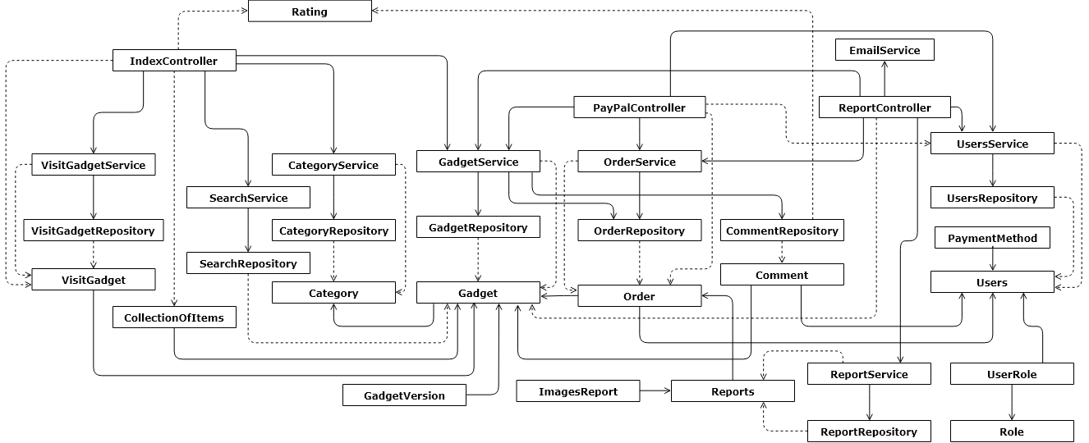

*Figure 4-8.Store Module*

##### **Category**

|  |  |  |
| --- | --- | --- |
| Name | Category | |
| Type | Class | |
| Package | vn.com.webgad.store.entity | |
| Field Summary | | |
| Modifier and Type | | Name |
| private String | | description |
| private int | | id |
| private java.util.List | | items |
| private String | | name |
| Constructor Summary | | |
| Category() | | |
| Method Summary | | |
| Modifier and Type | | Name |
| String | | getDescription() |
| int | | getId() |
| java.util.List | | getItems() |
| String | | getName() |
| void | | setDescription(String description) |
| void | | setId(int id) |
| void | | setItems(java.util.List items) |
| void | | setName(String name) |

##### **CategoryRepository**

|  |  |  |
| --- | --- | --- |
| Name | CategoryRepository | |
| Type | Class | |
| Package | vn.com.webgad.store.repository | |
| Field Summary | | |
| Modifier and Type | | Name |
| private org.hibernate.SessionFactory | | sessionFactory |
| Constructor Summary | | |
| CategoryRepository() | | |
| Method Summary | | |
| Modifier and Type | | Name |
| java.util.List | | getAllCategory() Get all category |
| Category | | getCategoryByID(int id) Get category by id |

##### **CategoryService**

|  |  |  |
| --- | --- | --- |
| Name | CategoryService | |
| Type | Class | |
| Package | vn.com.webgad.store.service | |
| Field Summary | | |
| Modifier and Type | | Name |
| (package private) CategoryRepository | | categoryRepository |
| Constructor Summary | | |
| CategoryService() | | |
| Method Summary | | |
| Modifier and Type | | Name |
| java.util.List | | getAllCategory() |
| Category | | getCategoryByID(int categoryID) |

##### **CollectionOfItems**

|  |  |  |
| --- | --- | --- |
| Name | CollectionOfItems | |
| Type | Class | |
| Package | vn.com.webgad.store.entity | |
| Field Summary | | |
| Modifier and Type | | Name |
| private String | | description |
| private String | | id |
| private java.util.List | | items |
| private String | | name |
| private boolean | | showing |
| private boolean | | showPaging |
| Constructor Summary | | |
| CollectionOfItems() | | |
| CollectionOfItems(String id, boolean showing, boolean showPaging, String name, String description, java.util.List items) | | |
| Method Summary | | |
| Modifier and Type | | Name |
| String | | getDescription() |
| String | | getId() |
| java.util.List | | getItems() |
| String | | getName() |
| boolean | | isShowing() |
| boolean | | isShowPaging() |
| void | | setDescription(String description) |
| void | | setId(String id) |
| void | | setItems(java.util.List items) |
| void | | setName(String name) |
| void | | setShowing(boolean showing) |
| void | | setShowPaging(boolean showPaging) |

##### **Comment**

|  |  |  |
| --- | --- | --- |
| Name | Comment | |
| Type | Class | |
| Package | vn.com.webgad.store.entity | |
| Field Summary | | |
| Modifier and Type | | Name |
| private String | | content |
| private String | | createDate |
| private Gadget | | gadget |
| private int | | id |
| private int | | rating |
| private String | | title |
| private Users | | user |
| Constructor Summary | | |
| Comment() | | |
| Comment(int id, String title, String content, int rating, String createDate, String email, String userName) | | |
| Method Summary | | |
| Modifier and Type | | Name |
| String | | getContent() |
| String | | getCreateDate() |
| Gadget | | getGadget() |
| int | | getId() |
| int | | getRating() |
| String | | getTitle() |
| Users | | getUser() |
| void | | setContent(String content) |
| void | | setCreateDate(String createDate) |
| void | | setGadget(Gadget gadget) |
| void | | setId(int id) |
| void | | setRating(int rating) |
| void | | setTitle(String title) |
| void | | setUser(Users user) |

##### **CommentRepository**

|  |  |  |
| --- | --- | --- |
| Name | CommentRepository | |
| Type | Class | |
| Package | vn.com.webgad.store.repository | |
| Field Summary | | |
| Modifier and Type | | Name |
| private org.hibernate.SessionFactory | | sessionFactory |
| Constructor Summary | | |
| CommentRepository() | | |
| Method Summary | | |
| Modifier and Type | | Name |
| java.util.List | | getCommentByGadgetID(String gadgetID, int startIndex, int numberOfRecord) Get comments of gadget by gadgetID |
| int | | getGadgetRatingScore(String gadgetID) Get rating score of a gadget by its id |
| java.util.List | | getRatingByGadgetID(String gadgetID) Get rating statistics |
| boolean | | saveComment(Comment comment, String email) Add a Comment |
| boolean | | updateRatingScore(float rating, String email) Update rating score for a Comment |

##### **Gadget**

|  |  |  |
| --- | --- | --- |
| Name | Gadget | |
| Type | Class | |
| Package | vn.com.webgad.store.entity | |
| Field Summary | | |
| Modifier and Type | | Name |
| private String | | avatarImage |
| private String | | bannerImage0 |
| private String | | bannerImage1 |
| private String | | bannerImage2 |
| private String | | bannerImage3 |
| private String | | bannerImage4 |
| private String | | bannerImage5 |
| private String | | bannerImage6 |
| private String | | bannerImage7 |
| private String | | bannerImage8 |
| private String | | bannerImage9 |
| private Category | | category |
| private java.util.List | | comments |
| private String | | createDay |
| private String | | description |
| private String | | howUse |
| private String | | id |
| private String | | name |
| private int | | numberOfRating |
| private java.util.List | | orders |
| private float | | price |
| private double | | ratingScore |
| private float | | size |
| private int | | status |
| private int | | totalRating |
| private String | | updateDay |
| private Users | | user |
| private String | | version |
| private java.util.List | | versions |
| private String | | whatsNewDescription |
| Constructor Summary | | |
| Gadget() | | |
| Gadget(String name) | | |
| Gadget(String id, String howUse) | | |
| Gadget(String id, String name, float price, String email, String userName, String avatarImage, double ratingScore) | | |
| Gadget(String id, String name, String description, String whatsNewDescription, float price, String avatarImage, String bannerImage0, String bannerImage1, String bannerImage2, String bannerImage3, String bannerImage4, String bannerImage5, String bannerImage6, String bannerImage7, String bannerImage8, String bannerImage9, String email, String userName, double ratingScore, long totalRating) | | |
| Method Summary | | |
| Modifier and Type | | Name |
| String | | getAvatarImage() |
| String | | getBannerImage0() |
| String | | getBannerImage1() |
| String | | getBannerImage2() |
| String | | getBannerImage3() |
| String | | getBannerImage4() |
| String | | getBannerImage5() |
| String | | getBannerImage6() |
| String | | getBannerImage7() |
| String | | getBannerImage8() |
| String | | getBannerImage9() |
| Category | | getCategory() |
| java.util.List | | getComments() |
| String | | getCreateDay() |
| String | | getDescription() |
| String | | getHowUse() |
| String | | getId() |
| String | | getName() |
| int | | getNumberOfRating() |
| java.util.List | | getOrders() |
| float | | getPrice() |
| double | | getRatingScore() |
| float | | getSize() |
| int | | getStatus() |
| int | | getTotalRating() |
| String | | getUpdateDay() |
| Users | | getUser() |
| String | | getVersion() |
| java.util.List | | getVersions() |
| String | | getWhatsNewDescription() |
| void | | setAvatarImage(String avatarImage) |
| void | | setBannerImage0(String bannerImage0) |
| void | | setBannerImage1(String bannerImage1) |
| void | | setBannerImage2(String bannerImage2) |
| void | | setBannerImage3(String bannerImage3) |
| void | | setBannerImage4(String bannerImage4) |
| void | | setBannerImage5(String bannerImage5) |
| void | | setBannerImage6(String bannerImage6) |
| void | | setBannerImage7(String bannerImage7) |
| void | | setBannerImage8(String bannerImage8) |
| void | | setBannerImage9(String bannerImage9) |
| void | | setCategory(Category category) |
| void | | setComments(java.util.List |
| void | | setCreateDay(String createDay) |
| void | | setDescription(String description) |
| void | | setHowUse(String howUse) |
| void | | setId(String id) |
| void | | setName(String name) |
| void | | setNumberOfRating(int numberOfRating) |
| void | | setOrders(java.util.List orders) |
| void | | setPrice(float price) |
| void | | setRatingScore(double ratingScore) |
| void | | setSize(float size) |
| void | | setStatus(int status) |
| void | | setTotalRating(int totalRating) |
| void | | setUpdateDay(String updateDay) |
| void | | setUser(Users user) |
| void | | setVersion(String version) |
| void | | setVersions(java.util.List versions) |
| void | | setWhatsNewDescription(String whatsNewDescription) |

##### **GadgetRepository**

|  |  |  |
| --- | --- | --- |
| Name | GadgetRepository | |
| Type | Class | |
| Package | vn.com.webgad.store.repository | |
| Field Summary | | |
| Modifier and Type | | Name |
| private static org.apache.log4j.Logger | | logger |
| private org.hibernate.SessionFactory | | sessionFactory |
| Constructor Summary | | |
| GadgetRepository() | | |
| Method Summary | | |
| Modifier and Type | | Name |
| Long | | countGadgetByCategory(int categoryID) Get total gadget record from a category |
| long | | countGadgetInstallByUser(String email) |
| Long | | countGadgetOnTrending() Count gadget on trending |
| java.util.List | | findGadgetInstallByUser(String email, int firstResult, int maxResults) Get news on trending example |
| java.util.List | | getGadgetByCategory(int categoryID, int startPosition, int maxResult) Get all gadget from a category |
| Gadget | | getGadgetByGadgetId(String gadgetId) |
| Gadget | | getGadgetByID(String gadgetID) Get gadget by id |
| java.util.List | | getGadgetByTopInstall(int startPosition, int maxResult) Get gadget by top install |
| java.util.List | | getGadgetOnTrending(int startPosition, int maxResult) Get gadget on trending |
| Gadget | | getHowUseByGadgetID(String gadgetID) Get how use of a gadget by id (install gadget) |
| java.util.List | | getLatestGadget(int startPosition, int maxResult) Get latest gadgets |
| java.util.List | | getSimilarGadget() Get similar gadget list |
| java.util.List | | getUserByGadget(String gadgetID) List user's installed gadgets |
| Long | | totalLatestGadget() Get total gadget record by latest gadgets |
| Long | | totalRecordGadgetByTopInstall() Get total gadget record by top install |

##### **GadgetSearch**

|  |  |  |
| --- | --- | --- |
| Name | GadgetSearch | |
| Type | Class | |
| Package | vn.com.webgad.store.model | |
| Field Summary | | |
| Modifier and Type | | Name |
| private String | | avatar |
| private String | | gadgetId |
| private String | | name |
| private float | | price |
| private int | | rating |
| private String | | userName |
| Constructor Summary | | |
| GadgetSearch() | | |
| GadgetSearch(String gadgetId, String name, float price, String avatar, String userName, int rating) | | |
| Method Summary | | |
| Modifier and Type | | Name |
| String | | getAvatar() |
| String | | getGadgetId() |
| String | | getName() |
| float | | getPrice() |
| int | | getRating() |
| String | | getUserName() |
| void | | setAvatar(String avatar) |
| void | | setGadgetId(String gadgetId) |
| void | | setName(String name) |
| void | | setPrice(float price) |
| void | | setRating(int rating) |
| void | | setUserName(String userName) |

##### **GadgetService**

|  |  |  |
| --- | --- | --- |
| Name | GadgetService | |
| Type | Class | |
| Package | vn.com.webgad.store.service | |
| Field Summary | | |
| Modifier and Type | | Name |
| private CommentRepository | | commentRepository |
| private GadgetRepository | | gadgetRepository |
| private OrderRepository | | orderRepository |
| Constructor Summary | | |
| GadgetService() | | |
| Method Summary | | |
| Modifier and Type | | Name |
| long | | countGadgetInstallByUser(String email) |
| java.util.List | | getCommentByGadgetID(String gadgetID, int startIndex, int numberOfRecord) |
| java.util.List | | getGadgetByCategory(int categoryID, int startPosition, int maxResult) |
| Gadget | | getGadgetByGadgetId(String gadgetId) |
| Gadget | | getGadgetByID(String gadgetID) |
| java.util.List | | getGadgetByTopInstall(int startPosition, int maxResult) |
| java.util.List | | getGadgetInstallByUser(String email, int firstResult, int maxResults) |
| java.util.List | | getGadgetOnTrending(int startPosition, int maxResult) |
| Gadget | | getHowUseByGadgetID(String gadgetID) |
| java.util.List | | getLatestGadget(int startPosition, int maxResult) |
| java.util.List | | getRatingByGadgetID(String gadgetID) |
| java.util.List | | getSimilarGadget() |
| Long | | getTotalLatestGadget() |
| Long | | getTotalRecordByCategoryID(int categoryID) |
| Long | | getTotalRecordByOnTrendingGadget() |
| Long | | getTotalRecordGadgetByTopInstall() |
| java.util.List | | getUserByGadget(String gadgetID) |
| boolean | | saveComment(Comment comment, String email) |
| boolean | | saveOrder(Order order, String email) |
| boolean | | updateRatingScore(float rating, String email) |

##### **GadgetVersion**

|  |  |  |
| --- | --- | --- |
| Name | GadgetVersion | |
| Type | Class | |
| Package | vn.com.webgad.store.entity | |
| Field Summary | | |
| Modifier and Type | | Name |
| private String | | createDay |
| private Gadget | | gadget |
| private String | | id |
| private String | | manifest |
| private static long | | serialVersionUID |
| private int | | versionNumber |
| private String | | versionString |
| Constructor Summary | | |
| GadgetVersion() | | |
| Method Summary | | |
| Modifier and Type | | Name |
| String | | getCreateDay() |
| Gadget | | getGadget() |
| String | | getManifest() |
| int | | getVersionNumber() |
| String | | getVersionString() |
| void | | setCreateDay(String createDay) |
| void | | setGadget(Gadget gadget) |
| void | | setManifest(String manifest) |
| void | | setVersionNumber(int versionNumber) |
| void | | setVersionString(String versionString) |

##### **IndexController**

|  |  |  |
| --- | --- | --- |
| Name | IndexController | |
| Type | Class | |
| Package | vn.com.webgad.store.controller | |
| Field Summary | | |
| Modifier and Type | | Name |
| private CategoryService | | categoryService |
| private GadgetService | | gadgetService |
| private static org.apache.log4j.Logger | | logger |
| private SearchService | | searchService |
| Constructor Summary | | |
| IndexController() | | |
| Method Summary | | |
| Modifier and Type | | Name |
| ObjectRespone | | getAll() Get all category controller method |
| ObjectRespone | | getGadgetByCategory(int categoryID, int page, int record) Get gadget by category controller method |
| ObjectRespone | | getGadgetByID(String gadgetID) Get gadget by id controller method |
| ObjectRespone | | getGadgetByTopInstall(int page, int record) Get gadget by top install controller method |
| ObjectRespone | | getGadgetOnTrending(int page, int record) Get gadget on trending controller method |
| ObjectRespone | | getInstallByUser(String email, int page, int size) |
| ObjectRespone | | getLatestGadget(int page, int record) Get latest gadget controller method |
| ObjectRespone | | getSimiliarGadget(int page, int record) Get similar gadget controller method |
| ObjectRespone | | getUserByGadget(String gadgetID) Get user list by gadget id controller method |
| ObjectRespone | | installGadget(String params) Install a gadget controller method |
| ObjectRespone | | loadIndexData() Load index data controller method |
| ObjectRespone | | saveComment() Add a comment controller method |
| ObjectRespone | | saveOrder() Add a order controller method |
| ObjectRespone | | search(String search, int page, int size) |
| ObjectRespone | | updateRatingScore() Update rating score controller method |

##### **ObjectRespone**

|  |  |  |
| --- | --- | --- |
| Name | ObjectRespone | |
| Type | Class | |
| Package | vn.com.webgad.store.model | |
| Field Summary | | |
| Modifier and Type | | Name |
| private int | | code |
| private String | | errorMessages |
| private String | | messages |
| private String | | redirectUrl |
| private Object | | responseData |
| private static long | | serialVersionUID |
| private boolean | | success |
| private int | | total |
| Constructor Summary | | |
| ObjectRespone() | | |
| Method Summary | | |
| Modifier and Type | | Name |
| int | | getCode() |
| String | | getErrorMessages() |
| String | | getMessages() |
| String | | getRedirectUrl() |
| Object | | getResponseData() |
| int | | getTotal() |
| boolean | | isSuccess() |
| void | | setCode(int code) |
| void | | setErrorMessages(String errorMessages) |
| void | | setMessages(String messages) |
| void | | setRedirectUrl(String redirectUrl) |
| void | | setResponseData(Object responseData) |
| void | | setSuccess(boolean success) |
| void | | setTotal(int total) |

##### **Order**

|  |  |  |
| --- | --- | --- |
| Name | Order | |
| Type | Class | |
| Package | vn.com.webgad.store.entity | |
| Field Summary | | |
| Modifier and Type | | Name |
| private Gadget | | gadget |
| private String | | id |
| private java.util.Date | | orderDate |
| private PaymentDeveloper | | paymentDeveloper |
| private float | | price |
| private Reports | | report |
| private int | | status |
| private Users | | user |
| Constructor Summary | | |
| Order() | | |
| Order(String id, int status) | | |
| Method Summary | | |
| Modifier and Type | | Name |
| Gadget | | getGadget() |
| String | | getId() |
| java.util.Date | | getOrderDate() |
| PaymentDeveloper | | getPaymentDeveloper() |
| float | | getPrice() |
| Reports | | getReport() |
| int | | getStatus() |
| Users | | getUser() |
| void | | setGadget(Gadget gadget) |
| void | | setId(String id) |
| void | | setOrderDate(java.util.Date orderDate) |
| void | | setPaymentDeveloper(PaymentDeveloper paymentDeveloper) |
| void | | setPrice(float price) |
| void | | setReport(Reports report) |
| void | | setStatus(int status) |
| void | | setUser(Users user) |

##### **OrderRepository**

|  |  |  |
| --- | --- | --- |
| Name | OrderRepository | |
| Type | Class | |
| Package | vn.com.webgad.store.repository | |
| Field Summary | | |
| Modifier and Type | | Name |
| private static org.apache.log4j.Logger | | logger |
| private org.hibernate.SessionFactory | | sessionFactory |
| Constructor Summary | | |
| OrderRepository() | | |
| Method Summary | | |
| Modifier and Type | | Name |
| boolean | | addOrder(Order order) |
| Order | | findOrderByOrderId(String orderId) |
| java.util.List | | findOrderSuccess() |
| boolean | | saveOrder(Order order, String email) Add a Order |
| boolean | | updateOrder(Order o) |

##### **OrderService**

|  |  |  |
| --- | --- | --- |
| Name | OrderService | |
| Type | Class | |
| Package | vn.com.webgad.store.service | |
| Field Summary | | |
| Modifier and Type | | Name |
| private OrderRepository | | orderRepository |
| Constructor Summary | | |
| OrderService() | | |
| Method Summary | | |
| Modifier and Type | | Name |
| boolean | | addOrder(Order o) |
| java.util.List | | findOrderSuccess() |
| Order | | getOrderByOrderId(String orderId) |
| boolean | | updateOrder(Order o) |

##### **PaymentMethod**

|  |  |  |
| --- | --- | --- |
| Name | PaymentMethod | |
| Type | Class | |
| Package | vn.com.webgad.store.entity | |
| Field Summary | | |
| Modifier and Type | | Name |
| private String | | cardNumber |
| private String | | emailAccount |
| private String | | fullName |
| private long | | paymentMethodId |
| private String | | type |
| private Users | | users |
| Constructor Summary | | |
| PaymentMethod() | | |
| Method Summary | | |
| Modifier and Type | | Name |
| String | | getCardNumber() |
| String | | getEmailAccount() |
| String | | getFullName() |
| long | | getPaymentMethodId() |
| String | | getType() |
| Users | | getUsers() |
| void | | setCardNumber(String cardNumber) |
| void | | setEmailAccount(String emailAccount) |
| void | | setFullName(String fullName) |
| void | | setPaymentMethodId(long paymentMethodId) |
| void | | setType(String type) |
| void | | setUsers(Users users) |

##### **PaymentRespone**

|  |  |  |
| --- | --- | --- |
| Name | PaymentRespone | |
| Type | Class | |
| Package | vn.com.webgad.store.model | |
| Field Summary | | |
| Modifier and Type | | Name |
| private java.util.Date | | createTime |
| private String | | gadgetId |
| private String | | gadgetName |
| private String | | orderId |
| private float | | price |
| Constructor Summary | | |
| PaymentRespone() | | |
| Method Summary | | |
| Modifier and Type | | Name |
| java.util.Date | | getCreateTime() |
| String | | getGadgetId() |
| String | | getGadgetName() |
| String | | getOrderId() |
| float | | getPrice() |
| void | | setCreateTime(java.util.Date createTime) |
| void | | setGadgetId(String gadgetId) |
| void | | setGadgetName(String gadgetName) |
| void | | setOrderId(String orderId) |
| void | | setPrice(float price) |

##### **PayPalController**

|  |  |  |
| --- | --- | --- |
| Name | PayPalController | |
| Type | Class | |
| Package | vn.com.webgad.store.controller | |
| Field Summary | | |
| Modifier and Type | | Name |
| private GadgetService | | gadgetService |
| private static org.apache.log4j.Logger | | logger |
| private OrderService | | orderService |
| private PaymentConfig | | paymentConfig |
| private UsersService | | usersService |
| Constructor Summary | | |
| PayPalController() | | |
| Method Summary | | |
| Modifier and Type | | Name |
| ObjectRespone | | cancelPayment(String paymentId, String token, String payerId) |
| ObjectRespone | | completePayment(String paymentId, String token, String payerId) |
| private PaypalObject | | convertInfoPayment(java.util.Map map) |
| ObjectRespone | | makePayment(String price, String gadgetId, String email) |

##### **Rating**

|  |  |  |
| --- | --- | --- |
| Name | Rating | |
| Type | Class | |
| Package | vn.com.webgad.store.entity | |
| Field Summary | | |
| Modifier and Type | | Name |
| private int | | numberOfRating |
| private int | | rating |
| Constructor Summary | | |
| Rating() | | |
| Rating(int rating, long numberOfRating) | | |
| Method Summary | | |
| Modifier and Type | | Name |
| int | | getNumberOfRating() |
| int | | getRating() |
| void | | setNumberOfRating(int numberOfRating) |
| void | | setRating(int rating) |

##### **ReportController**

|  |  |  |
| --- | --- | --- |
| Name | ReportController | |
| Type | Class | |
| Package | vn.com.webgad.store.controller | |
| Field Summary | | |
| Modifier and Type | | Name |
| private int | | bannerImageIndex |
| private EmailService | | emailService |
| private static org.apache.log4j.Logger | | logger |
| private OrderService | | orderService |
| private ReportService | | reportService |
| static String | | STATIC_IMAGE_URI |
| Constructor Summary | | |
| ReportController() | | |
| Method Summary | | |
| Modifier and Type | | Name |
| ObjectRespone | | addReport(String title, String description, String orderId, org.springframework.web.multipart.MultipartFile bannerImage0, org.springframework.web.multipart.MultipartFile bannerImage1, org.springframework.web.multipart.MultipartFile bannerImage2, javax.servlet.http.HttpServletRequest request) |
| private void | | copyAndSetImageReport(String reportId, ImagesReport ir, org.springframework.web.multipart.MultipartFile imageFile, ReportController.ImageType imageType) |
| private String | | copyImage(org.springframework.web.multipart.MultipartFile imageFile, ReportController.ImageType imageType) |
| private void | | sendEmail(Order o, Reports r) |

##### **ReportRepository**

|  |  |  |
| --- | --- | --- |
| Name | ReportRepository | |
| Type | Class | |
| Package | vn.com.webgad.store.repository | |
| Field Summary | | |
| Modifier and Type | | Name |
| private static org.apache.log4j.Logger | | logger |
| private org.hibernate.SessionFactory | | sessionFactory |
| Constructor Summary | | |
| ReportRepository() | | |
| Method Summary | | |
| Modifier and Type | | Name |
| boolean | | addReport(Reports r) |
| Boolean | | checkReportExist(String orderId) |

##### **Reports**

|  |  |  |
| --- | --- | --- |
| Name | Reports | |
| Type | Class | |
| Package | vn.com.webgad.store.entity | |
| Field Summary | | |
| Modifier and Type | | Name |
| private java.util.Date | | dateReport |
| private String | | description |
| private ImagesReport | | imagesReport |
| private Order | | order |
| private String | | reportId |
| private int | | status |
| private String | | title |
| Constructor Summary | | |
| Reports() | | |
| Reports(String reportId, int status) | | |
| Method Summary | | |
| Modifier and Type | | Name |
| java.util.Date | | getDateReport() |
| String | | getDescription() |
| ImagesReport | | getImagesReport() |
| Order | | getOrder() |
| String | | getReportId() |
| int | | getStatus() |
| String | | getTitle() |
| void | | setDateReport(java.util.Date dateReport) |
| void | | setDescription(String description) |
| void | | setImagesReport(ImagesReport imagesReport) |
| void | | setOrder(Order order) |
| void | | setReportId(String reportId) |
| void | | setStatus(int status) |
| void | | setTitle(String title) |

##### **ReportService**

|  |  |  |
| --- | --- | --- |
| Name | ReportService | |
| Type | Class | |
| Package | vn.com.webgad.store.service | |
| Field Summary | | |
| Modifier and Type | | Name |
| private ReportRepository | | reportRepository |
| Constructor Summary | | |
| ReportService() | | |
| Method Summary | | |
| Modifier and Type | | Name |
| boolean | | addReport(Reports r) |
| boolean | | checkReportExist(String orderId) |

##### **SearchRepository**

|  |  |  |
| --- | --- | --- |
| Name | SearchRepository | |
| Type | Class | |
| Package | vn.com.webgad.store.repository | |
| Field Summary | | |
| Modifier and Type | | Name |
| private static org.apache.log4j.Logger | | logger |
| private org.hibernate.SessionFactory | | sessionFactory |
| Constructor Summary | | |
| SearchRepository() | | |
| Method Summary | | |
| Modifier and Type | | Name |
| int | | countSearchGadget(String search) |
| java.util.List | | searchGadget(String search, int firstResult, int MaxResults) |

##### **SearchService**

|  |  |  |
| --- | --- | --- |
| Name | SearchService | |
| Type | Class | |
| Package | vn.com.webgad.store.service | |
| Field Summary | | |
| Modifier and Type | | Name |
| private SearchRepository | | searchRepository |
| Constructor Summary | | |
| SearchService() | | |
| Method Summary | | |
| Modifier and Type | | Name |
| int | | countSearchGadget(String search) |
| java.util.List | | searchGadget(String search, int startingIndex, int pageSize) |

##### **Users**

|  |  |  |
| --- | --- | --- |
| Name | Users | |
| Type | Class | |
| Package | vn.com.webgad.store.entity | |
| Field Summary | | |
| Modifier and Type | | Name |
| private boolean | | active |
| private String | | address |
| private java.util.Date | | birthDay |
| private java.util.Date | | createDay |
| private boolean | | developer |
| private String | | email |
| private String | | fullName |
| private boolean | | gender |
| private java.util.Date | | lastLoginDay |
| private String | | password |
| private String | | passwordSalt |
| private PaymentDeveloper | | paymentDeveloper |
| private java.util.List | | paymentMethodList |
| private String | | phone |
| private String | | userName |
| private java.util.List | | userRoleList |
| Constructor Summary | | |
| Users() | | |
| Users(String email, String userName) | | |
| Method Summary | | |
| Modifier and Type | | Name |
| String | | getAddress() |
| java.util.Date | | getBirthDay() |
| java.util.Date | | getCreateDay() |
| String | | getEmail() |
| String | | getFullName() |
| java.util.Date | | getLastLoginDay() |
| String | | getPassword() |
| String | | getPasswordSalt() |
| PaymentDeveloper | | getPaymentDeveloper() |
| java.util.List | | getPaymentMethodList() |
| String | | getPhone() |
| String | | getUserName() |
| java.util.List | | getUserRoleList() |
| boolean | | isActive() |
| boolean | | isDeveloper() |
| boolean | | isGender() |
| void | | setActive(boolean active) |
| void | | setAddress(String address) |
| void | | setBirthDay(java.util.Date birthDay) |
| void | | setCreateDay(java.util.Date createDay) |
| void | | setDeveloper(boolean developer) |
| void | | setEmail(String email) |
| void | | setFullName(String fullName) |
| void | | setGender(boolean gender) |
| void | | setLastLoginDay(java.util.Date lastLoginDay) |
| void | | setPassword(String password) |
| void | | setPasswordSalt(String passwordSalt) |
| void | | setPaymentDeveloper(PaymentDeveloper paymentDeveloper) |
| void | | setPaymentMethodList(java.util.List paymentMethodList) |
| void | | setPhone(String phone) |
| void | | setUserName(String userName) |
| void | | setUserRoleList(java.util.List userRoleList) |

##### **VisitGadget**

|  |  |  |
| --- | --- | --- |
| Name | VisitGadget | |
| Type | Class | |
| Package | vn.com.webgad.store.entity | |
| Field Summary | | |
| Modifier and Type | | Name |
| private long | | count |
| private String | | email |
| private String | | gadgetId |
| Constructor Summary | | |
| VisitGadget() | | |
| Method Summary | | |
| Modifier and Type | | Name |
| long | | getCount() |
| String | | getEmail() |
| String | | getGadgetId() |
| void | | setCount(long count) |
| void | | setEmail(String email) |
| void | | setGadgetId(String gadgetId) |

##### **VisitGadgetReporsitory**

|  |  |  |
| --- | --- | --- |
| Name | VisitGadgetReporsitory | |
| Type | Class | |
| Package | vn.com.webgad.store.repository | |
| Field Summary | | |
| Modifier and Type | | Name |
| private static org.apache.log4j.Logger | | logger |
| private org.hibernate.SessionFactory | | sessionFactory |
| Constructor Summary | | |
| VisitGadgetReporsitory() | | |
| Method Summary | | |
| Modifier and Type | | Name |
| boolean | | addVisitGadget(VisitGadget vg) |
| VisitGadget | | findVisitGadget(String email, String gadgetId) |

##### **VisitGadgetService**

|  |  |  |
| --- | --- | --- |
| Name | VisitGadgetService | |
| Type | Class | |
| Package | vn.com.webgad.store.service | |
| Field Summary | | |
| Modifier and Type | | Name |
| private VisitGadgetReporsitory | | visitGadgetReporsitory |
| Constructor Summary | | |
| VisitGadgetService() | | |
| Method Summary | | |
| Modifier and Type | | Name |
| boolean | | addVisitGadget(VisitGadget vg) |
| VisitGadget | | getVisitGadgetByEmailAndGadgetId(String email, String gadgetId) |

#### Mongo client library module

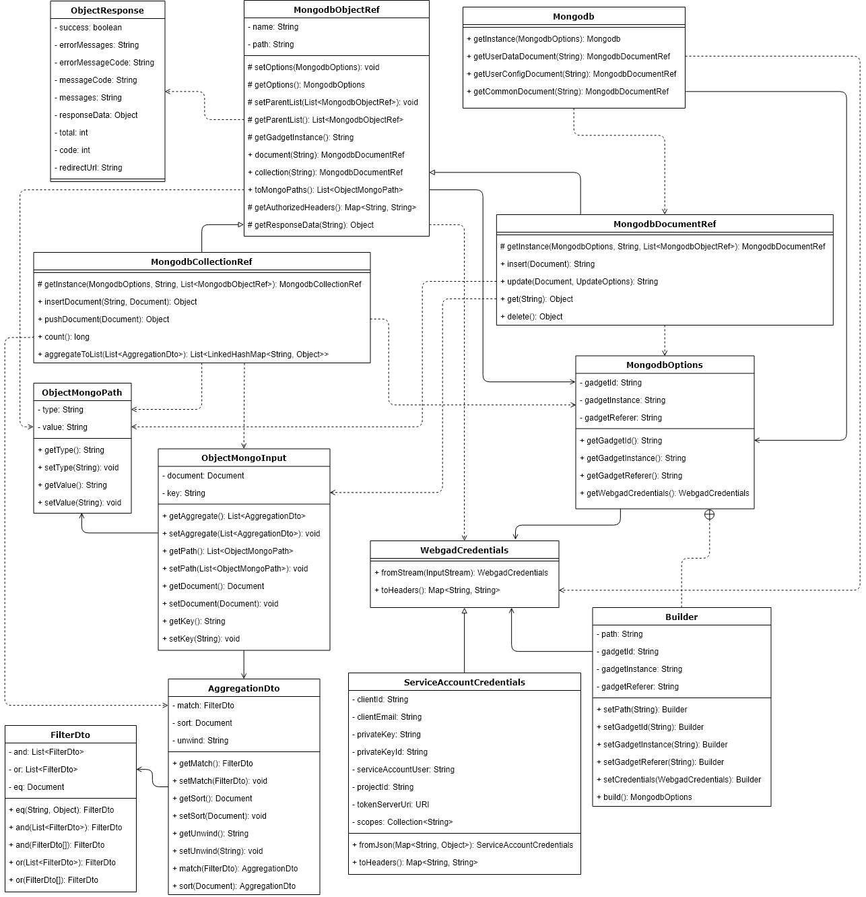

*Figure 4-9.Mongo client library*

##### **AggregationDto**

|  |  |  |
| --- | --- | --- |
| Name | AggregationDto | |
| Type | Class | |
| Package | vn.com.webgad.mongolib.dto | |
| Field Summary | | |
| Modifier and Type | | Name |
| private FilterDto | | match |
| private static long | | serialVersionUID |
| private org.bson.Document | | sort |
| private String | | unwind |
| Constructor Summary | | |
| AggregationDto() | | |
| Method Summary | | |
| Modifier and Type | | Name |
| FilterDto | | getMatch() |
| org.bson.Document | | getSort() |
| String | | getUnwind() |
| static AggregationDto | | match(FilterDto match) |
| void | | setMatch(FilterDto match) |
| void | | setSort(org.bson.Document sort) |
| void | | setUnwind(String unwind) |
| static AggregationDto | | sort(org.bson.Document sort) |

##### **FilterDto**

|  |  |  |
| --- | --- | --- |
| Name | FilterDto | |
| Type | Class | |
| Package | vn.com.webgad.mongolib.dto | |
| Field Summary | | |
| Modifier and Type | | Name |
| private java.util.List | | and |
| private org.bson.Document | | eq |
| private java.util.List | | or |
| private static long | | serialVersionUID |
| Constructor Summary | | |
| FilterDto() | | |
| Method Summary | | |
| Modifier and Type | | Name |
| static FilterDto | | and(FilterDto... filters) Creates a filter that performs a logical AND of the provided list of filters. |
| static FilterDto | | and(java.util.List filters) Creates a filter that performs a logical AND of the provided list of filters. |
| static FilterDto | | eq(String fieldName, Object value) |
| java.util.List | | getAnd() |
| org.bson.Document | | getEq() |
| java.util.List | | getOr() |
| static FilterDto | | or(FilterDto... filters) |
| static FilterDto | | or(java.util.List filters) |
| void | | setAnd(java.util.List and) |
| void | | setEq(org.bson.Document eq) |
| void | | setOr(java.util.List or) |

##### **FilterKeyValueDto**

|  |  |  |
| --- | --- | --- |
| Name | FilterKeyValueDto | |
| Type | Class | |
| Package | vn.com.webgad.mongolib.dto | |
| Field Summary | | |
| Modifier and Type | | Name |
| private String | | key |
| private static long | | serialVersionUID |
| private Object | | value |
| Constructor Summary | | |
| FilterKeyValueDto() | | |
| FilterKeyValueDto(String key, Object value) | | |
| Method Summary | | |
| Modifier and Type | | Name |
| String | | getKey() |
| Object | | getValue() |
| void | | setKey(String key) |
| void | | setValue(Object value) |

##### **Mongodb**

|  |  |  |
| --- | --- | --- |
| Name | Mongodb | |
| Type | Class | |
| Package | vn.com.webgad.mongolib.model | |
| Field Summary | | |
| Modifier and Type | | Name |
| static String | | COMMON_TYPE |
| static String | | CONFIG_TYPE |
| static String | | DATA_TYPE |
| protected MongodbOptions | | options |
| Constructor Summary | | |
| private | | |
| Method Summary | | |
| Modifier and Type | | Name |
| MongodbDocumentRef | | getCommonDocument() |
| static Mongodb | | getInstance(MongodbOptions options) |
| MongodbDocumentRef | | getUserConfigDocument() |
| MongodbDocumentRef | | getUserDataDocument() |

##### **MongodbBson**

|  |  |  |
| --- | --- | --- |
| Name | MongodbBson | |
| Type | Interface | |
| Package | vn.com.webgad.mongolib.model | |
| Field Summary | | |
| Modifier and Type | | Name |
| N/A | | |
| Constructor Summary | | |
| N/A | | |
| Method Summary | | |
| Modifier and Type | | Name |
| N/A | | |

##### **MongodbCollectionRef**

|  |  |  |
| --- | --- | --- |
| Name | MongodbCollectionRef | |
| Type | Class | |
| Package | vn.com.webgad.mongolib.model | |
| Field Summary | | |
| Modifier and Type | | Name |
| N/A | | |
| Constructor Summary | | |
| private | | |
| Method Summary | | |
| Modifier and Type | | Name |
| java.util.List<java.util.linkedhashmap></java.util.linkedhashmap | | aggregateToList(java.util.List pipeline) |
| long | | count() |
| protected static MongodbCollectionRef | | getInstance(MongodbOptions options, String path, java.util.List parentList) |
| Object | | insertDocument(String documentName, org.bson.Document doc) |
| Object | | pushDocument(org.bson.Document doc) |

##### **MongodbDocumentRef**

|  |  |  |
| --- | --- | --- |
| Name | MongodbDocumentRef | |
| Type | Class | |
| Package | vn.com.webgad.mongolib.model | |
| Field Summary | | |
| Modifier and Type | | Name |
| N/A | | |
| Constructor Summary | | |
| private | | |
| Method Summary | | |
| Modifier and Type | | Name |
| Object | | delete(String key) |
| Object | | get(String key) |
| protected static MongodbDocumentRef | | getInstance(MongodbOptions options, String path, java.util.List parentList) |
| String | | insert(org.bson.Document document) Inserts the provided document. |
| String | | update(org.bson.Document document) |
| String | | update(org.bson.Document document, com.mongodb.client.model.UpdateOptions options) |

##### **MongodbObjectRef**

|  |  |  |
| --- | --- | --- |
| Name | MongodbObjectRef | |
| Type | Class | |
| Package | vn.com.webgad.mongolib.model | |
| Field Summary | | |
| Modifier and Type | | Name |
| static String | | COLLECTION_TYPE |
| static String | | DOCUMENT_TYPE |
| static String | | GADGET_INSTANCE |
| static String | | GADGET_REFERER |
| protected String | | name |
| protected MongodbOptions | | options |
| protected java.util.List | | parentList |
| protected String | | path |
| Constructor Summary | | |
| protected | | |
| Method Summary | | |
| Modifier and Type | | Name |
| MongodbCollectionRef | | collection(String name) |
| MongodbDocumentRef | | document(String name) |
| protected java.util.Map | | getAuthorizedHeaders() |
| protected static String | | getGadgetInstance() |
| protected String | | getName() |
| protected MongodbOptions | | getOptions() |
| protected java.util.List | | getParentList() |
| protected String | | getPath() |
| protected Object | | getResponseData(String response) |
| protected void | | setName(String name) |
| protected void | | setOptions(MongodbOptions options) |
| protected void | | setParentList(java.util.List parentList) |
| protected void | | setPath(String path) |
| java.util.List | | toMongoPaths() |

##### **MongodbOptions**

|  |  |  |
| --- | --- | --- |
| Name | MongodbOptions | |
| Type | Class | |
| Package | vn.com.webgad.mongolib.model | |
| Field Summary | | |
| Modifier and Type | | Name |
| private String | | gadgetId |
| private String | | gadgetInstance |
| private String | | gadgetReferer |
| private WebgadCredentials | | webgadCredentials |
| Constructor Summary | | |
| private | | |
| Method Summary | | |
| Modifier and Type | | Name |
| String | | getGadgetId() |
| String | | getGadgetInstance() |
| String | | getGadgetReferer() |
| WebgadCredentials | | getWebgadCredentials() |

##### **MongodbOptions.Builder**

|  |  |  |
| --- | --- | --- |
| Name | MongodbOptions.Builder | |
| Type | Class | |
| Package | vn.com.webgad.mongolib.model | |
| Field Summary | | |
| Modifier and Type | | Name |
| private String | | gadgetId |
| private String | | gadgetInstance |
| private String | | gadgetReferer |
| private String | | path |
| private WebgadCredentials | | webgadCredentials |
| Constructor Summary | | |
| Builder() | | |
| Method Summary | | |
| Modifier and Type | | Name |
| MongodbOptions | | build() |
| MongodbOptions.Builder | | setCredentials(WebgadCredentials webgadCredentials) |
| MongodbOptions.Builder | | setGadgetId(String gadgetId) |
| MongodbOptions.Builder | | setGadgetInstance(String gadgetInstance) |
| MongodbOptions.Builder | | setGadgetReferer(String gadgetReferer) |
| MongodbOptions.Builder | | setPath(String path) |

##### **ObjectMongoInput**

|  |  |  |
| --- | --- | --- |
| Name | ObjectMongoInput | |
| Type | Class | |
| Package | vn.com.webgad.mongolib.dto | |
| Field Summary | | |
| Modifier and Type | | Name |
| private java.util.List | | aggregate |
| private org.bson.Document | | document |
| private String | | key |
| private java.util.List | | path |
| private static long | | serialVersionUID |
| Constructor Summary | | |
| ObjectMongoInput() | | |
| Method Summary | | |
| Modifier and Type | | Name |
| java.util.List | | getAggregate() |
| org.bson.Document | | getDocument() |
| String | | getKey() |
| java.util.List | | getPath() |
| void | | setAggregate(java.util.List aggregate) |
| void | | setDocument(org.bson.Document document) |
| void | | setKey(String key) |
| void | | setPath(java.util.List path) |

##### **ObjectMongoPath**

|  |  |  |
| --- | --- | --- |
| Name | ObjectMongoPath | |
| Type | Class | |
| Package | vn.com.webgad.mongolib.dto | |
| Field Summary | | |
| Modifier and Type | | Name |
| private static long | | serialVersionUID |
| private String | | type |
| private String | | value |
| Constructor Summary | | |
| ObjectMongoPath() | | |
| Method Summary | | |
| Modifier and Type | | Name |
| String | | getType() |
| String | | getValue() |
| void | | setType(String type) |
| void | | setValue(String value) |

##### **ObjectResponse**

|  |  |  |
| --- | --- | --- |
| Name | ObjectResponse | |
| Type | Class | |
| Package | vn.com.webgad.mongolib.model | |
| Field Summary | | |
| Modifier and Type | | Name |
| private int | | code |
| private String | | errorMessageCode |
| private String | | errorMessages |
| private String | | messageCode |
| private String | | messages |
| private String | | redirectUrl |
| private Object | | responseData |
| private static long | | serialVersionUID |
| private boolean | | success |
| private int | | total |
| Constructor Summary | | |
| ObjectResponse() | | |
| Method Summary | | |
| Modifier and Type | | Name |
| int | | getCode() |
| String | | getErrorMessageCode() |
| String | | getErrorMessages() |
| String | | getMessageCode() |
| String | | getMessages() |
| String | | getRedirectUrl() |
| Object | | getResponseData() |
| int | | getTotal() |
| boolean | | isSuccess() |
| void | | setCode(int code) |
| void | | setErrorMessageCode(String errorMessageCode) |
| void | | setErrorMessages(String errorMessages) |
| void | | setMessage(String messages) |
| void | | setMessageCode(String messageCode) |
| void | | setRedirectUrl(String redirectUrl) |
| void | | setResponseData(Object responseData) |
| void | | setSuccess(boolean success) |
| void | | setTotal(int total) |

##### **ServiceAccountCredentials**

|  |  |  |
| --- | --- | --- |
| Name | ServiceAccountCredentials | |
| Type | Class | |
| Package | vn.com.webgad.auth.oauth2 | |
| Field Summary | | |
| Modifier and Type | | Name |
| private String | | clientEmail |
| private String | | clientId |
| private String | | privateKey |
| private String | | privateKeyId |
| private String | | projectId |
| private java.util.Collection | | scopes |
| private String | | serviceAccountUser |
| private java.net.URI | | tokenServerUri |
| Constructor Summary | | |
| ServiceAccountCredentials(String clientId, String clientEmail, String privateKey, String privateKeyId, String serviceAccountUser, String projectId, java.net.URI tokenServerUri, java.util.Collection scopes) | | |
| Method Summary | | |
| Modifier and Type | | Name |
| (package private) static ServiceAccountCredentials | | fromJson(java.util.Map json) |
| (package private) static ServiceAccountCredentials | | fromPkcs8(String clientId, String clientEmail, String privateKeyPkcs8, String privateKeyId, java.util.Collection scopes, java.net.URI tokenServerUri, String serviceAccountUser, String projectId) |
| String | | getClientEmail() |
| String | | getClientId() |
| String | | getPrivateKey() |
| String | | getPrivateKeyId() |
| String | | getProjectId() |
| java.util.Collection | | getScopes() |
| String | | getServiceAccountUser() |
| java.net.URI | | getTokenServerUri() |
| (package private) static java.security.PrivateKey | | privateKeyFromPkcs8(String privateKeyPkcs8) Helper to convert from a PKCS#8 String to an RSA private key |
| java.util.Map | | toHeaders() |

##### **UnauthorizedException**

|  |  |  |
| --- | --- | --- |
| Name | UnauthorizedException | |
| Type | Class | |
| Package | vn.com.webgad.mongolib.exception | |
| Field Summary | | |
| Modifier and Type | | Name |
| private static long | | serialVersionUID |
| Constructor Summary | | |
| UnauthorizedException() | | |
| UnauthorizedException(String message) | | |
| Method Summary | | |
| Modifier and Type | | Name |
| N/A | | |

##### **WebgadCredentials**

|  |  |  |
| --- | --- | --- |
| Name | WebgadCredentials | |
| Type | Class | |
| Package | vn.com.webgad.auth.oauth2 | |
| Field Summary | | |
| Modifier and Type | | Name |
| (package private) static String | | SERVICE_ACCOUNT_FILE_TYPE |
| (package private) static String | | USER_FILE_TYPE |
| Constructor Summary | | |
| WebgadCredentials() | | |
| Method Summary | | |
| Modifier and Type | | Name |
| static WebgadCredentials | | fromStream(java.io.InputStream credentialsStream) Returns credentials defined by a JSON file stream. |
| abstract java.util.Map | | toHeaders() |

### User interface design

The user interface of the application must be user-friendly, intuitive and easy to use, implementing the ergonomics standards.

#### Webgad System

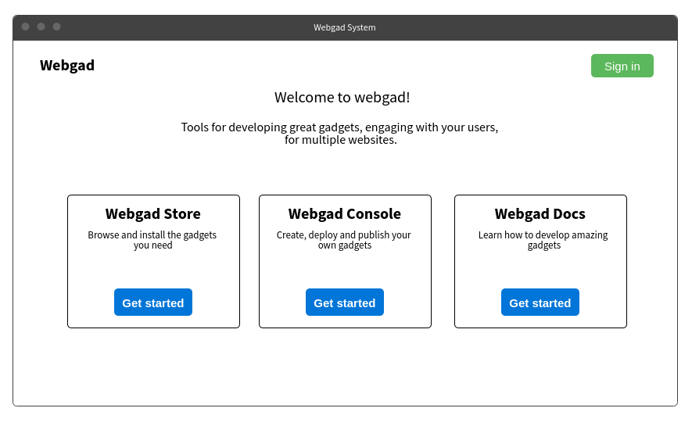

*Figure 4-10.Webgad System Interface*

#### Webgad Document

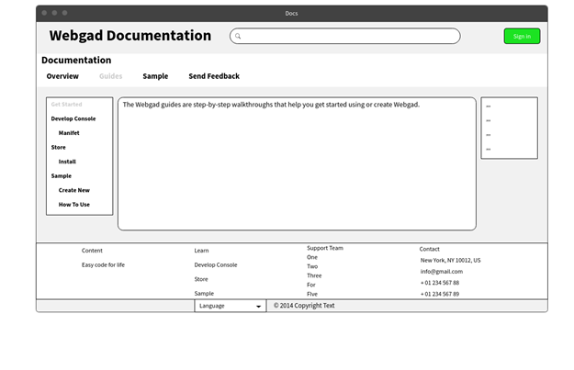

*Figure 4-11.Webgad Document Interface*

#### Webgad Store

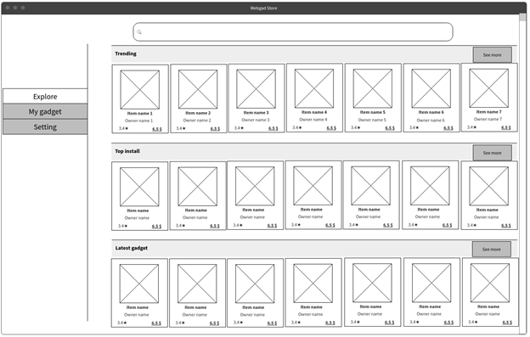

*Figure 4-12.Webgad Store Interface - Home*

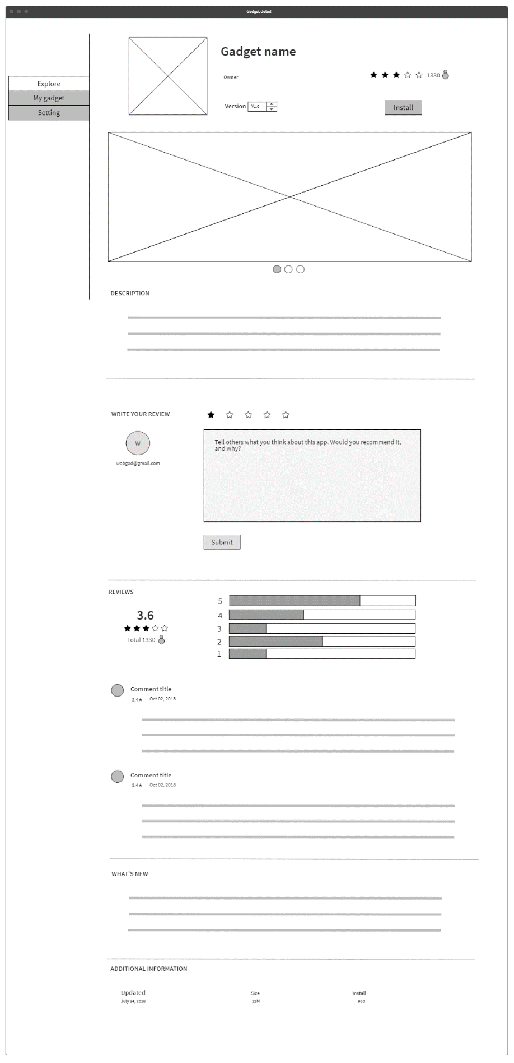

*Figure 4-13.Webgad Store Interface – Gadget Detail*

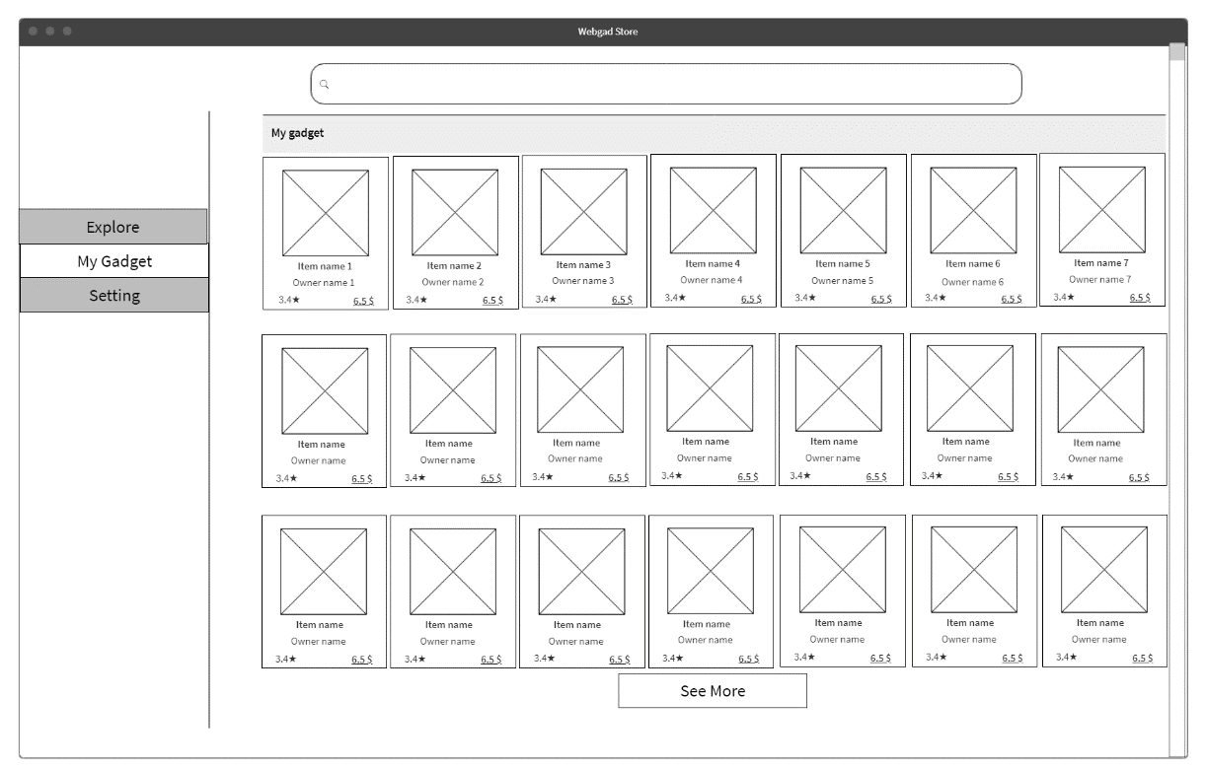

*Figure 4-14.Webgad Store Interface – My Gadget*

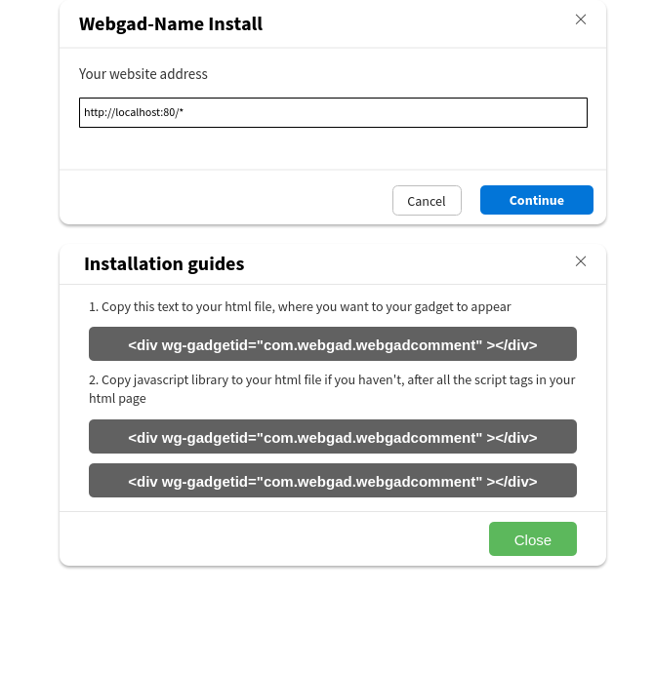

*Figure 4-15.Webgad Store Interface – Install Gadget*

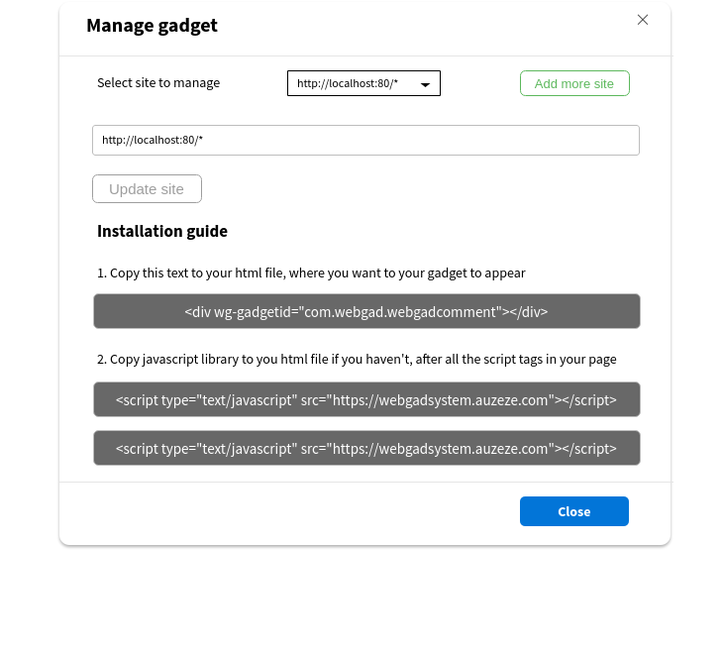

*Figure 4-16.Webgad Store Interface – Manage Gadget*

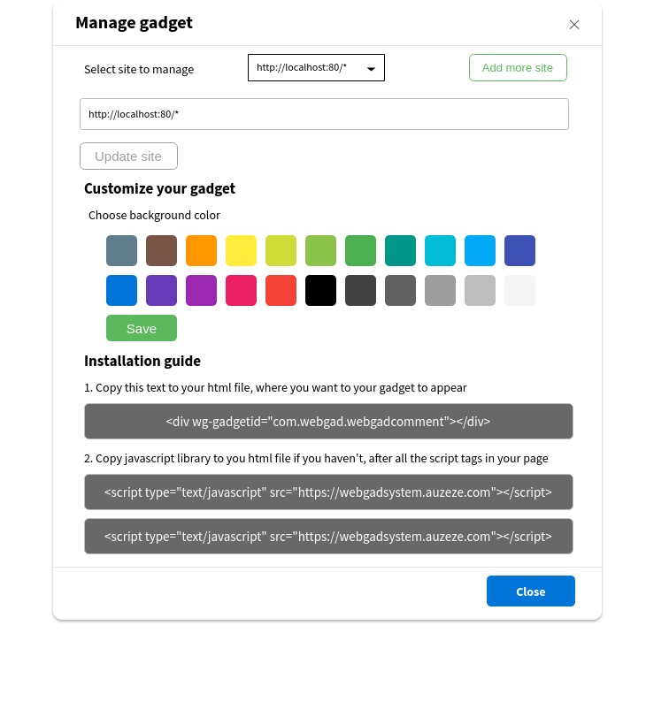

*Figure 4-17.Webgad Store Interface – Manage Gadget*

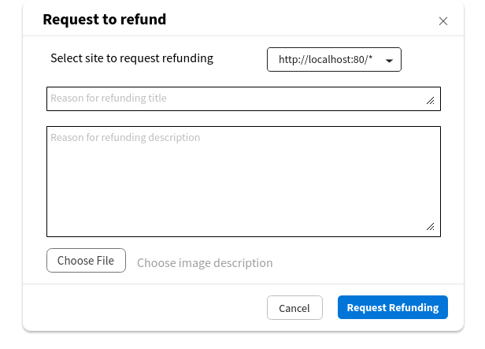

*Figure 4-18.Webgad Store Interface – Request to refund*

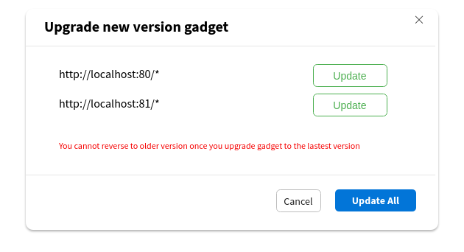

*Figure 4-19.Webgad Store Interface – Upgrade version*

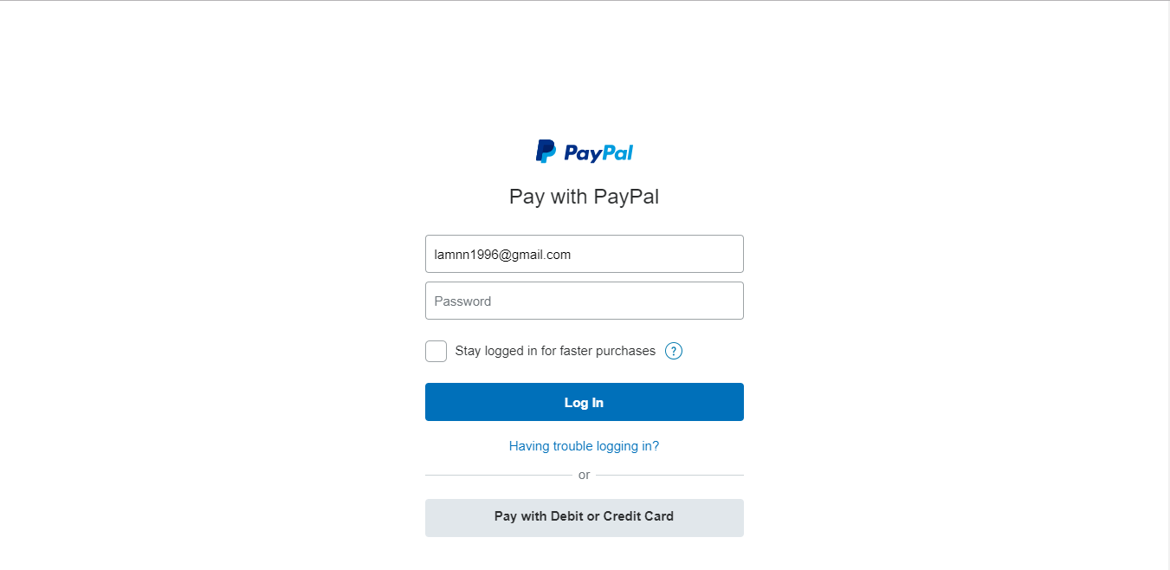

*Figure 4-20.Webgad Store Interface – Purchase Gadget*

#### Webgad Console

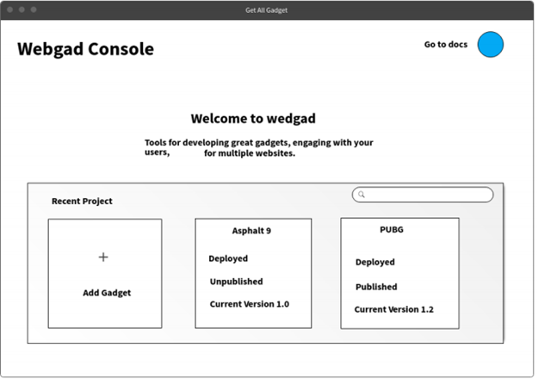

*Figure 4.21.Webgad Console Interface – Home*

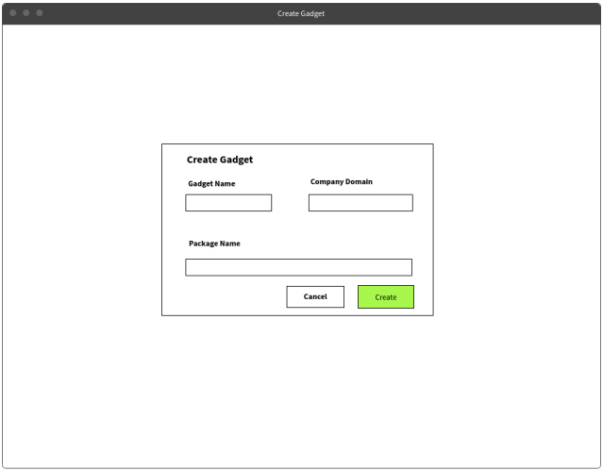

*Figure 4-22.Webgad Console Interface – Create Gadget*

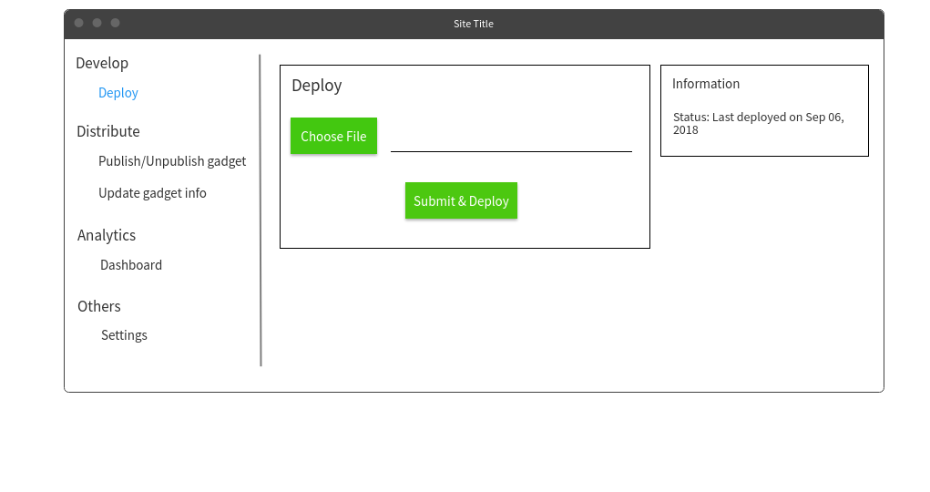

*Figure 4-23.Webgad Console Interface – Deploy Gadget*

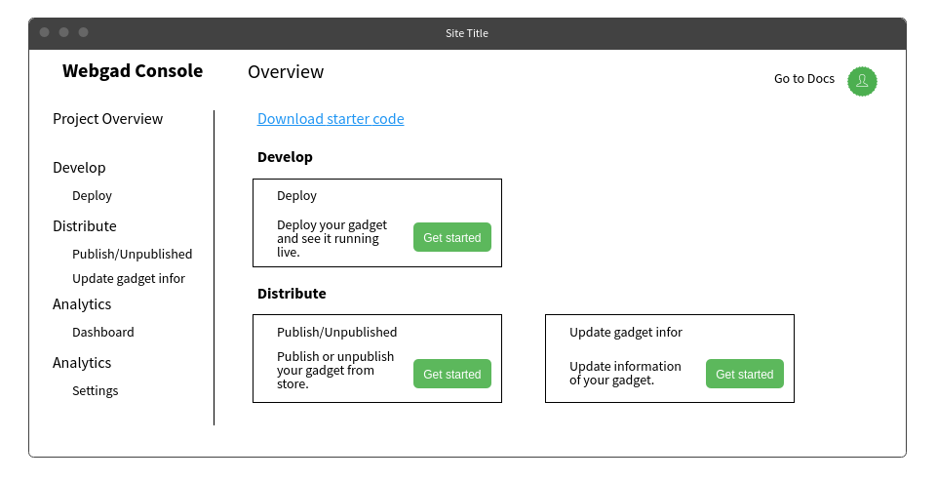

*Figure 4-24.Webgad Console Interface – Overview*

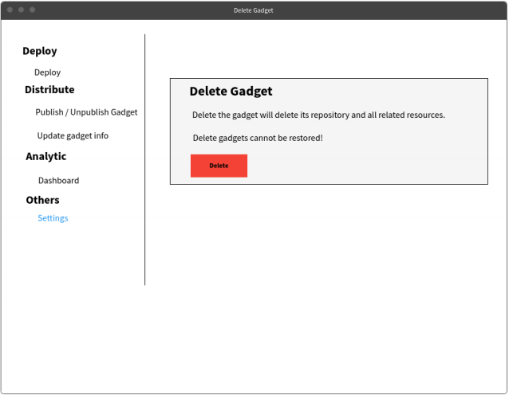

*Figure 4-25.Webgad Console Interface – Settings*

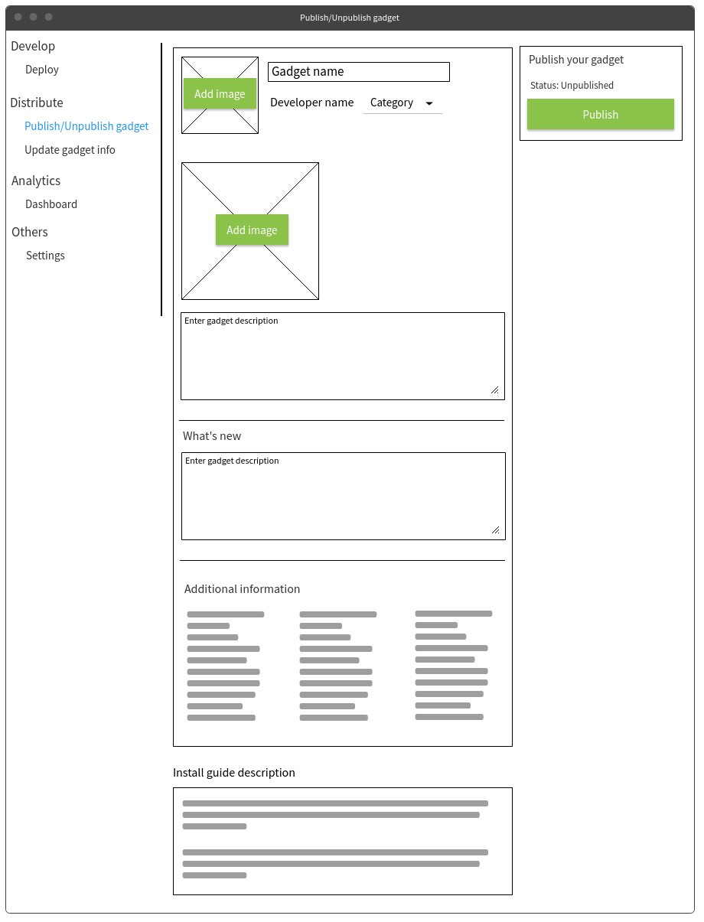

*Figure 4-26.Webgad Console Interface – Publish/Unpublished Gadget*

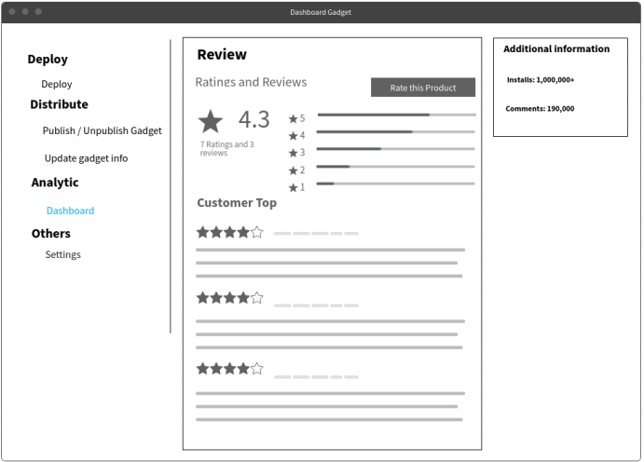

*Figure 4-27.Webgad Console Interface – Dashboard*

#### Admin

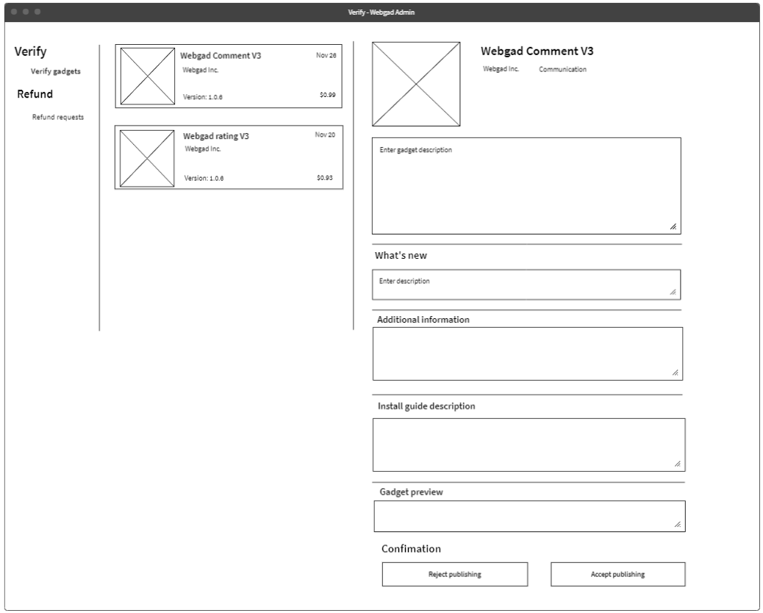

*Figure 4-28.Admin Interface – Verify Publish Gadget*

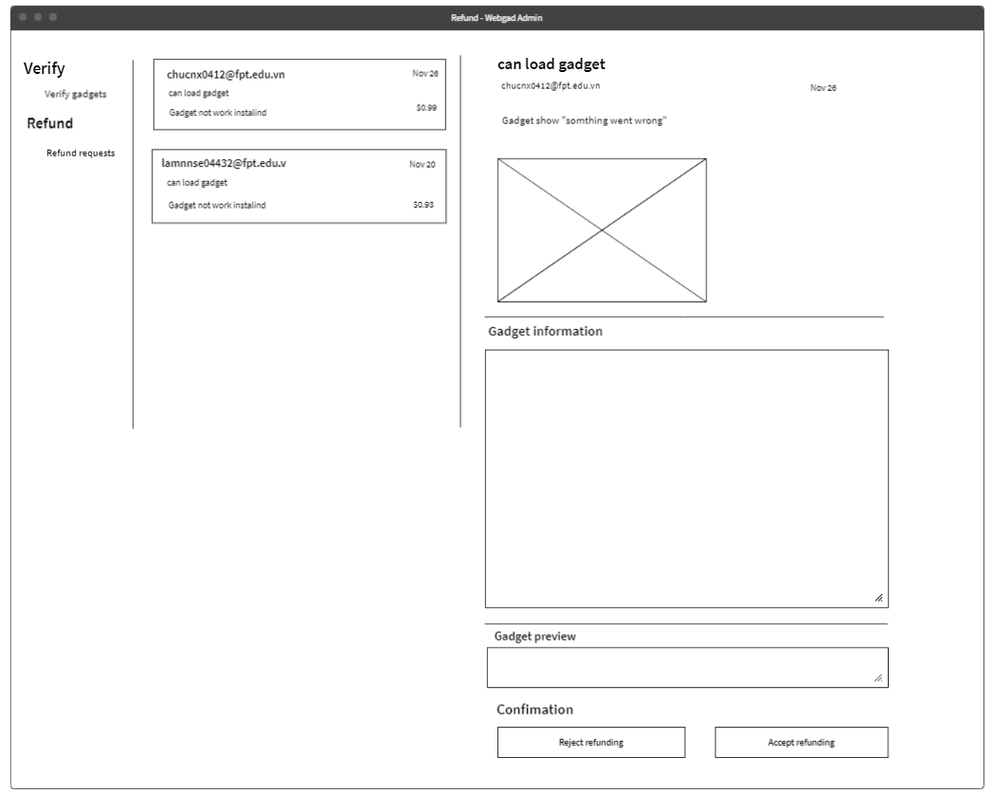

*Figure 4-29.Admin Interface – Verify Claim Gadget*

#### User profile

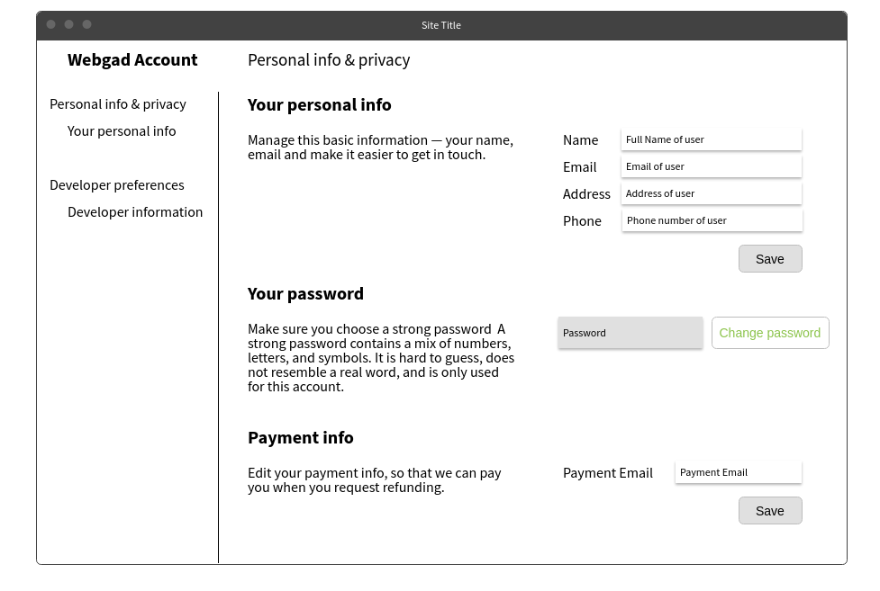

*Figure 4-30.Account profile Interface*

### Sequence diagram for each function

#### Function “Register”

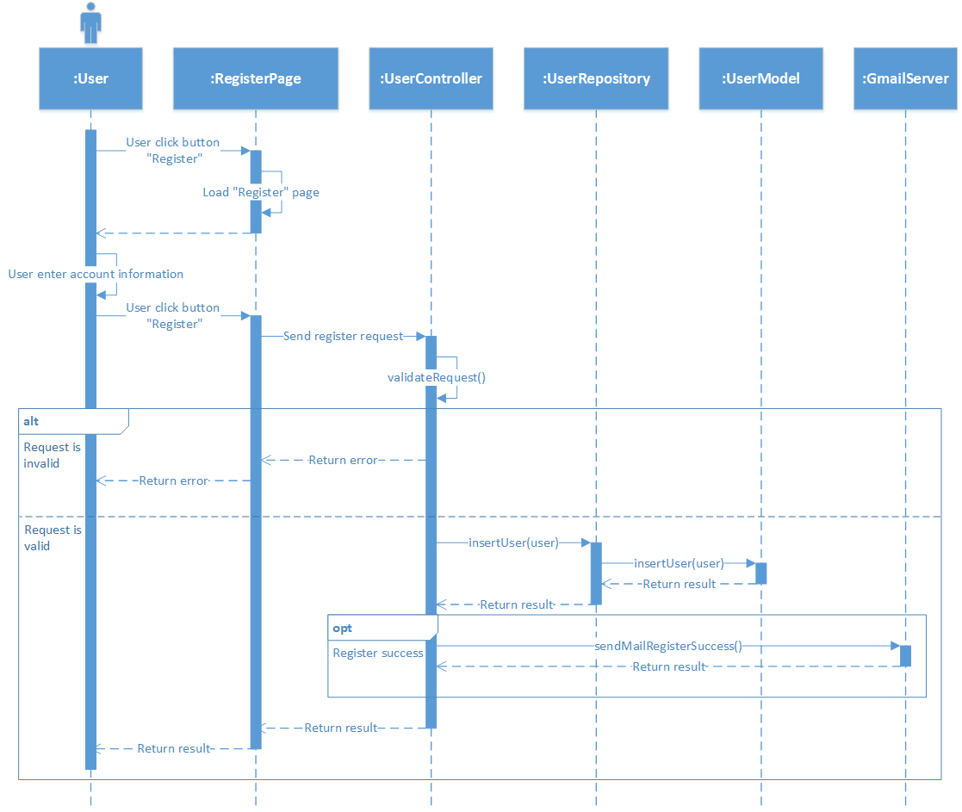

#### Function “Sign-in”

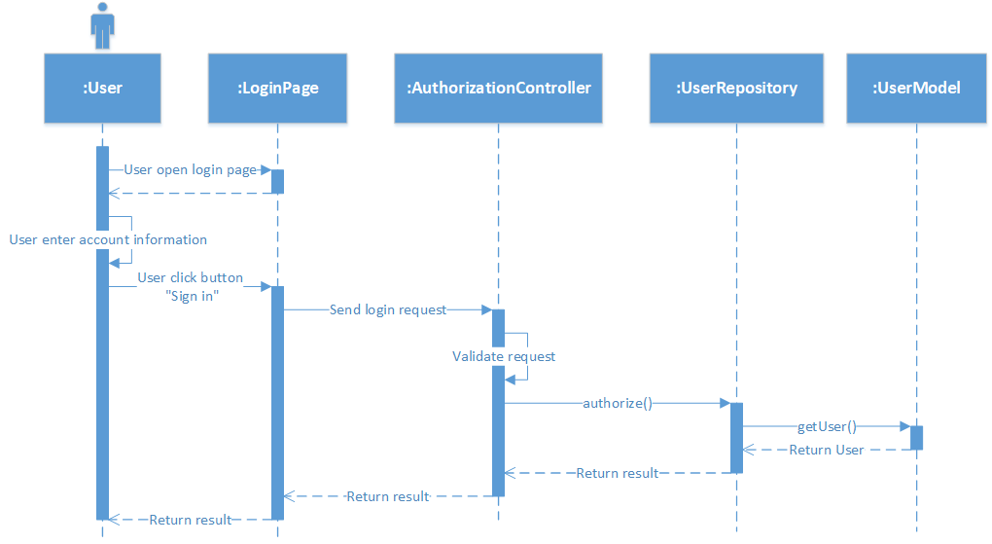

#### Function “Sign-out”

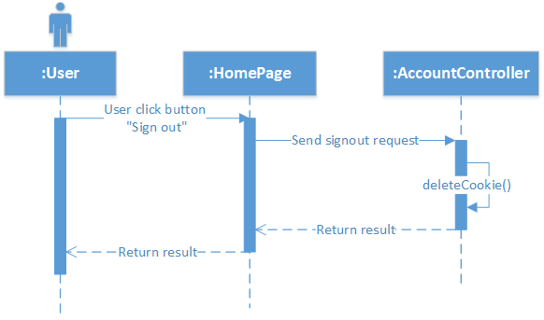

#### Function “Change password”

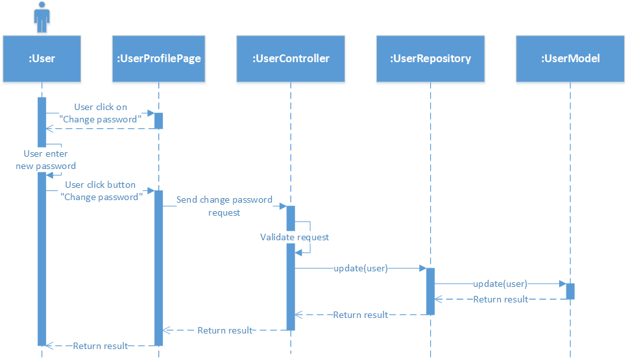

#### Function “Edit profile”

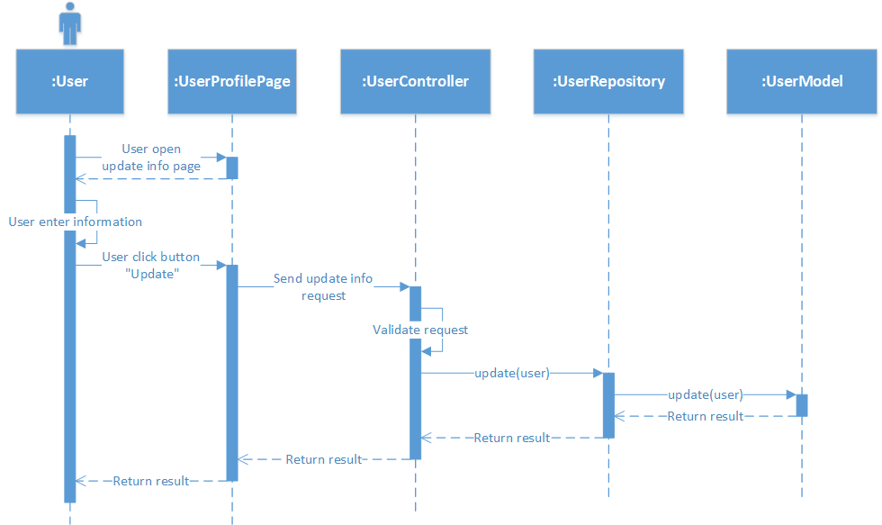

#### Function “Forgot password”

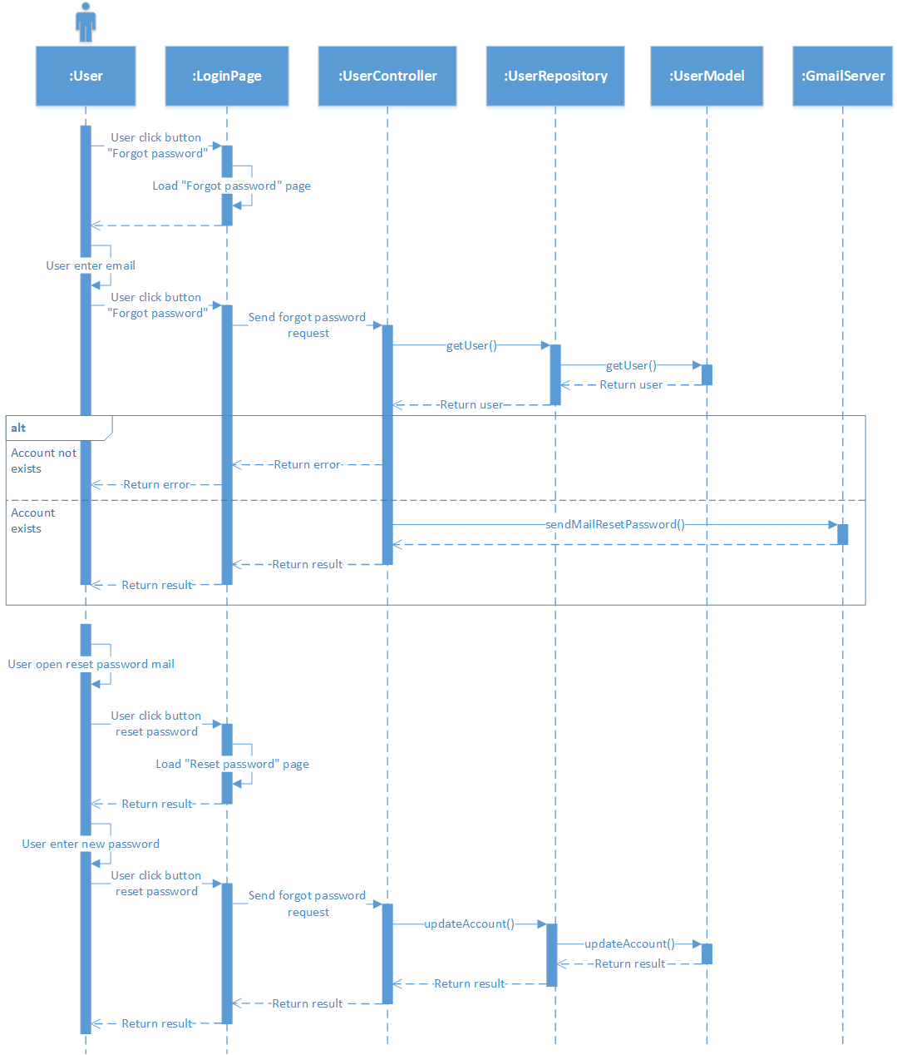

#### Function “Search Gadget”

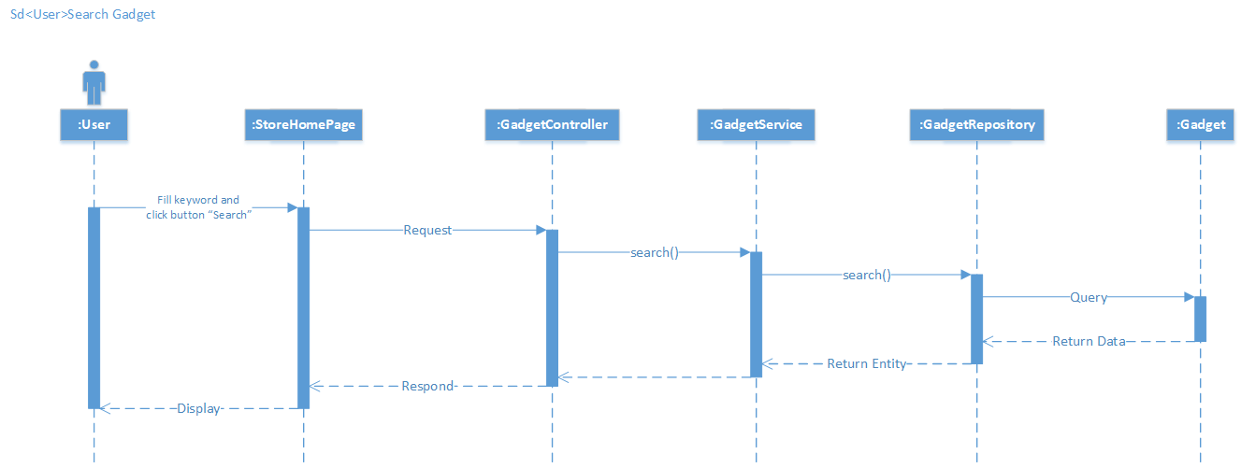

#### Function “Browse Gadget”

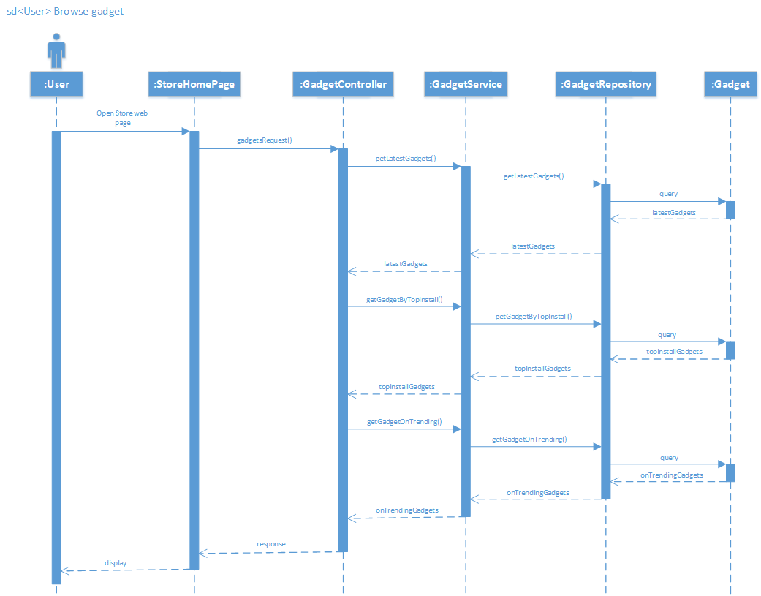

#### Function “View Gadget detail”

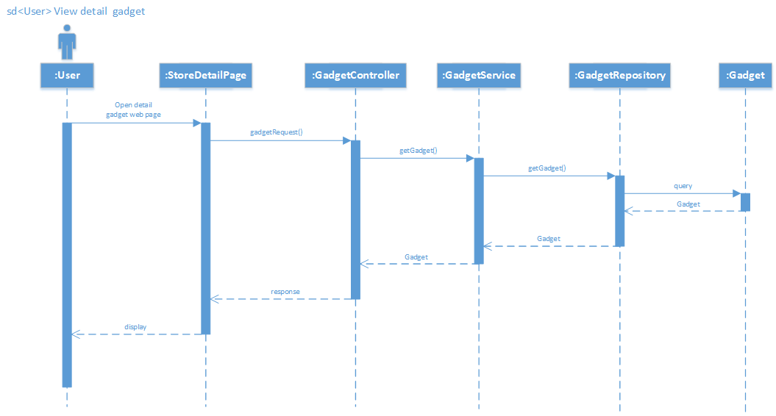

#### Function “Install Gadget”

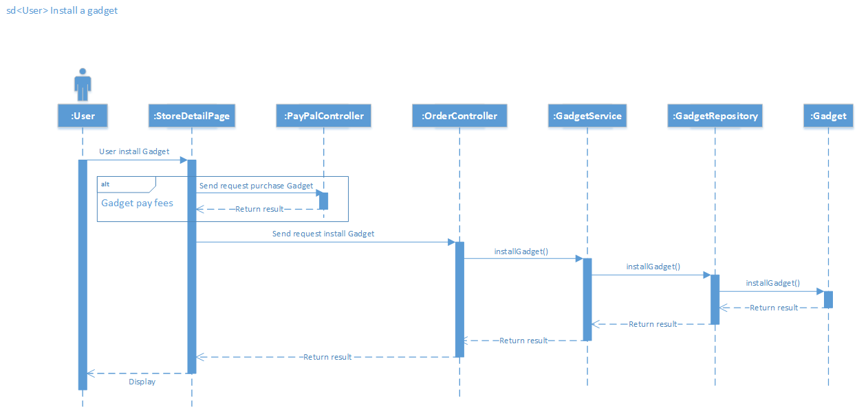

#### Function “Purchase Gadget”

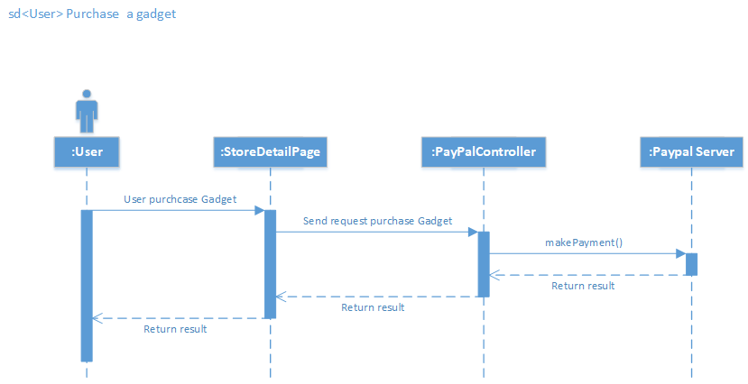

#### Function “Claim Gadget”

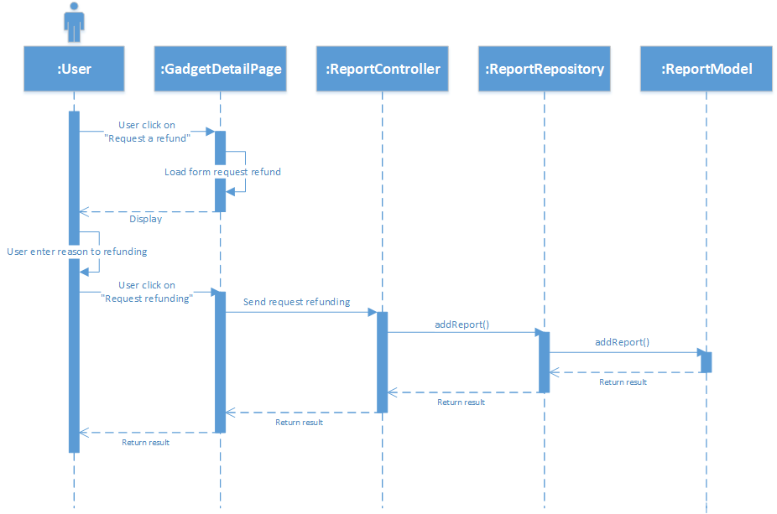

#### Function “Giving feedback”

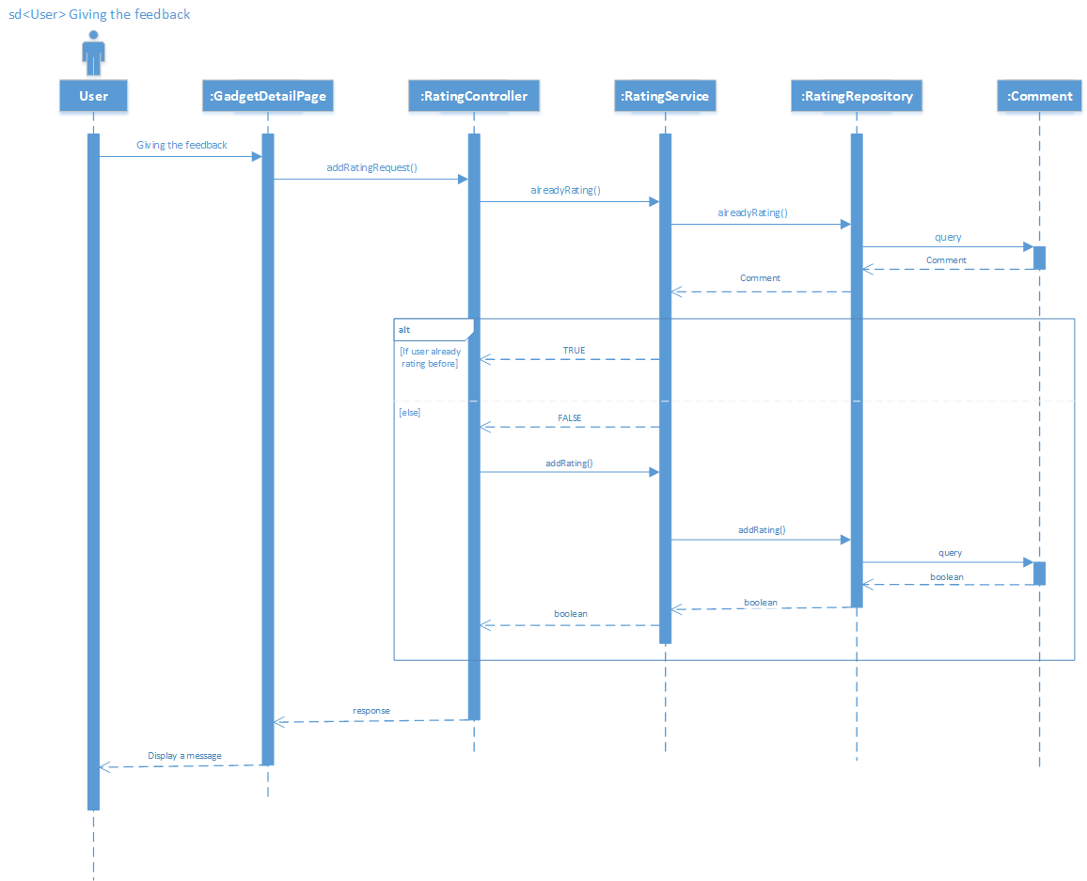

#### Function “View all Gadget purchased”

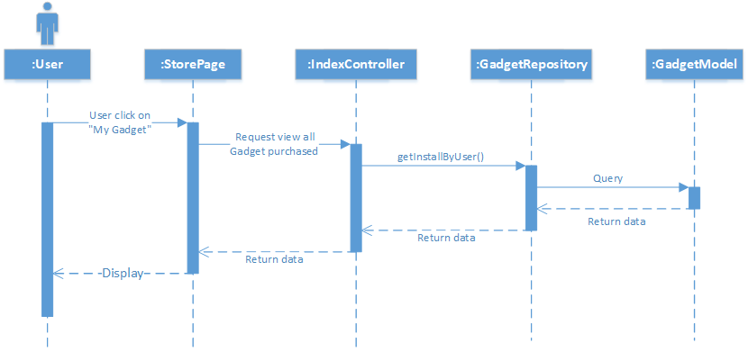

#### Function “Update new version”

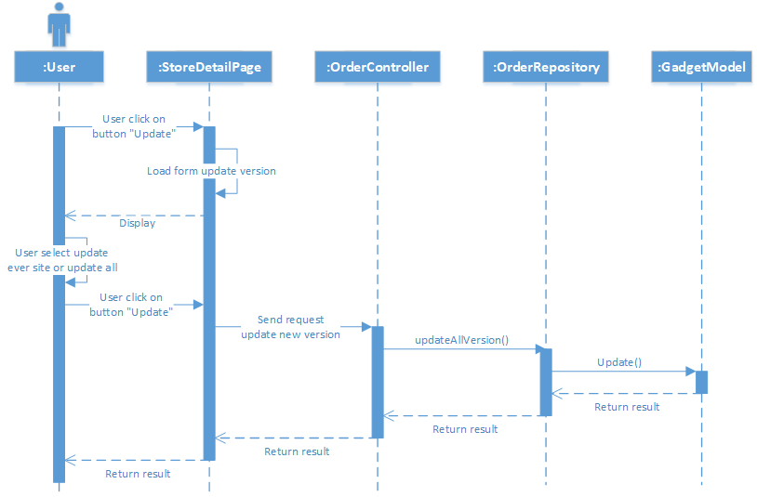

#### Function “Edit feedback”

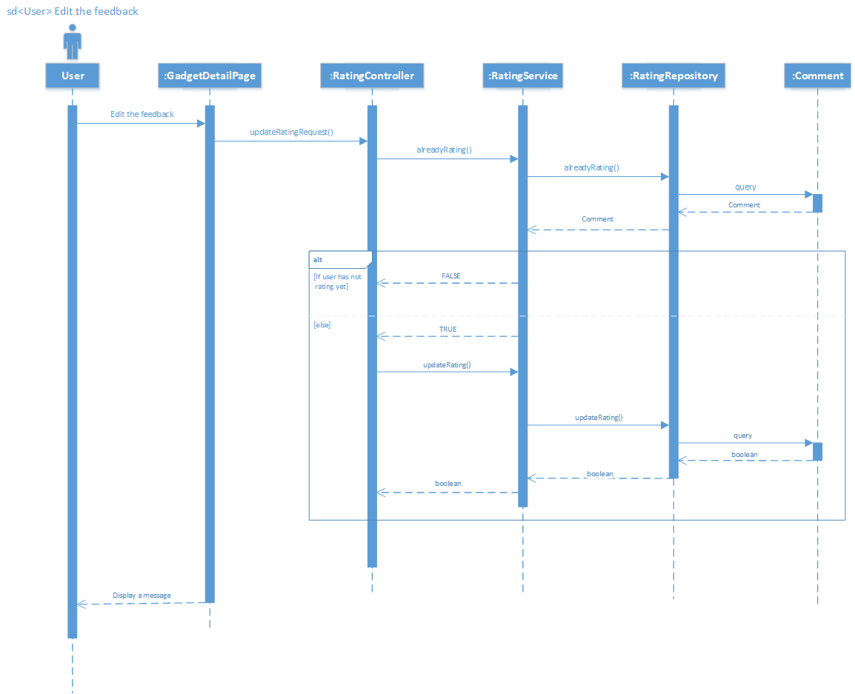

#### Function “Customize Gadget”

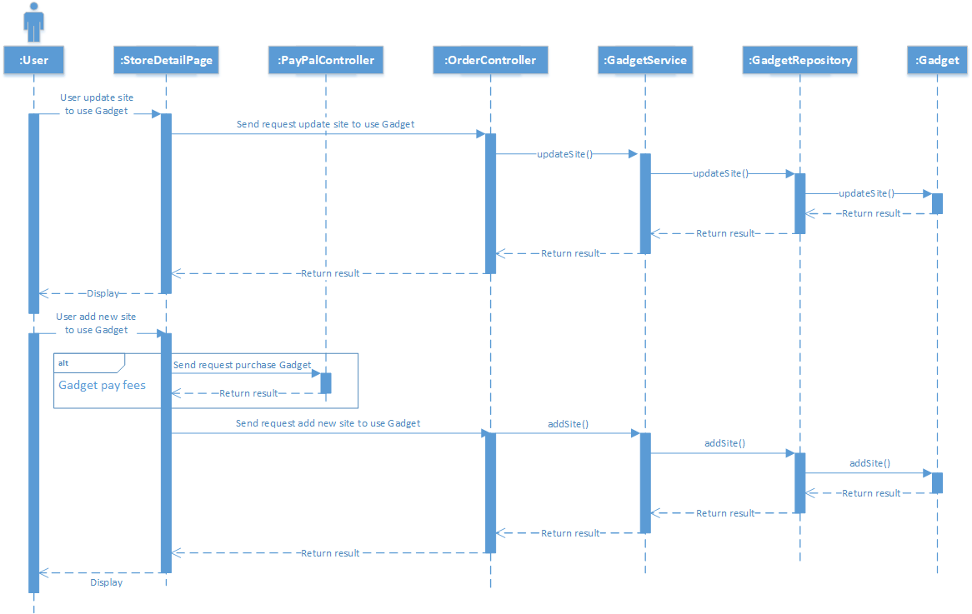

#### Function “Create Gadget”

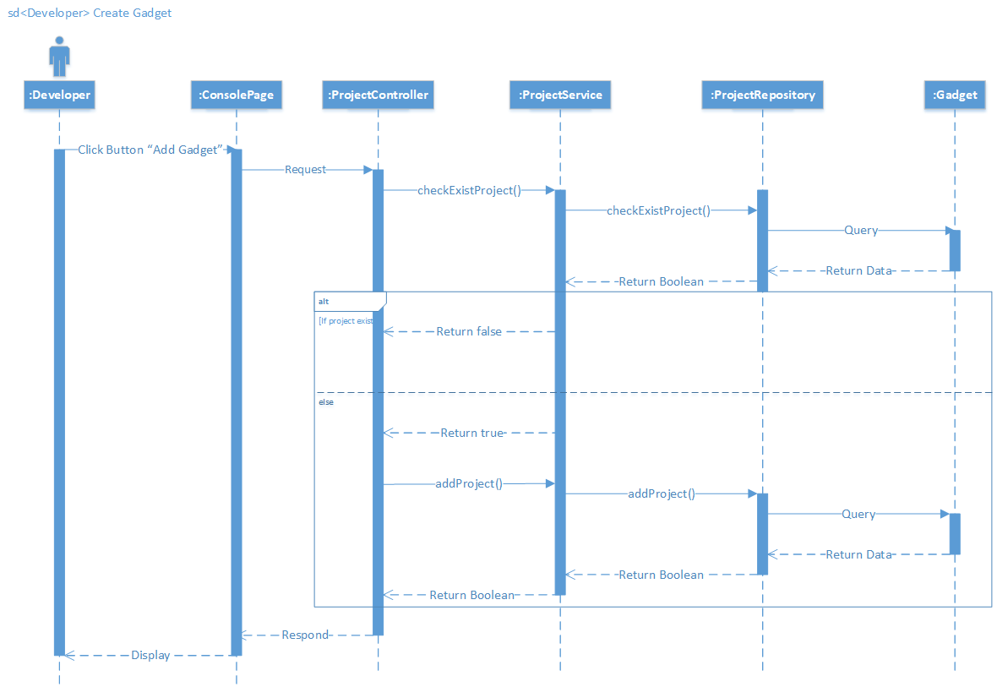

#### Function “View all Dev-Gadget”

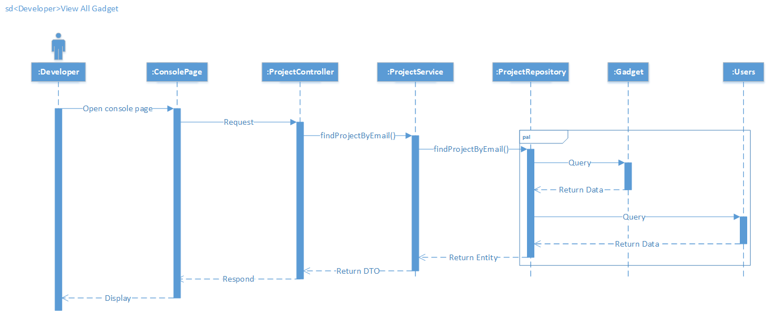

#### Function “Delete Gadget”

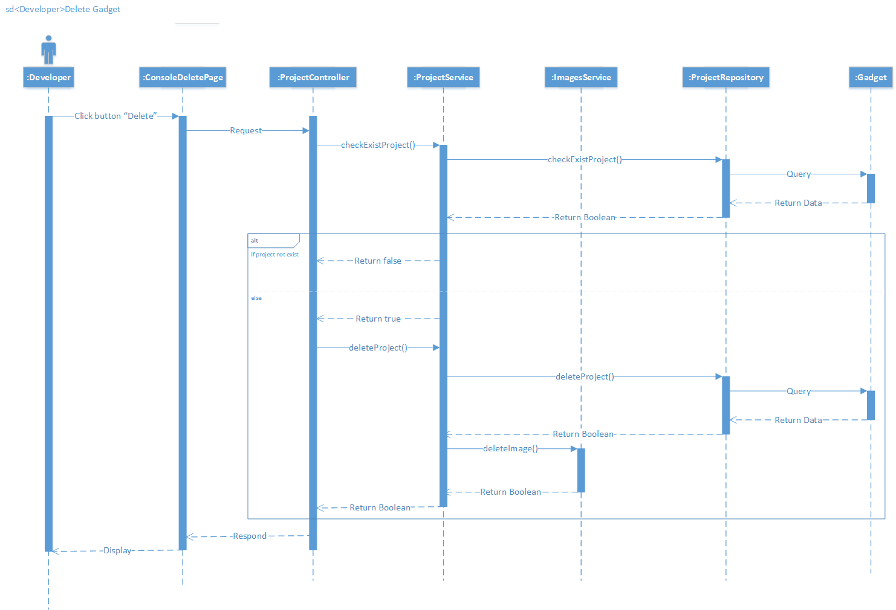

#### Function “Deploy Gadget”

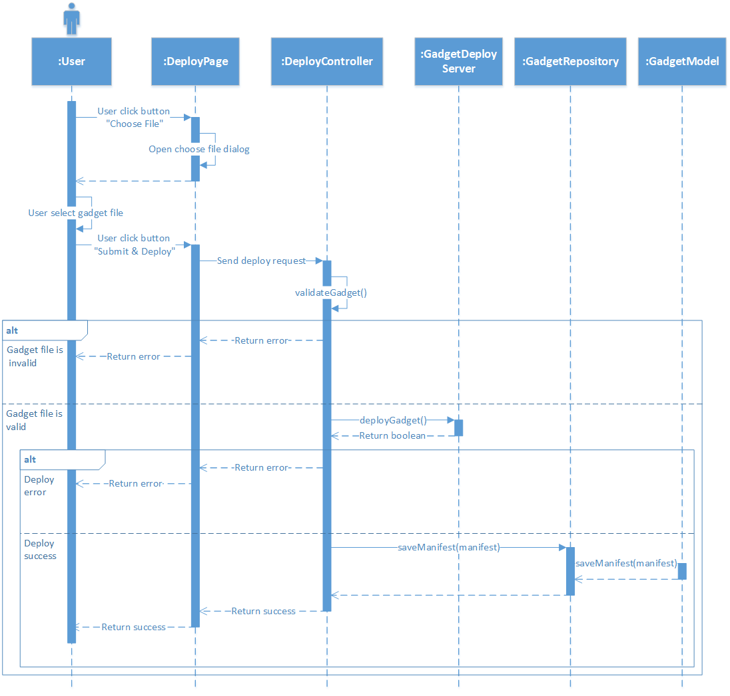

#### Function “Publish Gadget”

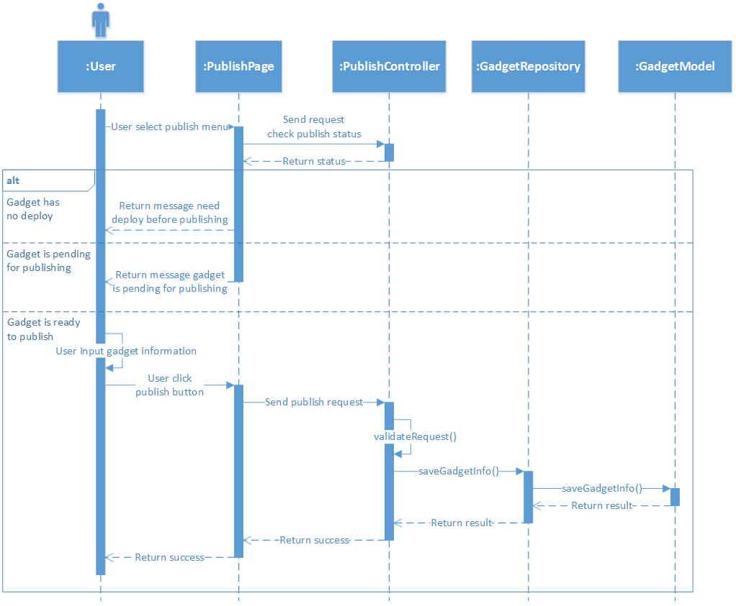

#### Function “Unpublished Gadget”

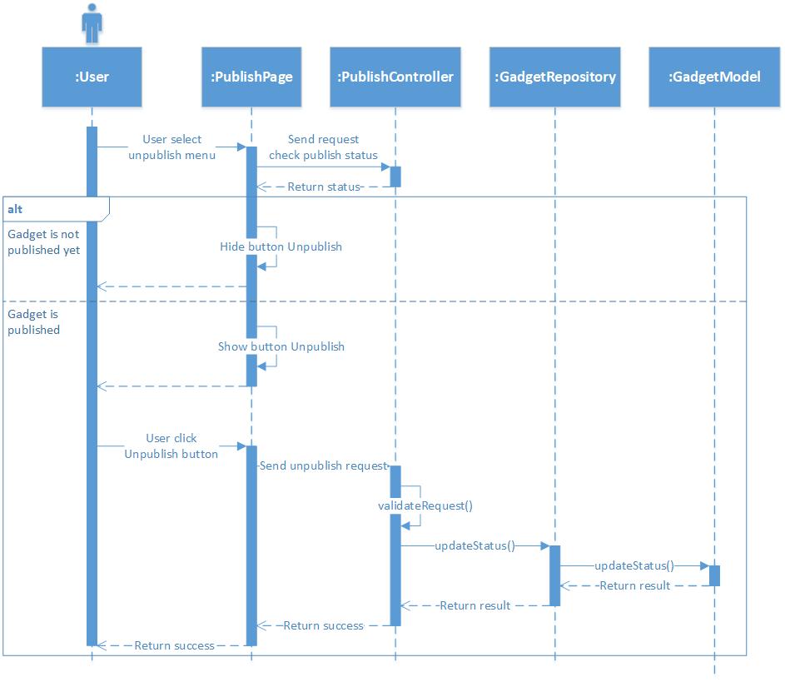

#### Function “Download starter code”

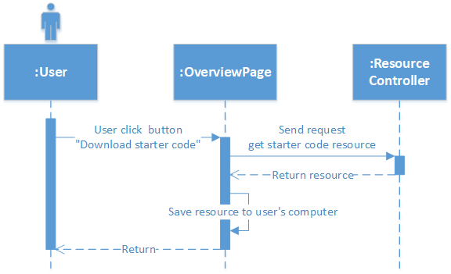

#### Function “Download service accounts credential”

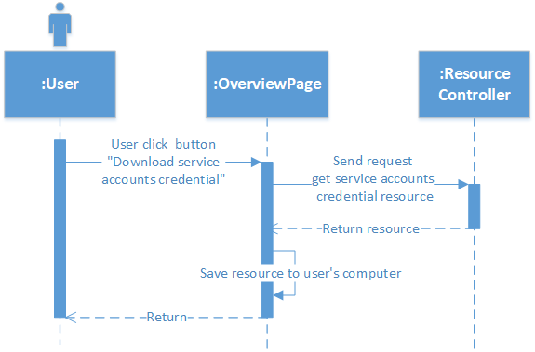

#### Function “View list request publish”

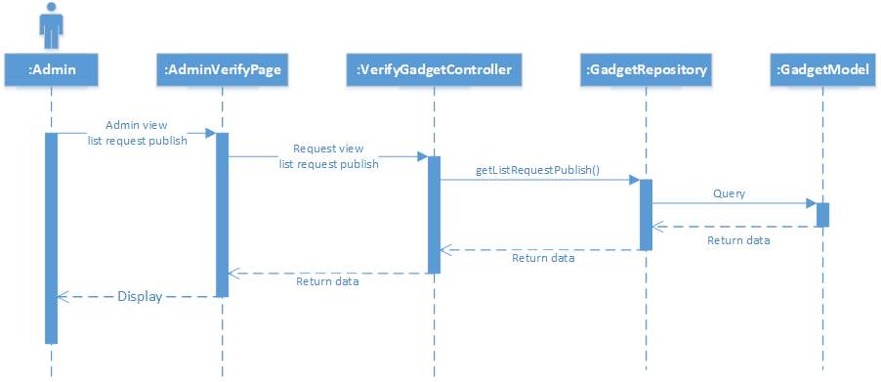

#### Function “Verify publish Gadget”

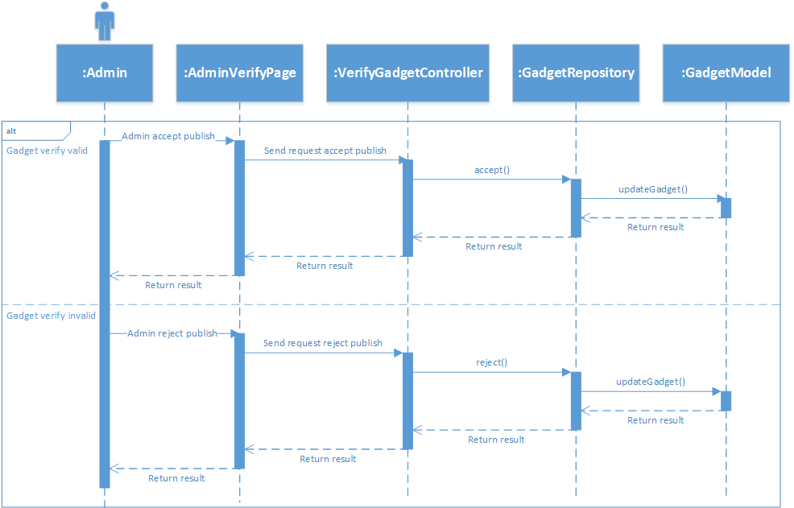

#### Function “View list claim”

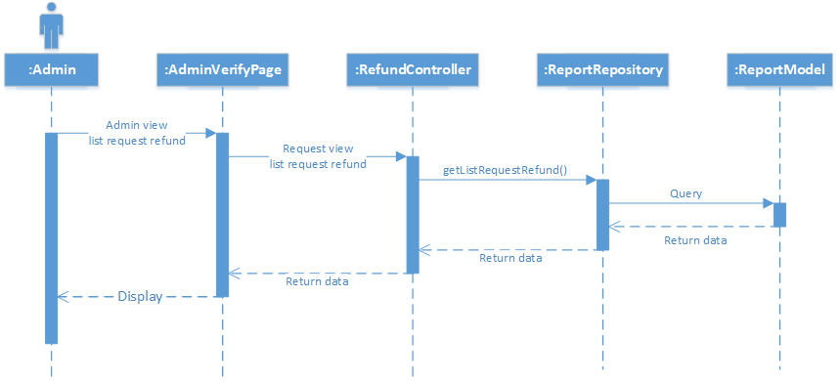

#### Function “Verify claim”

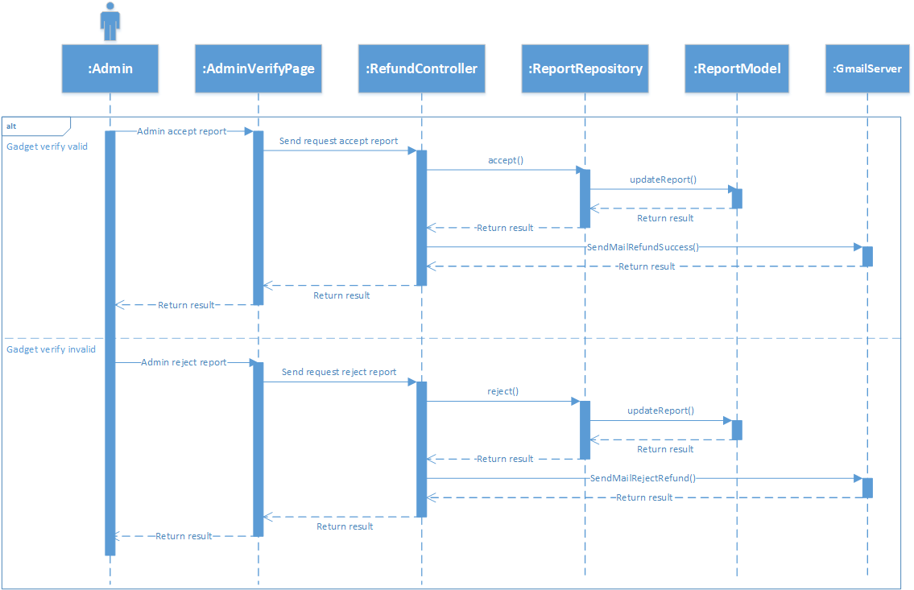

## Database design

### Table Relationship Diagram:

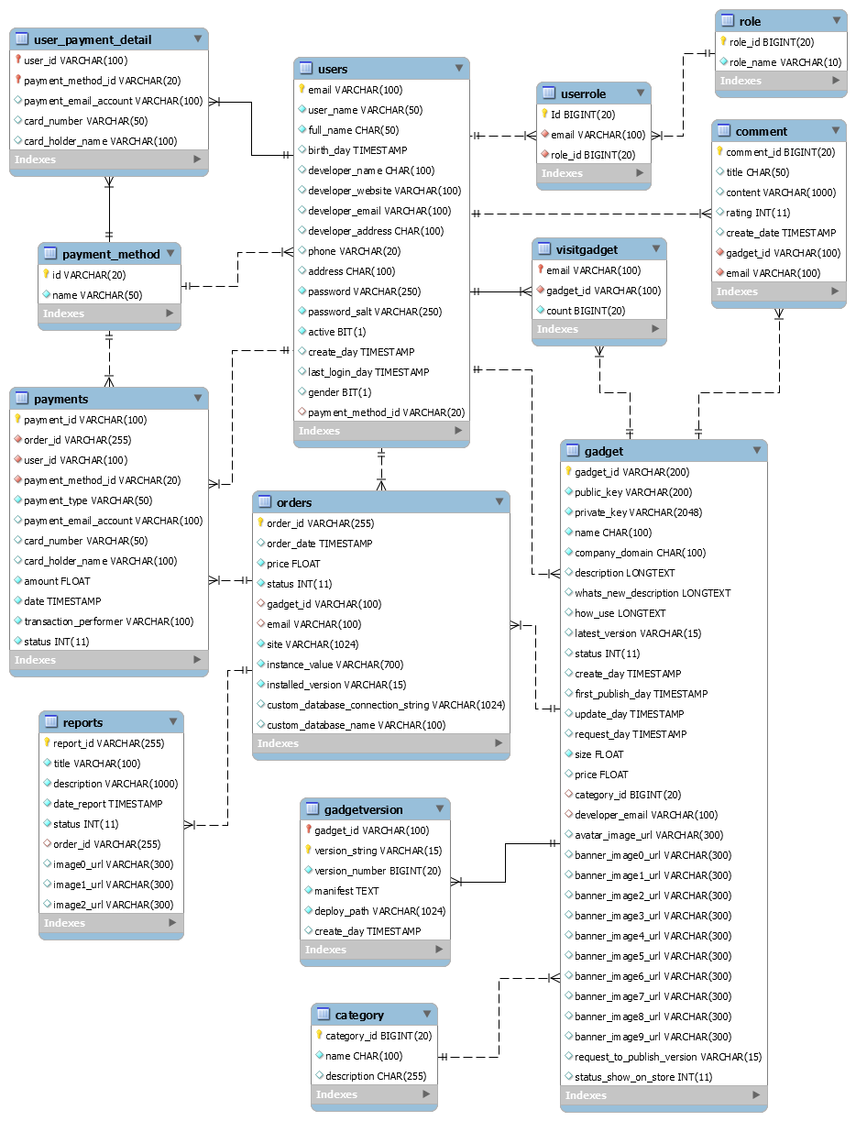

*Figure 0‑31.Database design*

### Database Explanation:

#### Role table

|  |  |  |  |  |  |
| --- | --- | --- | --- | --- | --- |
| No | Field Name | Type | Max Length | Allow Null | Description |
| **1** | role_id | bigint | 20 | No | Role of user  Primary key |
| **2** | role_name | varchar | 10 | No | Name of user |

#### UserRole table

|  |  |  |  |  |  |
| --- | --- | --- | --- | --- | --- |
| No | Field Name | Type | Max Length | Allow Null | Description |
| **1** | id | bigint | 20 | No | Primary key |
| **2** | role_id | bigint | 20 | No | Role of user  UNIQUE Foreign key references to role _id in table Role |
| **3** | email | varchar | 100 | No | Email of user  UNIQUE Foreign key references to email in table Users |

#### Users table

|  |  |  |  |  |  |
| --- | --- | --- | --- | --- | --- |
| No | Field Name | Type | Max Length | Allow Null | Description |
| **1** | email | varchar | 100 | No | Email of user  Primary key |
| **2** | user_name | varchar | 50 | No | User name of user |
| **3** | full_name | char | 50 | No | Full name of user |
| **4** | birth_day | timestamp |  | Yes | Birth day of user |
| **5** | developer_name | char | 100 | Yes | Developer name of user |
| **6** | developer_website | varchar | 100 | Yes | Website of developer |
| **7** | developer_email | varchar | 100 | Yes | Email of developer |
| **8** | developer_address | char | 100 | Yes | Address of developer |
| **9** | phone | varchar | 20 | Yes | Phone of user |
| **10** | address | char | 100 | Yes | Address of user |
| **11** | password | varchar | 250 | No | Password of user |
| **12** | password_salt | varchar | 250 | No | Password salt of user |
| **13** | active | bit |  | No | Active of user  0 : User is not active  1 : User is active |
| **14** | create_day | timestamp |  | Yes | Date created user |
| **15** | last_login_day | timestamp |  | Yes | Last login date of user |
| **16** | gender | bit |  | Yes | Gender of user  0: Female  1: Male |
| **17** | payment_method_id | varchar | 20 | Yes | Foreign key references to id in table payment_method |

#### Comment table

|  |  |  |  |  |  |
| --- | --- | --- | --- | --- | --- |
| No | Field Name | Type | Max Length | Allow Null | Description |
| **1** | comment_id | bigint | 20 | No | Id of comment  Primary key |
| **2** | title | char | 50 | Yes | Title of comment |
| **3** | content | nvarchar | 1000 | Yes | Content of comment |
| **4** | rating | int |  | Yes | Rating of gadget |
| **5** | create_date | timestamp |  | Yes | Date created comment |
| **6** | gadget_id | varchar | 100 | No | Id of gadget  UNIQUE Foreign key references to gadget_id in table Gadget |
| **7** | email | varchar | 100 | No | Email of user  UNIQUE Foreign key references to email in table Users |

#### Orders table

|  |  |  |  |  |  |
| --- | --- | --- | --- | --- | --- |
| No | Field Name | Type | Max Length | Allow Null | Description |
| **1** | order_id | varchar | 255 | No | Id of order  Primary key |
| **2** | Order_date | timestamp |  | Yes | Date order of gadget |
| **3** | price | float |  | No | Price of order |
| **4** | status | varchar | 20 | No | Status of order |
| **5** | gadget_id | varchar | 100 | Yes | Id of gadget  UNIQUE Foreign key references to gadget_id in table Gadget |
| **6** | email | varchar | 100 | Yes | Email of user  UNIQUE Foreign key references to email in table Users |
| **7** | site | varchar | 1024 | No | Site of order |
| **8** | instance_value | varchar | 700 | No | Unique identifier for gadget id, email and site |
| **9** | installed_version | varchar | 15 | No | Current gadget’s version that user installed on this site |
| **10** | custom_database_connection_string | varchar | 1024 | No | String to connect to database of user |
| **11** | custom_database_name | varchar | 100 | No | Name’s database of user |

#### Category table

|  |  |  |  |  |  |
| --- | --- | --- | --- | --- | --- |
| No | Field Name | Type | Max Length | Allow Null | Description |
| **1** | category_id | int | 20 | No | Id of category  Primary key |
| **2** | name | varchar | 100 | No | Name of category |
| **3** | description | varchar | 255 | Yes | Description of category |

#### Gadget table

|  |  |  |  |  |  |
| --- | --- | --- | --- | --- | --- |
| No | Field Name | Type | Max Length | Allow Null | Description |
| **1** | gadget_id | varchar | 100 | No | Id of gadget  Primary key |
| **2** | public_key | varchar | 200 | No | Authentication developer have permission to change the gadget database |
| **3** | private_key | varchar | 2048 | No | Authentication developer have permission to change the gadget database |
| **4** | name | char | 100 | No | Name of gadget |
| **5** | company_domain | char | 100 | No | Company domain of gadget |
| **6** | description | longtext |  | Yes | Description about gadget |
| **7** | whats_new_description | longtext |  | Yes | Whats new! descrption |
| **8** | how_use | longtext |  | Yes | How to install gadget |
| **9** | latest_version | varchar | 10 | Yes | latest version of gadget |
| **10** | status | int | 11 | Yes | Status/state of gadget  Value:  0: Undeployed  1: Deployed  2: Pending for admin verify  3: Published  4: Published/Deployed New Version |
| **11** | create_day | timestamp |  | Yes | CURRENT_TIMESTAMP  Gadget creation time |
| **12** | first_publish_day | timestamp |  | Yes | The first day the gadget is published |
| **13** | update_day | timestamp |  | Yes | Gadget last update time |
| **14** | request_day | timestamp |  | Yes | Date request to admin to publish |
| **15** | size | float |  | No | Size of gadget (KB) |
| **16** | price | float |  | Yes | Price of gadget ($) |
| **17** | avatar_image_url | varchar | 300 | Yes | Avatar image url of gadget |
| **18** | banner_image0_url | varchar | 300 | Yes | Banner image url of gadget |
| **19** | banner_image1_url | varchar | 300 | Yes | Banner image url of gadget |
| **20** | banner_image2_url | varchar | 300 | Yes | Banner image url of gadget |
| **21** | banner_image3_url | varchar | 300 | Yes | Banner image url of gadget |
| **22** | banner_image4_url | varchar | 300 | Yes | Banner image url of gadget |
| **23** | banner_image5_url | varchar | 300 | Yes | Banner image url of gadget |
| **24** | banner_image6_url | varchar | 300 | Yes | Banner image url of gadget |
| **25** | banner_image7_url | varchar | 300 | Yes | Banner image url of gadget |
| **26** | banner_image8_url | varchar | 300 | Yes | Banner image url of gadget |
| **27** | banner_image9_url | varchar | 300 | Yes | Banner image url of gadget |
| **28** | category_id | bigint | 20 | Yes | Category id of gadget  Foreign key references to category_id in Category table |
| **29** | developer_email | varchar | 100 | Yes | The creator of this gadget  Foreign key references to email in Users table |
| **30** | status_show_on_store | int | 11 | Yes | Status/state of gadget on store  Value:  0: Hide on store  1: Show on store |
| **31** | request_to_publish_version | varchar | 15 | No | Version publish of gadget |

#### Gadgetversion table

|  |  |  |  |  |  |
| --- | --- | --- | --- | --- | --- |
| No | Field Name | Type | Max Length | Allow Null | Description |
| **1** | gadget_id | varchar | 100 | No | Id of gadget  Compound primary key  Foreign key references to gadget_id in Gadget table |
| **2** | version_string | varchar | 10 | No | Version name of gadget |
| **3** | version_number | bigint | 20 | No | Version number of gadget |
| **4** | manifest | text |  | No | Manifest configuration gadget |
| **5** | deploy_path | varchar | 1024 | No | The path of the product has been deployed |
| **6** | create_day | timestamp |  | Yes | CURRENT_TIMESTAMP  Version creation time |

#### Payments table

|  |  |  |  |  |  |
| --- | --- | --- | --- | --- | --- |
| No | Field Name | Type | Max Length | Allow Null | Description |
| **1** | payment_id | varchar | 100 | No | Id of payment developer  Primary key |
| **2** | payment_type | varchar | 50 | No | Type of payment |
| **3** | payment_email_account | varchar | 100 | Yes | Email amount of user |
| **4** | card_number | varchar | 50 | Yes | Card number of user |
| **5** | card_holder_name | varchar | 100 | Yes | Card holder name of user |
| **6** | amount | float |  | No | Amount of payment |
| **7** | date | timestamp |  | No | The creation date of payment |
| **8** | transaction_performer | varchar | 100 | No | Email of person who perform this transaction |
| **9** | status | int |  | No | Status of payment  0: Fail  1: Success |
| **10** | order_id | varchar | 255 | No | Order id of report  Foreign key references to order_id in Orders table |
| **11** | user_id | varchar | 100 | No | email of users  Foreign key references to email in Orders table |
| **12** | payment_method_id | varchar | 20 | No | id of payment method  Foreign key references to id in payment_method table |

#### Payment_method table

|  |  |  |  |  |  |
| --- | --- | --- | --- | --- | --- |
| No | Field Name | Type | Max Length | Allow Null | Description |
| **1** | id | varchar | 20 | No | Id of payment method  Primary key |
| **2** | name | varchar | 50 | No | name of payment method |

#### Reports table

|  |  |  |  |  |  |
| --- | --- | --- | --- | --- | --- |
| No | Field Name | Type | Max Length | Allow Null | Description |
| **1** | report_id | varchar | 255 | No | Id of report  Primary key |
| **2** | title | varchar | 255 | No | Title of report |
| **3** | description | varchar | 255 | No | Description of gadget |
| **4** | date_report | timestamp |  | No | The creation date of report |
| **5** | status | int | 11 | No | Status of report |
| **6** | image0_url | varchar | 300 | Yes | Attached image of report |
| **7** | image1_url | varchar | 300 | Yes | Attached image of report |
| **8** | image2_url | varchar | 300 | Yes | Attached image of report |
| **9** | order_id | varchar | 255 | Yes | Order id of report  Foreign key references to order_id in Orders table |

#### User_payment_detail table

|  |  |  |  |  |  |
| --- | --- | --- | --- | --- | --- |
| No | Field Name | Type | Max Length | Allow Null | Description |
| **1** | user_id | varchar | 100 | No | Id of user payment detail  Primary key  Foreign key references to email in Users table |
| **2** | payment_method_id | varchar | 20 | No | Id of user payment detail  Primary key  Foreign key references to id in Payment_method table |
| **3** | payment_email_account | varchar | 100 | Yes | Email account of user |
| **4** | card_number | varchar | 50 | Yes | Card number of user |
| **5** | card_holder_name | varchar | 100 | Yes | Card holder name of user |

#### VisitGadget table

|  |  |  |  |  |  |
| --- | --- | --- | --- | --- | --- |
| No | Field Name | Type | Max Length | Allow Null | Description |
| **1** | email | varchar | 100 | No | Id of VisitGadget  Primary key  Foreign key references to email in Users table |
| **2** | gadget_id | varchar | 100 | No | Id of VisitGadget  Primary key  Foreign key references to gadget_id in Gadget table |
| **3** | count | bigint | 20 | No | Number of visitors to the gadget |

## Recommendation implementation detail

### Introduction

Recommendation systems have become very popular in recent years and are used in various web applications. Recommendation Systems are software tools that are used to provide suggestions to user according to their requirement by predicted how interested a user is to an item. The suggestions associate with various decision-making processes, such as which items to buy, what music to listen to.

### Description

#### System Description

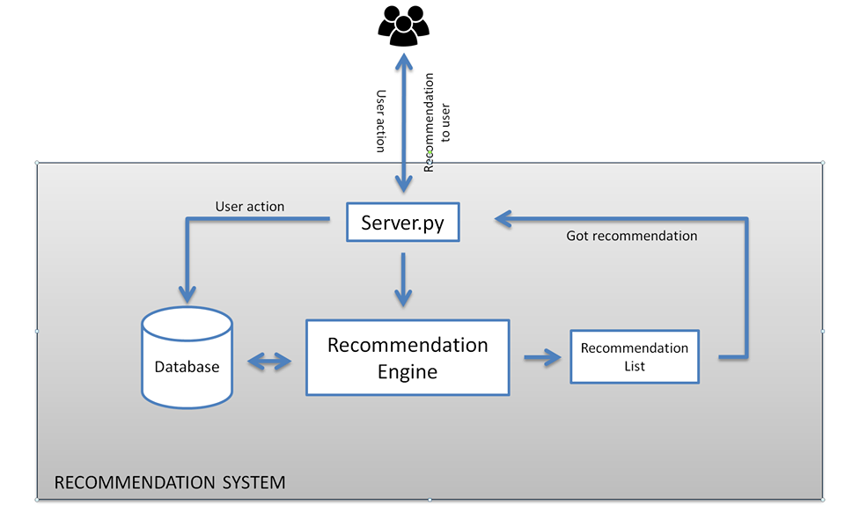

* **server.py**: using flask API handle request from client.
* **Recommendation engine**: get user data from requesttoanalysis then return recommended list gadgets.

#### Main approaches for Recommender Systems

Recommendation Systems are usually divided into two major groups:

* Collaborative-filtering: In this approach recommendation for each active user is received by comparing with the preferences of other users who have rated the product in similar way to the active user.
* Content-Based: In this approach recommendation depends on users former choices. Item description and a profile of the user’s orientation play an important role.

In our system, we are using hybrid filtering approaches combined both collaborative filtering and content-based. This approaches to overcome some common problems that are associated with above filtering approaches such as cold start problem.

##### **Data collection**

The data can be collected by two means: explicitly and implicitly.

* Explicit data is information that is provided intentionally: rating gadgets.
* Implicit data is information that is not provided intentionally but gathered from available data streams from search history, clicks.

##### **Data storage**

Data collected will be storaged in MySQL server and extracted when server get request.

##### **Filtering the data**

###### **Content based filtering**

This algorithm recommends products which are similar to the ones that user has most viewed in the past.

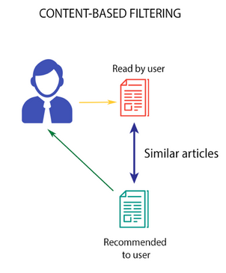

*Source: Medium*

**CountVectorizer:**

CountVectorizer works on Terms Frequency, i.e. counting the occurrences of tokens and building a sparse matrix of documents x tokens. In this approach, we are using CountVectorizer convert corpus to a matrix of token counts and build a vocabulary of known words.

|  |  |  |  |  |  |
| --- | --- | --- | --- | --- | --- |
|  | chatbot | mail | website | gadget | auto |
| Chatbot auto reply | 1 | 0 | 0 | 0 | 1 |
| Mail gadget for website | 0 | 1 | 1 | 1 | 0 |

The content-based filtering algorithm finds the cosine of the angle between the profile vector and item vector, i.e. **cosine similarity** then makes list recommendation based on similarity matrix**.** Suppose A is the profile vector and B is the item vector, then the similarity between them can be calculated as:

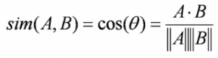

###### **Memory-Based collaborative filtering**

There are two kind of collaborative filtering: User-user based and Item-item based. In this system, we are choosing Item-item base because of some reasons:

* The number of items is usually smaller than the number of user; the similarity matrix is much smaller, which is convenient for storing and calculating in the following steps.
* Each item can be rated by many users. As a result, the average value of each row is less changed with a few more ratings. As such, updating the Similarity Matrix matrix can be done less frequently.

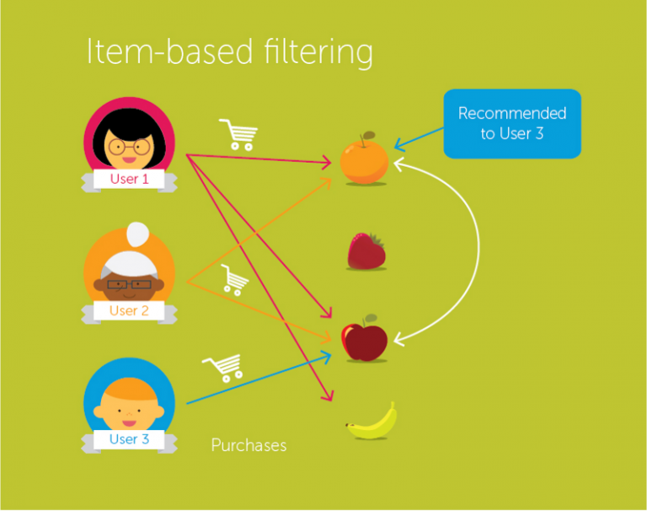

*Source: Medium*

This algorithm first finds the similarity score between item . Based on this similarity score, it then picks out the most similar gadget and recommends gadget which these users have liked or bought previously.

Item-item Collaborative filtering can be obtained from the User-user Collaborative filtering by transposing the utility matrix, and are considered items that are rate users. After calculating the final result, we reposition again to get the result.

**Cosine similarity:**

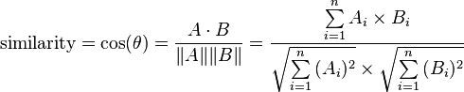

Where {\displaystyle A_{i}} θ is the angle between the vectors

$A_{i}$, $B_{i}$ is component of vector A, B

**Building item-to-item similarity matrix algorithm:**

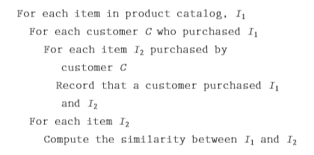

*Published by Amazon.com*

After implemented we got Similarity matrix.

|  |  |  |  |  |  |
| --- | --- | --- | --- | --- | --- |
|  | **Item 0** | **Item 1** | **Item 2** | **Item 3** | **Item 4** |
| **Item 0** | **1** | **0.77** | **0.49** | **-0.88** | **-0.52** |
| **Item 1** | **0.77** | **1** | **0** | **-0.64** | **-0.14** |
| **Item 2** | **0.49** | **0** | **1** | **-0.55** | **-0.88** |
| **Item 3** | **-0.89** | **-0.64** | **-0.55** | **1** | **0.68** |
| **Item 4** | **-0.52** | **-0.14** | **-0.88** | **0.68** | **1** |

*Similarity matrix*

**The resulting similarity ranges from −1 meaning exactly opposite, to 1 meaning exactly the same, with 0 indicating orthogonality or decorrelation, while in-between values indicate intermediate similarity or dissimilarity.**

The built item-to-item matrix is saved in a file as a Python pickle object which can be loaded to the memory very quickly.

**Predict rating for unrated items:**

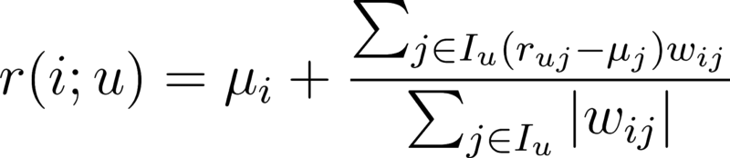

Where **r (i; u), $r_{ui}$** is predicted rating of item i for user u

$μ_{i}$**, $μ_{j}$** is average rating of item i to item j across all user

$I_{u}$ is the set of item rated by user u

$ω_{ij}$ indicate the similarity value between item i and item j

|  |  |  |  |  |  |  |  |
| --- | --- | --- | --- | --- | --- | --- | --- |
|  | **User 0** | **User 1** | **User 2** | **User 3** | **User 4** | **User 5** | **User 6** |
| **Item 0** | **5** | **5** | **2** | **0** | **1** | **1.68** | **2.70** |
| **Item 1** | **5** | **4.23** | **2.33** | **0** | **1.67** | **2** | **3.38** |
| **Item 2** | **4.15** | **4** | **1** | **-0.5** | **0.71** | **1** | **1** |
| **Item 3** | **2** | **2** | **3** | **4** | **4** | **2.10** | **4** |
| **Item 4** | **2** | **0** | **4** | **2.9** | **4.06** | **3.1** | **5** |

*Predicted missing ratings matrix*

###### **Advantages & limitations of algorithms**

* **Content-based filtering:**

**Advantages**

* Unlike Collaborative Filtering, if the items have sufficient descriptions, we avoid the “new item problem”.
* Content representations are varied and they open up the options to use different approaches like: text processing techniques, the use of semantic information, inferences, etc…
* It is easy to make a more transparent system: we use the same content to explain the recommendations
* Provide transparency to their active user by giving explanation how recommender system works.
* Content-based recommenders system is adequate to recommend items not rated by any user. This wills be advantageous for new user.

**Limitations**

* Content-Based RecSys tend to over-specialization: they will recommend items similar to those already consumed, with a tendency of creating a “filter bubble”.
* The methods based on Collaborative Filtering have shown to be, empirically, more precise when generating recommendations.
* **Collaborative filtering**

**Advantages**

* It benefits from large user bases: the more people are using the system, the better recommendations will become
* It’s flexible across different domains. Collaborative filtering approaches are well suited to highly diverse sets of items. It is based on real-life activity, allowing it to make connections between seemingly disparate item that nonetheless might be relevant to some set of users
* It produces more serendipitous recommendations. When it comes to recommendations, accuracy isn’t always the highest priority. Most users have interests that span different subsets, which in theory can result in more diverse (and interesting) recommendations.
* It can capture more nuance around items By relying on actual human experience, collaborative filtering can sometimes recommend items that have a greater affinity with one another than a strict comparison of their attributes would suggest.

**Limitations**

* Complexity and expense. Collaborative filtering algorithms can run into scalability problems when the number of users and items gets too high.
* Data sparsity Many user signals are ambiguous, users don’t rate every item they interact with, and many users don’t rate anything at all.
* The “cold start” problem: both to new items and to new users. Items with lots of history get recommended a lot, while those without never make it into the recommendation engine, resulting in a positive feedback loop. At the same time, new users have no history and thus the system doesn’t have any good recommendations.

##### **Hybrid filtering**

Basically, hybrid approach is to aggregate collaborative filtering and content-based filtering to improve recommendation accuracy then cold start and the sparsity are common problems in recommender systems which are resolved.

According [1] Recommendation Systems into following seven classes:

* Weighted: The scores (or votes) of several recommendation techniques are combined together to produce a single recommendation
* Switching: The system switches between recommendation techniques depending on the current situation.
* Mixed: Recommendations from several different recommenders are presented at the same time
* Feature Combination: Features from different recommendation data sources are thrown together into a single recommendation algorithm
* Feature Augmentation: Output from one technique is used as an input feature to another.
* Cascade: One recommender refines the recommendations given by another
* Meta-level: The model learned by one recommender is used as input to another.

In our system, we choose weighted hybrid technique.

**Weighted hybrid technique:**

This technique computes the prediction score as results of all recommendation approaches by considering them as variables in a linear combination. This technique gives each of them weight and summing up the weighted results.

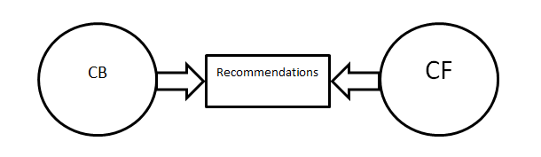

Since we are interested in combining 2 recommendation approaches. Weighted prediction score can be written as:

${\tilde{R}}_{u,i}$**= $σ_{1}$ $∙$ ${R_{u,i}}^{(1)}$ $+{(1 -σ}_{1})$ $∙$ ${R_{u,i}}^{(2)}$**

where $σ_{1}$ denotes weight of algorithm ${R_{u,i}}^{(1)}$

${\tilde{R}}_{u,i}$ Weighted prediction rating

${R_{u,i}}^{(1)}$ Prediction rating of Collaborative filtering algorithm.

${R_{u,i}}^{(2)}$ Prediction rating of algorithm Content-based algorithm.

The optimized weight can be gained by compute:

$σ_{1}$**= $\frac{∑_{u}∑_{i}(R_{u,i} - {R_{u,i}}^{\left(2\right)})({R_{u,i}}^{\left(1\right)} - {R_{u,i}}^{(2)})}{∑_{u}∑_{i}{({R_{u,i}}^{\left(1\right)} - {R_{u,i}}^{(2)})}^{2}}$**

### Reference

[1] R. Burke, “Hybrid recommender systems: survey and experiments”, User Modeling and User-Adapted Interaction 12 (4) (2002) 331–370.

[2] The optimization of weights in weighted hybrid recommendation algorithm Wenfu Lin School of Computer Science Communication University of China Beijing, China laodalinwenfu@gmail.com Ying Li, Shuang Feng, Yongbin Wang School of Computer Science Communication University of China Beijing, China.

### Related content

International Journal of Computer Applications (0975 – 8887) Volume 110 – No. 4, January 2015 31 Survey on Collaborative Filtering, Content-based Filtering and Hybrid Recommendation System.

# CHAPTER 5: SOFTWARE TESTING DOCUMENT

## Purpose

This is software testing document of Webgad System. The purpose of this chapter is to describe the test strategy, test plan, test approach and defect log.

The documentation can help and guide both development and testing team through the help of well-written specifications and test plans or a simple list to follow on testing to ensure the quality of the program.

Furthermore, this documentation is used to detect software failures, so that defects may be discovered and correct to ensure that our project is thoroughly tested and resulting in a successful implementation of a new social application we are developing. It contains the following sections:

* Test strategy
* Test plan
* Test approach
* Defect log
* Test report

## Test strategy

### Objective and scope

The objective of testing is to satisfy all the requirement of the business use cases. The scope of this test will be limited to testing Webgad web application. The quality goal is 100% test cases are executed and 98% passed.

### Testing tools and environment

#### Testing tools

|  |  |  |  |
| --- | --- | --- | --- |
| No | Name | Version | Description |
| 1 | Google chrome | 70.0.3538.77 | GUI testing |
| 2 | Junit library | 4.21 | Java unit test |
| 3 | Eclipse Java EE IDE | 4.8.0 | IDE for java unit test |

#### Testing environment

|  |  |  |  |
| --- | --- | --- | --- |
| No | Type of testing | Software | Hardware |
| 1 | Unit test | Google chrome 70.0.3538.77 | Personal computer with minimum requirements:   * Intel core i5 * Ram 8GB |
| Eclipse Java EE IDE 4.8.0 |
| 2 | Integration test, system test | Google chrome 70.0.3538.77 | Personal computer with minimum requirements:   * Intel core i5 * Ram 8GB |
| Eclipse Java EE IDE 4.8.0 |
| Java jdk1.8.0_161 |

### Resources and responsibilities

|  |  |  |
| --- | --- | --- |
| No | Resources | Responsibilities |
| 1 | Project manager | * Responsible for project schedules and overall success of the project. |
| 2 | Test leader | * Manage overall of the software quality. * Define test strategy. * Define test plan, test approach. * Create and review test case, defect log. |
| 3 | Tester | * Understand the requirements of the project. * Implement integration test following requirement. * Create test cases. * Execute test. * Log bug. |
| 4 | Developer | * Create unit test * Fix bug |

### Acceptance criteria

|  |  |  |
| --- | --- | --- |
| No | Acceptance criteria | Note |
| 1 | 100% test cases are executed |  |
| 2 | 98% test cases are passed |  |
| 3 | 95% of medium severity defects have been closed |  |
| 4 | 100% of high severity defects have been closed |  |

### Risk list

|  |  |  |  |  |
| --- | --- | --- | --- | --- |
| No | Condition | Mitigation | Contingency | Doer |
| 1 | The hardware maybe corrupted when testing | Change hardware | Re-plan schedule | DuyTQ |

### Test process

The test process is following the FPT-Software process.

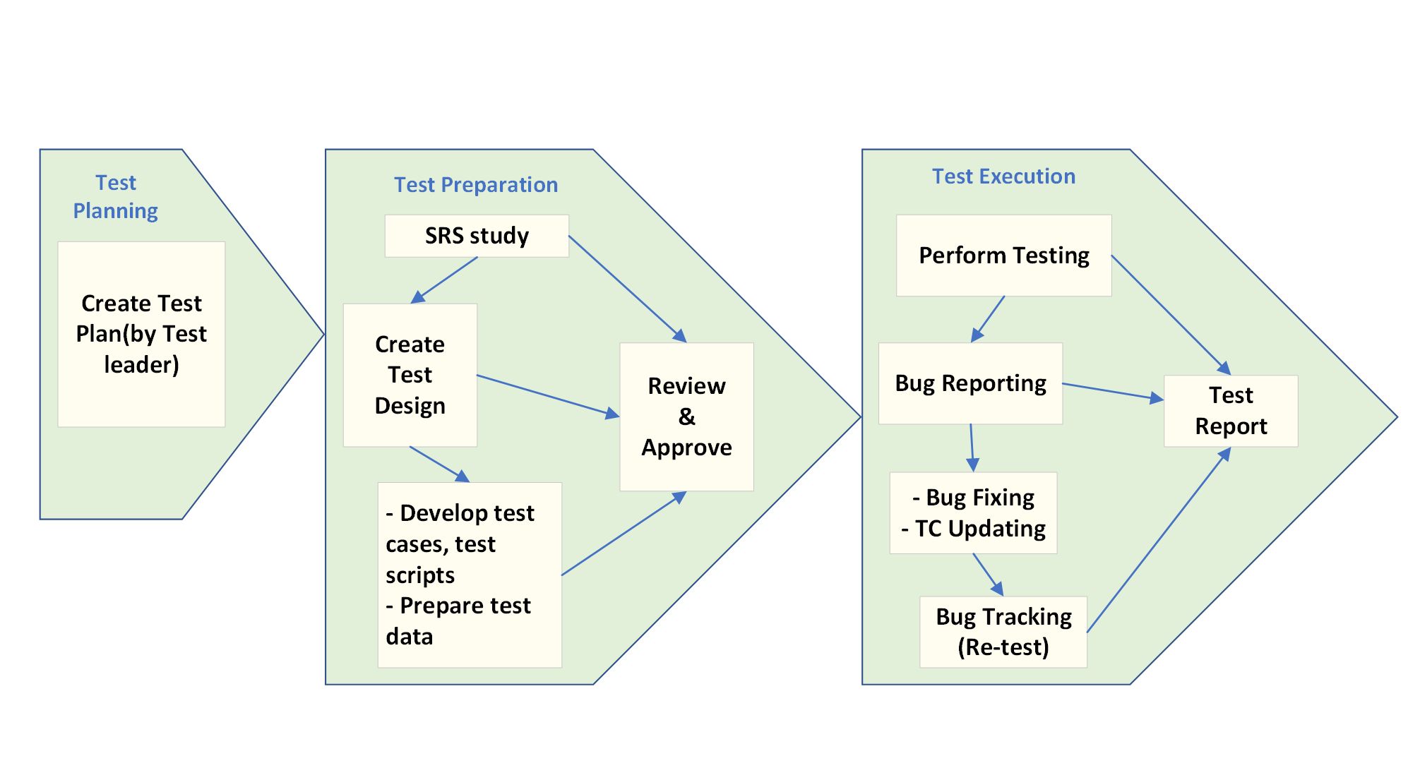

*Figure 5-1.Test process*

**Description:**

1. **Test plan:** Test leader takes responsible to create a test plan.
2. **Test preparation:** Testing team study the SRS document, create test design for each stage.
3. **Test execution:** Tester and developer perform the test following the plan. The bug is logged by tester and developer is assigned to fix the code in order to fix the bugs.

## Test plan

### Test model

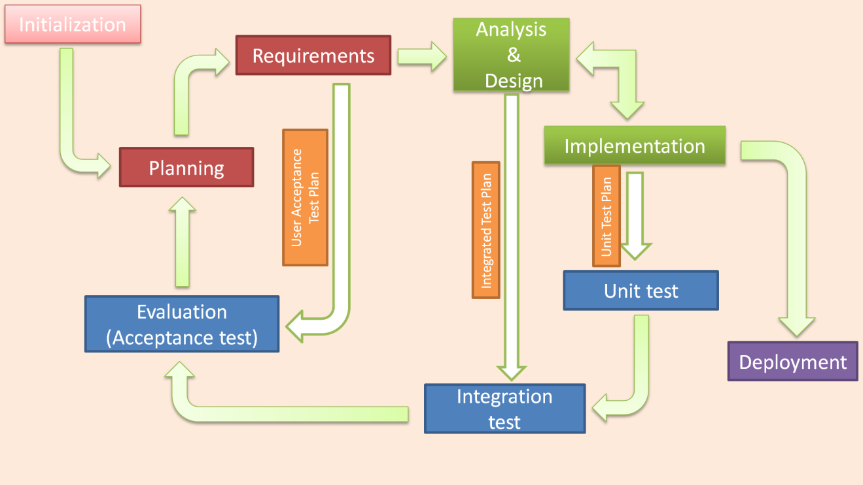

*Figure 5‑2.Iterative testing model*

### Stage of testing

|  |  |  |  |
| --- | --- | --- | --- |
| No | Testing level | Description | Implementation |
| 1 | Unit test | * **Unit test is performed by developers.** * **All the test cases are NOT documented.** | Development team:   1. Nguyễn Xuân Chức 2. Nguyễn Ngọc Lâm 3. Nguyễn Văn Vũ 4. Tô Quang Duy |
| 2 | Integration test | * **Integration test is performed by testers.** * **Material is “integration_test_case_v2.0.xls”.** | Tester team:   1. Nguyễn Thanh Sơn 2. Nguyễn Ngọc Lâm 3. Nguyễn Văn Vũ 4. Tô Quang Duy |
| 3 | System test | * **System test is performed by testers.** * **Material is “System_test_case.xls”.** | Tester team:   1. Nguyễn Thanh Sơn 2. Nguyễn Ngọc Lâm 3. Nguyễn Văn Vũ 4. Tô Quang Duy |
| 4 | Acceptance test | Acceptance test is performed by BA.  Material “User requirement”, “Check list”. | BA team:   1. Nguyễn Xuân Chức |

### Function to be tested

|  |  |  |  |
| --- | --- | --- | --- |
| No | Module | Function Name | Number of test case (Estimate) |
| 1 | Account Module | Register account | 13 |
| 2 | Forgot password | 5 |
| 3 | Change password | 14 |
| 4 | View user profile | 3 |
| 5 | Update user profile | 7 |
| 6 | View user payment information | 3 |
| 7 | Update user payment information | 8 |
| 8 | View developer information | 4 |
| 9 | Update developer information | 6 |
| 10 | Admin Module | Pay for the developer | 11 |
| 11 | Refunds for users | 13 |
| 12 | Verify a gadget | 9 |
| 13 | Console Module | View gadget dashboard | 3 |
| 14 | View created gadget project list | 1 |
| 15 | Gadget project overview | 2 |
| 16 | Create a gadget project | 7 |
| 17 | Delete a gadget project | 4 |
| 18 | Download gadget credential | 4 |
| 19 | Store Module | View gadgets by category | 3 |
| 20 | View gadgets by developer | 3 |
| 21 | View gadgets by top install | 1 |
| 22 | View on trending gadget | 1 |
| 23 | View user also install gadget | 2 |
| 24 | View latest gadget | 1 |
| 25 | View similar gadget | 1 |
| 26 | View details a gadget | 3 |
| 27 | View gadget comment list | 4 |
| 28 | Search gadget | 2 |
| 29 | Pay for a gadget | 7 |
| 30 | Report a gadget | 10 |
| 31 | Reviews a gadget | 10 |

### Function not to be tested

|  |  |  |
| --- | --- | --- |
| No | Module | Function name |
| 1 | Account Module | Send email confirm register, forgot password |
| 2 | Admin Module | Send email accept or reject report, refund |
| 3 | Store Module | Send email order, report, payment |
| 4 | Pay with paypal |

### Type of testing

The following type of testing is used in this project are:

|  |  |  |
| --- | --- | --- |
| No | Type of test | Description |
| 1 | Automation unit test | * Testing on code level to identify bugs in functions. |
| 2 | GUI test | * GUI test is used to test the user interface of the software. It will be performed fully on all screens. The target is to cover the verification of mocks defined before. It also includes fields:  1. Check if error messages are displayed correctly. 2. Check if Font is readable. 3. Check the screen solution |
| 3 | Functional test | * Functional test is used to test for each logical path of use case. |
| 4 | Acceptance test | * Passing all the use case without critical errors. |

The table below are the stages in which test are executed:

|  |  |  |  |  |
| --- | --- | --- | --- | --- |
| Type of test | Stage of test | | | |
| Unit test | Integration test | System test | Acceptance test |
| Automation unit test | √ |  |  |  |
| GUI test |  | √ | √ | √ |
| Functional test |  | √ | √ | √ |
| Acceptance test |  |  |  | √ |

### Test milestone

|  |  |  |  |
| --- | --- | --- | --- |
| Task | | Start date | End date |
| Iterator 1 | Create test plan | 10/15/2018 | 17/10/2018 |
| Create and execute unit test | 10/18/2018 | 24/10/2018 |
| Create and execute integration test | 10/18/2018 | 23/10/2018 |
| Create and execute system test | 10/25/2018 | 27/10/2018 |
| Create and execute acceptance test | 10/28/2018 | 29/10/2018 |
| Iterator 2 | Create test plan | 10/30/2018 | 01/11/2018 |
| Create and execute unit test | 11/02/2018 | 09/11/2018 |
| Create and execute integration test | 11/10/2018 | 17/11/2018 |
| Create and execute system test | 11/18/2018 | 21/11/2018 |
| Create and execute acceptance test | 11/22/2018 | 24/11/2018 |

### Deliverables

|  |  |  |  |
| --- | --- | --- | --- |
| No | Deliverables | Responsibilities | Delivered date |
| 1 | Test plan | Tô Quang Duy | 01/11/2018 |
| 2 | Unit test | Nguyễn Xuân Chức, Nguyễn Ngọc Lâm, Tô Quang Duy | 09/11/2018 |
| 3 | Integration test | Nguyễn Văn Vũ, Tô Quang Duy,  Nguyễn Ngọc Lâm | 17/11/2018 |
| 4 | System test | Nguyễn Ngọc Lâm | 21/11/2018 |
| 5 | Acceptance test | Nguyễn Xuân Chức | 24/11/2018 |
| 6 | Defect logs | Nguyễn Ngọc Lâm | 10/12/2018 |
| 7 | Final test summary report | Tô Quang Duy | 11/12/2018 |

## Test approach

### Unit test

#### Implement junit library

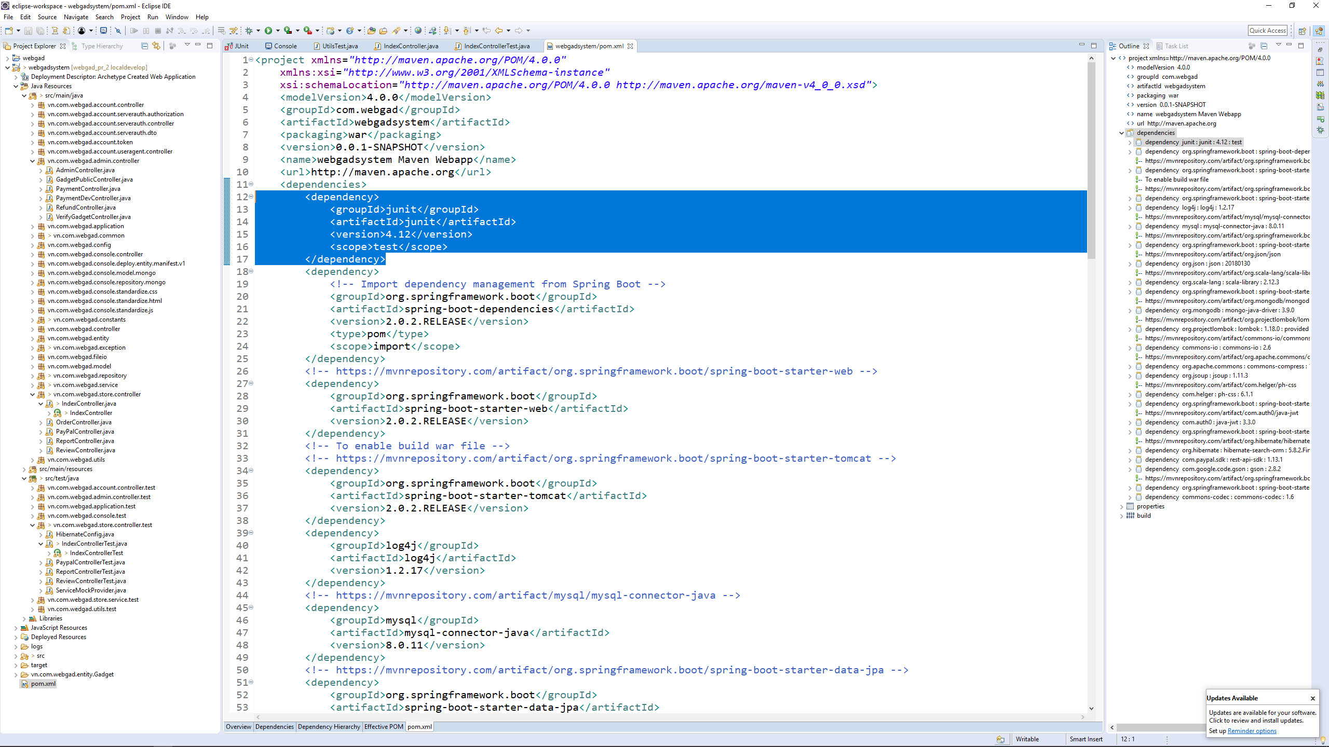

*Figure 5-3.Implement junit library*

#### Create test class and test method

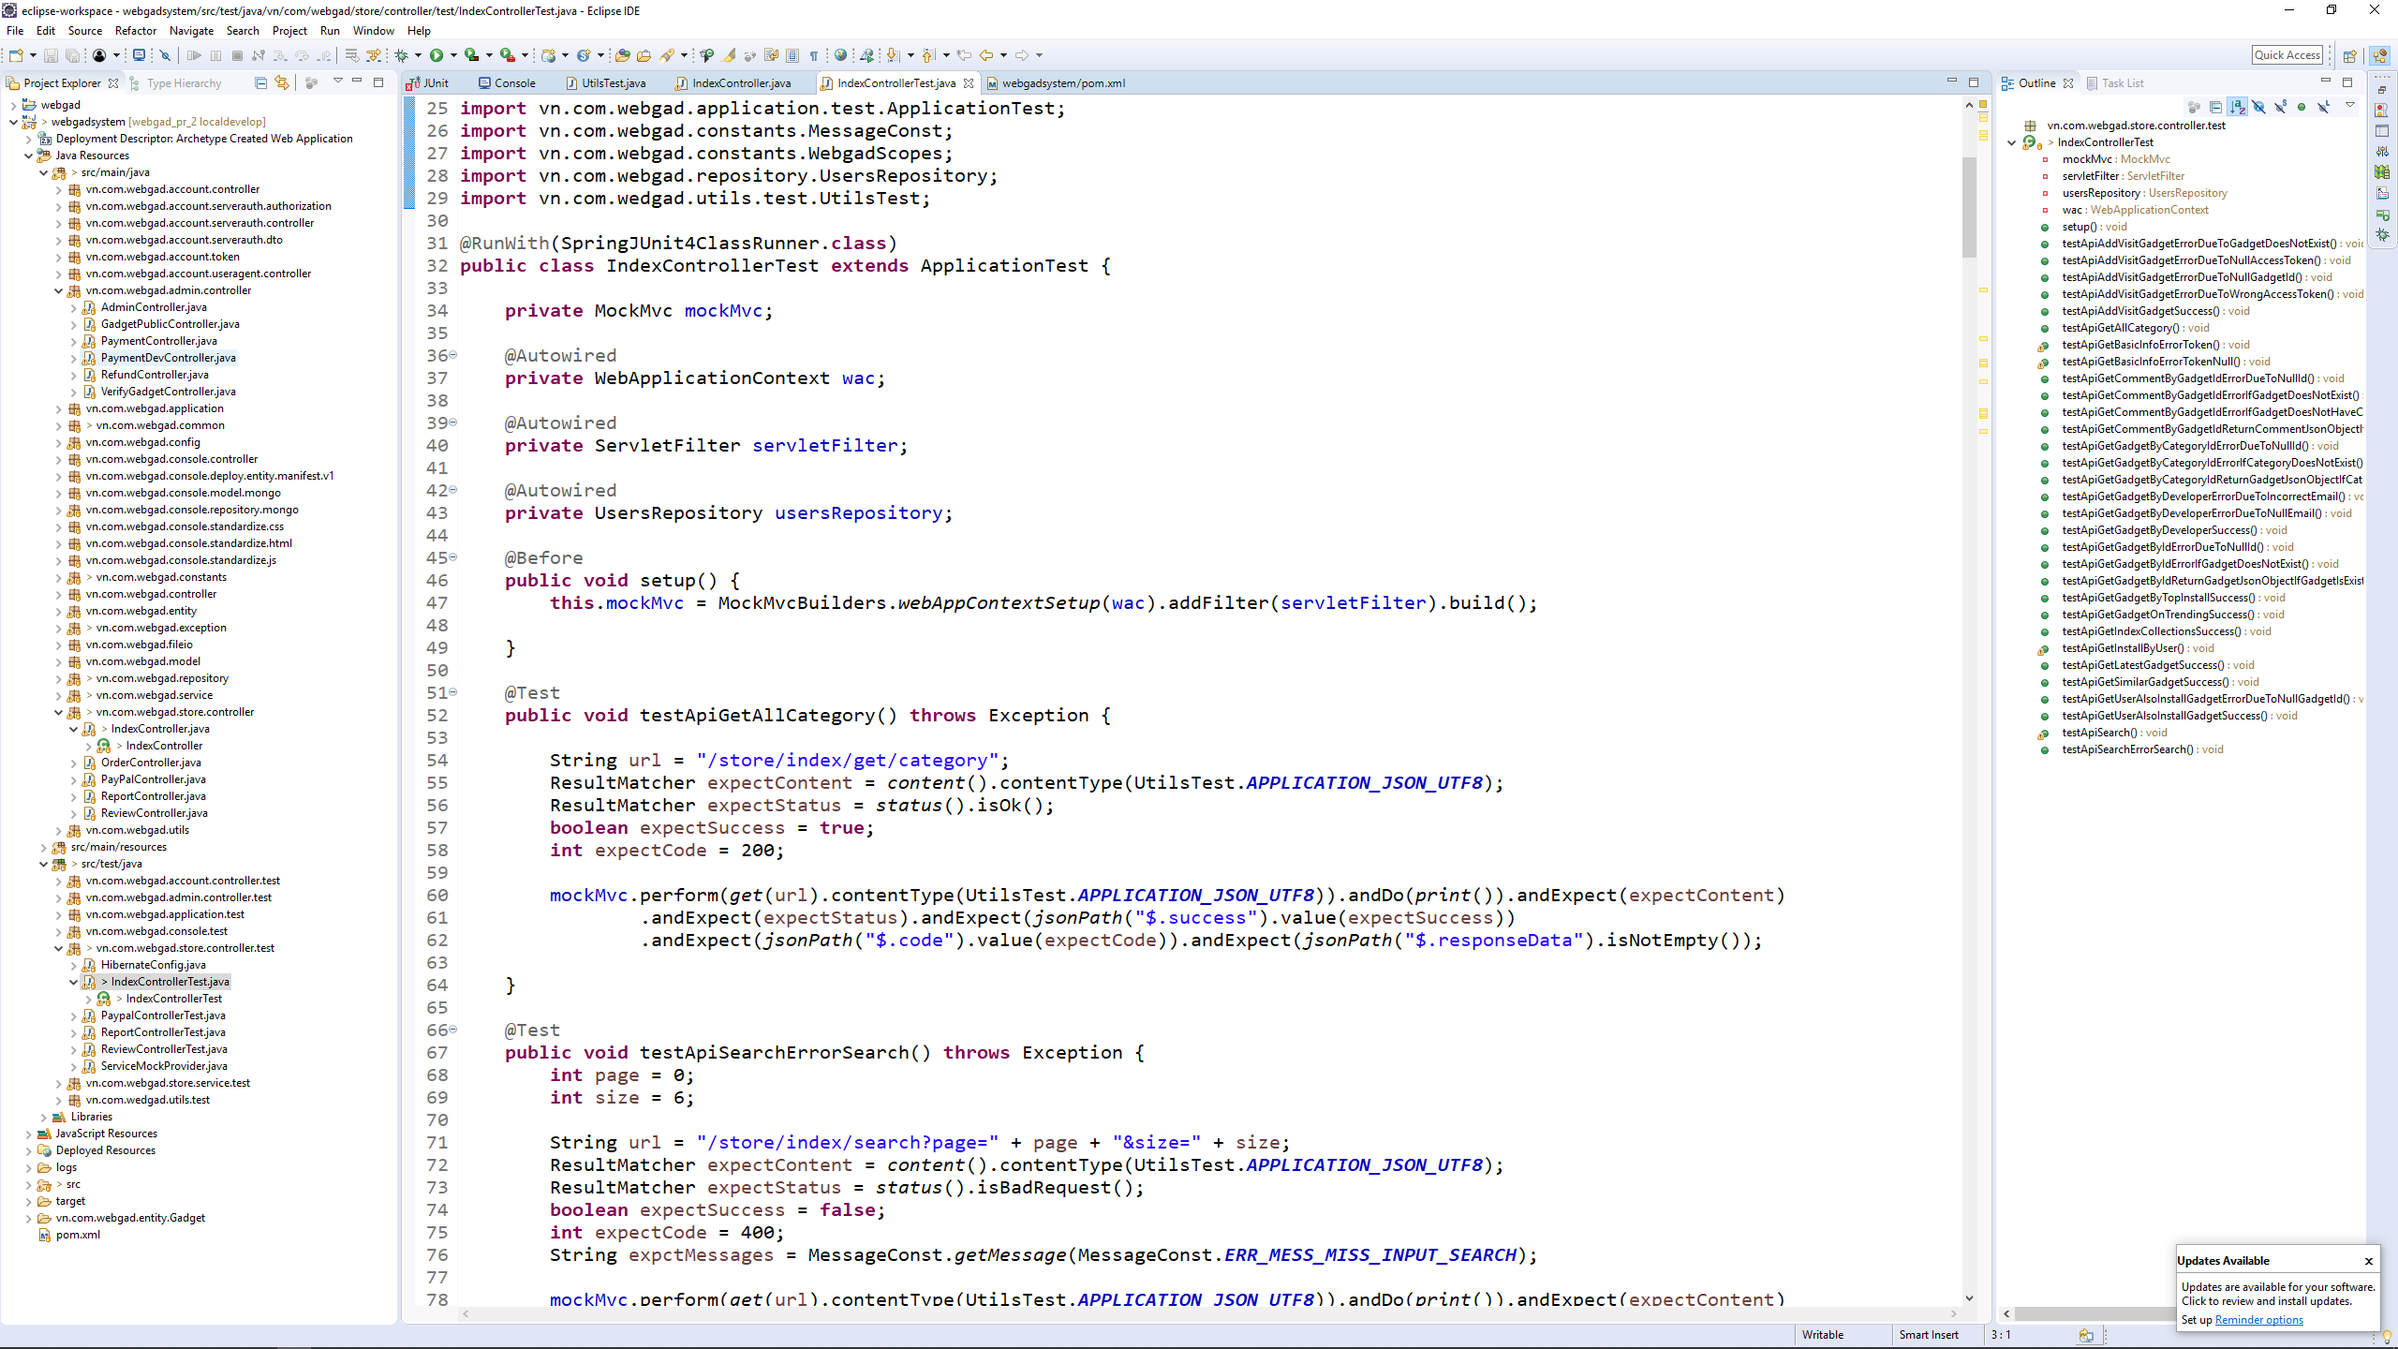

*Figure 5-4.Test class & test method*

#### Execute unit test

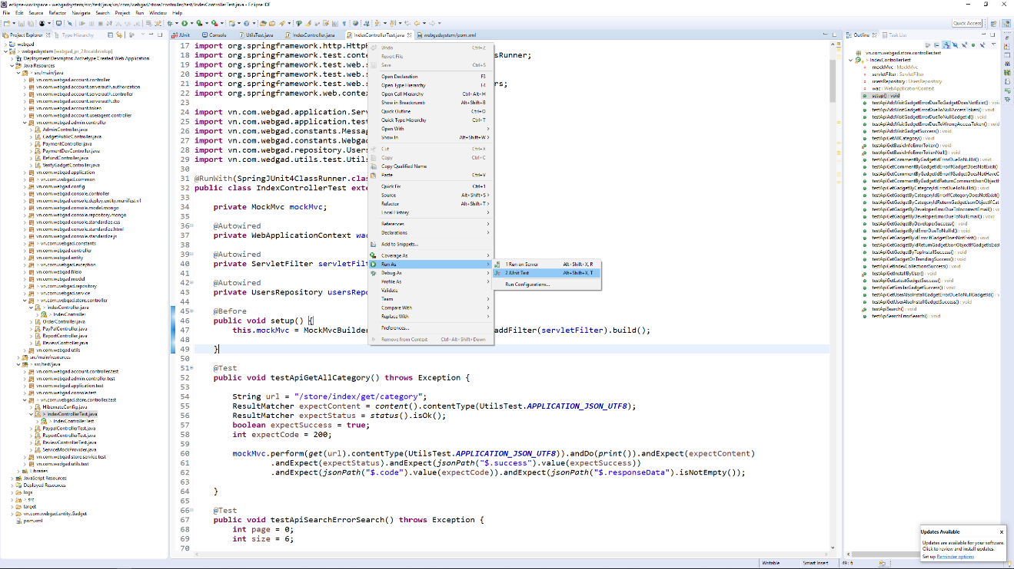

*Figure 5-5.Execute unit test*

#### Test result

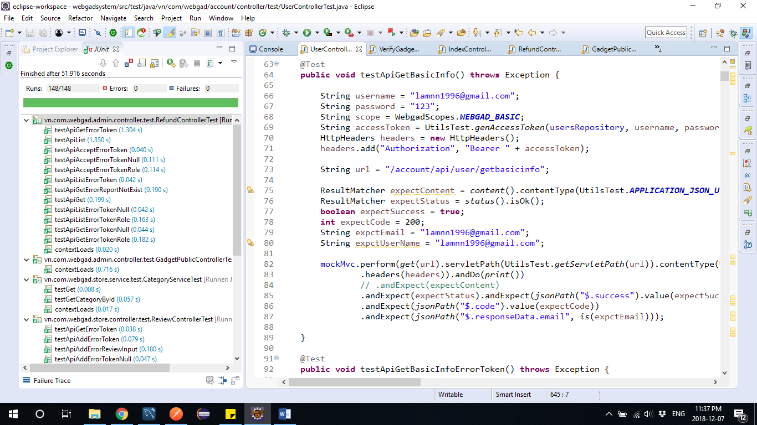

*Figure 5-6.Test result*

### Integration test

The detail test case is written in “Integration_test_case_v2.0.xls”.

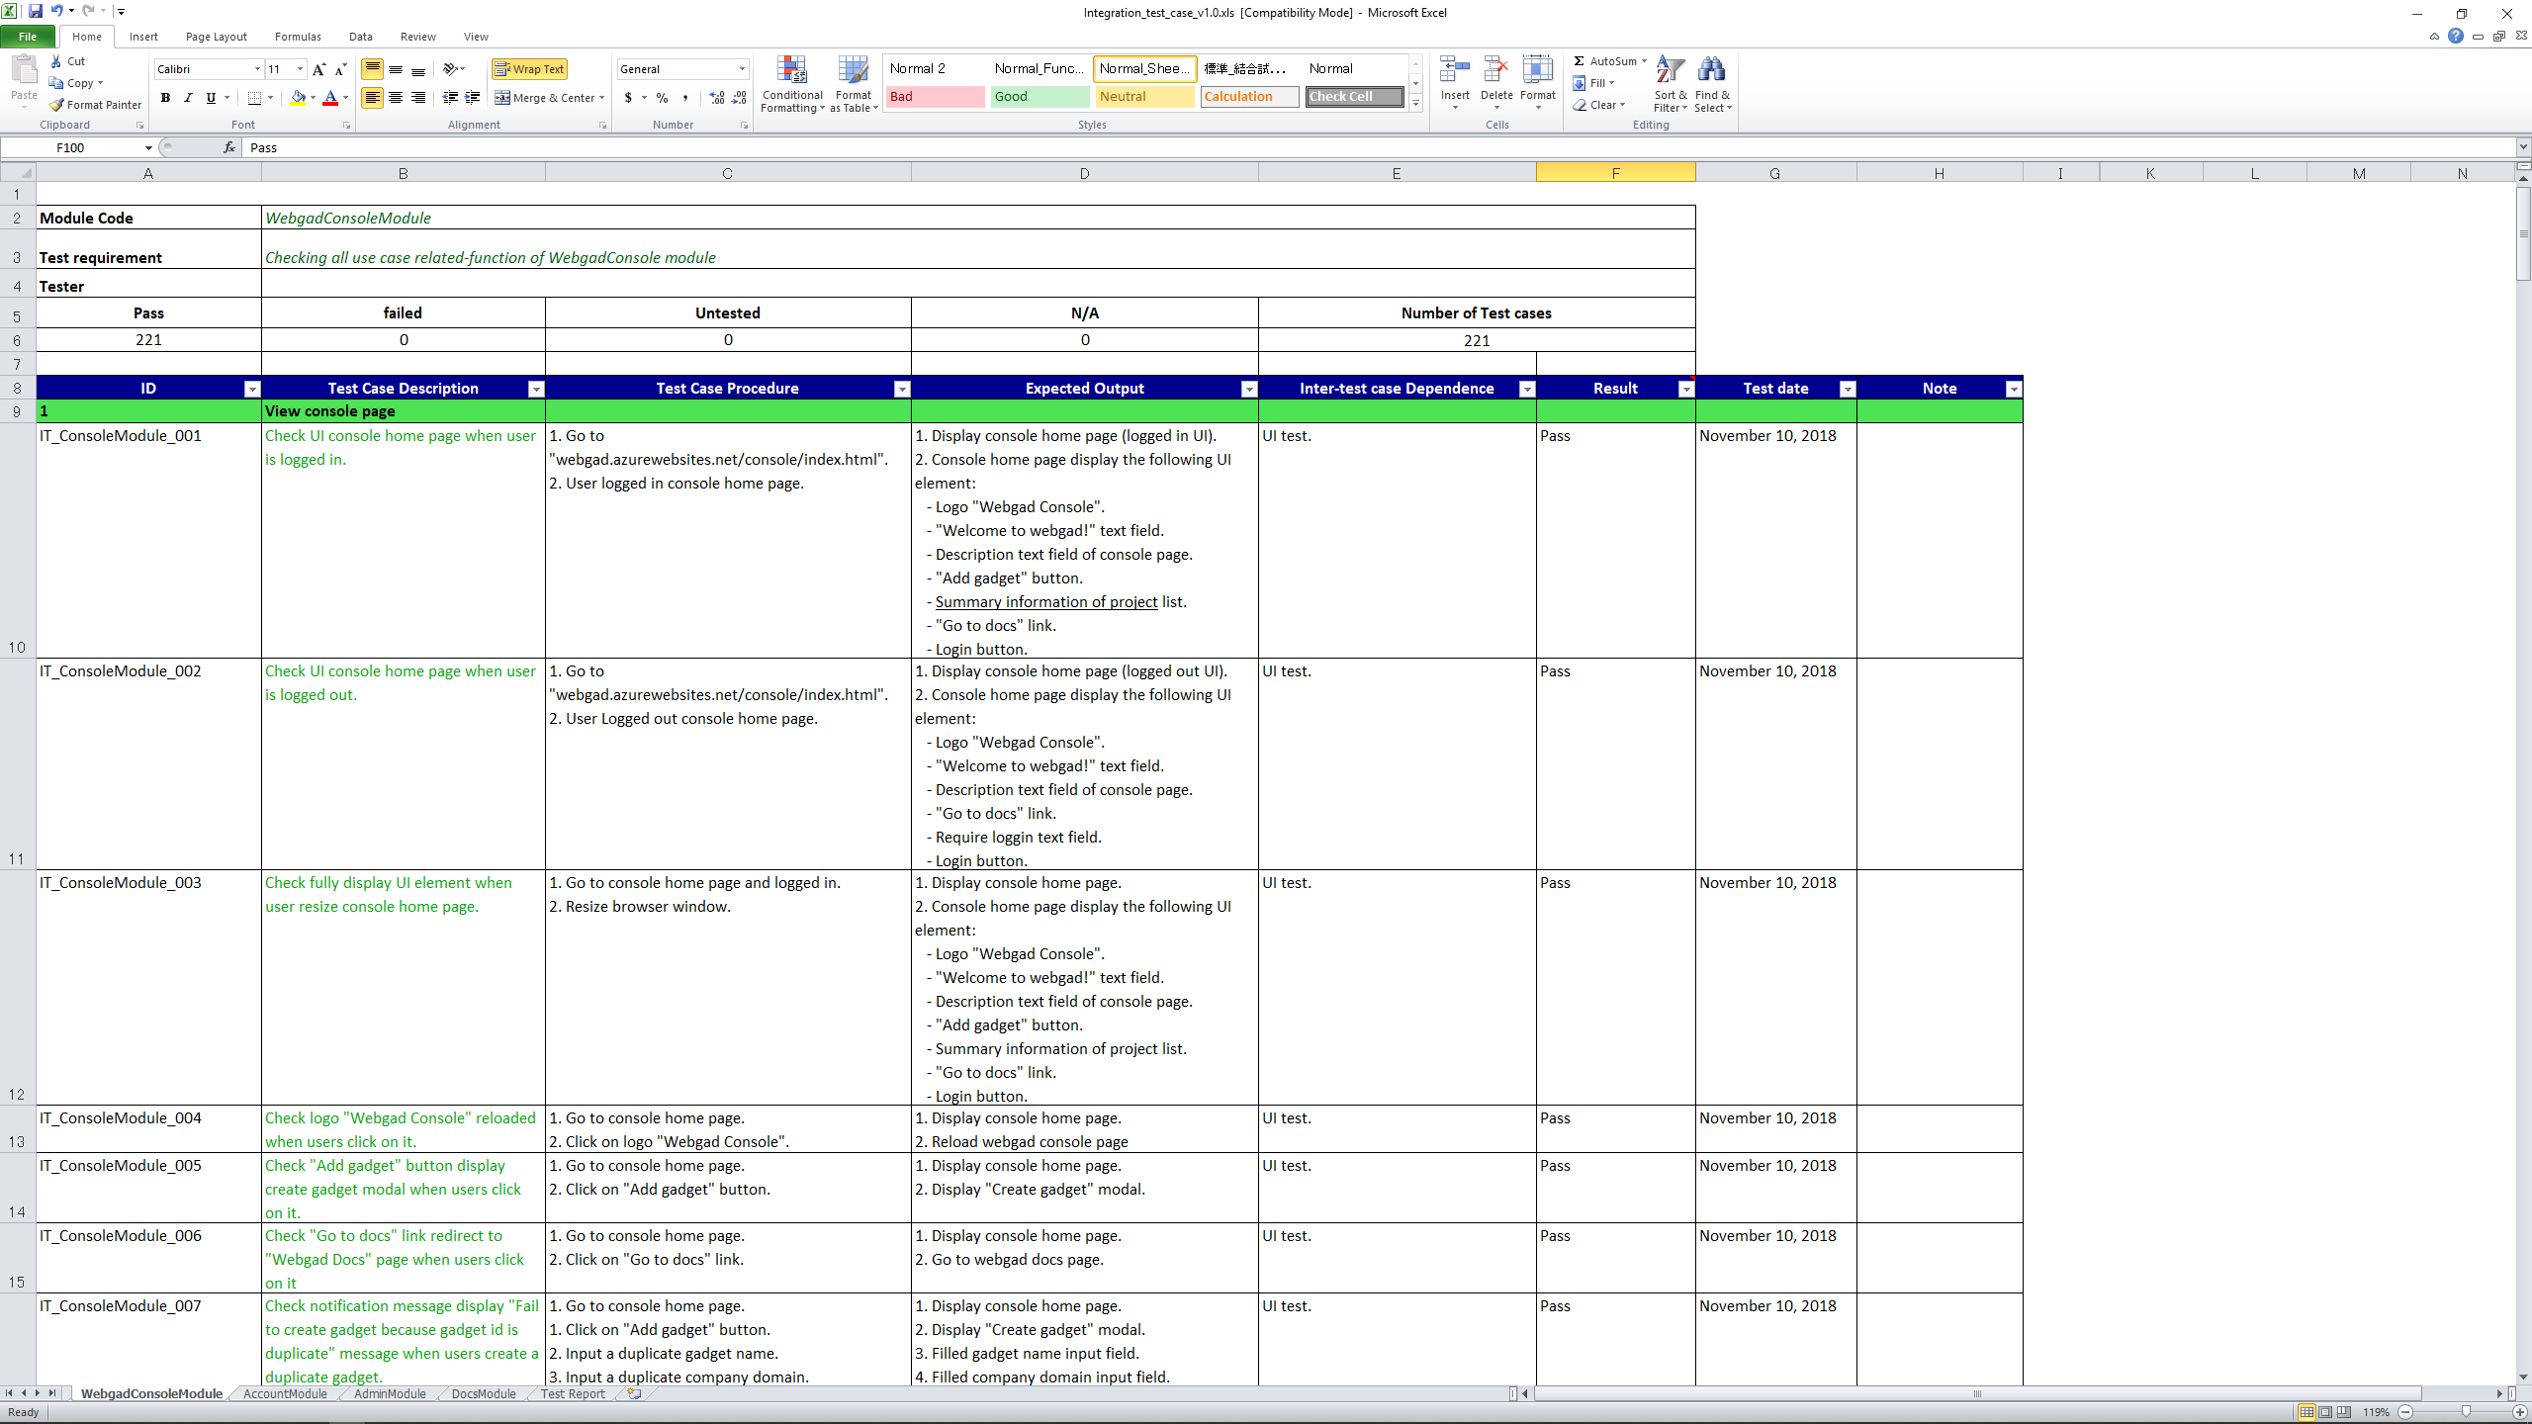

*Figure 5-7.Test case sample*

### Acceptance Test

We perform acceptance test to determine whether or not our system has met the requirement specifications. The main purpose of this test is to evaluate the system's compliance with the business requirements and verify if it is has met the required criteria for delivery to end users.

**Checklist:**

|  |  |  |  |
| --- | --- | --- | --- |
| No | Checklist | Yes | No |
| General | | | |
| 1 | Text on all pages for spelling and grammatical errors. | √ |  |
| 2 | Functionality of buttons available on all pages. | √ |  |
| 3 | Validation error messages are displayed properly. | √ |  |
| 4 | Delete functionality for any record on page are asked for confirmation. | √ |  |
| 5 | All numeric values are formatted properly. | √ |  |
| 6 | Navigation space is the same on all pages. | √ |  |
| 7 | Feature buttons on all page display with the right role of users. | √ |  |
| 8 | Numeric fields check whether negative numbers could be displayed. | √ |  |
| GUI and usability | | | |
| 1 | Display error page when error. | √ |  |
| 2 | Waiting icon appear for waiting display data. | √ |  |
| 3 | Color red is used for all error messages. | √ |  |
| 4 | Project state is displayed and colored with appropriate state | √ |  |
| 5 | Design style is friendly and easy to use | √ |  |
| 6 | The text easy to understand. Don't use slang, acronyms, and abbreviations. | √ |  |
| 7 | The static text is clear, concise, and meaningful. | √ |  |
| 8 | The screen designed to fit with multiple screen size. | √ |  |
| Performance | | | |
| 1 | Page load time is within acceptable range. | √ |  |

## Defect log

### Defect life cycle

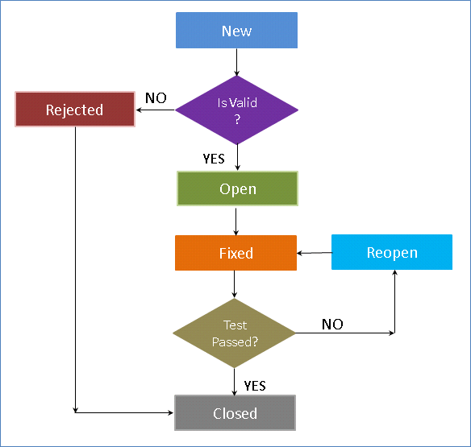

*Figure 5-8.Defect life cycle*

#### Description:

* We use Google Docs with defect log template of FPT-Software for logging defects.
* Processes:
* When a bug is found, testers change the status and assign for developer.
* Developers fix bugs and change status of bugs to resolve.
* If the bug is fixed then tester change the status to close, otherwise will be re-open again to fix.

### Defect sample

The defect is logged in “Defect_log_v2.0.xlsx” file.

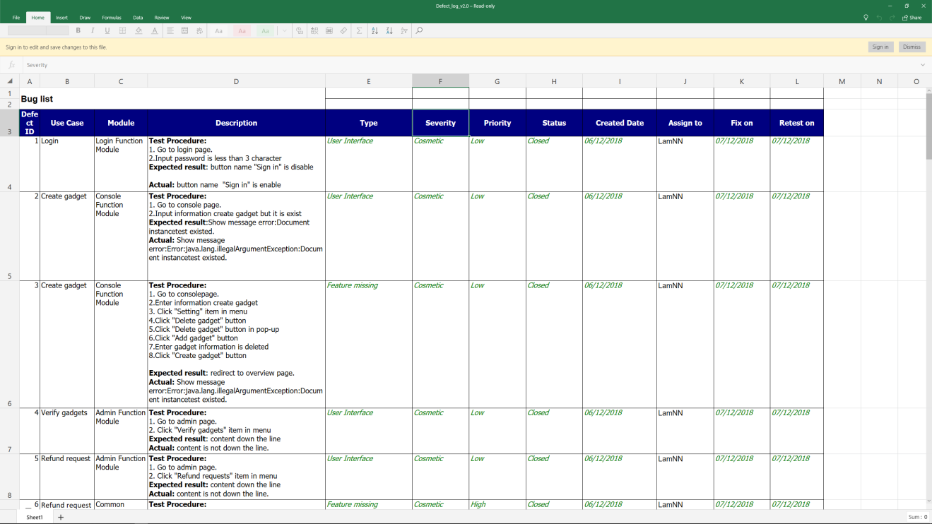

*Figure 5-9.Defect log*

## Test report

### Unit test report

|  |  |  |  |  |  |  |
| --- | --- | --- | --- | --- | --- | --- |
| No | Module | Function Name | Number of test case (Estimate) | Do not test | Pass | Fail |
| 1 | Account Module | Register account | 13 | 0 | 13 | 0 |
| 2 | Forgot password | 5 | 0 | 5 | 0 |
| 3 | Change password | 14 | 0 | 14 | 0 |
| 4 | View user profile | 3 | 0 | 3 | 0 |
| 5 | Update user profile | 7 | 0 | 7 | 0 |
| 6 | View user payment information | 3 | 0 | 3 | 0 |
| 7 | Update user payment information | 8 | 0 | 8 | 0 |
| 8 | View developer information | 4 | 0 | 4 | 0 |
| 9 | Update developer information | 6 | 0 | 6 | 0 |
| 10 | Admin Module | Pay for the developer | 11 | 0 | 11 | 0 |
| 11 | Refunds for users | 13 | 0 | 13 | 0 |
| 12 | Verify a gadget | 9 | 0 | 9 | 0 |
| 13 | Console Module | View gadget dashboard | 3 | 0 | 3 | 0 |
| 14 | View created gadget project list | 1 | 0 | 1 | 0 |
| 15 | Gadget project overview | 2 | 0 | 2 | 0 |
| 16 | Create a gadget project | 7 | 0 | 7 | 0 |
| 17 | Delete a gadget project | 4 | 0 | 4 | 0 |
| 18 | Download gadget credential | 4 | 0 | 4 | 0 |
| 19 | Store Module | View gadgets by category | 3 | 0 | 3 | 0 |
| 20 | View gadgets by developer | 3 | 0 | 3 | 0 |
| 21 | View gadgets by top install | 1 | 0 | 1 | 0 |
| 22 | View on trending gadget | 1 | 0 | 1 | 0 |
| 23 | View user also install gadget | 2 | 0 | 2 | 0 |
| 24 | View latest gadget | 1 | 0 | 1 | 0 |
| 25 | View similar gadget | 1 | 0 | 1 | 0 |
| 26 | View details a gadget | 3 | 0 | 3 | 0 |
| 27 | View gadget comment list | 4 | 0 | 4 | 0 |
| 28 | Search gadget | 2 | 0 | 2 | 0 |
| 29 | Pay for a gadget | 7 | 0 | 7 | 0 |
| 30 | Report a gadget | 10 | 0 | 10 | 0 |
| 31 | Reviews a gadget | 10 | 0 | 10 | 0 |
| Total | | | 165 | 0 | 165 | 0 |

### Integration test report

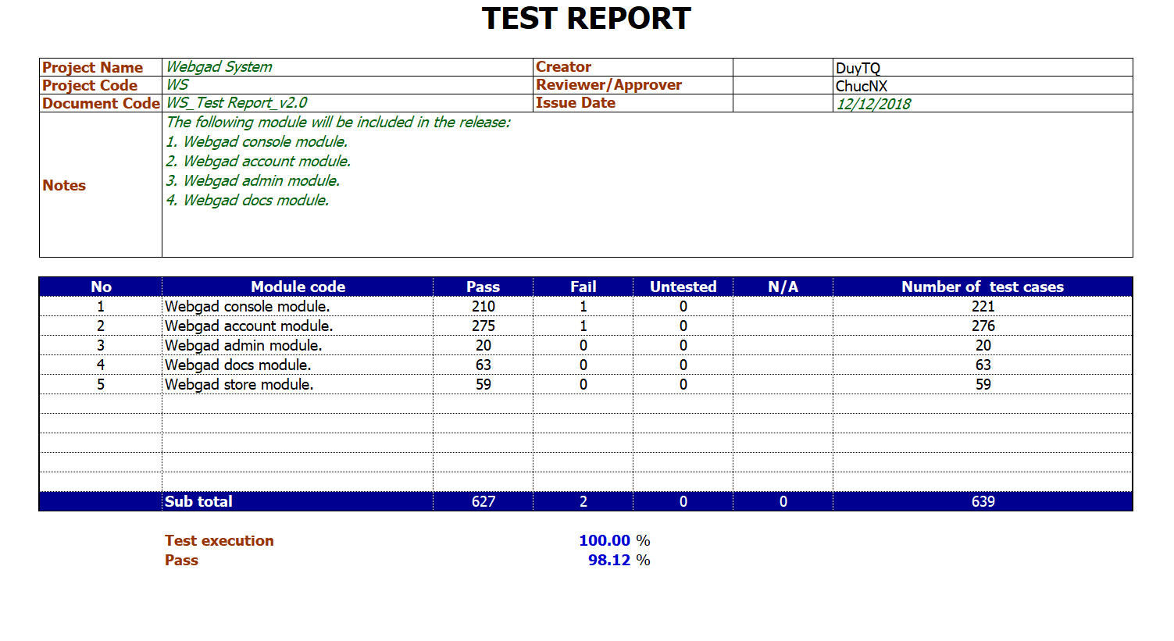

*Figure 5-10.Integration test report*

# CHAPTER 6: SOFTWARE USER’S MANUAL

## Webgad System deployment guidelines

### Prepare environment

Create a tomcat server on Azure, Example app name: webgad

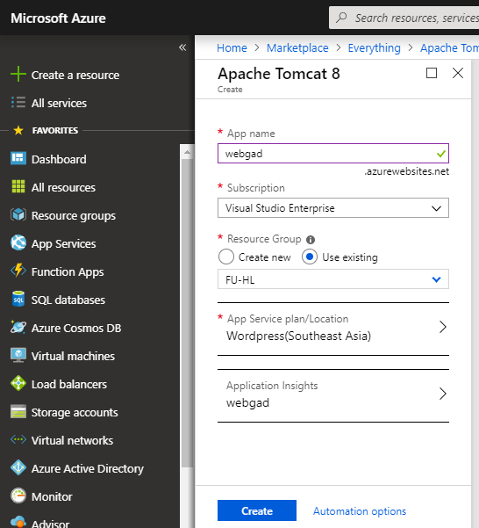

Add user role and username, password to allow deploy gadgets

* Go to <https://webgad.scm.azurewebsites.net/dev>
* Open file bin/apache-tomcat-8.5.24/conf/tomcat-users.xml
* Add the following lines inside the <tomcat-users> tag

<role rolename="manager-script"/>

<user username="managerscript" password="your-password" roles="manager-script"

In project, update file config.properties inside resources folder

DEPLOY_SERVER_URI=https://webgad.azurewebsites.net

DEPLOY_SERVER_USERNAME=managerscript

DEPLOY_SERVER_PASSWORD=yourpassword

Update sql connection string: Open files hibernate.properties and update the values of jdbc.driverClassName, jdbc.url, jdbc.username, jdbc.password according to your sql connection configuration.

Update no sql connection string: Open file mongo.properties and update the values of mongo.database, spring.data.mongodb.uri according to your no sql connection configuration.

Update email address of mailer: Open file application.properties and update the values of spring.mail.username, spring.mail.password according to your email information

### Deploy webgad server

Export source code project to war file: In Eclipse, right click project, select Export…, select WAR file, save file with name ROOT.war

Deploy project using war file

* Open <https://webgad.scm.azurewebsites.net/dev>.
* Navigate to folder bin/apache-tomcat-8.5.24/webapps.
* Delete project ROOT if exists.
* Right click folder webapps, select Upload Files.
* Select the war file that you just exported.

## Recommendation server deployment guidelines

### Prepare environment

#### Install python

* Download and install python follow their guide at [*https://www.python.org/downloads/release/python-367*](https://www.python.org/downloads/release/python-367)*.*

#### Install virtualenv and virtualenvwrapper

Virtualenv creates a new directory where the dependencies will be installed.

* Open command prompt and type the following commands:
  + *pip install virtualenv*
  + *pip install virtualenvwrapper-win*
* Create a new virtual environments by the following command:
  + *mkvirtualenv env*

Virtualenvwrapper will create a package name “Envs” and virtual environment “env” by default.

* Move our python source code to “Envs” folder.
* To activate “env” environment, use the command:
  + *workon env*

#### Install dependencies

* Activate “env” environment, use the command:
* *workon env*
* Install the following dependencies by typing the following commands:
* *pip install flask*
* *pip install flask-sqlalchemy*
* *pip install pymysql*
* *pip install numpy*
* *pip install pandas*

#### Update sql connection string

Update sql connection string: Open files config.py and update the values of jdbc.driverClassName, jdbc.url, jdbc.username, jdbc.password according to your sql connection configuration.

### Deploy recommendation server

* Open command prompt and typing the following commands:
* *cd Envs*
* *workon env*
* *set flask_config=development*
* *set flask_app=run.py*
* *flask run --host=0.0.0.0*

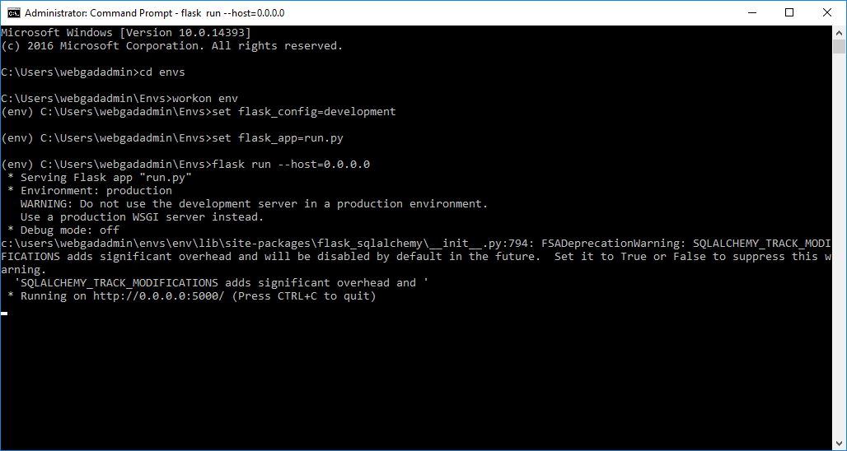

*Figure 6-1.Deploy recommend server*

## User guides

To access “Webgad System” user must open browser and enter <https://webgad.azurewebsites.net/>.

### Guide for Guest

#### Sign-up

1. Access to “Webgad System”.
2. Click on button “Sign in” on top right of page.

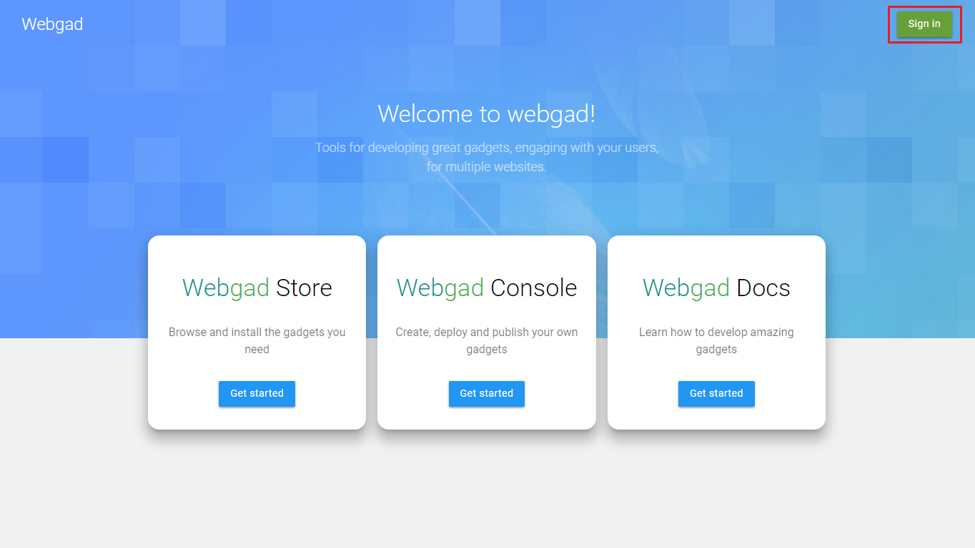

1. Click on link “Create account”.

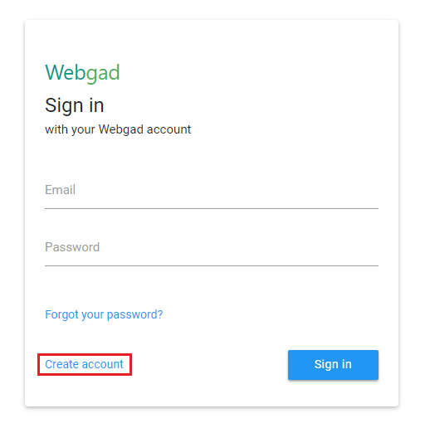

1. Input information to all field.

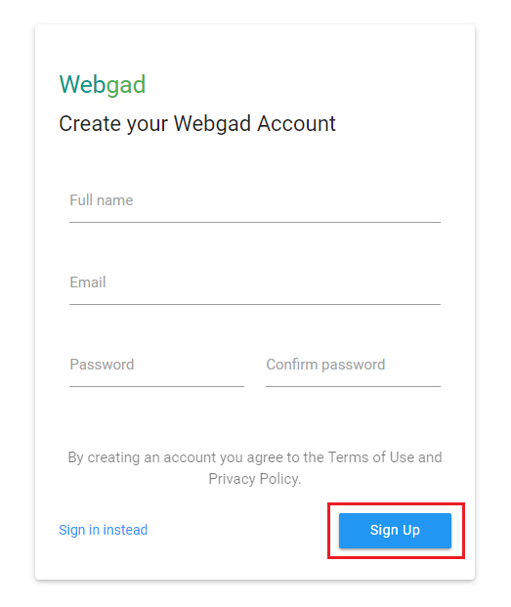

1. Click on button “Sign up”.

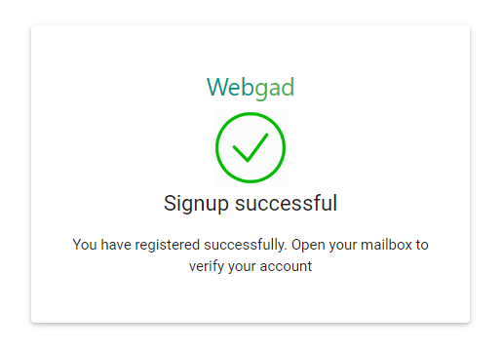

1. Sign-up successfully and open your email, click on button “Validate Account” to verify account.

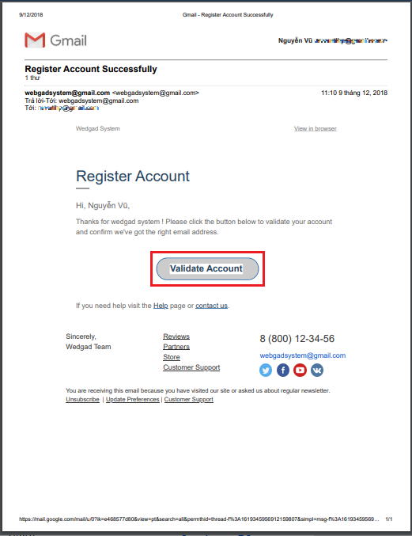

1. Verify account successfully and click on button “Go home” to ready to using all service of “Webgad System”.

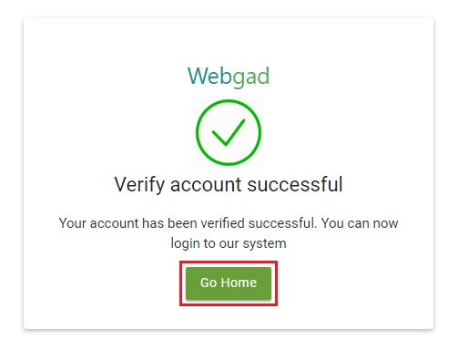

#### View Store

1. Access to “Webgad System”.
2. Click on button “Get started” below logo “Webgad Store”.

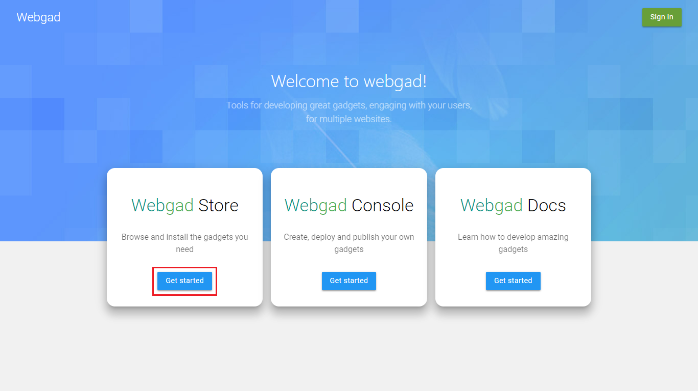

1. Starts choose a gadget to install.

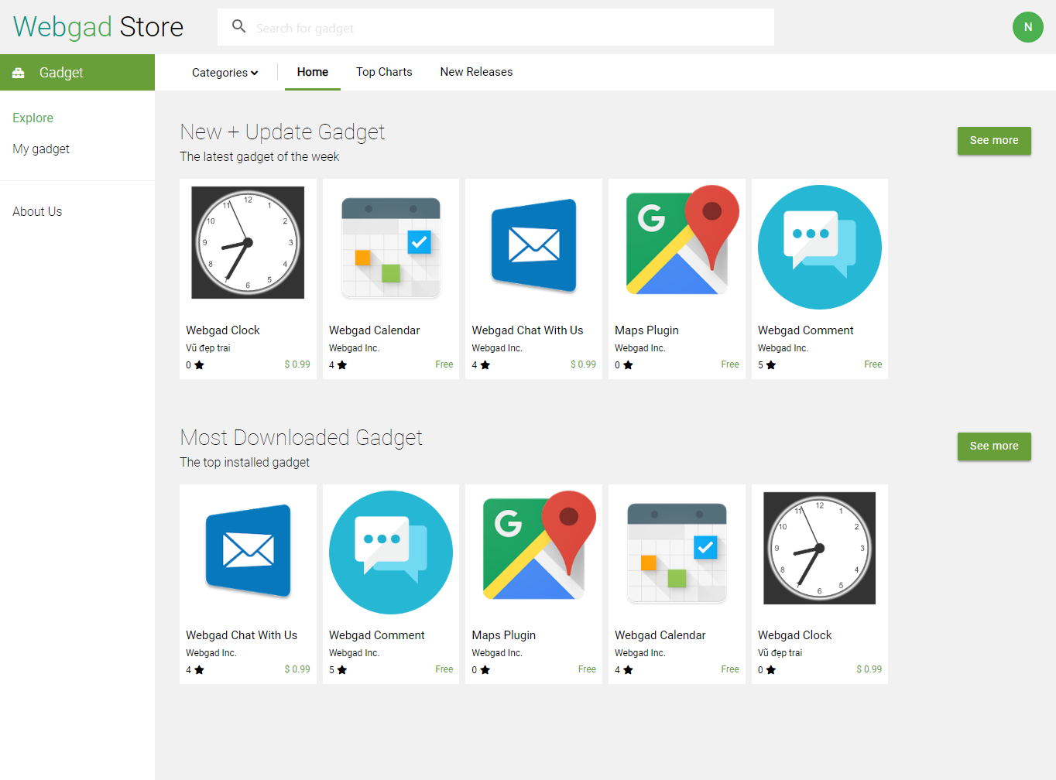

#### View Document

1. Access to “Webgad System”.
2. Click on button “Get started” below logo “Webgad Docs”.

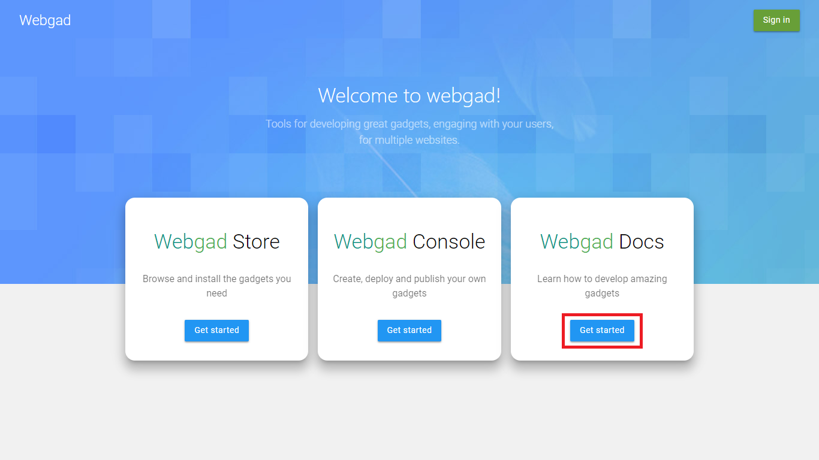

1. Guideline and sample to install or develop a gadget on “Webgad System”.

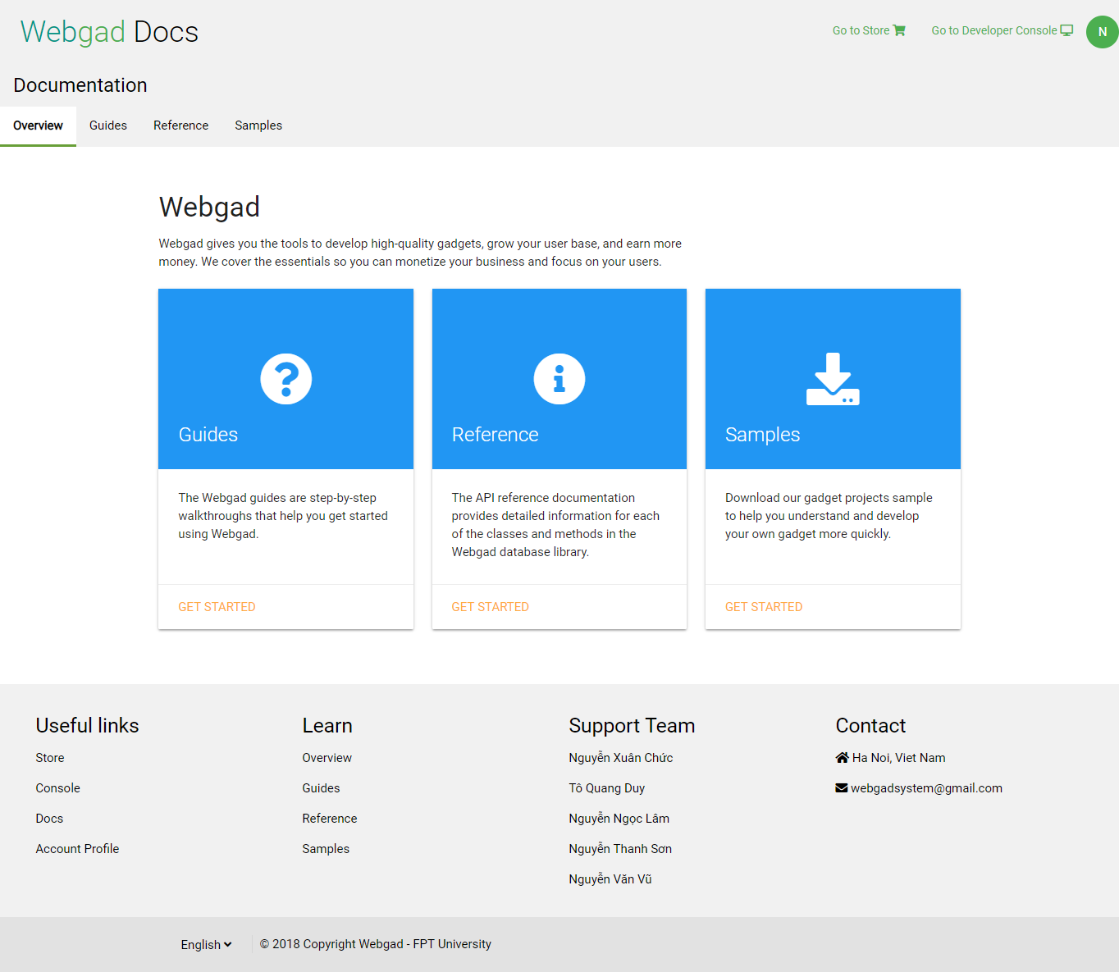

### Guide for User

#### Sign-in

1. Access to “Webgad System”.
2. Click on button “Sign in” on top right of page.

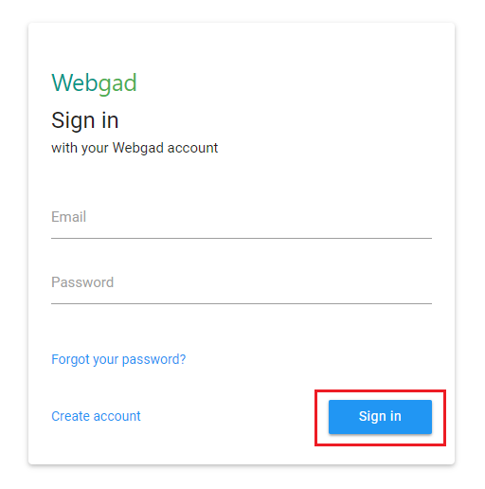

1. Input “Email” and “Password then click on button “Sign in”.

#### Sign-out

1. After login to the system, click on your avatar on top right of page.
2. Click on button “Sign out”.

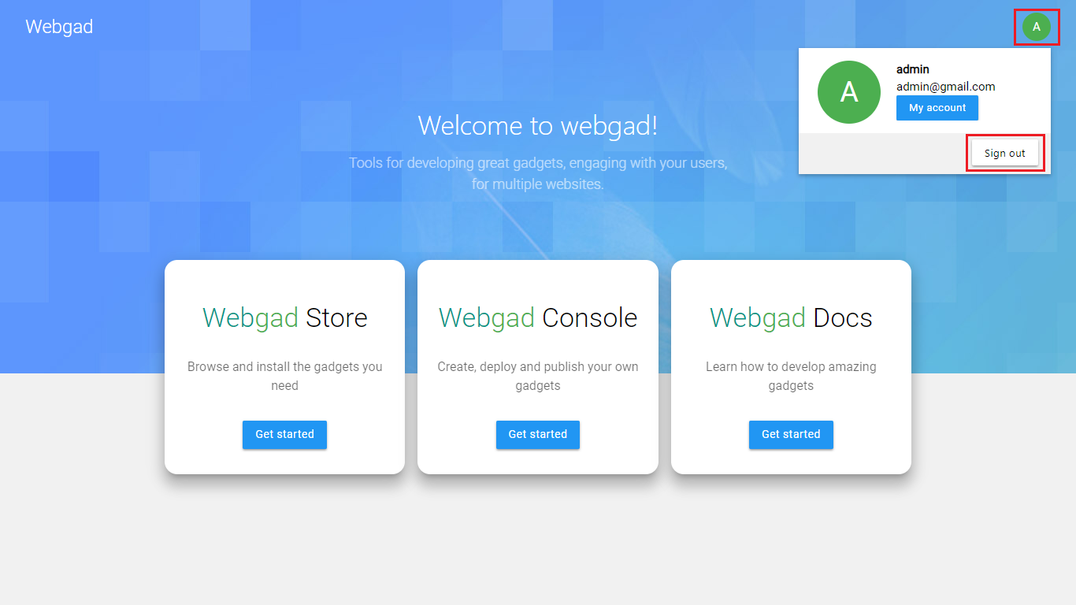

#### Change password

1. After login to the system, click on your avatar on top right of page.
2. Click on button “My account”.

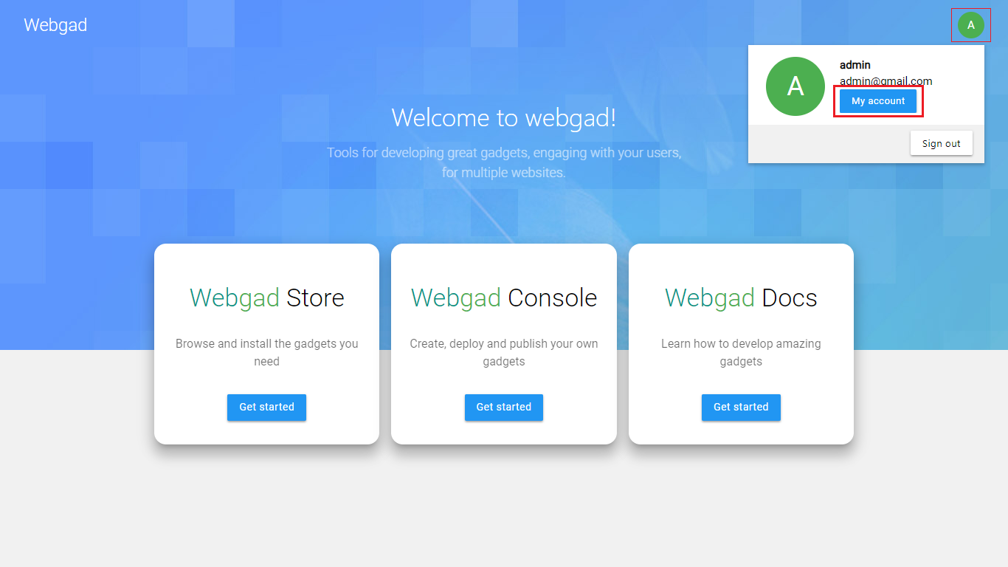

1. Click on link “Change password”

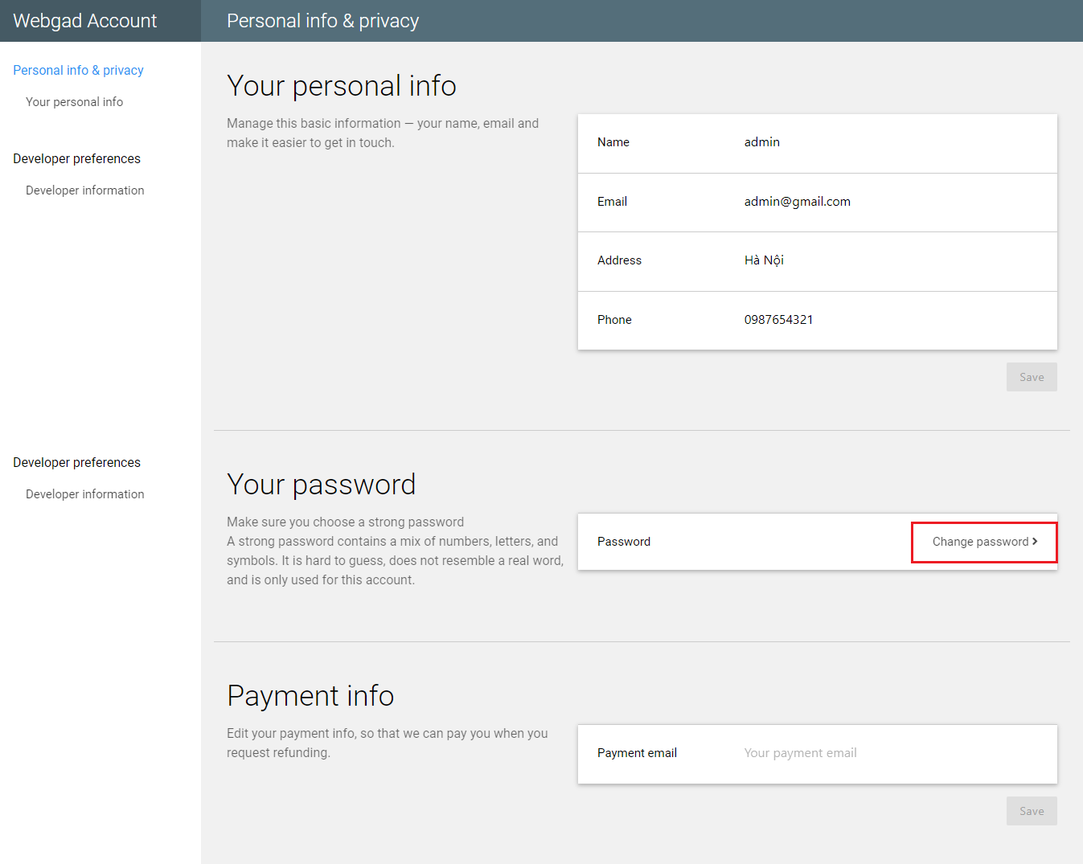

1. Input information to all field then click on button “Change password”.

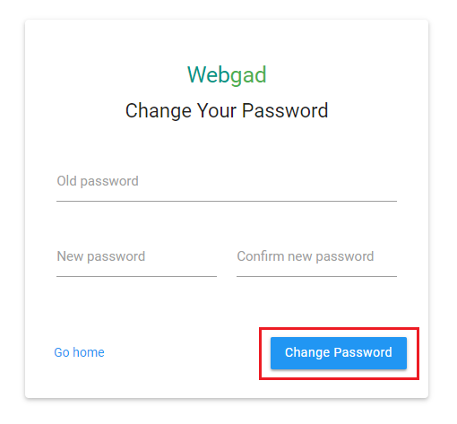

1. Change password successfully and click on button”Go home”.

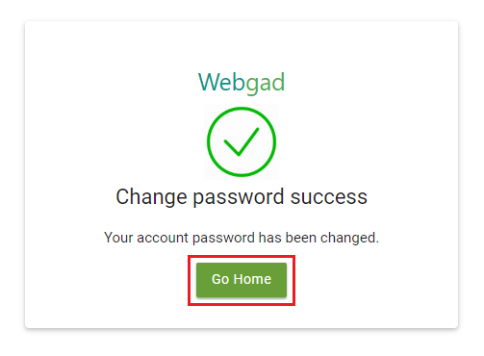

#### Forgot password

1. Access to “Webgad System”.
2. Click on button “Sign in” on top right of page.
3. Click on link “Forgot your password?”.

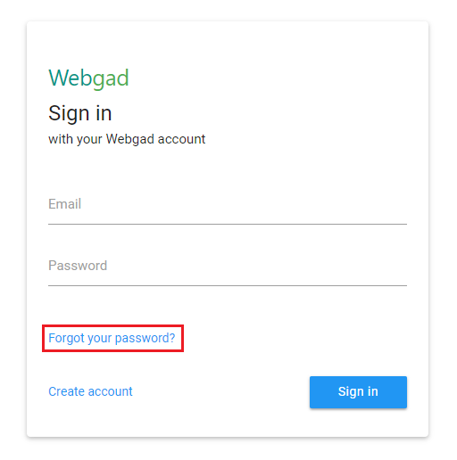

1. Input email registered to text field then click on button “Reset Password”.

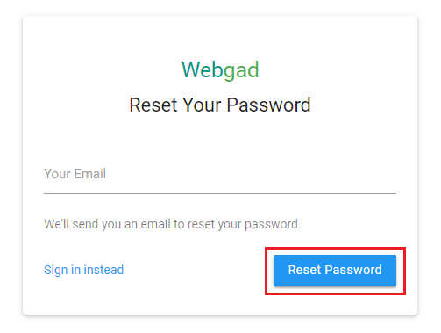

1. Reset password successfully and open your email.

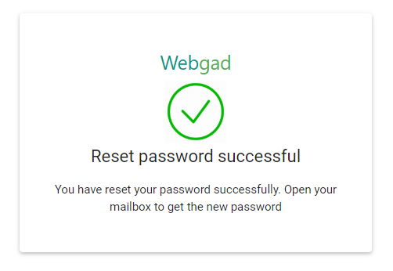

1. Use new password to sign-in the “Webgad System” and change your password.

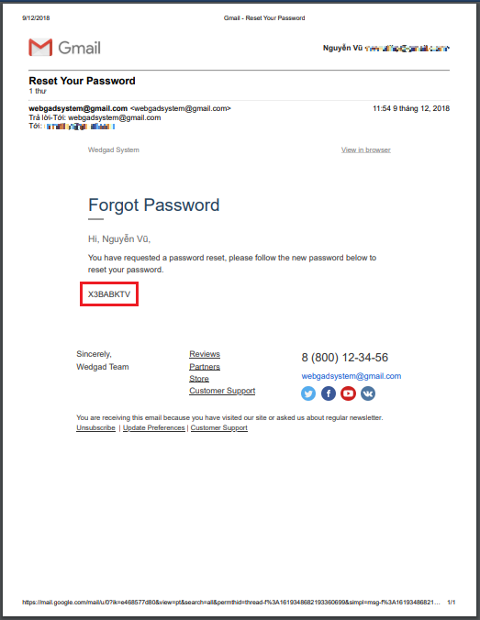

#### Edit profile

1. After login to the system, click on your avatar on top right of page.
2. Click on button “My account”.



1. Update information to all field and click on button “Save”.

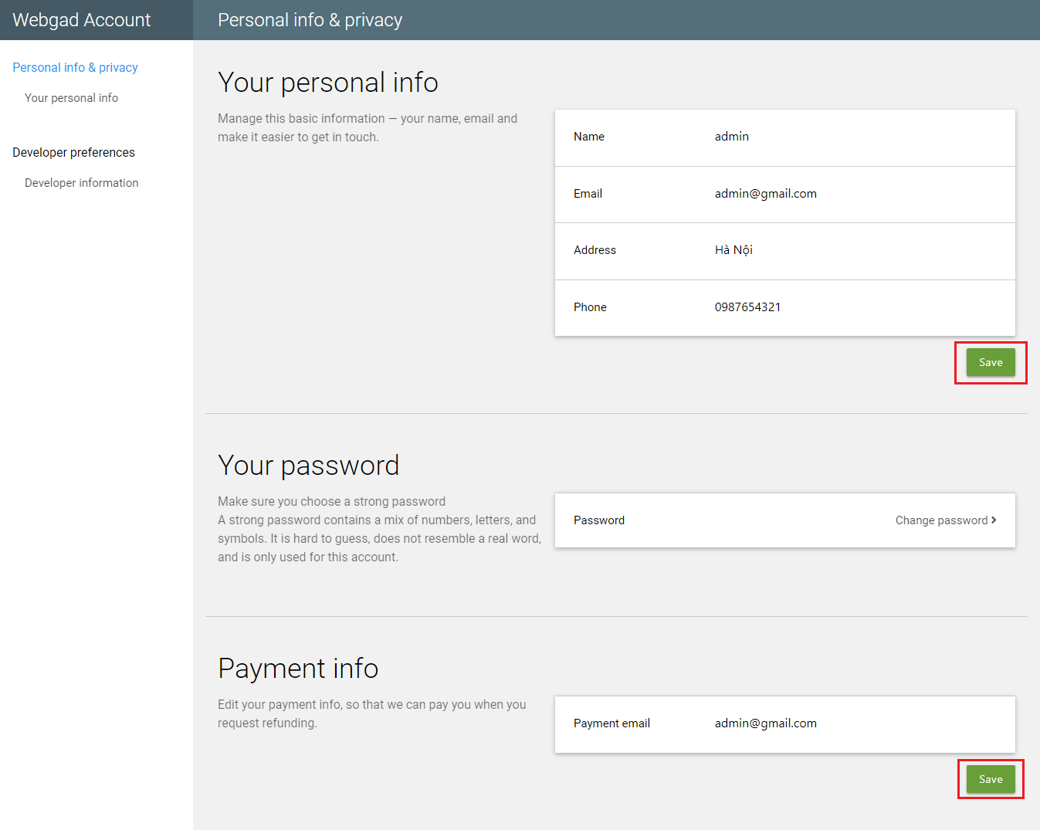

1. Select “Developer preferences”, update information field and click on button “Save”.

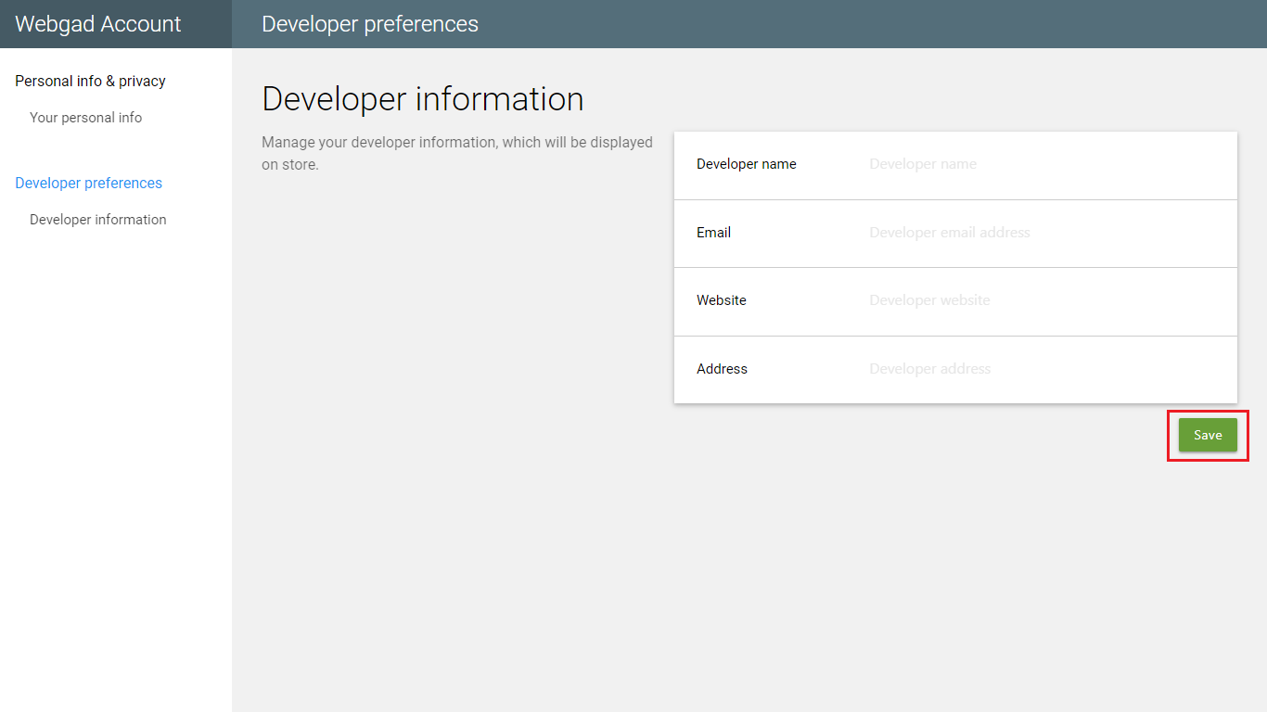

### Guide for Gadget User

#### View “My gadget”

1. Access to “Webgad Store”.
2. Clickk on menu “My gadget” on left menu bar.

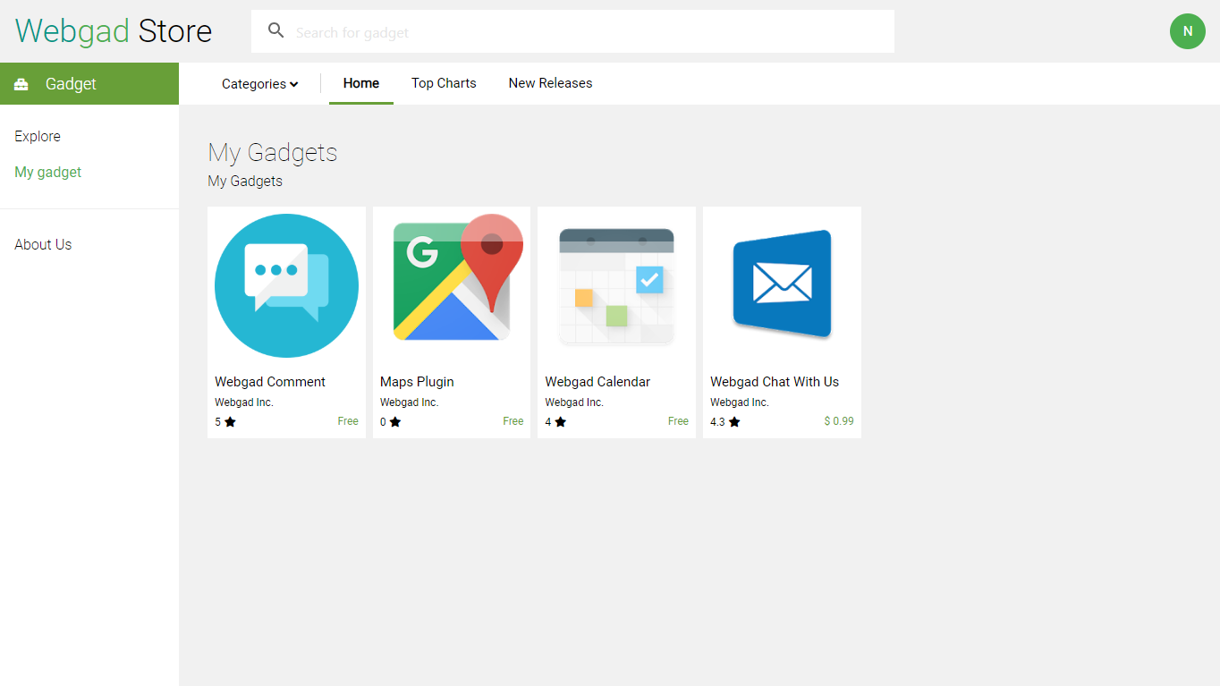

#### Install gadget

1. Access to “Webgad Store”.
2. Select a gadget want to install and click on button “Install”.

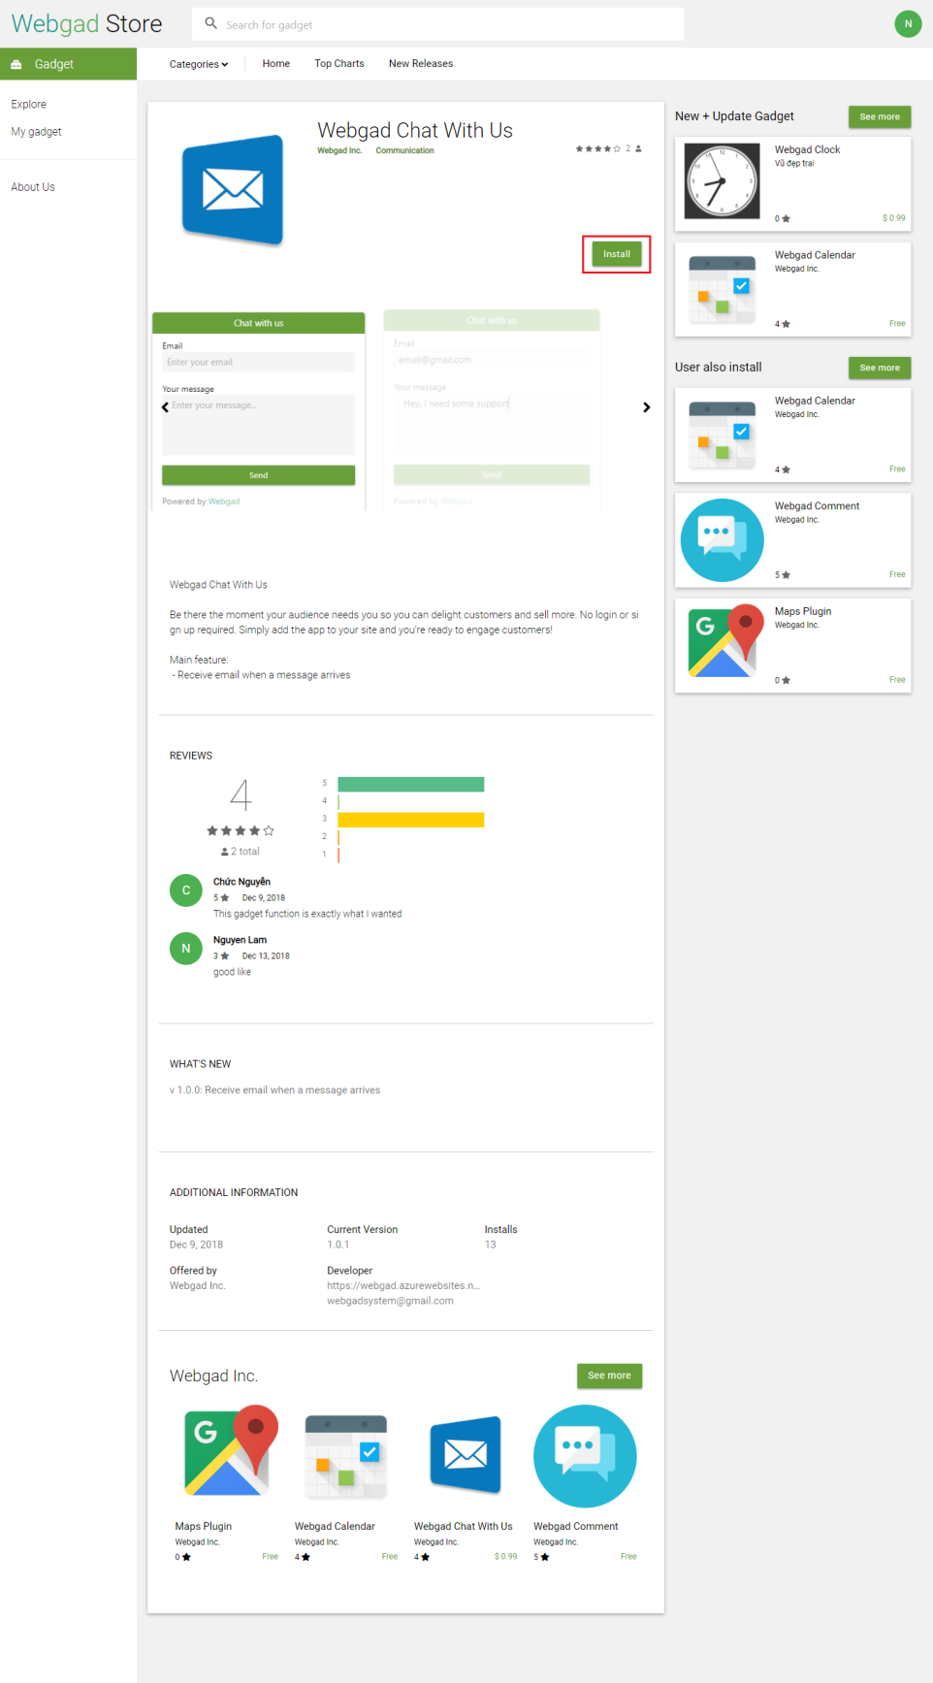

1. Input URL website to text field and click on button “Continue”.

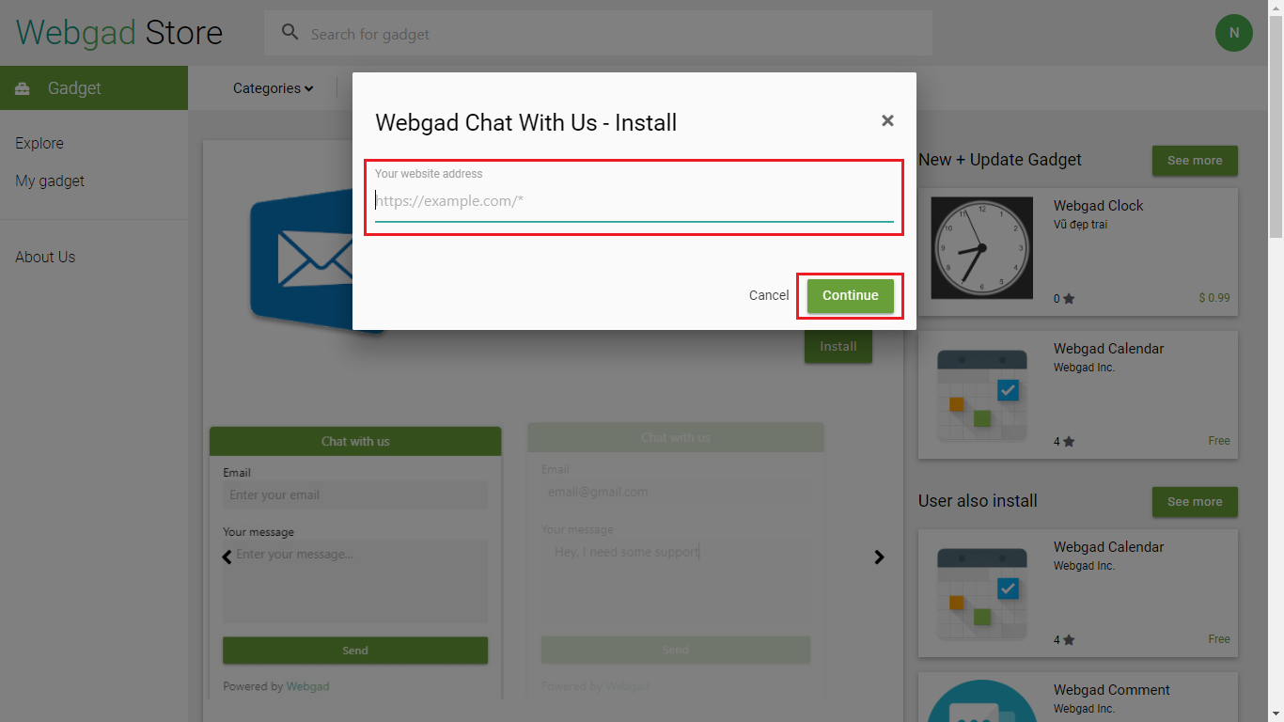

1. Follow step by step in “Installation guide”.

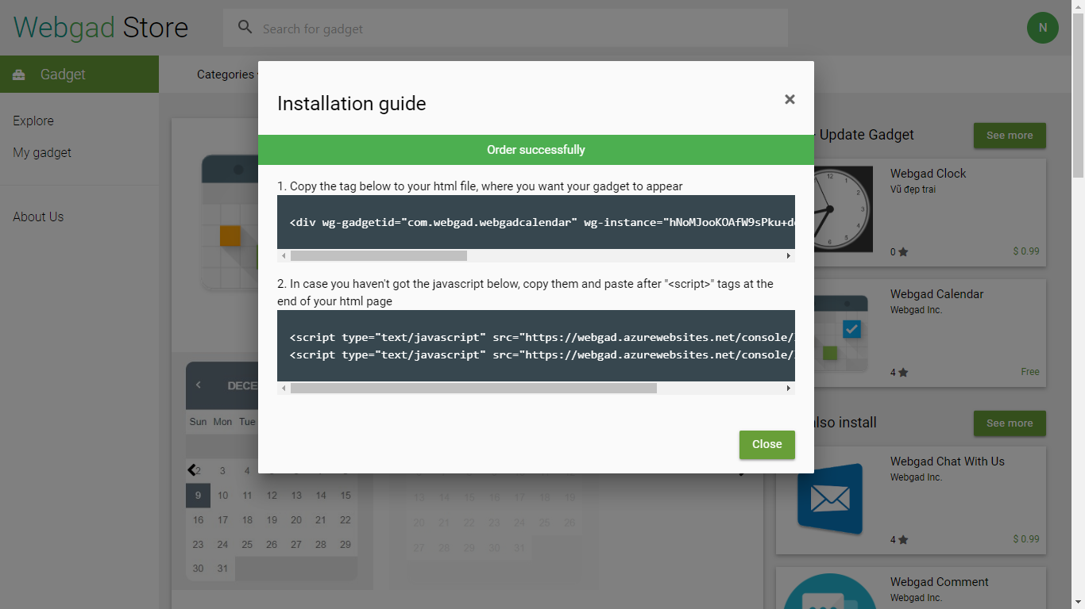

#### Purchase gadget

1. Access to “Webgad Store”.
2. If gadgets have pay fee, after input URL website and click on button “Continue”, the system automatic switch to form payment with paypal.

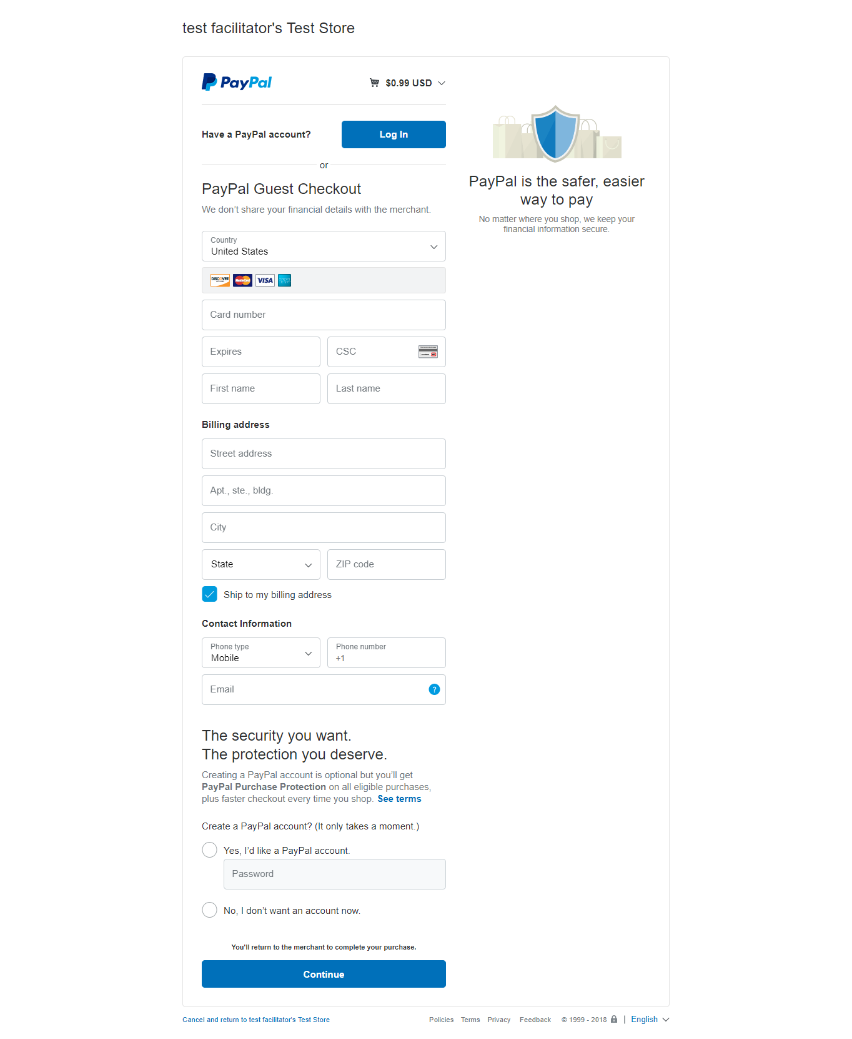

1. After payment successfully, follow step by step in “Installation guide”.

#### Giving feedback

1. After install gadget successfully, you can giving feedback to producer.

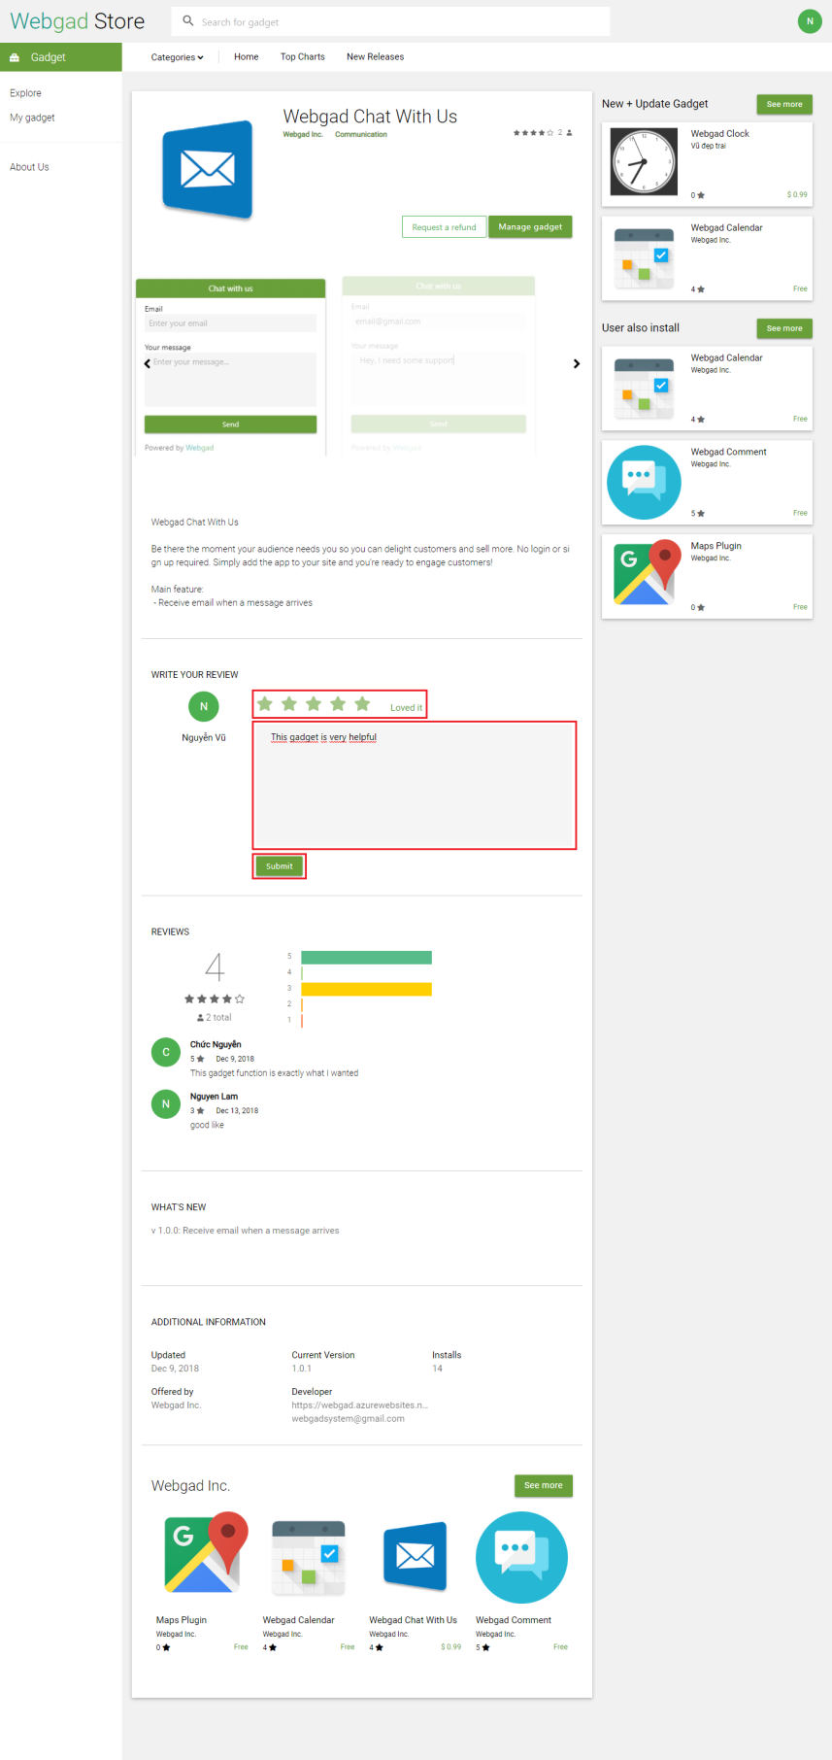

#### Customize gadget

1. After install gadget successfully, you can customize it. Such as change color, font..., update URL website or add new URL. Click on button “Manage gadget”.

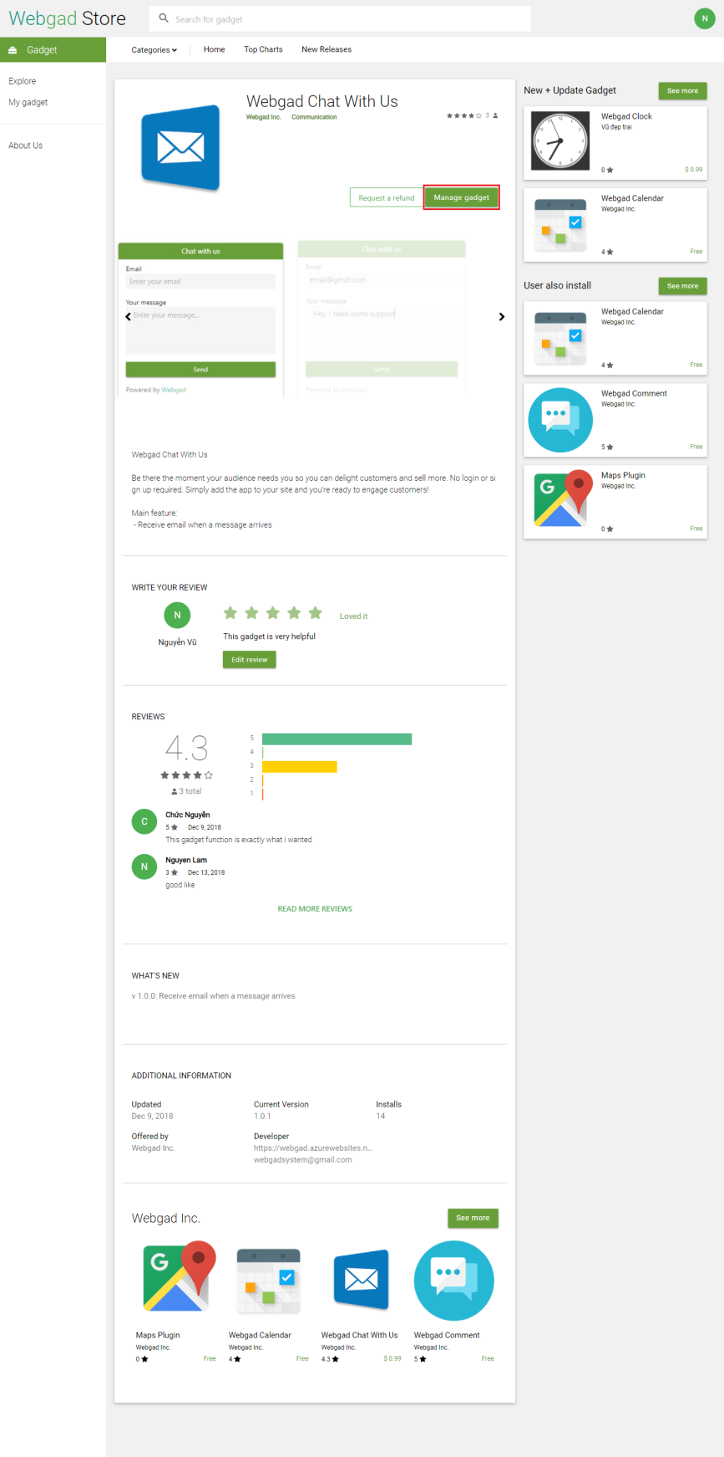

1. For add new URL website, click on button “Add more site”.

For update URL website, select site to manage, input URL website to textfield and click on button “Update site”.

For setting color of gadget, choose color and click on button “Save”.vv…

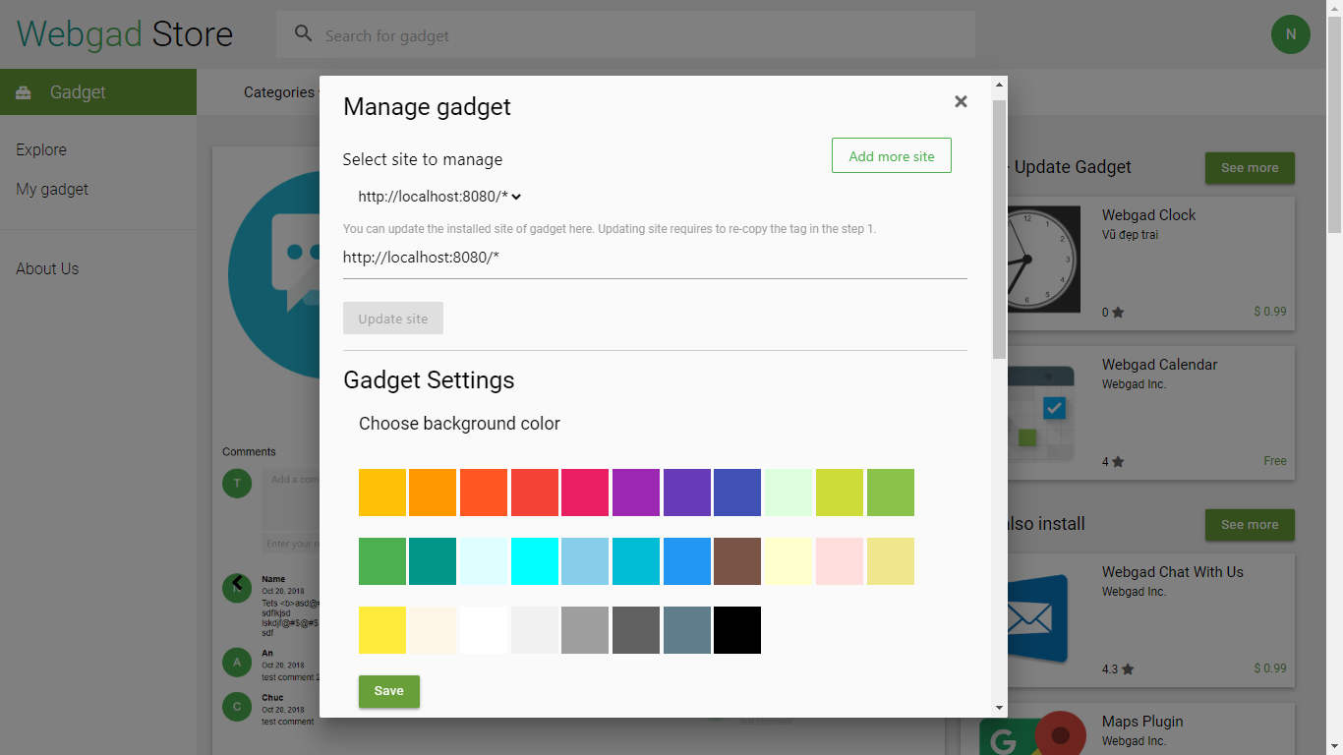

#### Report gadget

* + - 1. After purchased gadget 2-days you can request to refund if this gadget is errored. Click on button “Request a refund”.

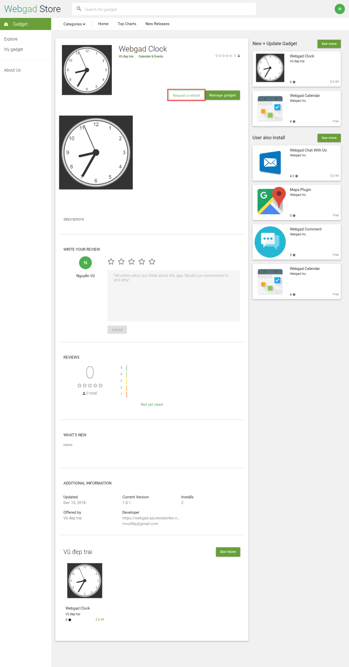

1. Select site, input reason, image description error and click on button “Request refunding”.

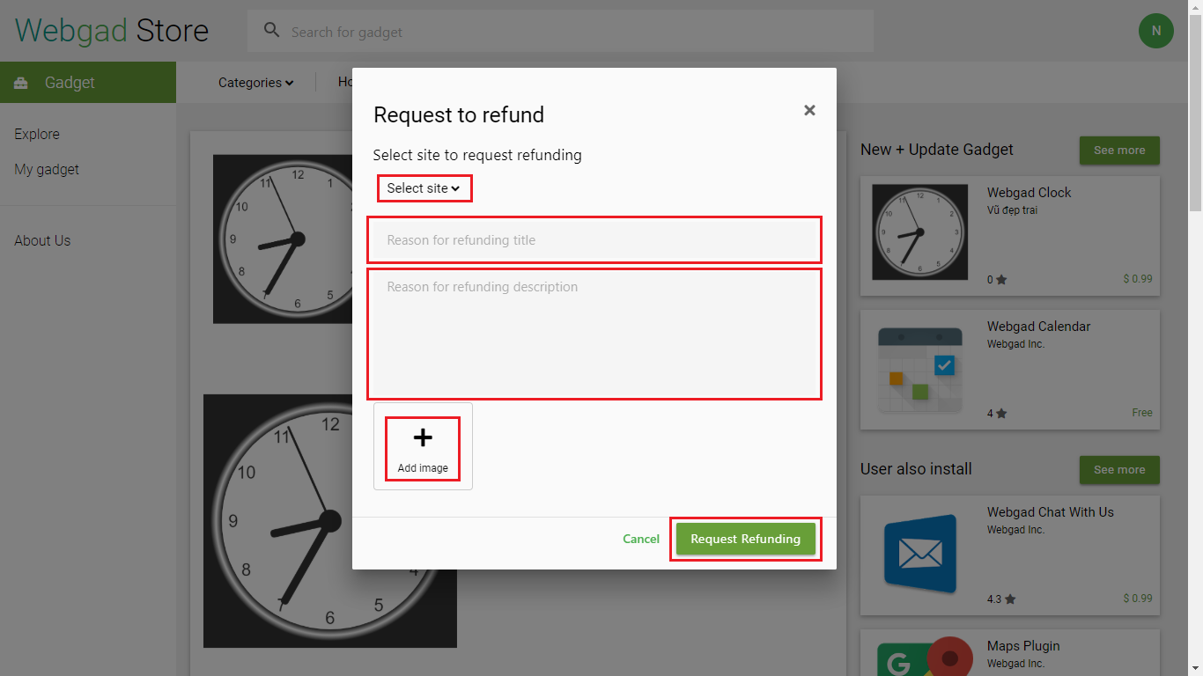

1. Check your email and waiting for admin verify your request.

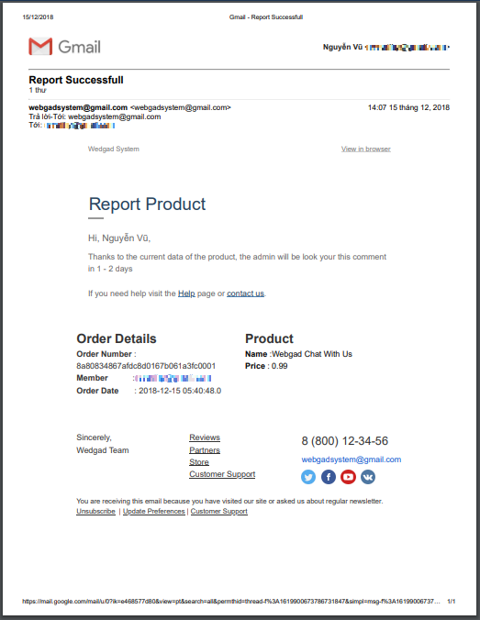

#### Update version gadget

1. After installed gadget, if this gadget release new version, you can update new version for gadget. Click on button “Update”.

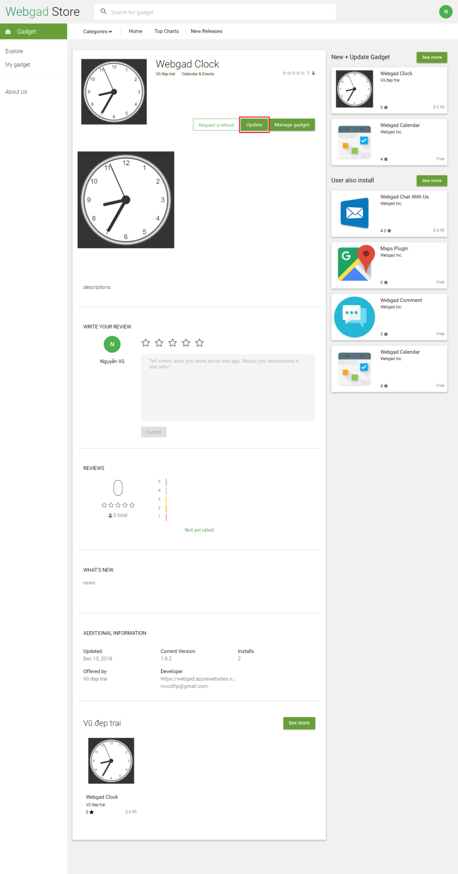

1. Select update for each of URL website or update all of them.

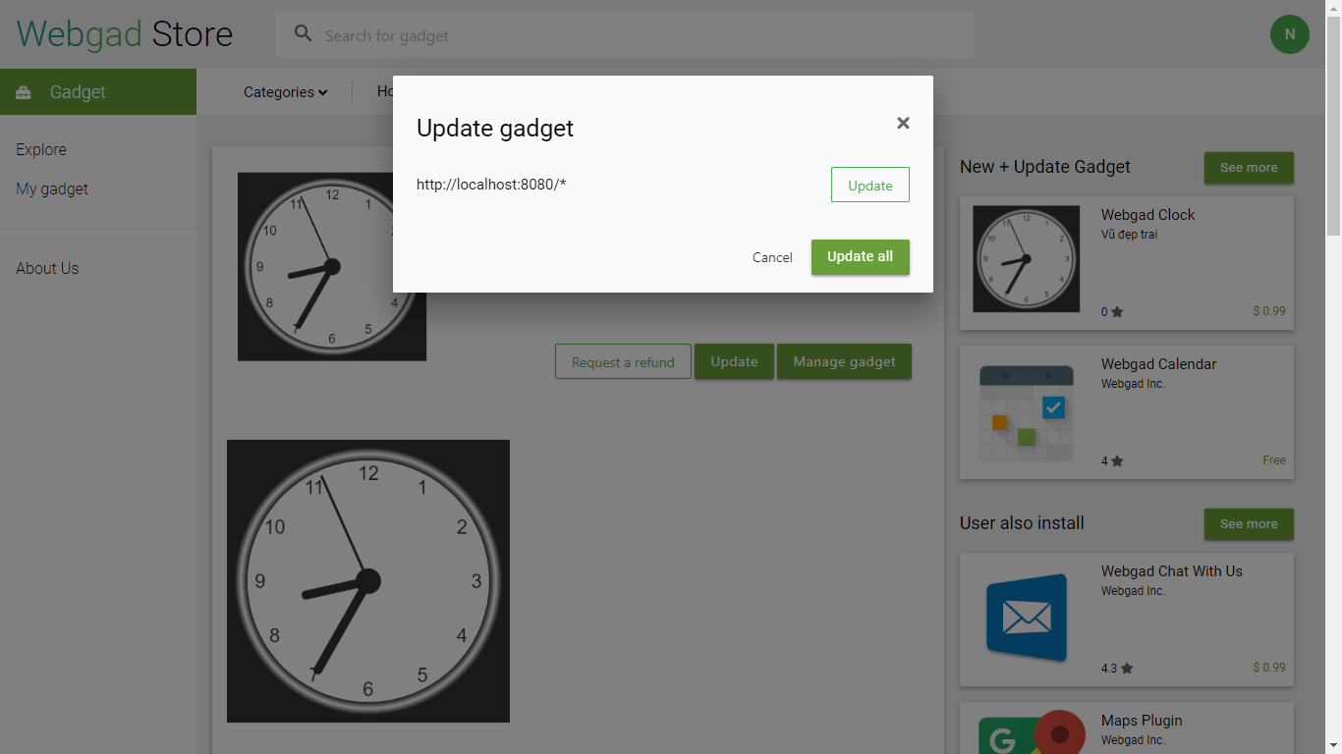

### Guide for Gadget Developer

#### Create gadget

1. Access to “Webgad Console”.

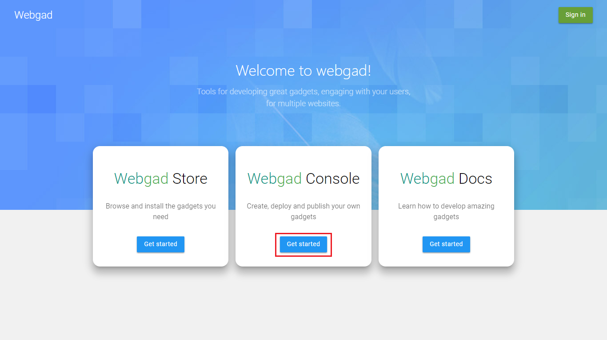

1. Click on “Add gadget”.

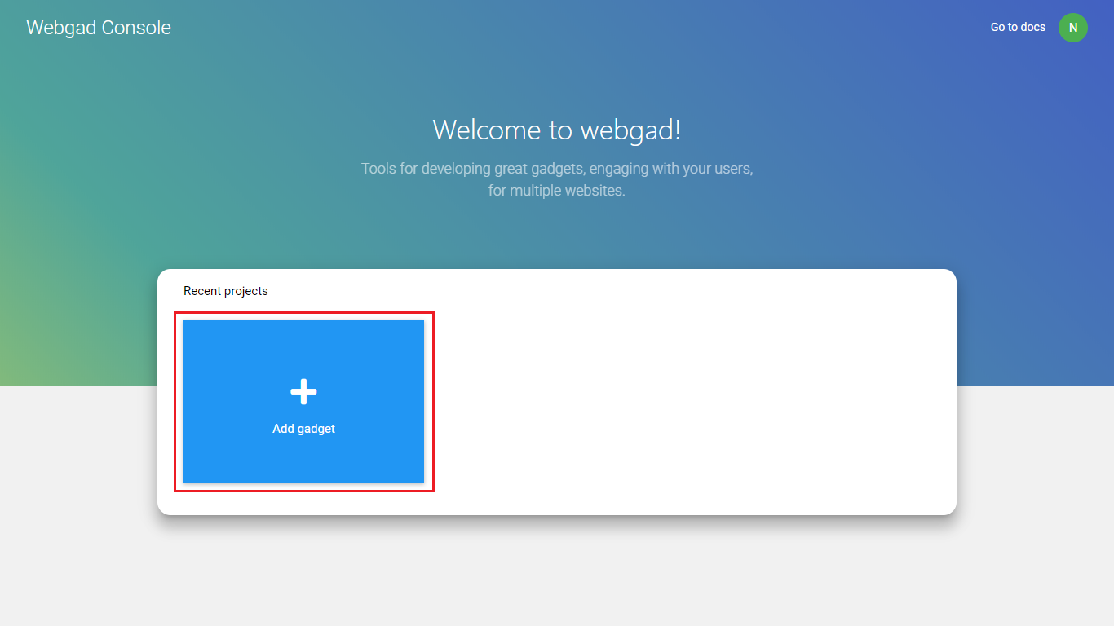

1. Input information to all field then click on button “Create gadget”.

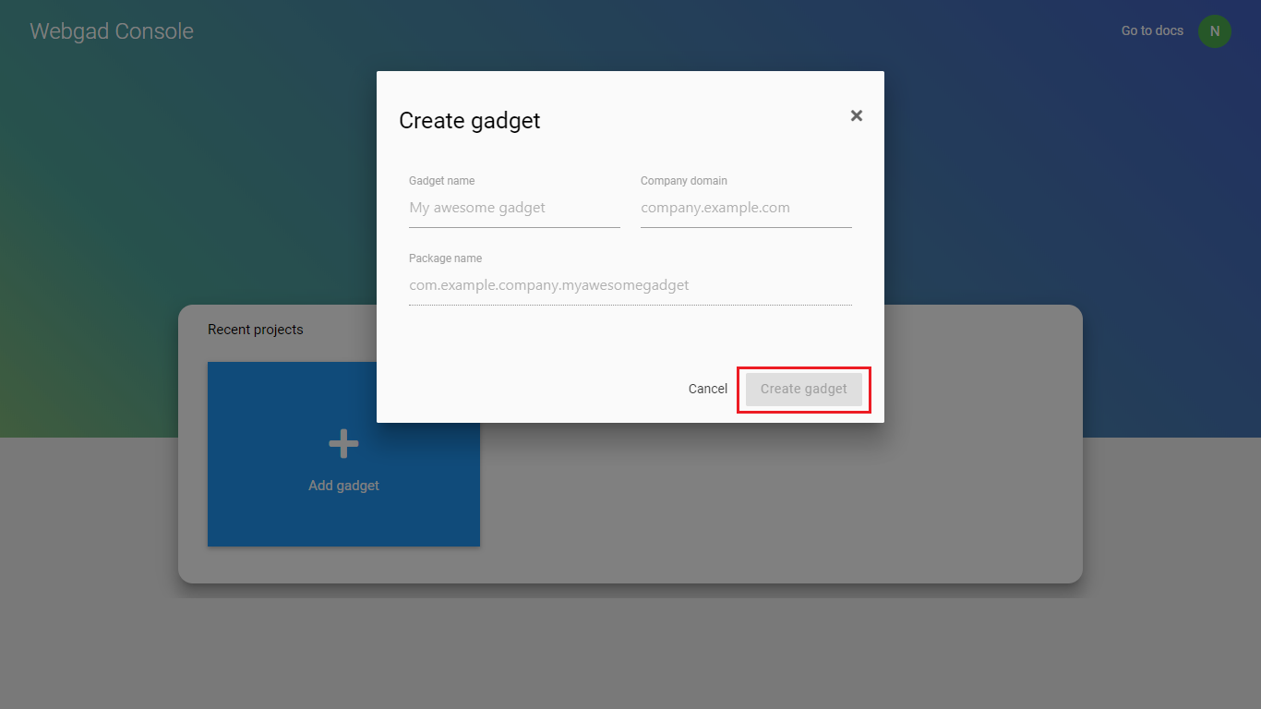

#### Delete gadget

1. After access to “Webgad Console”, select a gadget want to delete.

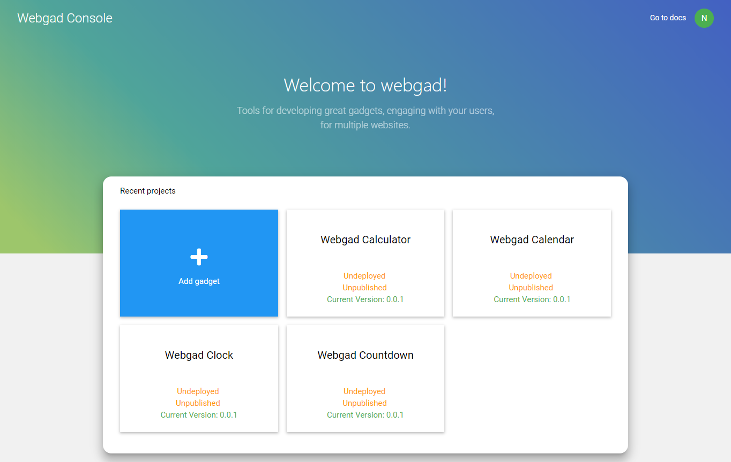

1. Select menu “Settings” on left menu bar.

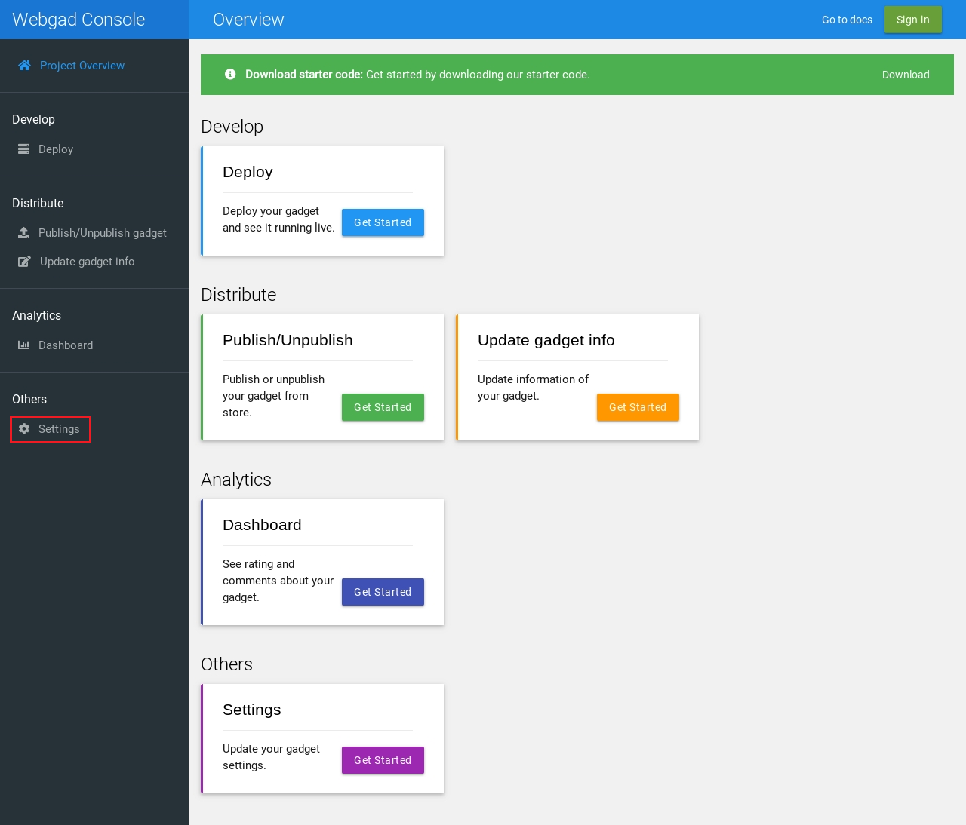

1. Click on button “Delete gadget”.

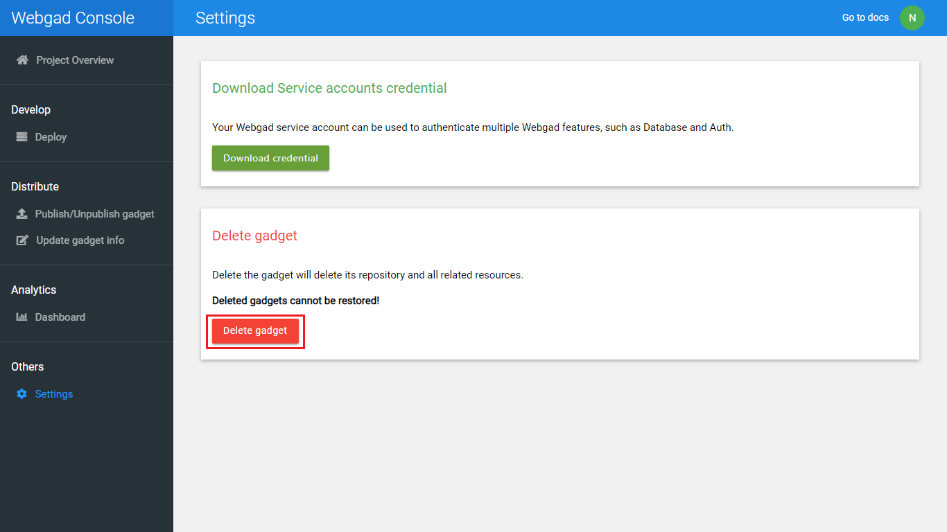

1. Confirm delete gadget and click on button “Delete gadget”.

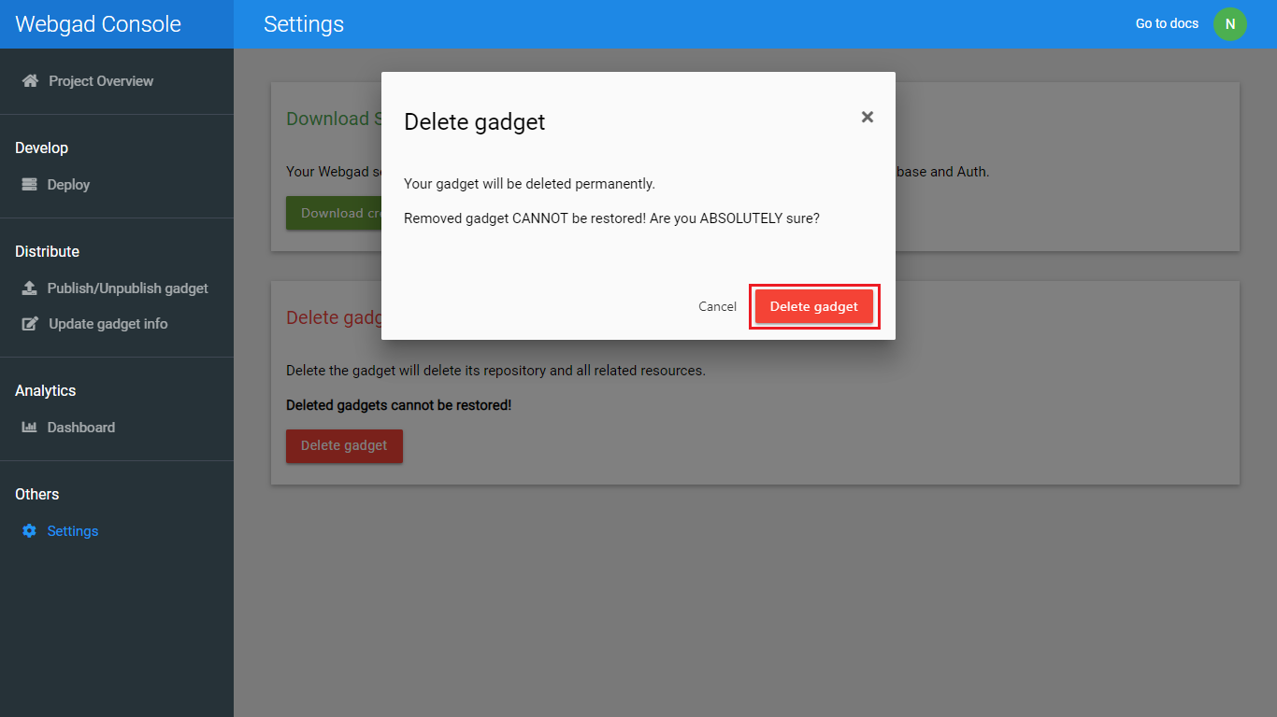

#### Download starter code

1. Click on link “Download” in “Download starter code” notification.

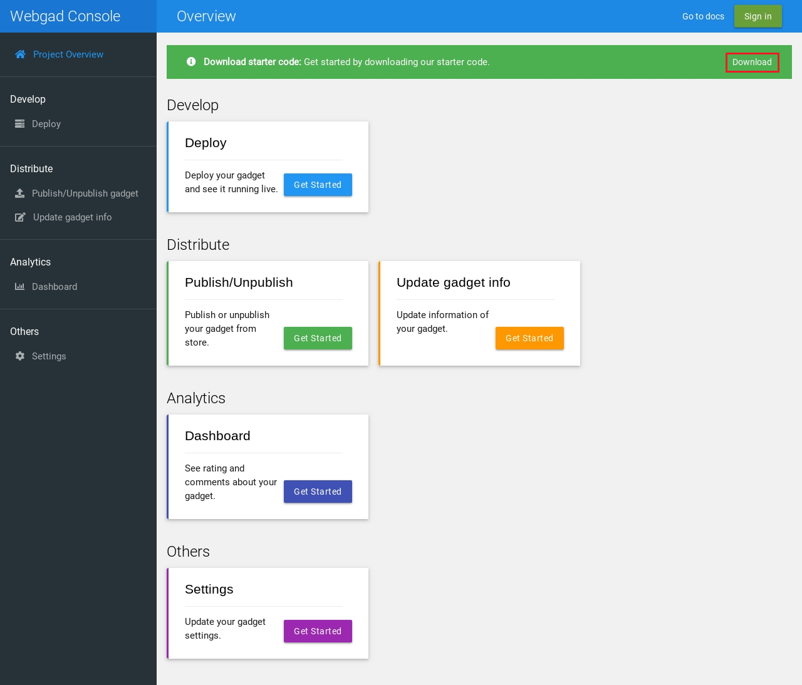

#### Deploy gadget

1. After select a gadget want to deploy, click on menu “Deploy” on left menu bar or click on button “Get started” in “Deploy” tag.

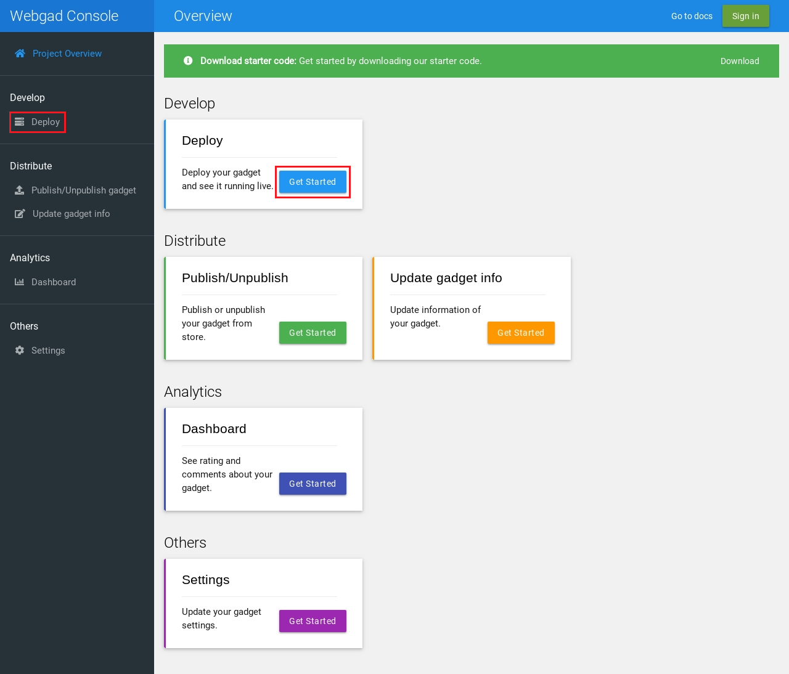

1. Choose file “gadget.war” and click on button “Submit & Deploy” to deploy gadget.

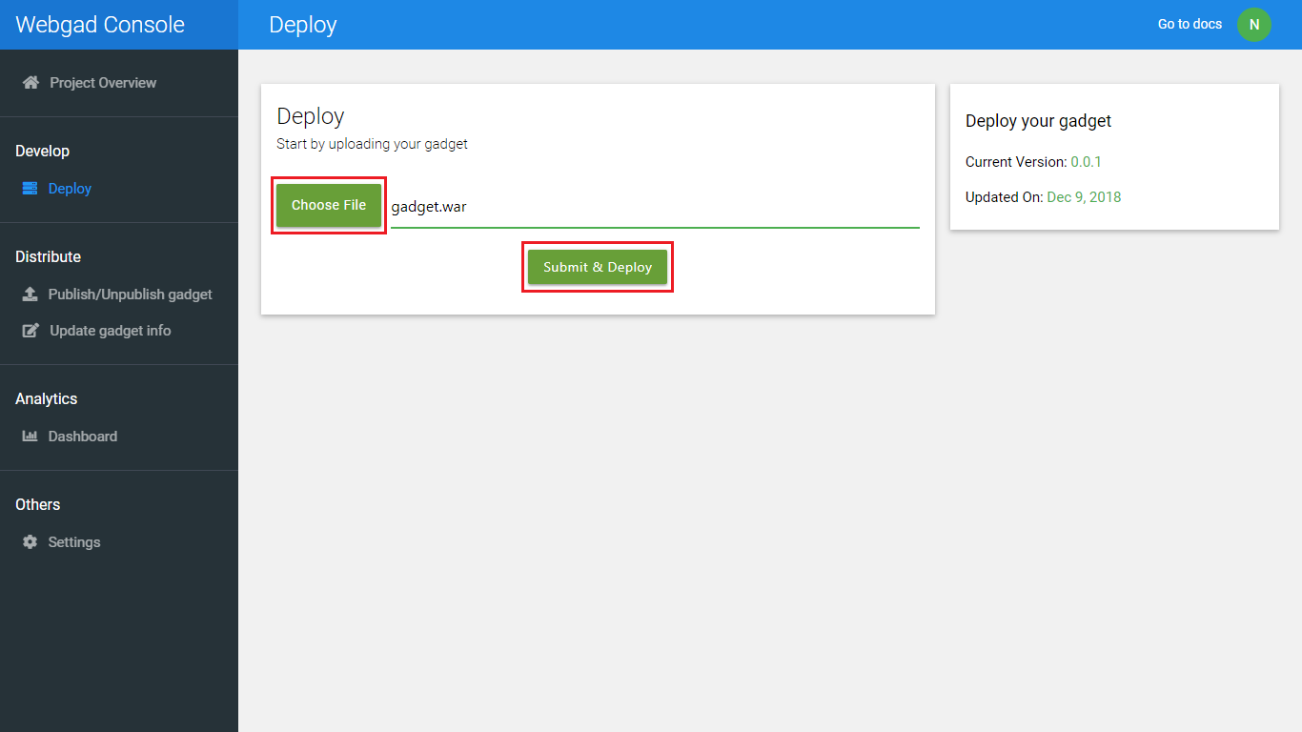

#### Publish/Unpublish gadget

1. After select a gadget want to deploy, click on menu “Publish/Unpublish gadget” on left menu bar or click on button “Get started” in “Publish/Unpublish” tag.

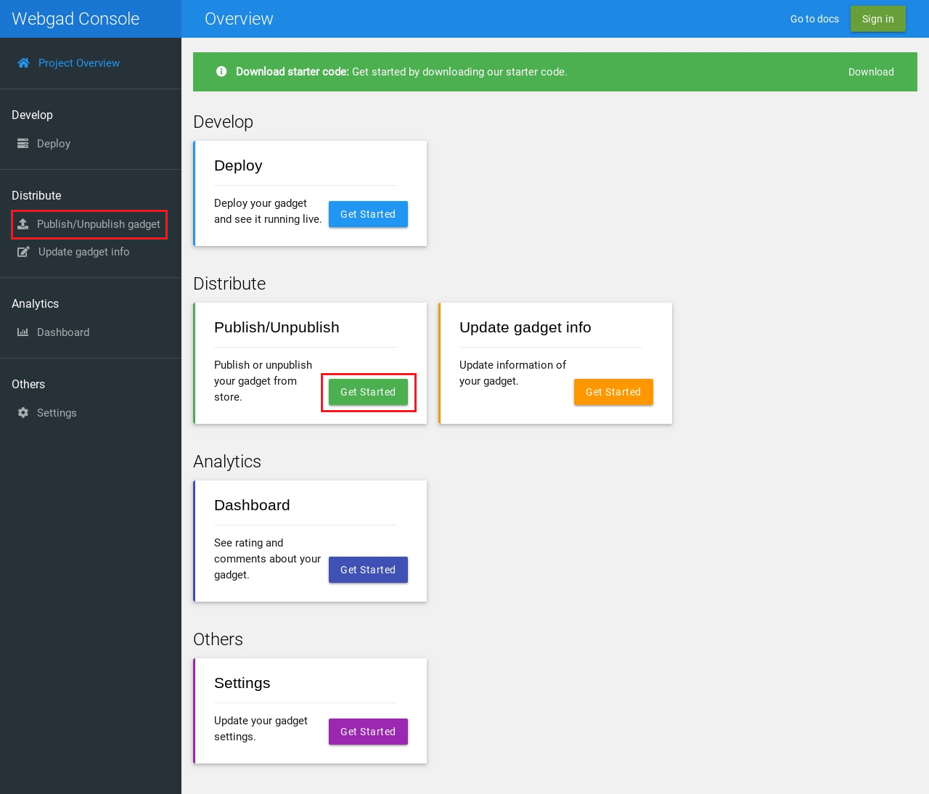

1. Input all information of gadget and click on button “Publish”.

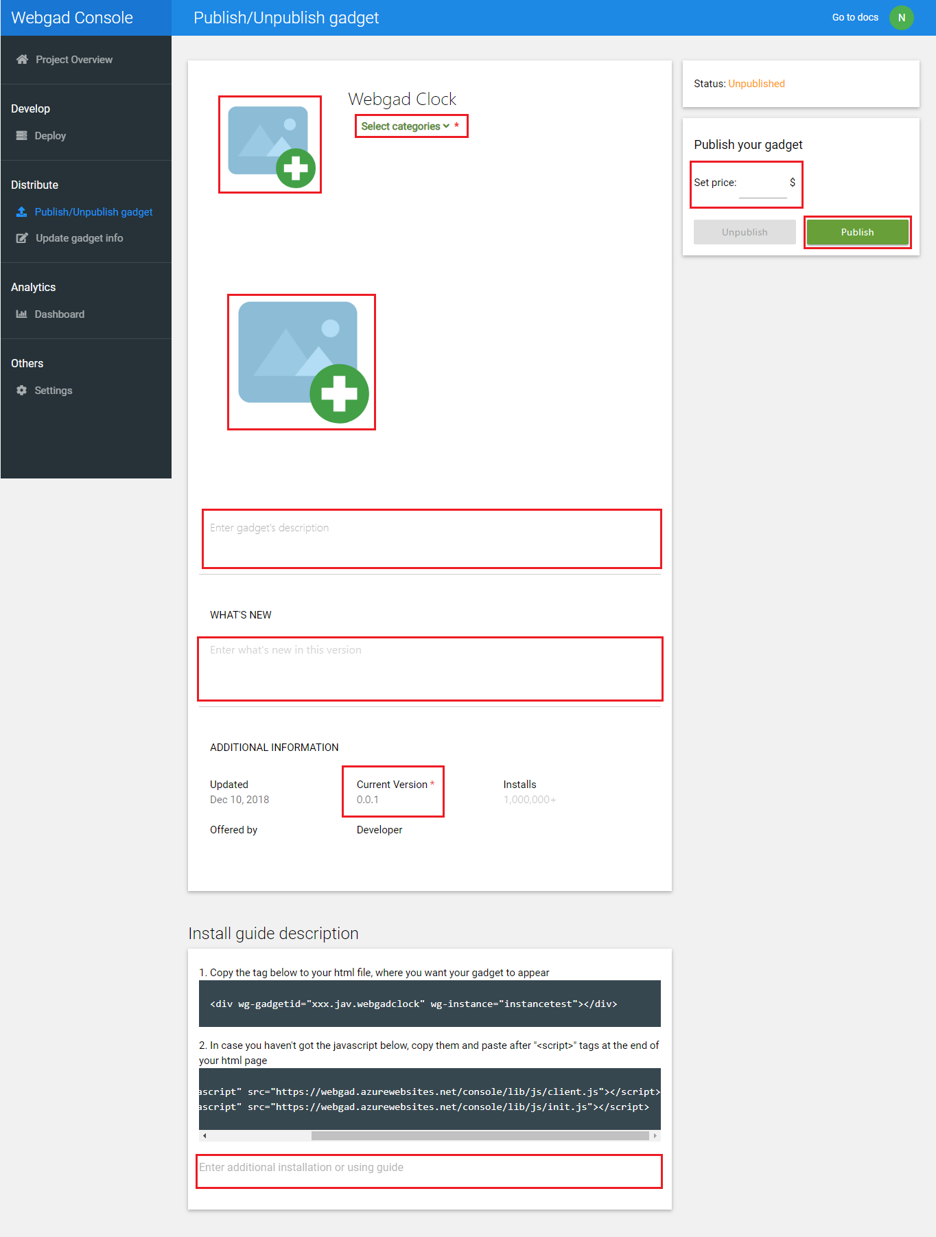

1. After publish if you want to unpublish the gadget click on button “Unpublish”.

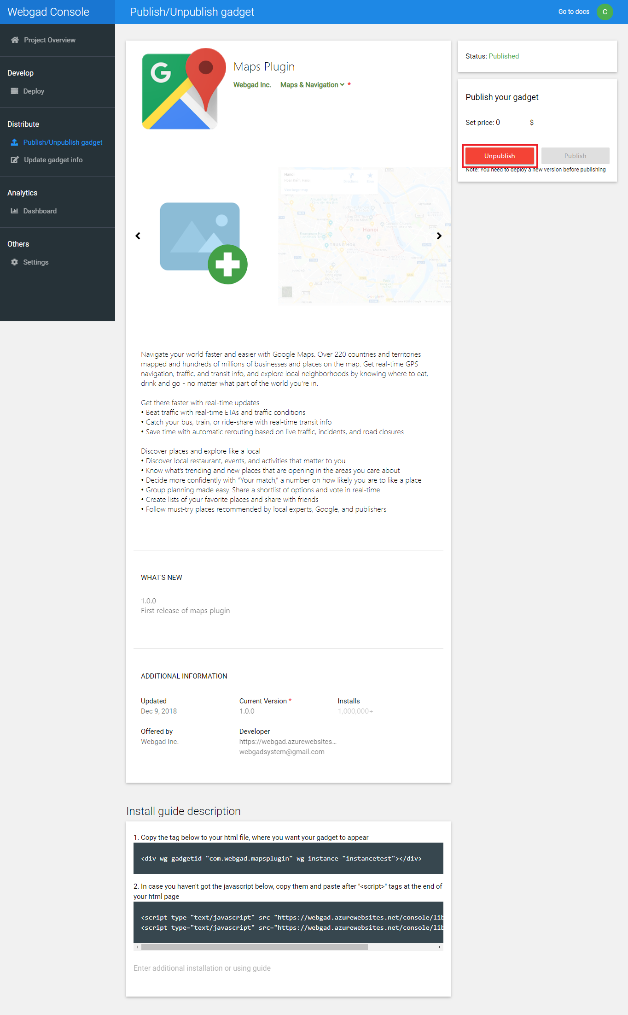

#### Download service accounts credential

1. Select menu “Settings” on left menu bar and click on button “Download credential” in “Download Service accounts credential” notification.

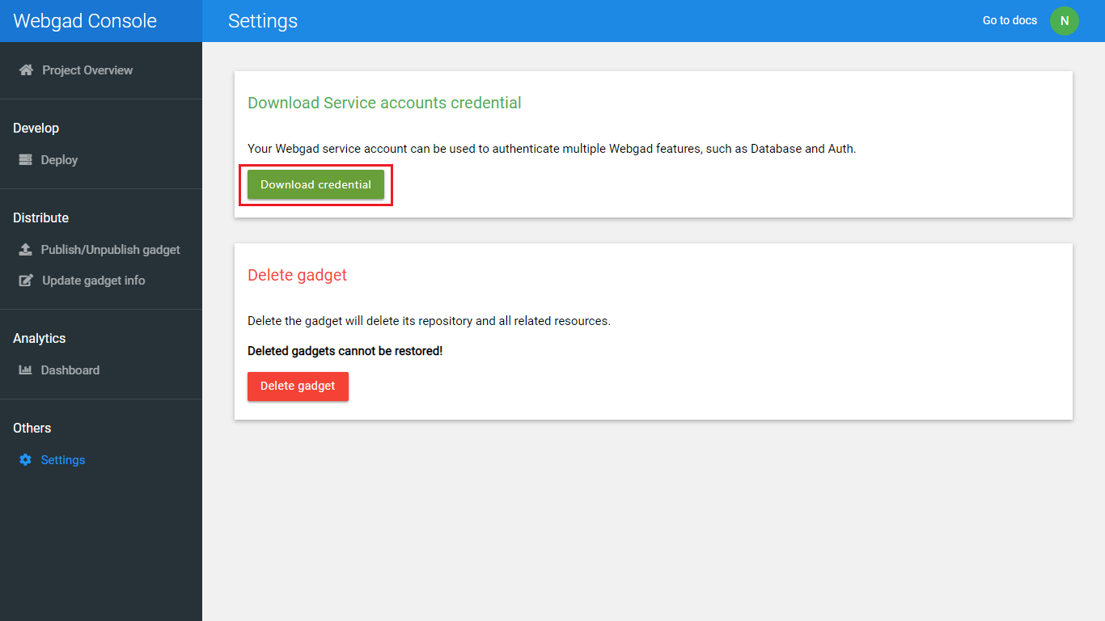

## Admin guides

To access “Webgad System” admin must open browser and enter <https://webgad.azurewebsites.net/admin/verify.html>.

### Verify gadget

1. Access to “Webgad System” for admin.
2. Select a gadget and check all information. If valid click on button “Accept publishing”.

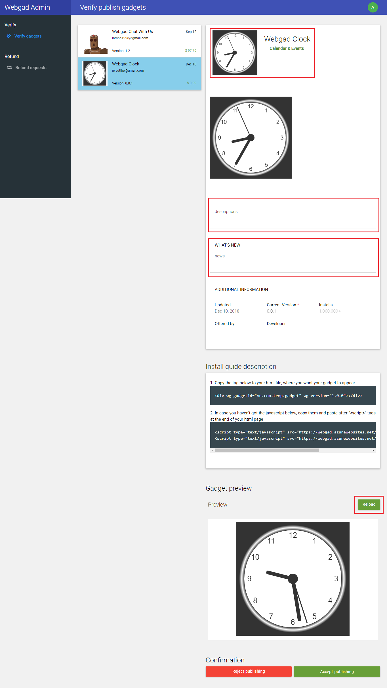

1. If gadget invalid click on button “Reject publishing” and input reason then click on button “Reject request”.

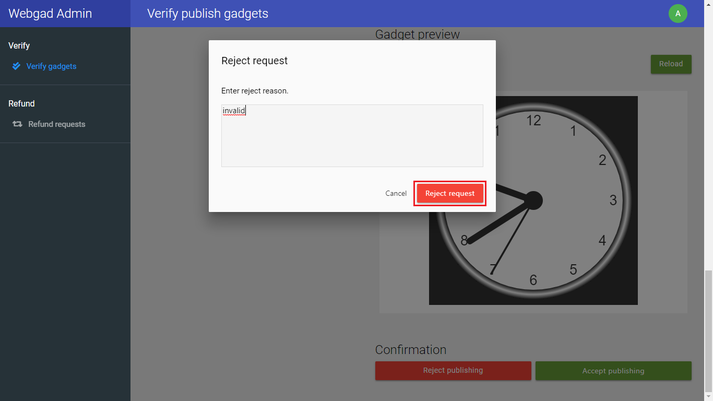

### Verify claim

1. Access to “Webgad System” for admin.
2. Select menu “Refund requests” on left menu bar.
3. Select a gadget and check all information. If valid click on button “Accept refunding”.

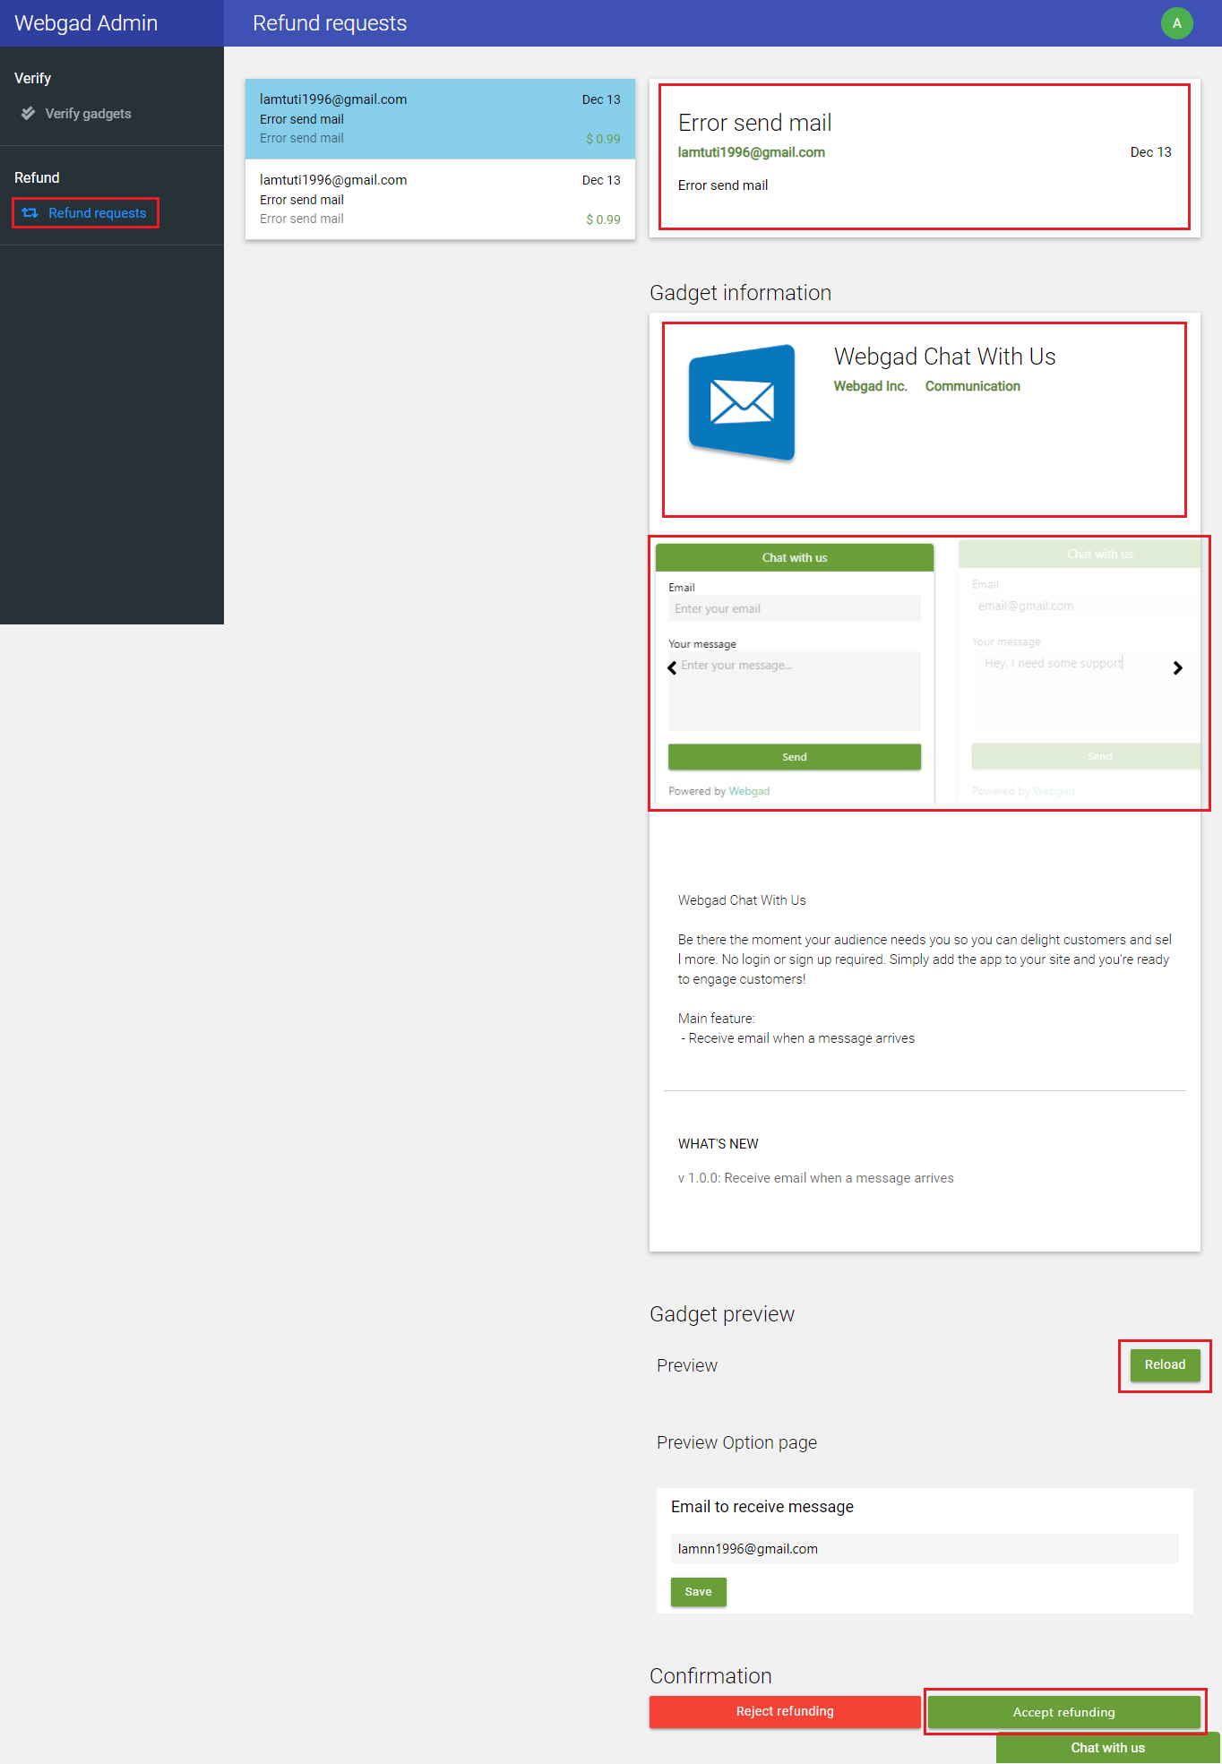

1. If gadget invalid click on button “Reject refunding” and input reason then click on button “Reject request”.

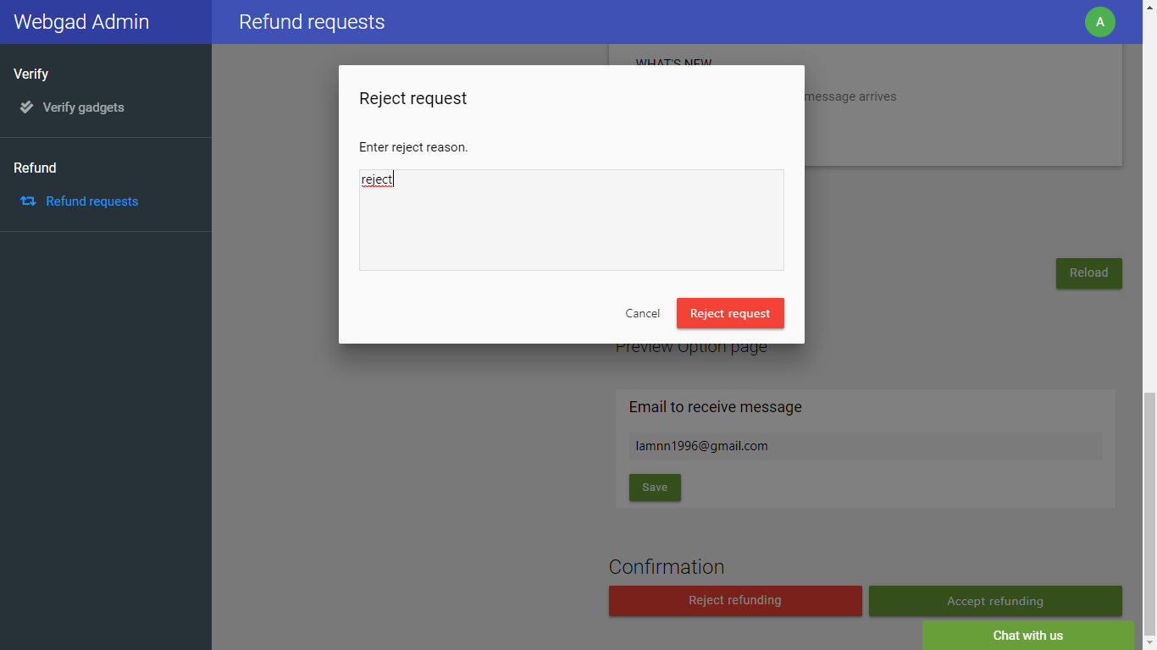

# References

[*https://auth0.com/blog/what-is-and-how-does-single-sign-on-work/*](https://auth0.com/blog/what-is-and-how-does-single-sign-on-work/)

[*https://tools.ietf.org/html/rfc6749*](https://tools.ietf.org/html/rfc6749)

[*https://www.oauth.com/oauth2-servers/access-tokens/authorization-code-request/*](https://www.oauth.com/oauth2-servers/access-tokens/authorization-code-request/)

[*https://github.com/auth0/java-jwt*](https://github.com/auth0/java-jwt)

[*https://stormpath.com/blog/token-auth-for-java*](https://stormpath.com/blog/token-auth-for-java)

[*https://developers.google.com/web/fundamentals/web-components/shadowdom*](https://developers.google.com/web/fundamentals/web-components/shadowdom)

[*https://developer.mozilla.org/en-US/docs/Web/Web_Components/Using_shadow_DOM*](https://developer.mozilla.org/en-US/docs/Web/Web_Components/Using_shadow_DOM)

[*https://docs.mongodb.com/manual/introduction/*](https://docs.mongodb.com/manual/introduction/)

[*http://mongodb.github.io/mongo-java-driver/3.8/driver/tutorials/aggregation/*](http://mongodb.github.io/mongo-java-driver/3.8/driver/tutorials/aggregation/)